HANDWRITTEN DIGIT RECOGNITION

A Project Report Submitted in
the partial fulfillment of the requirements for the award of the degree of

BACHELOR OF TECHNOLOGY
In

DEPARTMENT OF COMPUTER SCIENCE AND ENGINEERING
By
G. Greeshma Sai – 2420030550
Hasini Peddi – 2420030784
B. Keerthi Reddy – 2420030774

Under the Esteemed Guidance of

Dr. N. Sunanda
Associate Professor

Department of Computer Science and Engineering

AY-2026–2027

Semester: Odd




K L (Deemed to be) University
DEPARTMENT OF COMPUTER SCIENCE AND ENGINEERING

Declaration

The Project Report entitled “Handwritten Digit Recognition Using K-Nearest Neighbors (KNN) and Support Vector Machine (SVM)” is a record of Bonafide work of Hasini Peddi – 2420030784, G. Greeshma Sai – 2420030550, B. Keerthi Reddy – 2420030774 submitted in partial fulfillment for the award of B. Tech in Computer Science and Engineering to the K L University. The results embodied in this report have not been copied from any other departments/University/Institute.

Hasini Peddi – 2420030784
G. Greeshma Sai – 2420030550
B. Keerthi Reddy– 2420030774

K L (Deemed to be) University
Department of Computer Science and Engineering

CERTIFICATE

This is certify that the mini project based report entitled “Handwritten Digit Recognition Using K-Nearest Neighbors (KNN) and Support Vector Machine (SVM)” is a bonafide work done and submitted by Hasini Peddi – 2420030784, G. Greeshma Sai – 2420030550, B. Keerthi Reddy – 2420030774 in partial fulfillment of the requirements for the award of the degree of BACHELOR OF TECHNOLOGY in Department of Computer Science and Engineering, K L (Deemed to be University), during the academic year 2026-2027.

_____________________  Signature of the Guide  Dr. N. Sunanda  Associate Professor, CSE | _____________________  Course Coordinator  Dr. N. Sunanda  Department of CSE | _____________________  Head of the Department  Dr. P. Venkateswara Rao  Department of CSE

ACKNOWLEDGEMENT
The success in this project would not have been possible but for the timely help and guidance rendered by many people. Our wish to express my sincere thanks to all those who has assisted us in one way or the other for the completion of my project.

Our greatest appreciation to my Course Coordinator and my guide Dr. N. Sunanda Associate Professor, Department of Computer Science and Engineering which cannot be expressed in words for her tremendous support, encouragement and guidance for this project.

We express our gratitude to Dr. P. Venkateswar Rao, Head of the Department of Computer Science and Engineering for providing us with adequate facilities, ways and means by which we are able to complete this project-based Lab.

We thank all the members of teaching and non-teaching staff members, and also who have assisted me directly or indirectly for successful completion of this project. Finally, I sincerely thank my parents, friends and classmates for their kind help and cooperation during my work.

Hasini Peddi – 2420030784
G. Greeshma Sai – 2420030550
B. Keerthi Reddy – 2420030774

Abstract
Handwritten digit recognition is an important application of Machine Learning and image processing. Recognizing handwritten numbers automatically can be challenging because different people write the same digits in different styles, shapes and sizes.
The project “Handwritten Digit Recognition Using KNN and SVM” focuses on developing an interactive application that identifies handwritten digits from 0 to 9. The application allows users to either draw a digit using an interactive drawing canvas or upload an image containing a handwritten digit.
The system uses the MNIST dataset, which consists of 60,000 training images and 10,000 testing images. Each image is represented in a standard size of 28 × 28 pixels. Before classification, the input image undergoes preprocessing operations such as grayscale conversion, cropping, centering, resizing and pixel normalization to ensure a consistent input format.
Two Machine Learning algorithms, K-Nearest Neighbors (KNN) and Support Vector Machine (SVM), are implemented to recognize handwritten digits. Both models independently generate predictions for the given input. The application displays their predictions and provides a performance comparison using accuracy, precision, recall, F1-score, graphs and confusion matrices.
In the evaluated results, KNN achieved an accuracy of 97.05%, while SVM achieved 97.67%. The results indicate that SVM performed slightly better than KNN on the evaluated MNIST test dataset. The application is developed using Python, Streamlit and Scikit-learn, providing an interactive interface for digit recognition and model performance analysis. This project demonstrates the practical use of Machine Learning algorithms in image classification and provides an understanding of image preprocessing, model training, prediction and evaluation.
Keywords: Handwritten Digit Recognition, Machine Learning, MNIST Dataset, KNN, SVM, Image Preprocessing, Streamlit.
Index
S. No. | Chapters | Topics | Page.no
 |  | Acknowledgement | 4
 |  | Abstract | 5
1 | Introduction | 1.1 Background of the Project  1.2 Problem Statement  1.3 Scope of the Project  1.4 Objectives  1.5 Importance of the Application  1.6 Target Users/Audience
2 | System Requirements | 2.1 Hardware Requirements  2.2 Software Requirements  2.3 Development Tools and Frameworks
3 | Technology Stack | 3.1 Front-end – Streamlit  3.2 Application Logic – Python  3.3 Machine Learning – Scikit-learn  3.4 Image Processing – Pillow and NumPy  3.5 Data Visualization – Matplotlib  3.6 Model Storage – Joblib
4 | System Architecture | 4.1 High-Level Architecture Diagram  4.2 Description of System Modules  4.3 Application Execution Architecture
5 | Design | 5.1 User Interface Design and Screenshots  5.2 System Workflow / Data Flow Diagram
6 | Implementation | 6.1 Module-wise Implementation  6.2 User Input and Image Upload  6.3 Image Preprocessing  6.4 KNN Model Implementation  6.5 SVM Model Implementation  6.6 Prediction and Performance Analysis
7 | Features | 7.1 List of Main Features  7.2 Working of Each Feature  7.3 Interactive Drawing and Image Upload  7.4 Model Comparison Dashboard
8 | Testing | 8.1 Functional Testing  8.2 Integration Testing  8.3 Tools Used for Testing  8.4 Test Cases and Results  8.5 Model Performance Evaluation
9 | Deployment | 9.1 Steps to Run the Application  9.2 Python Environment Configuration  9.3 Local Application Execution
10 | Challenges & Limitations | 10.1 Issues Faced During Development  10.2 Solutions Applied  10.3 Current Limitations
11 | Future Enhancements | 11.1 Planned Features  11.2 Deep Learning Integration  11.3 Character Recognition and Cloud Deployment
12 | Conclusion | 12.1 Summary of the Project  12.2 Achievements  12.3 Skills Learned During Development
13 | References | Research Papers, Dataset and Technical Documentation
14 | Appendices | Application Screenshots  Sample Code Snippets  Installation and Setup Instructions  User Manual

CHAPTER 1
Introduction
1.1 Background of the Project
Handwritten digit recognition is a widely used application of Machine Learning and image processing. It focuses on identifying numerical digits written by humans and converting them into digital information.
People write numbers in different styles. Even when two people write the same digit, their handwriting may differ in shape, size, thickness and alignment. This makes it difficult for a computer to identify handwritten digits directly.
Machine Learning helps solve this problem by learning patterns from previously labeled handwritten images. After learning these patterns, the model can classify new handwritten images into their corresponding digit classes.
In this project, we developed a handwritten digit recognition application using two Machine Learning algorithms: K-Nearest Neighbors (KNN) and Support Vector Machine (SVM).
The application accepts input through an interactive drawing canvas or an image upload option. The input image is processed into a standard format and passed to the trained models for prediction. The system also compares the performance of both algorithms through a visual dashboard.
1.2 Problem Statement
Recognizing handwritten digits automatically is challenging because handwriting differs from person to person. Variations in digit shape, stroke thickness, size, alignment and background can affect recognition accuracy.
Traditional manual recognition requires human effort and may become time-consuming when processing large numbers of handwritten documents.
Therefore, the main problem addressed in this project is to develop an interactive system that can accept handwritten digit images, preprocess them into a consistent format and classify them accurately using Machine Learning algorithms.
The project also aims to compare KNN and SVM using the same dataset and evaluation metrics to identify which algorithm performs better for handwritten digit recognition.
1.3 Scope of the Project
The scope of this project includes:
- Recognizing handwritten numerical digits from 0 to 9.
- Providing an interactive drawing canvas for user input.
- Allowing users to upload handwritten digit images.
- Converting images into grayscale format.
- Cropping and centering handwritten digits.
- Resizing images into 28 × 28 pixels.
- Normalizing pixel values between 0 and 1.
- Implementing KNN and SVM classification algorithms.
- Training and testing models using the MNIST dataset.
- Displaying predictions from both models.
- Comparing model performance through evaluation metrics.
- Visualizing results using graphs and confusion matrices.
The current implementation focuses on numerical digit recognition and does not support complete handwritten sentences or alphabet recognition.
1.4 Objectives
The main objectives of this project are:
- To develop an interactive handwritten digit recognition application.
- To allow users to draw or upload handwritten digit images.
- To preprocess input images into a standard 28 × 28 format.
- To implement KNN and SVM Machine Learning algorithms.
- To train and test the models using the MNIST dataset.
- To evaluate model performance using accuracy, precision, recall and F1-score.
- To compare the performance of both algorithms.
- To display prediction results through a user-friendly dashboard.
1.5 Importance of the Application
Handwritten digit recognition plays an important role in reducing manual effort involved in reading and processing numerical information.
The application demonstrates how Machine Learning can be used to identify handwritten numbers automatically. It also helps users understand how image processing and classification algorithms work together to generate predictions.
This project provides practical knowledge of image preprocessing, Machine Learning model training, classification, testing and performance evaluation.
1.6 Target Users/Audience
The intended users of the application include:
- Students learning Machine Learning and image processing.
- Faculty members and academic researchers.
- Developers experimenting with image classification.
- Users interested in handwritten digit recognition.
- Educational institutions demonstrating Machine Learning applications.
CHAPTER 2
System Requirements
2.1 Hardware Requirements
The following hardware configuration is suitable for running the project.
Processor : Intel Core i3 / i5 or equivalent
RAM : 4 GB minimum, 8 GB recommended
Storage : At least 1 GB of free space
Operating Input : Keyboard and Mouse
Display : Standard Laptop or Desktop Display
GPU : Optional

2.2 Software Requirements
The software requirements used for the project are:
- Operating System: Windows 10 or Windows 11.
- Programming Language: Python 3.x.
- Development Environment: Visual Studio Code / Jupyter Notebook.
- Application Framework: Streamlit.
- Machine Learning Library: Scikit-learn.
- Numerical Processing: NumPy.
- Data Handling: Pandas, where used.
- Data Visualization: Matplotlib.
- Image Processing: Pillow.
- Model Storage: Joblib.
2.3 Development Tools and Frameworks
Python:
Python is the main programming language used in this project. It is used for image processing, model training, prediction and application development.
Streamlit:
Streamlit is used to create the interactive web application. It provides the drawing canvas, image upload interface, prediction results and performance dashboard.
Scikit-learn:
Scikit-learn provides the Machine Learning algorithms used in the project. It is used to implement KNN and SVM and evaluate their performance.
NumPy:
NumPy is used for numerical calculations and handling image data in the form of arrays.
Pandas:
Pandas is useful for handling structured data and organizing evaluation results wherever required in the implementation.
Matplotlib:
Matplotlib is used to generate graphs and visual representations of model performance.
Pillow:
Pillow is used to open, convert, resize and process image files.
Joblib:
Joblib is used to save trained Machine Learning models and load them when the application runs.
CHAPTER 3
Technology Stack
3.1 Front-end – Streamlit
Streamlit is an open-source Python framework used to build interactive web applications.
In this project, Streamlit is used to create the user interface. It allows users to draw handwritten digits, upload images, submit inputs and view prediction results.
It also displays the model comparison dashboard with graphs, performance metrics and confusion matrices.
3.2 Application Logic – Python
Python is used to develop the main application logic. It manages image preprocessing, model loading, prediction generation and performance analysis.
Python also connects the different project modules and ensures that the input image moves through the complete recognition process.
3.3 Machine Learning – Scikit-learn
Scikit-learn is a Machine Learning library used for implementing classification algorithms.
In this project, two algorithms are implemented:
K-Nearest Neighbors (KNN): A distance-based classification algorithm that predicts a class based on the nearest training samples.
Support Vector Machine (SVM): A classification algorithm that learns decision boundaries to distinguish between different digit classes.
3.4 Image Processing – Pillow and NumPy
Pillow is used to read and manipulate images, while NumPy is used to represent image data as numerical arrays.
These tools support grayscale conversion, image resizing, pixel manipulation and normalization.
3.5 Data Visualization – Matplotlib
Matplotlib is used to generate visualizations for model evaluation and comparison.
It helps display performance graphs, confusion matrices and other analysis results.
3.6 Model Storage – Joblib
Joblib is used to store trained Machine Learning models in serialized files.
The application loads these saved models when it needs to generate predictions, avoiding the need to train the models every time the application starts.
CHAPTER 4
System Architecture
4.1 High-Level Architecture Diagram
Insert the system architecture diagram here.
The architecture follows this sequence:
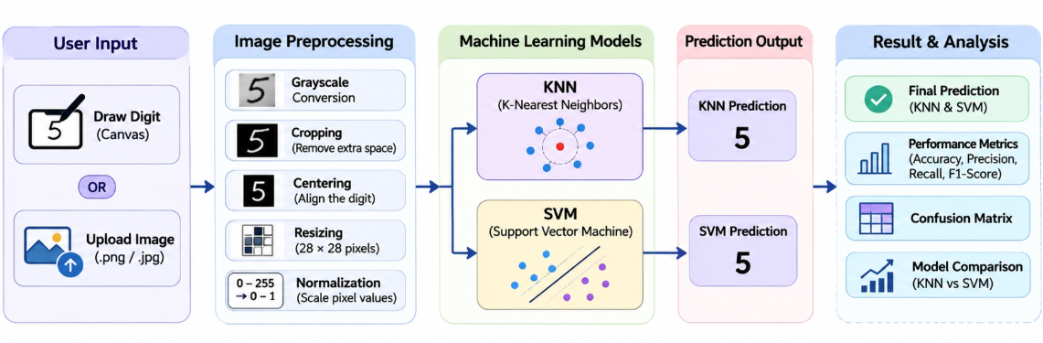
4.2 Description of System Modules
1. User Input Layer
This layer allows the user to provide a handwritten digit through the drawing canvas or image upload option.
2. Image Preprocessing Layer
The input image is prepared through grayscale conversion, cropping, centering, resizing and normalization.
3. Machine Learning Layer
The processed image is passed to the trained KNN and SVM models for classification.
4. Prediction Layer
The predictions from both models are generated and displayed to the user.
5. Performance Analysis Layer
This layer provides model evaluation results through accuracy, precision, recall, F1-score, graphs and confusion matrices.
4.3 Application Execution Architecture
The application is designed to run locally using Python and Streamlit.
The user starts the application from the project directory. Streamlit creates a local web interface that can be accessed through a browser.
The application uses the trained model files and required Python libraries to process images and generate predictions.
CHAPTER 5
Design
5.1 User Interface Design and Screenshots
The application is designed with a simple and interactive interface.
The main interface contains the following sections:
1. Main Application Screen
Displays the project interface and available input options.
2. Interactive Drawing Canvas
Allows users to draw handwritten digits directly using a mouse or supported input device.
3. Image Upload Section
Allows users to select and upload a handwritten digit image from their computer.
4. Preprocessed Image Display
Displays the processed 28 × 28 image before classification.
5. Prediction Results
Displays the predictions generated by KNN and SVM.
6. Performance Dashboard
Displays evaluation metrics, comparison graphs, confusion matrices and error analysis.
Insert the screenshots of the actual working application under this section.
5.2 System Workflow / Data Flow Diagram
A Data Flow Diagram represents how data moves through the system.
In this project, the input image is provided by the user and passed to the preprocessing module. After preprocessing, the image is given to the KNN and SVM models. Both models generate predictions, which are displayed through the application interface.
The overall data flow is:
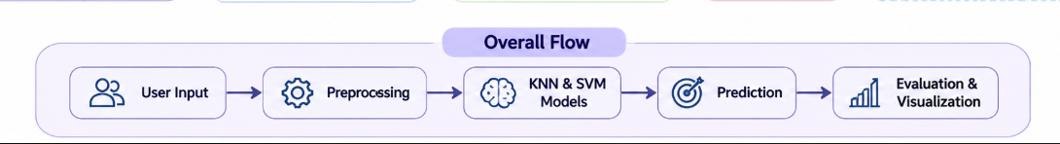

CHAPTER 6
Implementation
6.1 Module-wise Implementation
The project is divided into four major modules.
Module 1: User Input Module
This module allows users to provide handwritten digit images through an interactive drawing canvas or by uploading an image.
Input: Handwritten digit image.
Output: Input image ready for preprocessing.
Module 2: Image Preprocessing Module
This module prepares the input image for classification. It performs grayscale conversion, inversion when required, cropping, centering, resizing and normalization.
Input: Raw handwritten image.
Output: Processed 28 × 28 image.
Module 3: Machine Learning Classification Module
This module uses KNN and SVM algorithms to recognize handwritten digits. Both trained models independently generate predictions.
Input: Processed image.
Output: Predicted digit from KNN and SVM.
Module 4: Prediction and Performance Analysis Module
This module displays the prediction results and compares the performance of both algorithms using evaluation metrics and visualizations.
Input: Model predictions and evaluation results.
Output: Predicted digit, accuracy, graphs, precision, recall, F1-score and confusion matrices.
6.2 User Input and Image Upload
The user input module provides two ways to submit handwritten digits.
The first option is an interactive drawing canvas where the user draws a digit directly.
The second option allows the user to upload an image containing a handwritten digit.
After receiving the input, the application sends the image to the preprocessing module.
6.3 Image Preprocessing
Image preprocessing is an important step because Machine Learning models require input images in a consistent format.
The following operations are performed:
Grayscale Conversion:
The input image is converted into grayscale to reduce unnecessary color information.
Image Inversion:
The image is inverted when required to match the expected background and digit color format.
Cropping:
Unnecessary empty areas around the handwritten digit are removed.
Centering:
The digit is positioned properly within the image.
Resizing:
The image is resized to 28 × 28 pixels to match the MNIST dataset format.
Normalization:
Pixel values are converted from the range 0–255 into the range 0–1.
After preprocessing, the image is represented using 784 pixel values.
6.4 KNN Model Implementation
K-Nearest Neighbors is a supervised Machine Learning classification algorithm.
It predicts the class of a new input by identifying the nearest training samples.
In this project, KNN is implemented with K = 3 and Euclidean distance.
The algorithm follows these steps:
- Load the training dataset.
- Calculate the distance between the input and training samples.
- Identify the three nearest neighbors.
- Apply majority voting.
- Predict the digit class.
The KNN model is used as a distance-based classification approach for recognizing handwritten digits.
6.5 SVM Model Implementation
Support Vector Machine is a supervised Machine Learning algorithm used for classification.
SVM learns decision boundaries that help distinguish different digit classes.
In this project, the RBF kernel is used with C = 10.
The algorithm follows these steps:
- Load the training dataset.
- Train the SVM classifier.
- Learn decision boundaries between digit classes.
- Process the input image.
- Predict the digit class.
The RBF kernel helps the model classify complex patterns that cannot always be separated using simple linear boundaries.
6.6 Prediction and Performance Analysis
After preprocessing, the same input image is passed to both KNN and SVM.
Each model independently generates a prediction.
The application displays both outputs so that users can compare the predictions.
The performance dashboard evaluates both models using:
- Accuracy
- Precision
- Recall
- F1-score
- Confusion matrices
- Model comparison graphs
- Class-wise performance
- Misclassified image analysis
- Robustness analysis
CHAPTER 7
Features
7.1 List of Main Features
The major features of the application are:
- Interactive digit drawing.
- Handwritten image upload.
- Automatic image preprocessing.
- KNN-based digit recognition.
- SVM-based digit recognition.
- Side-by-side prediction display.
- Model agreement and disagreement display.
- Performance comparison dashboard.
- Confusion matrix visualization.
- Misclassified image analysis.
- Robustness analysis using image variations.
7.2 Working of Each Feature
Interactive Digit Drawing:
The user draws a digit on the drawing canvas. The application captures the drawing and prepares it for recognition.
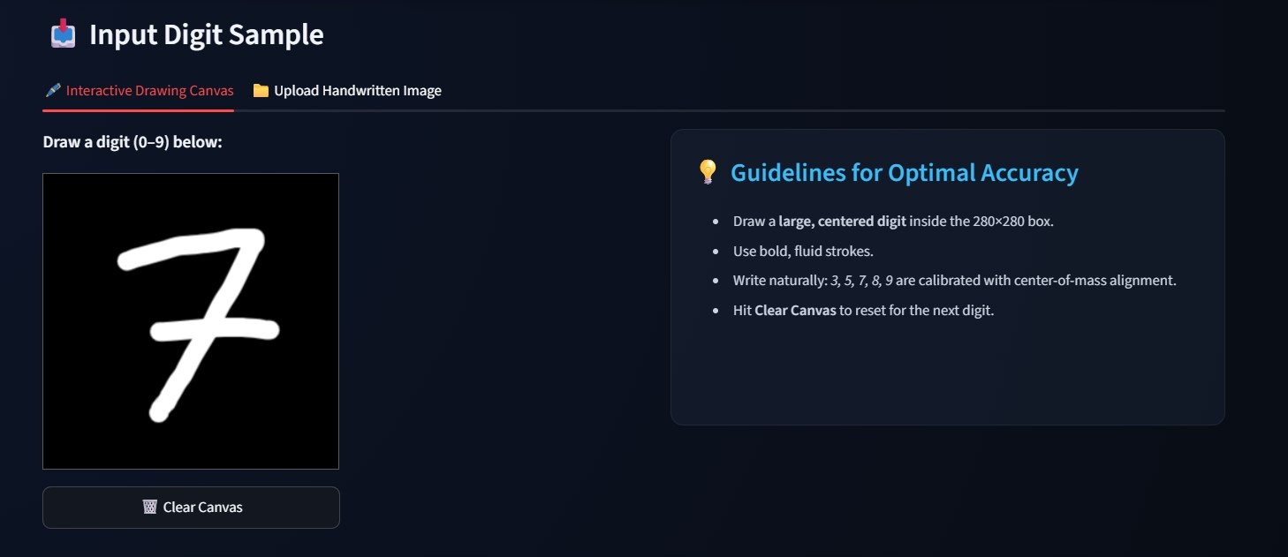
Image Upload:
The user selects a handwritten digit image from the computer. The application reads the image and sends it to preprocessing.
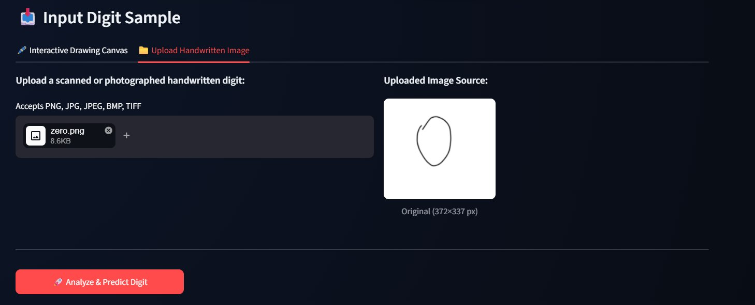
Image Preprocessing:
The input image is converted into grayscale, cropped, centered, resized and normalized.
KNN Recognition:
The KNN model identifies the nearest training samples and predicts the digit using majority voting.
SVM Recognition:
The SVM model uses its learned decision boundaries to classify the input image.
Prediction Comparison:
The application displays the outputs of both models. It also indicates whether the models agree or disagree.
Performance Dashboard:
The dashboard displays the performance of both algorithms using evaluation metrics and visualizations.
7.3 Interactive Drawing and Image Upload
The application provides two input methods.
Users can draw a digit directly using the canvas or upload an existing handwritten image.
This makes the application useful for testing both manually created and existing handwritten digit images.
7.4 Model Comparison Dashboard
The dashboard provides a detailed comparison between KNN and SVM.
The dashboard helps users understand which model performs better and what types of errors occur during classification.
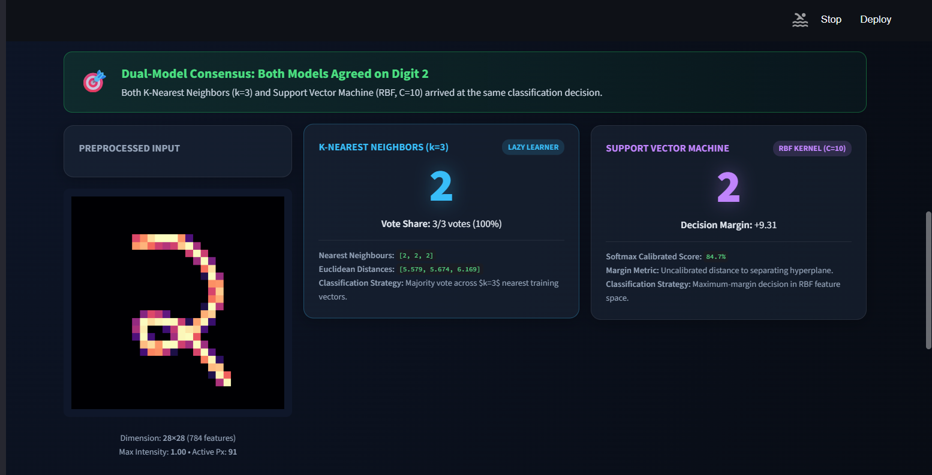

CHAPTER 8
Testing
8.1 Functional Testing
Functional testing is performed to verify whether the main features of the application work as expected.
The following operations are tested:
- Drawing a digit on the canvas.
- Uploading a handwritten image.
- Processing the input image.
- Generating KNN predictions.
- Generating SVM predictions.
- Displaying both model outputs.
- Viewing the performance dashboard.
- Clearing the drawing canvas.
8.2 Integration Testing
Integration testing checks whether the different modules work together correctly.
The following sequence is verified:
- User provides a handwritten digit.
- The preprocessing module receives the image.
- The processed image is passed to both Machine Learning models.
- Both models generate predictions.
- Prediction results are displayed.
- Performance information is shown in the dashboard.
8.3 Tools Used for Testing
The following tools and libraries are used:
- Python for executing the application.
- Streamlit for testing the user interface.
- Scikit-learn for model evaluation.
- NumPy for numerical operations.
- Matplotlib for visualizing results.
- VS Code and Jupyter Notebook for development and testing.
Postman testing is not applicable because the current implementation does not use a separate REST API backend.
8.4 Test Cases and Results
Test Case ID | Test Case | Expected Result | Status
TC-01 | Draw a digit on the canvas | Input should be accepted and prediction displayed | Pass (if successfully tested)
TC-02 | Upload a handwritten image | Image should be processed and prediction displayed | Pass (if successfully tested)
TC-03 | Compare KNN and SVM | Both model predictions should be displayed | Pass (if successfully tested)
TC-04 | Clear the drawing canvas | Drawing area should be reset | Pass (if successfully tested)
TC-05 | Open performance dashboard | Evaluation metrics and graphs should be displayed | Pass (if successfully tested)

8.5 Model Performance Evaluation
The models are evaluated using the MNIST test dataset.
The following results were obtained in the latest evaluation discussed for this project.
Evaluation Metric | KNN | SVM
Accuracy | 97.05% | 97.67%
Precision | 97.09% | 97.68%
Recall | 97.01% | 97.65%
F1-score | 97.04% | 97.66%

The results indicate that SVM achieved higher performance than KNN across the reported evaluation metrics.
SVM achieved 97.67% accuracy, while KNN achieved 97.05% accuracy.
Therefore, SVM performed slightly better on the evaluated MNIST test dataset.
CHAPTER 9
Deployment
9.1 Steps to Run the Application
The application can be executed locally using the following steps:
- Install Python on the computer.
- Open the project folder in Visual Studio Code.
- Create a Python virtual environment.
- Activate the virtual environment.
- Install the required Python libraries.
- Ensure that the trained KNN and SVM model files are available.
- Run the Streamlit application.
Command to execute the application:
python -m streamlit run app.py

After executing the command, Streamlit displays a local URL in the terminal.
Open that URL in a web browser to access the application.
9.2 Python Environment Configuration
The project uses a Python virtual environment to manage the required libraries.
The environment contains the necessary packages for image processing, Machine Learning, data handling and application development.
The trained model files must be available in the correct project directory so that the application can load them successfully.
9.3 Local Application Execution
The application runs locally through Streamlit.
The user interface and application logic operate within the same Python application environment.
Separate front-end and back-end hosting are not required for the current implementation.
CHAPTER 10
Challenges and Limitations
10.1 Issues Faced During Development
During the development of this project, we faced several challenges.
Different Handwriting Styles:
Different users write the same digit in different shapes and sizes. This can affect the prediction accuracy.
Image Size and Alignment:
Uploaded images may contain unnecessary empty space and different image dimensions.
Background and Pixel Differences:
Some images may contain white backgrounds with dark digits, while the model expects a different image format.
Model Prediction Differences:
KNN and SVM may sometimes generate different predictions because they use different classification techniques.
Environment Configuration:
Managing Python libraries, virtual environments and saved model files required careful configuration.
10.2 Solutions Applied
The following solutions were applied:
- Grayscale conversion was used to standardize input images.
- Cropping was used to remove unnecessary background areas.
- Centering was applied to improve digit alignment.
- Resizing was performed to convert images into 28 × 28 pixels.
- Normalization was used to scale pixel values between 0 and 1.
- Image inversion handling was included where required.
- Both KNN and SVM models were used to compare predictions.
- Joblib was used to save and load trained models.
10.3 Current Limitations
The current system has the following limitations:
- The application recognizes numerical digits from 0 to 9 only.
- The models are trained primarily using the MNIST dataset.
- Unusual handwriting styles may reduce prediction accuracy.
- Poorly written or ambiguous digits may be misclassified.
- The system does not currently recognize alphabets or complete sentences.
- The current implementation is designed for local execution.
CHAPTER 11
Future Enhancements
11.1 Planned Features
The project can be extended in several ways.
Deep Learning Integration:
Convolutional Neural Networks (CNNs) can be introduced to improve handwritten digit recognition.
Character Recognition:
The system can be extended to recognize handwritten alphabets and special characters.
Real-Time Recognition:
Continuous handwritten input and real-time prediction can be introduced.
Mobile Application:
A mobile-friendly application can be developed to make the system accessible through smartphones.
Cloud Deployment:
The application can be hosted online so that users can access it from different devices.
Dataset Expansion:
Additional handwritten samples from different users can be included to improve generalization.
11.2 Deep Learning Integration
In future development, CNN-based models can be implemented to automatically learn important image features.
These models may improve recognition performance by learning complex patterns from handwritten images.
11.3 Character Recognition and Cloud Deployment
The application can be extended to recognize alphabets and complete handwritten text.
Cloud deployment can also be introduced to make the application accessible online without requiring local installation.
CHAPTER 12
Conclusion
12.1 Summary of the Project
The project “Handwritten Digit Recognition Using KNN and SVM” was developed as an interactive Machine Learning application.
The system allows users to draw or upload handwritten digit images. The input image is processed using image preprocessing techniques and classified using KNN and SVM algorithms.
The application displays predictions from both models and provides a performance comparison dashboard containing accuracy, precision, recall, F1-score, graphs and confusion matrices.
The evaluated results show that KNN achieved 97.05% accuracy, while SVM achieved 97.67% accuracy. SVM performed slightly better than KNN in the reported evaluation.
The project demonstrates how image processing and Machine Learning algorithms can be combined to recognize handwritten digits.
12.2 What Was Achieved
The major achievements of the project include:
- Developed an interactive handwritten digit recognition application.
- Implemented drawing and image upload functionality.
- Applied image preprocessing techniques.
- Implemented KNN and SVM classification algorithms.
- Trained and tested models using the MNIST dataset.
- Compared both algorithms using multiple evaluation metrics.
- Developed a performance analysis dashboard.
- Identified classification errors through confusion matrices and error analysis.
12.3 Skills Learned During Development
Through this project, we gained practical experience in:
- Python programming.
- Image processing and preprocessing.
- Machine Learning classification.
- KNN and SVM algorithms.
- Dataset handling.
- Model training and evaluation.
- Streamlit application development.
- Data visualization.
- Model saving and loading.
- Team collaboration and technical documentation.
CHAPTER 13
References
- Yann LeCun, Corinna Cortes and Christopher J. C. Burges, “The MNIST Database of Handwritten Digits.” Available at: http://yann.lecun.com/exdb/mnist
- Scikit-learn Documentation, “K-Nearest Neighbors Classification.” Available at: https://scikit-learn.org/stable/modules/neighbors.html
- Scikit-learn Documentation, “Support Vector Machines.” Available at: https://scikit-learn.org/stable/modules/svm.html
- Streamlit Documentation. Available at: https://docs.streamlit.io/
- NumPy Documentation. Available at: https://numpy.org/doc/
- Matplotlib Documentation. Available at: https://matplotlib.org/stable/
- Pillow Documentation. Available at: https://pillow.readthedocs.io/
- Joblib Documentation. Available at: https://joblib.readthedocs.io/
- Chunmei Zhang et al., “ResNet18-ThunderSVM: Hybrid Intelligence for Handwritten Digit Recognition by Fusing Deep Spatial Features and High-Performance Classification,” Scientific Reports, 2026.
- Lei Guo and Zihan Wang, “Task-fMRI-Derived Number-Related Functional Brain Topology Constrained Spiking Neural Networks for Handwritten Digit Recognition,” Applied Sciences, 2026.
- Raghav Sethi and Varda Pareek, “Optical Handwritten Digit Recognition using Deep Learning Models on the MNIST Dataset,” 2026.
- Dan Zhao et al., “Handwritten Digit Recognition Based on Ghost Imaging and Cake-Cutting Hadamard Matrix,” Physics Letters A, 2026.
CHAPTER 14
Appendices
14.1 Application Screenshots
The following screenshots demonstrate the working of the application:
- Main application interface.
- Interactive drawing canvas.
- Handwritten image upload section.
- Preprocessed image display.
- KNN prediction output.
- SVM prediction output.
- Model comparison dashboard.
- Confusion matrices.
- Error analysis and robustness visualizations.
14.2 Sample Code Snippets
The following is a simplified example of the KNN and SVM implementation.
- from sklearn.neighbors import KNeighborsClassifier
- from sklearn.svm import SVC

- # Initialize KNN model
- knn = KNeighborsClassifier(n_neighbors=3)

- # Initialize SVM model
- svm = SVC(kernel="rbf", C=10)

- # Train both models
- knn.fit(X_train, y_train)
- svm.fit(X_train, y_train)

- # Generate predictions
- knn_prediction = knn.predict(X_test)
- svm_prediction = svm.predict(X_test)

14.3 Installation and Setup Instructions
Step 1: Install Python 3.x.
Step 2: Open the project folder in Visual Studio Code.
Step 3: Activate the virtual environment.
.\venv\Scripts\Activate.ps1

Step 4: Install the required libraries.
pip install -r requirements.txt

Step 5: Run the application.
python -m streamlit run app.py

Step 6: Open the local URL displayed in the terminal.
14.4 User Manual
The application can be used through the following steps:
- Open the Streamlit application in a browser.
- Select the drawing canvas or image upload option.
- Draw a handwritten digit or upload an image.
- Click the Analyze and Predict button.
- View the preprocessed image.
- Check the predictions generated by KNN and SVM.
- Compare the predictions from both models.
- Open the performance dashboard.
- View the evaluation metrics, graphs and confusion matrices.
14.5 Team Contributions
Hasini Peddi:
- Developed the user input module.
- Worked on the interactive drawing canvas.
- Worked on image upload functionality.
- Worked on displaying KNN and SVM predictions.
- Worked on the model comparison and performance dashboard.
- Worked on result visualization and presentation.
G. Greeshma Sai:
- Worked on the image preprocessing module.
- Implemented grayscale conversion.
- Worked on cropping and centering.
- Worked on image resizing.
- Worked on pixel normalization.
B. Keerthi Reddy:
- Worked on KNN implementation.
- Worked on SVM implementation.
- Worked on model training using the MNIST dataset.
- Worked on testing and prediction.
- Evaluated model performance using accuracy, precision, recall and F1-score.
All three team members contributed to project integration, testing, debugging and documentation according to their actual work.

