Data Tidying

Monika Sikand

1/16/2019

library(dplyr)  
library(tidyr)  
#library(stats)

to call a function from a specific package ‘package_name::function_name(…)’

# Data Cleaning

Read in data file

catch_df <- read.csv(url( "https://knb.ecoinformatics.org/knb/d1/mn/v2/object/df35b.302.1",method = "libcurl"), stringsAsFactors = FALSE)  
head(catch_df)

## Region Year Chinook Sockeye Coho Pink Chum All notesRegCode  
## 1 SSE 1886 0 5 0 0 0 5   
## 2 SSE 1887 0 155 0 0 0 155   
## 3 SSE 1888 0 224 16 0 0 240   
## 4 SSE 1889 0 182 11 92 0 285   
## 5 SSE 1890 0 251 42 0 0 292   
## 6 SSE 1891 0 274 24 0 0 298

# Split- Apply-Combine

# Joins

## R Markdown

This is an R Markdown document. Markdown is a simple formatting syntax for authoring HTML, PDF, and MS Word documents. For more details on using R Markdown see <http://rmarkdown.rstudio.com>.

When you click the **Knit** button a document will be generated that includes both content as well as the output of any embedded R code chunks within the document. You can embed an R code chunk like this:

summary(cars)

## speed dist   
## Min. : 4.0 Min. : 2.00   
## 1st Qu.:12.0 1st Qu.: 26.00   
## Median :15.0 Median : 36.00   
## Mean :15.4 Mean : 42.98   
## 3rd Qu.:19.0 3rd Qu.: 56.00   
## Max. :25.0 Max. :120.00

## Including Plots

You can also embed plots, for example:

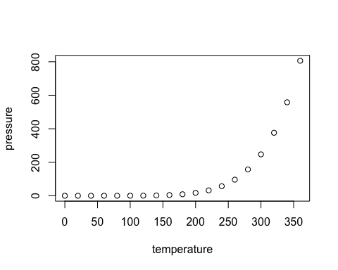

Note that the echo = FALSE parameter was added to the code chunk to prevent printing of the R code that generated the plot.