1. For min. jerk trajectory, use target angle and ramp duration such that the trajectory is similar in speed as for the actual assessments. One needs to tune the PID for those cases. E.g. 20 degrees and 2 seconds ramp duration are fine.
2. Start tuning P part. Increase it such that controller becomes stiff enough
   1. Also when being at target, deviation from target should be relatively hard to achieve so also small errors are amplified strong enough. With the current labview file this can be tested by moving the endeffector to the target position and again running the program. One can also increase the time to let it run longer.
   2. Drawback of relatively high P-gain: vibrations visible by position/velocity/voltage etc.

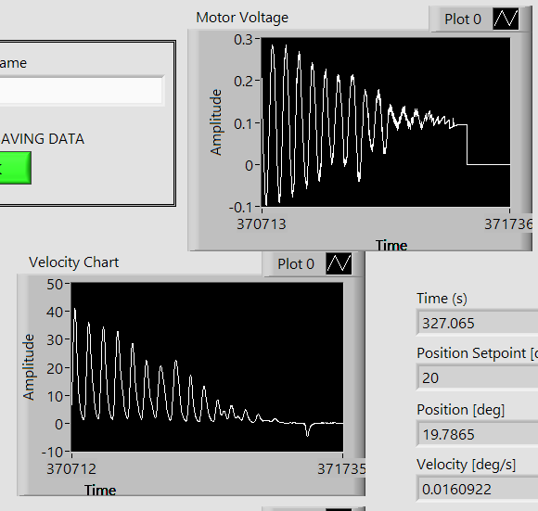Vibration can be easily seen with and without finger attached to endeffector.

Vibrations can be reduced by D-part later.

E.g. for me P = 0.9

1. 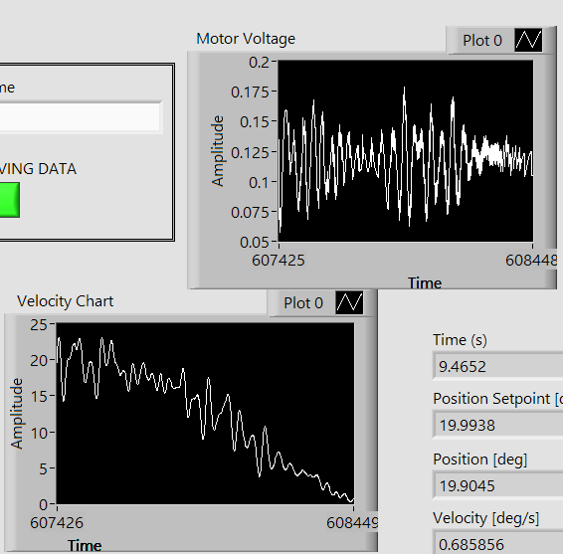Tuning D part: Start at 0.001. Increase until vibrations do not seem to be further reduce anymore. There will always be some vibrations left e.g. see plots below. However comparing the two figures one can see that the magnitude of vibrations is lower. Also they cannot be seen and felt that good anymore.

E.g. for me D = 0.004

1. Deviate endeffector more such that e.g. 40 deg need to be passed within 2 seconds. If in this case vibration bubbles appear at some point as shown in the following figure, the P-gain is too high. The P-gain should be put as high as possible but after having done the D-part, we know that we cannot use D-part to support such high P-gains as previously selected.

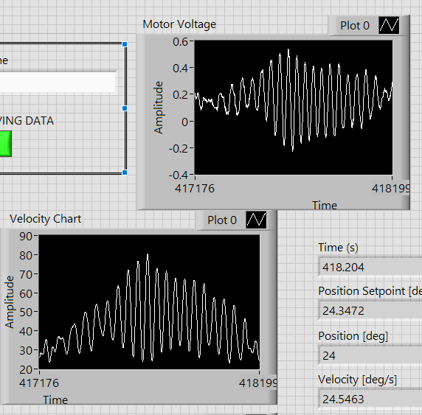 Decrease the P-gain until also at larger/faster movements the vibrations stay low. Test with and without finger attached since finger acts as damper in the system but system also needs to be stable without finger attached. For me I decrease P-gain to 0.3.

1. Tune I-part: Change setup a bit. Put a target angle and put endeffector there. put time to e.g. 5 seconds and adjust scale in wave chart such that target angle +/- 1 degree are displayed. Run with I-part = 0. You will notice that there is a steady state error. Increase I part to reduce the steady state error. Deveate the endeffector and reduce the time to 1 seconds. Check if the steady state error is still small enough with your chosen I-gain. I selected I = 10.

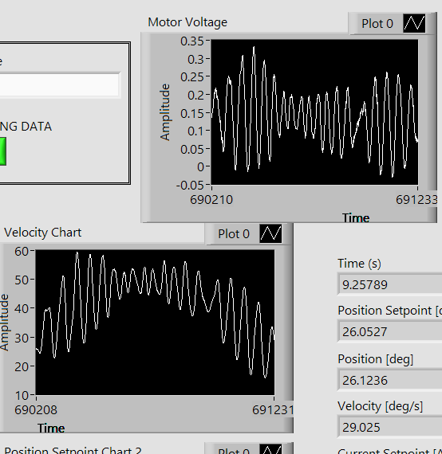

When it is too high (in my case e.g. 15), vibration bubbles start to appear when moving e.g. 30 degrees in 2 seconds without having finger in system:

So decrease I gain again. Final gain for me: I = 10.

There was always a small steady state error also with I part present. See the position chart below

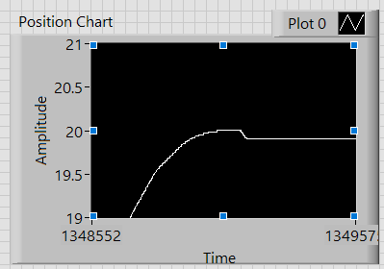As soon as PID control stops, the position moves slightly back which is due to friction (without attaching finger!).

1. Do a final check: Deviate endeffector and let it move at different speeds. Feel/Look that the vibrations are still small for the desired range of velocities the device needs to be able to perform stable. Put the endeffector to target position and while PID is running, shake the endeffector to see that it stays at the target in a stiff enough manner and that it is not starting to shake (resonance!).
2. K(e): Does not change anything. I checked values up to 0.9 but there was no effect so I set it to zero.
3. Final gains for me: k(e) = 0, Kp = 0.3, Ki = 10, Kd = 0.004