**Maximum Acceleration**

Initial definition of the task: apply 10 V for 10ms.

I’m interested in measuring position difference over the measurement time, from which I can calculate acceleration (second derivative).

**How to do the measurement:**

1. Run “1_maximum_acceleration_main.vi”
2. Choose if you want to measure positive or negative direction (positive is clockwise)
3. Move the end-effector by hand so that there is enough space for the movement (for example if you measure positive acceleration, move it a bit to the negative direction)
4. If you wish to record the data, enter a **non-existent** name in the tdms field and press save data
5. Press start
6. Wait until movement is finished
7. Press save data in order to stop recording (pressing stop also works, but terminates whole program)
8. repeat

Repeat the measurement to have data to compare (I did 3)

**How to do the analysis**

1. enter tdms file path in “read in the tdms file”
2. Ein Bild, das Text enthält.

   Automatisch generierte Beschreibungadjust deg parameter for the polyfit: increase until error shows (for me always 18)  
   choose value where error just does not show
3. 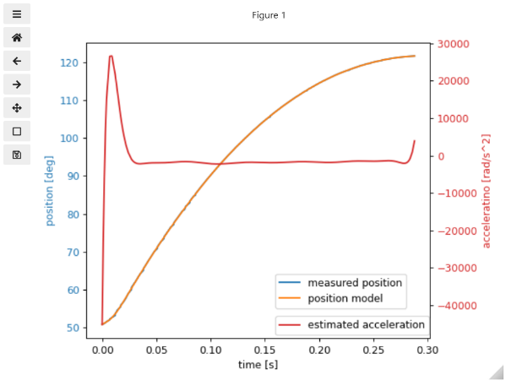Run everything and check the plot, it should look something like this:  
   if it does not, probably the analysed range is wrong  
   🡪 check the start_index and the end_index (they are probably only one apart)  
     
     
     
     
     
     
   Ein Bild, das Text enthält.

   Automatisch generierte Beschreibungadjust the marked 0 to be higher than the current start_index (I always put plus 10) and run again  
     
   try and error until you see that the correct data-section is displayed in your plot



1. The program prints the max and the min acceleration, depending on you measurement (positive or negative) you have to read the corresponding value
2. Take the average of your measured values
3. You’re done 🎉