**Dynamic Friction Measurement Protocol**

How it works: measure the consumed current, while a constant velocity is maintained.

**How to do the measurement (*3_dynamic_friction_main.vi*):**

1. Choose the correct Mike version in the top left corner in the block diagram
2. Run the program
3. **Very important!** Set the integral PID gain (Ki) to **0.** If not, there will be instabilities, which can damage the system!
4. Set the ramp distance and ramp duration according to the velocity you want to achieve (see *DynamicFriction_Mike3* and *DynamicFriction_Mike6*  in the data analysis folder for examples) for positive/negative velocities, set positive/negative ramp distances
5. Move the end effector by hand to the place where you want to start your trajectory (I always moved it to the mechanical stop)
6. Enter a **non-existent** tdms file name and press “save data”
7. Press run
8. Wait for the trajectory to be finished
9. Press “save data” to stop the data recording
10. Repeat steps 4 to 9 until you have all recordings of all velocities you need
11. Press “stop” to terminate the program

**How to do the analysis:**

The data analysis consists of two main steps: The analysis of all recorded tdms files to determine the viscous friction torques and to analyse the obtained torques.

1. Ein Bild, das Text enthält.

   Automatisch generierte BeschreibungAdjust the file name and the torque constant:
2. 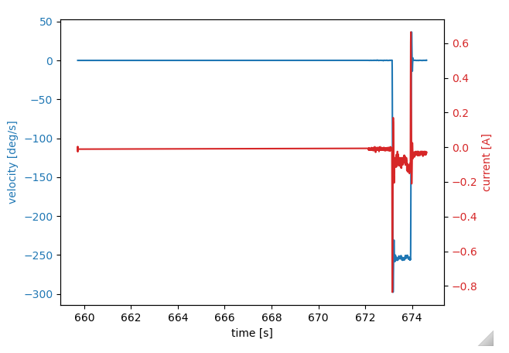Plot your data by running the program or only the #plotting section of the notebook, it will look something like this:
3. 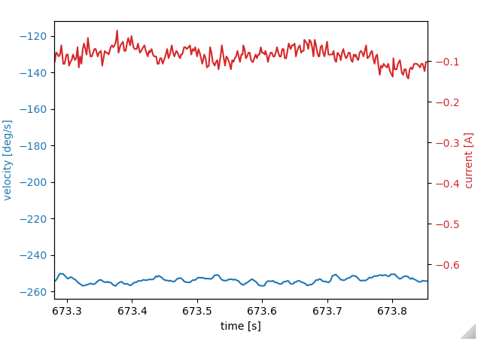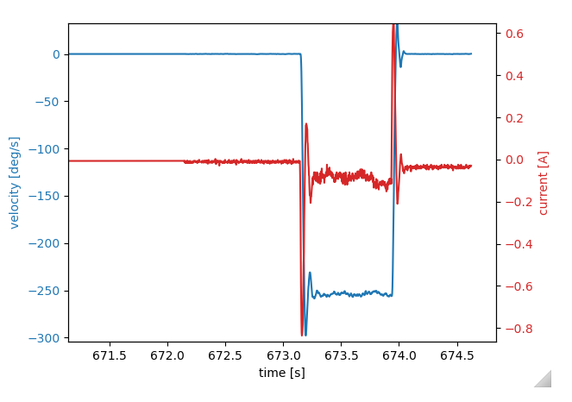Zoom into the plot to find the section where the velocity is as constant as possible:
4. Read the time from your plot where you want to start and end your analysis and write them to the parame
5. Run the whole program and read the friction torque as well as the average current from the output. Write the values down (I wrote them to the excel files in the data analysis folder).
6. Repeat these steps until you have determined all friction torques
7. Plot the aquired data (you can use the *DynamicFriction_plotter* if you wrote the data to an excel file as in my examples