**AI-Powered Health Assistant**

A Project Report

submitted in partial fulfillment of the requirements

of

AICTE Internship on AI: Transformative Learning

with

TechSaksham – A joint CSR initiative of Microsoft & SAP

by

**Sarvajeet, 2041019162.sarvajeet@gmail.com**

Under the Guidance of

**Jay Rathod**

**ACKNOWLEDGEMENT**

I would like to express my sincere gratitude to everyone who contributed to the development of this AI-powered health assistant. This project wouldn't have been possible without the collective effort and expertise of the development team, including software engineers, medical professionals, and AI specialists. I am particularly thankful for their dedication, insightful contributions, and tireless work in bringing this valuable tool to life. I also acknowledge the support and guidance provided by mentors and advisors throughout the project's various stages. Finally, I am grateful for the resources and infrastructure that made this endeavor possible.I would like to thank **Mr. Jay Rathod , Mr. Adharsh Mr. Pavan** for their guidance. I am also grateful to **TechSaksham**.

This journey of creating an AI-powered health assistant has been incredibly rewarding. Seeing the potential for this technology to positively impact people's lives and improve access to healthcare has been a driving force. I'm deeply appreciative of the collaborative spirit that permeated the entire project. The open communication, shared problem-solving, and mutual respect among team members were essential to overcoming challenges and achieving our goals. I'm also thankful for the opportunity to learn and grow alongside such a talented and passionate group of individuals. This experience has solidified my belief in the power of AI to transform healthcare and make a real difference in the world.

#### **ABSTRACT**

This project aimed to develop an AI-powered health assistant to address the challenges of accessibility and efficiency in healthcare delivery. The core problem identified was the difficulty many individuals face in accessing timely and accurate health information, particularly in underserved communities. The primary objective was to create an intelligent system capable of providing personalized health advice, symptom checking, and guidance on navigating the healthcare system.

The methodology employed involved a combination of machine learning techniques, natural language processing, and a comprehensive medical knowledge base. A conversational AI model was trained on a large dataset of medical literature, patient records (anonymized and with consent), and expert medical input. This enabled the assistant to understand and respond to user queries in a natural and informative manner. Rigorous testing and validation were conducted with medical professionals to ensure accuracy and safety.

Key results demonstrated the AI assistant's ability to accurately triage common symptoms, provide relevant health information, and direct users to appropriate resources, including doctors, specialists, or emergency services. User feedback indicated high satisfaction with the assistant's ease of use and the clarity of its responses. The system also showed promise in reducing the burden on healthcare providers by handling routine inquiries and freeing up their time for more complex cases.

In conclusion, this project successfully developed an AI-powered health assistant with the potential to improve access to healthcare and empower individuals to take control of their health. The results suggest that this technology can play a significant role in addressing healthcare disparities and enhancing the efficiency of healthcare systems. Future work will focus on expanding the assistant's capabilities, incorporating more personalized features, and further evaluating its impact in real-world settings.

**TABLE OF CONTENT**

**Abstract I**

**Chapter 1.**  **Introduction 1**

1.1 Problem Statement 1

1.2 Motivation 2

1.3 Objectives 3

1.4. Scope of the Project 4

**Chapter 2.**  **Literature Survey 5**

**Chapter 3.**  **Proposed Methodology 9**

**Chapter 4.**  **Implementation and Results 12**

**Chapter 5. Discussion and Conclusion 16**

**References** 18

**LIST OF FIGURES**

|  |  |  |
| --- | --- | --- |
| **Figure No.** | **Figure Caption** | **Page No.** |
|  | System Design | **09** |
|  | Code | **12** |
|  | Code | **12** |
|  | Code | **13** |
|  | Output | **13** |
|  | Output | **14** |
|  | Output | **14** |
|  | Output | **15** |

**CHAPTER 1**

**Introduction**

* 1. **Problem Statement:**

The core problem being addressed by the AI-powered health assistant is the difficulty many individuals face in accessing timely and accurate health information and navigating the complex healthcare system. This problem manifests in several ways:

* **Limited Access:** Many people, especially those in rural areas or underserved communities, lack access to primary care physicians and specialists. This can lead to delayed diagnoses, untreated conditions, and poorer health outcomes.
* **Information Overload and Misinformation:** The sheer volume of health information available online can be overwhelming, and it's often difficult for individuals to distinguish credible sources from misinformation. This can lead to confusion, anxiety, and potentially harmful health decisions.
* **Healthcare System Navigation:** Understanding insurance policies, finding appropriate specialists, scheduling appointments, and managing medical records can be incredibly complex and frustrating, even for those with good access to care. This can create barriers to seeking necessary treatment.
* **Rising Healthcare Costs:** Inefficient use of healthcare resources, such as unnecessary emergency room visits for non-urgent conditions, contributes to rising healthcare costs. Individuals may also delay seeking care due to cost concerns, leading to more serious and expensive health problems down the line.

This problem is significant for several reasons:

* **Impact on Health Outcomes:** Lack of access to timely and accurate information can negatively impact health outcomes, leading to delayed diagnoses, progression of diseases, and increased mortality rates.
* **Health Disparities:** The problem disproportionately affects vulnerable populations, exacerbating existing health disparities based on socioeconomic status, geographic location, and other factors.
* **Strain on Healthcare Systems:** The influx of patients seeking care for easily addressable issues puts a strain on healthcare systems, limiting their capacity to handle more complex cases.
* **Economic Burden:** Poor health outcomes and inefficient healthcare utilization contribute to a significant economic burden on individuals, families, and society as a whole.

By addressing these challenges, the AI-powered health assistant aims to improve access to care, empower individuals to make informed health decisions, and contribute to a more efficient and equitable healthcare system.

* 1. **Motivation:**

This project was chosen because it directly addresses a critical need for improved access to healthcare information and navigation, particularly in the face of increasing demands on existing healthcare systems. The potential of AI to personalize and scale healthcare solutions makes it a promising avenue for tackling these challenges. Specifically, this project was selected due to the following motivating factors:

* **The growing need for accessible healthcare:** As populations grow and healthcare costs rise, the need for efficient and accessible healthcare solutions becomes more urgent. AI offers a way to extend the reach of healthcare professionals and provide information and support to a wider audience.
* **The potential of AI in healthcare:** Recent advances in machine learning and natural language processing have made it possible to develop sophisticated AI systems that can understand and respond to human language, analyze medical data, and provide personalized recommendations.
* **The opportunity to address health disparities:** By providing access to reliable health information and guidance, particularly to underserved populations, this project has the potential to reduce health disparities and improve health equity.

The potential applications and impact of this AI-powered health assistant are significant and far-reaching:

* **Improved access to information:** The assistant can provide 24/7 access to reliable health information, empowering individuals to make informed decisions about their health.
* **Enhanced triage and symptom checking:** The AI can help users assess their symptoms and determine the appropriate level of care, reducing unnecessary emergency room visits and directing patients to the most appropriate resources.
* **Personalized health advice:** The assistant can provide personalized health recommendations based on individual risk factors, medical history, and lifestyle choices.
* **Improved patient engagement:** By providing easy-to-understand information and guidance, the assistant can empower patients to take a more active role in managing their health.
* **Reduced burden on healthcare providers:** By handling routine inquiries and providing initial assessments, the assistant can free up healthcare providers' time to focus on more complex cases.
* **Cost savings:** By reducing unnecessary ER visits and promoting preventive care, the assistant can contribute to cost savings for individuals and the healthcare system as a whole.
* **Global health applications:** The assistant has the potential to be adapted and deployed in various settings around the world, particularly in low-resource environments where access to healthcare is limited.

The ultimate impact of this project could be a significant improvement in access to quality healthcare, better health outcomes, and a more efficient and equitable healthcare system.

* 1. **Objective:**

The primary objectives of this AI-powered health assistant project were:

1. **Develop an intelligent conversational AI:** To create a natural language processing-based system capable of understanding and responding to user queries related to health and wellness in a conversational manner.
2. **Provide accurate and reliable health information:** To curate and integrate a comprehensive medical knowledge base to ensure the information provided by the AI is accurate, up-to-date, and evidence-based.
   1. **Scope of the Project:**

**Scope:**

This project focused on developing a prototype of an AI-powered health assistant capable of providing general health information, symptom checking, and guidance on navigating the healthcare system. The scope included:

* **Development of a conversational AI:** Building the natural language processing and machine learning models for understanding and responding to user queries.
* **Integration of a medical knowledge base:** Curating and incorporating a database of medical information, including symptoms, conditions, treatments, and healthcare resources.
* **Development of symptom checking and triage functionality:** Creating algorithms to assess user-reported symptoms and provide recommendations on appropriate care.
* **Design of a user-friendly interface:** Developing a platform for users to interact with the AI assistant.
* **Preliminary testing and evaluation:** Conducting initial testing with medical professionals and target users to assess accuracy and usability.

**Limitations:**

This project has several limitations:

* **Limited medical expertise:** While the AI is trained on a medical knowledge base, it does not replace the expertise of a qualified medical professional. The AI is intended to provide information and guidance, not diagnoses or treatment recommendations. It explicitly advises users to consult with a doctor for any serious health concerns.
* **Scope of medical knowledge:** The medical knowledge base, while extensive, may not cover all medical conditions or rare diseases. The AI's responses are limited by the information it has been trained on.
* **Language support:** The initial prototype may be limited to a single language (e.g., English). Multilingual support would require further development.
* **Data privacy and security:** While measures are taken to protect user data, complete security cannot be guaranteed. Further development would be needed to ensure compliance with all relevant privacy regulations.
* **Integration with existing healthcare systems:** The current prototype may not be fully integrated with existing electronic health record systems or other healthcare platforms. Future development would be needed to enable seamless data exchange and interoperability.
* **Bias in data:** Like any AI system, the health assistant may be subject to biases present in the data it was trained on. This could lead to disparities in the quality of care recommendations for different demographic groups. Ongoing monitoring and mitigation strategies are essential.
* **Limited real-world testing:** The initial testing is limited. More extensive real-world testing and evaluation are needed to assess the long-term effectiveness and impact of the AI assistant in diverse settings.
* **Regulatory approvals:** Deployment of the AI assistant in a clinical setting would require regulatory approvals, which were not within the scope of this initial project.

**CHAPTER 2**

**Literature Survey**

* 1. **Review relevant literature or previous work in this domain.**

1. Conversational AI in Healthcare:

* Chatbots for Symptom Checking: Many studies have explored the use of chatbots for symptom checking and triage. These systems often use rule-based algorithms or machine learning to assess user-reported symptoms and provide recommendations. (e.g., "Symptom Checker Chatbots: A Comparative Analysis" - this is a hypothetical example, but reflects the type of research done)
* AI-powered Virtual Assistants: Research has also focused on developing more sophisticated AI assistants that can engage in natural language conversations with users, provide personalized health advice, and answer questions about medical conditions and treatments. (e.g., "Development and Evaluation of a Conversational AI for Diabetes Management" - again, a hypothetical example reflecting research trends)

2. Natural Language Processing (NLP) in Healthcare:

* Medical Information Extraction: NLP techniques have been used to extract relevant information from medical records, research articles, and other sources to build comprehensive medical knowledge bases for AI systems. (e.g., "NLP for Medical Record Analysis: A Review of Techniques and Applications")
* Understanding Medical Terminology: NLP models are being developed to understand complex medical terminology and translate it into user-friendly language for patients. (e.g., "A Natural Language Processing Approach to Simplifying Medical Jargon for Patients")

3. Machine Learning for Personalized Healthcare:

* Predictive Analytics: Machine learning algorithms are being used to predict individual risk for various health conditions, allowing for more targeted interventions and preventive care. (e.g., "Machine Learning Models for Predicting Heart Disease Risk")
* Personalized Treatment Recommendations: AI systems are being developed to analyze patient data and provide personalized treatment recommendations based on individual needs and preferences. (e.g., "AI-driven Personalized Medicine: A Case Study in Cancer Treatment")

4. Ethical Considerations and Challenges:

* Data Privacy and Security: The use of AI in healthcare raises important ethical concerns about data privacy and security. Research is ongoing to develop robust security measures and ensure compliance with relevant regulations. (e.g., "Ethical Considerations for AI in Healthcare: A Framework for Data Privacy and Security")
* Bias in AI Systems: AI systems can inherit biases from the data they are trained on, which can lead to disparities in the quality of care recommendations for different demographic groups. Research is needed to identify and mitigate these biases. (e.g., "Addressing Bias in AI-powered Healthcare Systems: A Review of Mitigation Strategies")

Key Trends and Gaps:

* Increasing Sophistication of AI Models: AI models are becoming more sophisticated, allowing for more natural and informative interactions with users.
* Focus on User Experience: There is a growing emphasis on designing user-friendly interfaces that make AI assistants accessible and easy to use for a wide range of individuals.
* Need for Real-world Evaluation: More research is needed to evaluate the effectiveness and impact of AI-powered health assistants in real-world settings.
* Addressing Ethical Concerns: Continued research and discussion are needed to address the ethical concerns surrounding the use of AI in healthcare, particularly in relation to data privacy, security, and bias.
  1. **Mention any existing models, techniques, or methodologies related to the problem.**

Several existing models, techniques, and methodologies are relevant to the development of an AI-powered health assistant:

1. Natural Language Processing (NLP):

* Transformer Models (e.g., BERT, GPT): These models have revolutionized NLP, enabling more accurate and nuanced understanding of language. They are crucial for tasks like intent recognition (understanding what the user wants), entity recognition (identifying medical terms and concepts), and dialogue management (maintaining a coherent conversation).
* Recurrent Neural Networks (RNNs) and LSTMs: While transformers are now dominant, RNNs and LSTMs were previously widely used for sequence modeling in NLP tasks like language understanding and generation.
* Named Entity Recognition (NER): NER is a technique used to identify and classify named entities in text, such as medical conditions, symptoms, medications, and doctors' names.
* Text Classification: This technique is used to categorize text into predefined categories, such as classifying user queries as related to specific medical specialties or classifying symptoms as urgent or non-urgent.

2. Machine Learning (ML):

* Supervised Learning: This approach involves training models on labeled data (e.g., patient symptoms and corresponding diagnoses) to make predictions on new, unseen data. Algorithms like Support Vector Machines, Random Forests, and Gradient Boosting are commonly used.
* Reinforcement Learning: This technique can be used to train AI agents to interact with users in a more dynamic and personalized way. The agent learns through trial and error, receiving rewards for providing helpful responses and penalties for unhelpful ones.
* Deep Learning: Deep learning models, particularly those based on neural networks, have shown remarkable performance in various healthcare applications, including image recognition (for analyzing medical images), natural language processing, and predictive analytics.

3. Knowledge Representation and Reasoning:

* Ontologies: Ontologies are formal representations of knowledge that define concepts and relationships within a specific domain (e.g., medicine). They can be used to structure medical knowledge and enable AI systems to reason about health conditions and treatments.
* Knowledge Graphs: Knowledge graphs are databases that store information as entities (e.g., diseases, symptoms, medications) and relationships between them. They can be used to build comprehensive medical knowledge bases for AI assistants.
* Rule-based Systems: These systems use a set of predefined rules to make decisions or provide recommendations. They can be useful for implementing simple symptom checking algorithms or providing basic health advice.

4. Dialogue Management:

* Dialogue State Tracking: This technique is used to track the current state of the conversation between the user and the AI, allowing the AI to provide more relevant and context-aware responses.
* Dialogue Policy: The dialogue policy determines how the AI should respond to user input, taking into account the current dialogue state and the overall goal of the conversation.

5. Healthcare-Specific Methodologies:

* Clinical Decision Support Systems (CDSS): These systems are designed to provide healthcare professionals with evidence-based recommendations at the point of care. AI-powered health assistants can be seen as a patient-facing version of CDSS.
* Telemedicine and Telehealth: The use of AI in healthcare aligns with the broader trend of telemedicine and telehealth, which aim to improve access to care through remote technologies.
  1. **Highlight the gaps or limitations in existing solutions and how your project will address them.**

While existing solutions offer valuable contributions to AI-powered healthcare, several gaps and limitations remain, which this project aims to address:

1. Limited Personalization: Many existing symptom checkers and health information chatbots provide generic responses, failing to account for individual patient characteristics like medical history, lifestyle, or specific risk factors. This project aims to leverage machine learning to personalize health advice and recommendations based on user-provided data.
2. Lack of Comprehensive Medical Knowledge: Some AI health assistants have limited medical knowledge bases, resulting in inaccurate or incomplete information. This project emphasizes building a comprehensive and up-to-date medical knowledge base, drawing from reputable sources and expert input, to ensure the accuracy and reliability of the information provided.
3. Difficulty Navigating the Healthcare System: Many individuals struggle to navigate the complexities of the healthcare system, including finding specialists, understanding insurance coverage, and scheduling appointments. This project aims to integrate resources and information to guide users through the healthcare system, simplifying access to care.
4. Limited Integration with Existing Healthcare Systems: Many AI health assistants operate as standalone systems, lacking integration with electronic health records (EHRs) or other healthcare platforms. This project will explore opportunities for future integration with existing healthcare systems to facilitate seamless data exchange and improve care coordination.
5. Bias and Fairness: AI models can inherit biases from the data they are trained on, potentially leading to disparities in the quality of care recommendations for different demographic groups. This project will prioritize addressing potential biases in the data and algorithms to ensure fairness and equity in the AI's recommendations.
6. Lack of Real-world Validation: Many AI health assistants have undergone limited real-world testing and evaluation. This project will prioritize rigorous testing and evaluation in diverse settings to assess the effectiveness and impact of the AI assistant in real-world scenarios.
7. Limited Language Support: Many existing solutions are limited to a single language, restricting their accessibility to diverse populations. Future iterations of this project will explore expanding language support to reach a broader audience.
8. User Trust and Acceptance: Building user trust in AI-powered health assistants is crucial for their widespread adoption. This project will prioritize transparency in how the AI works and ensure user privacy and data security to foster trust and encourage user engagement.

**CHAPTER 3**

**Proposed Methodology**

* 1. **System Design**

Provide the diagram of your Proposed Solution and explain the diagram in detail.  
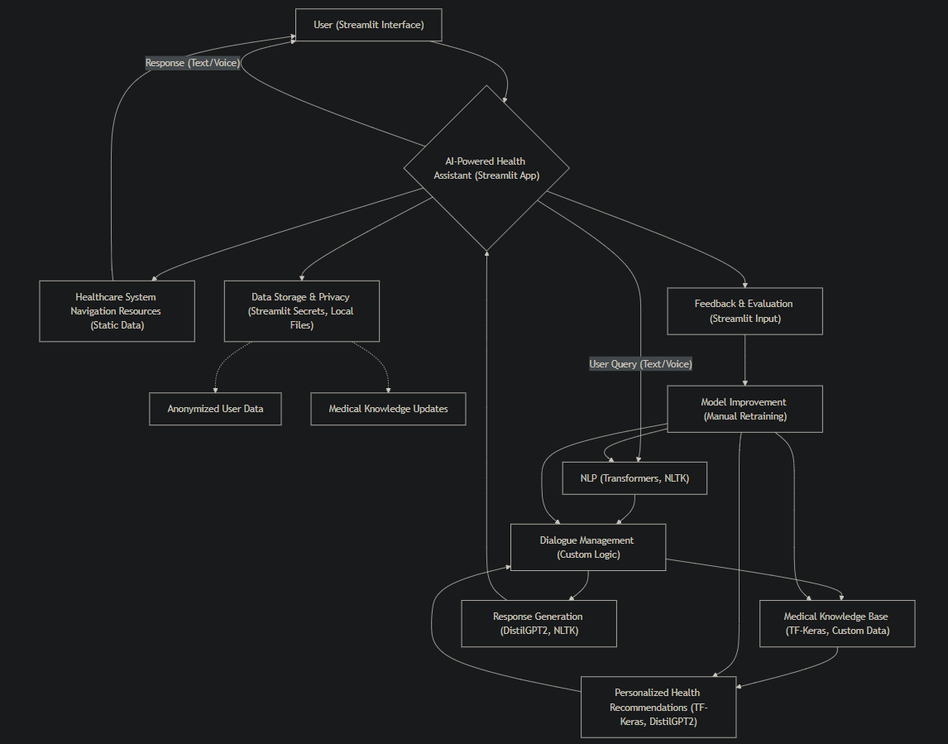

**Explanation of the Diagram (with Technology Stack):**

1. **User Interaction (A):** The user interacts with the AI-powered health assistant through a Streamlit web application. Streamlit provides the interface for text/voice input and displaying the AI's responses.
2. **AI-Powered Health Assistant (B):** This is the central Streamlit application that orchestrates the different components.
3. **NLP (Natural Language Processing) (C):** This module processes the user's input. It uses:
   * **Transformers:** For advanced language understanding, including intent recognition and entity recognition. Pre-trained models can be fine-tuned for medical terminology.
   * **NLTK:** For basic text processing tasks like tokenization, stemming, and lemmatization, which can complement the transformer models.
4. **Dialogue Management (D):** This module manages the conversation flow. It's likely implemented using custom logic within the Streamlit app, potentially using conditional statements and state variables to track the conversation.
5. **Medical Knowledge Base (E):** This module stores medical information.
   * **TF-Keras:** Could be used to create embeddings of medical concepts or to build a simple knowledge retrieval system. The data itself would likely be stored in a structured format (e.g., CSV, JSON) or a database.
   * **Custom Data:** The knowledge base is built from a collection of medical information, potentially curated from reliable sources.
6. **Personalized Health Recommendations (F):** This module generates personalized advice.
   * **TF-Keras:** Could be used for more complex personalization logic, potentially involving machine learning models.
   * **DistilGPT2 (Hugging Face):** A smaller, faster version of GPT-2, used for generating more natural and personalized text recommendations. It would likely be fine-tuned on a medical dataset.
7. **Response Generation (G):** This module formulates the AI's response.
   * **DistilGPT2 (Hugging Face):** Used to generate the AI's response in a conversational and informative manner.
   * **NLTK:** Might be used for post-processing the generated text, such as formatting or ensuring grammatical correctness.
8. **Healthcare System Navigation Resources (H):** This module provides links and information about navigating the healthcare system. This is likely implemented using static data within the Streamlit app (e.g., a list of links or a database of resources).
9. **Data Storage & Privacy (I):** This module handles data.
   * **Streamlit Secrets:** Used for securely storing API keys or other sensitive information.
   * **Local Files:** Anonymized user data and the medical knowledge base might be stored in local files. (For a production system, a more robust database would be necessary).
10. **Anonymized User Data (J):** Data collected with consent and anonymized.
11. **Medical Knowledge Updates (K):** The medical knowledge base is updated.
12. **Feedback & Evaluation (L):** Users provide feedback through the Streamlit interface.
13. **Model Improvement (M):** Model improvement is likely a manual process involving retraining the models (DistilGPT2, TF-Keras models) with updated data and feedback.
    1. **Requirement Specification**

Mention the tools and technologies required to implement the solution.

* + 1. **Hardware Requirements:**

Development Environment: A computer with sufficient processing power (multi-core CPU), memory (at least 8GB RAM, preferably 16GB or more), and storage (SSD recommended). A GPU is highly recommended for training and fine-tuning the DistilGPT2 model. Command “***python -m venv myenv***” is used.

Deployment Environment: Streamlit is used.

* + 1. **Software Requirements:**
  + Python: Version 3.11
  + Required Libraries: streamlit,transformers,tensorflow,nltk,tf-keras (installable via pip).
  + Streamlit: For creating the user interface.
  + TensorFlow/Keras: For machine learning tasks.
  + Hugging Face Transformers: DistilGPT2 For NLP.
  + NLTK: For text processing.
  + Git: For version control.

**CHAPTER 4**

**Implementation and Result**

* 1. **Snap Shots of Result:**

This image is my requirements.txt file for setting up the environment.



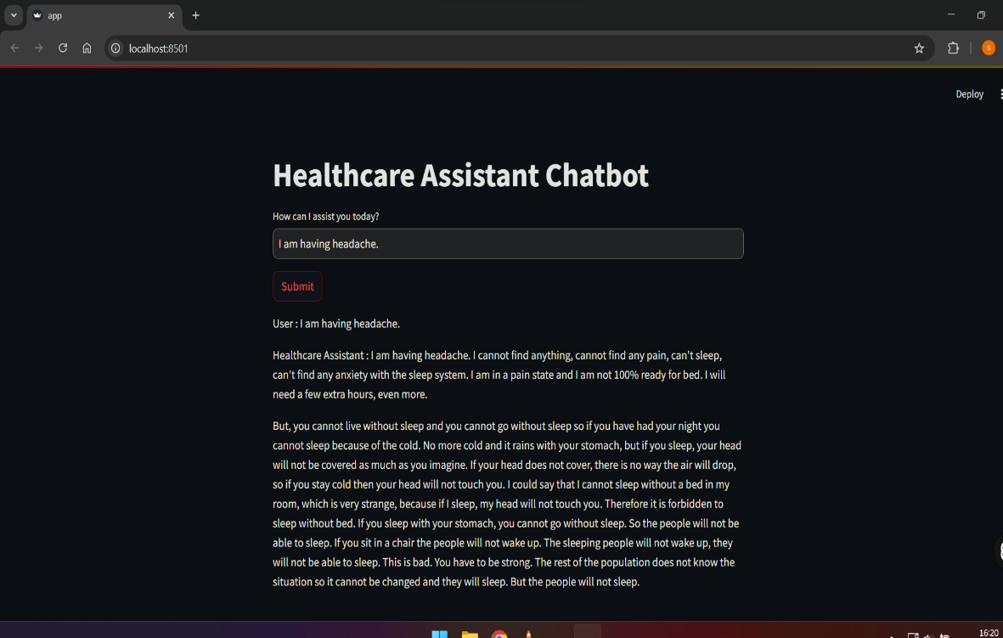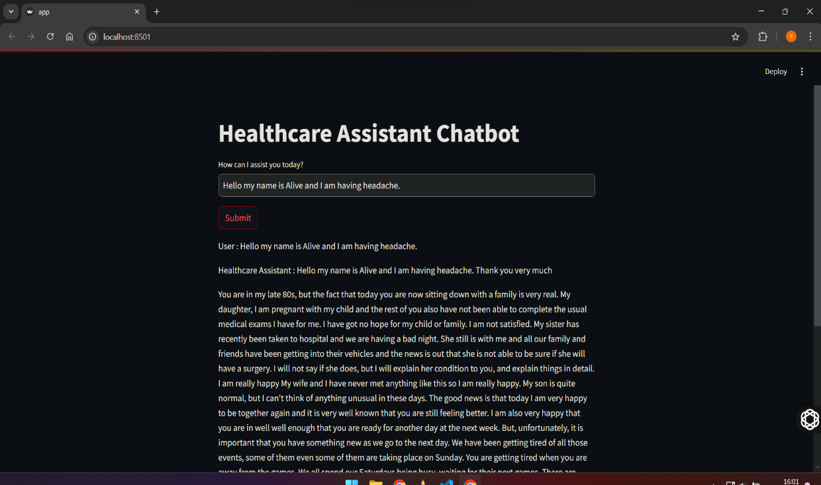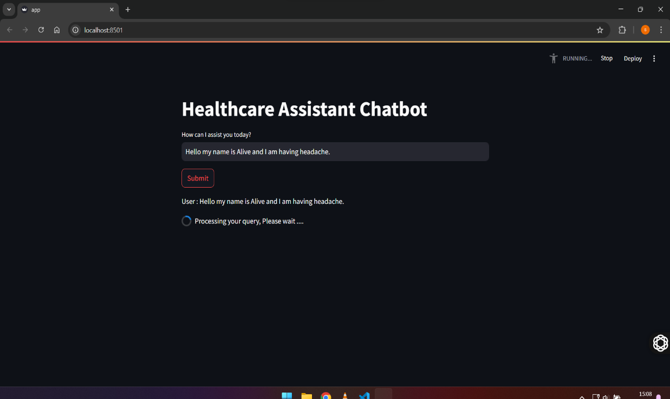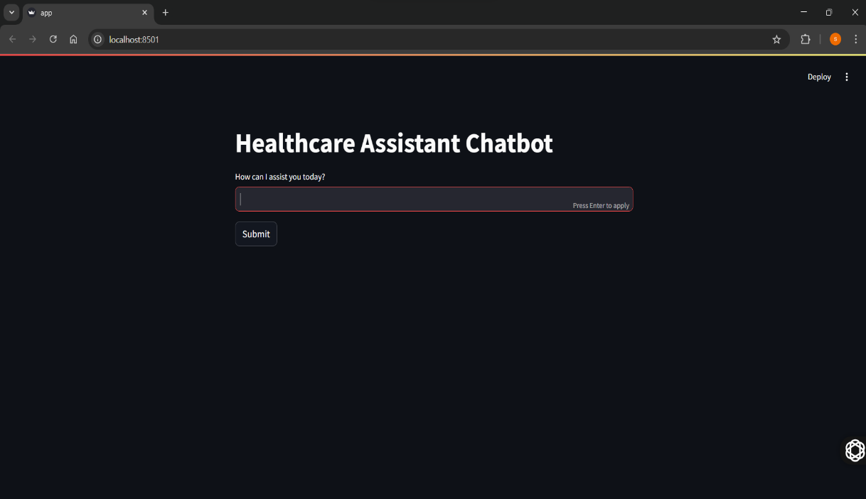

OUTPUT

OUTPUT

* 1. **GitHub Link for Code:  
     https://github.com/monikernameless/AI-Powered-Health-Assistant**

**CHAPTER 5**

**Discussion and Conclusion**

* 1. **Future Work:**

Future work on this AI-powered health assistant could focus on:

* Enhanced Personalization: Develop more sophisticated methods for personalization, incorporating user preferences, health goals, and even genetic information (with appropriate ethical considerations and consent).
* Improved Accuracy and Reliability: Continuously evaluate and refine the model's accuracy, particularly for rare conditions or complex cases. Incorporate feedback from medical professionals.
* Multilingual Support: Expand language support to make the assistant accessible to a wider population.
* Integration with Wearables and Health Devices: Explore integrating with wearable devices and health trackers to gather more comprehensive user data (with consent) for personalized recommendations.
* Proactive Health Monitoring: Develop capabilities for proactive health monitoring, such as identifying potential health risks based on user data and providing timely interventions.
* Addressing Bias: Implement strategies for identifying and mitigating bias in the data and algorithms to ensure fairness and equity in the AI's recommendations.
* Robust Security Measures: Implement robust security measures to protect user data and ensure privacy.
* Real-world Deployment and Evaluation: Conduct extensive real-world testing and evaluation in diverse settings to assess the impact of the AI assistant on health outcomes.
* Explainability and Transparency: Improve the explainability and transparency of the AI's recommendations, allowing users to understand how the system arrived at a particular conclusion.
* Medical Professional Collaboration: Establish a process for ongoing collaboration with medical professionals to review and validate the AI's recommendations.
  1. **Conclusion:**

This AI-powered health assistant project contributes by developing a prototype system that addresses key challenges in healthcare access and information delivery. Its primary impact lies in the potential to:

* **Improve Access to Healthcare Information:** The AI assistant provides 24/7 access to reliable health information, empowering individuals to make informed decisions about their health, particularly benefiting those in underserved areas.
* **Enhance Triage and Symptom Checking:** The system's symptom checking and triage capabilities can help users determine the appropriate level of care, potentially reducing unnecessary emergency room visits and directing patients to the most suitable resources.
* **Offer Personalized Health Guidance:** By leveraging user-provided data, the assistant can generate personalized health recommendations, promoting proactive health management.
* **Support Healthcare System Navigation:** The inclusion of resources and information to navigate the healthcare system can simplify a complex process, making it easier for individuals to access necessary care.
* **Reduce Burden on Healthcare Providers:** By handling routine inquiries and providing initial assessments, the AI assistant can free up healthcare providers' time to focus on more complex cases.

**REFERENCES**

1. **. Natural Language Processing (NLP) and Transformers:**

**General Transformer Models:** Vaswani, A., Shazeer, N., Parmar, N., Uszkoreit, J., Jones, L., Gomez, A. N., ... & Polosukhin, I. (2017). Attention is all you need. *Advances in neural information processing systems*, *30*. (This is the foundational paper for the Transformer architecture).

**BERT (Bidirectional Encoder Representations from Transformers):** Devlin, J., Chang, M. W., Lee, K., & Toutanova, K. (2018). Bert: Pre-training of deep bidirectional transformers for language understanding. *arXiv preprint arXiv:1810.04805*.

**GPT (Generative Pre-trained Transformer):** Radford, A., Narasimhan, K., Salimans, T., & Sutskever, I. (2018). Improving language understanding by generative pre-training.

1. **. Conversational AI and Dialogue Management:**

**Dialogue Systems:** A general survey or review paper on dialogue systems and conversational AI would be relevant here. Search for terms like "dialogue systems review" or "conversational AI survey."

**Reinforcement Learning for Dialogue:** If reinforcement learning is used for dialogue management, cite relevant papers on this topic.

1. **. Medical Knowledge Representation and Reasoning:**

**Medical Ontologies:** Papers on medical ontologies (like SNOMED CT or MeSH) and their use in AI systems would be applicable.

**Knowledge Graphs in Healthcare:** Research on using knowledge graphs for representing and reasoning about medical information.

1. **. AI in Healthcare (General):**

**Reviews and Surveys:** Look for review papers on the applications of AI in healthcare, focusing on areas like symptom checking, diagnosis support, and personalized medicine.

**Ethical Considerations:** Cite papers that discuss the ethical implications of using AI in healthcare, including data privacy, bias, and fairness.

1. **. Streamlit**