Active Object [AO] vs ProdCons N elems [PC]

Amount – amount of resources requested

100 producers, 100 consumers

Producers comparision
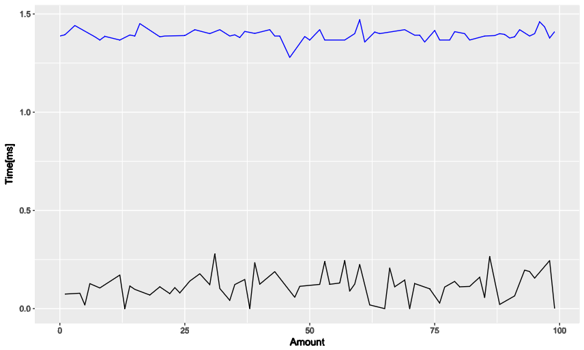
Consumers comparision
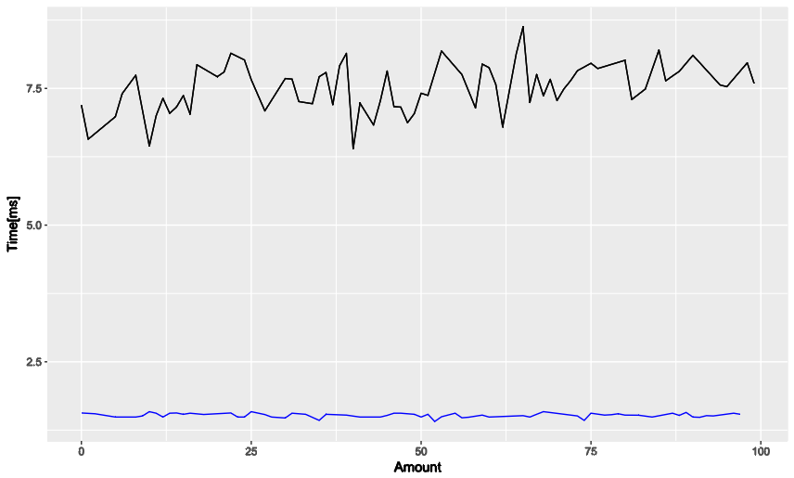

1000 producers, 1000 consumers

Producers comparision
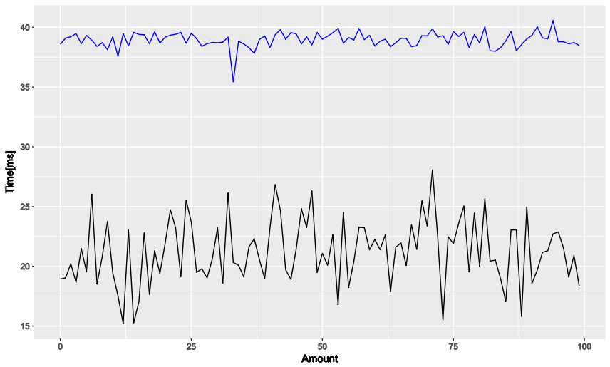
Consumers comparision
