**27-05-2024**

Open the Application

E:\MVC\MVC_API-Applicationdone in 3-05-2024(Visualstudio2022)

Open database-**Employee1,** Table name:- **WebApiTab**

After open the application Install the Package

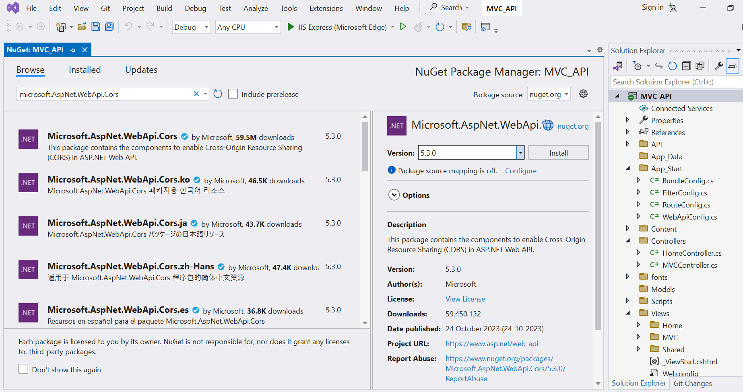

* Then open Webconfig File,Then set cors

//To set Cors

var cors = new EnableCorsAttribute("http://localhost:4200","*","*");

config.EnableCors(cors);

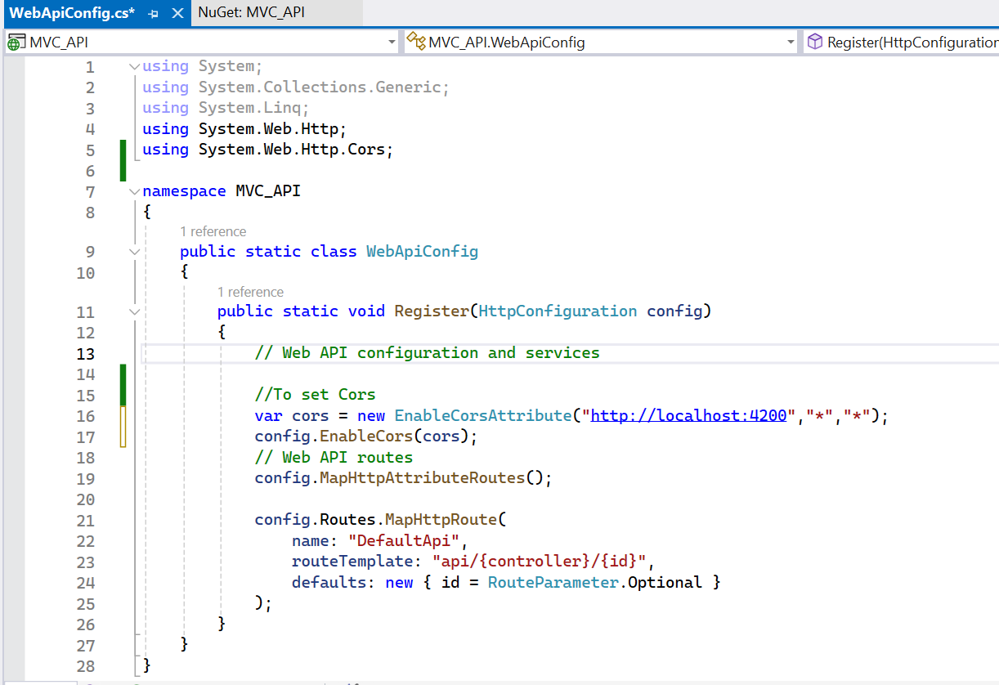

Then Save the WebConfig File.

* Open VSCODE🡪File🡪openfolder🡪choose the angular folder that present in E drive

After Create new Apllication, For that open Terminal Then type the **ng new APIWithAngular(Appln Name)**

* OpenFolder

File🡪open folder🡪E:/Angular/ **APIWithAngular**

The open Terminal🡪New terminal🡪type ng generate service myservice(ervice name)

Then Type Y

Then open Src🡪App module.ts🡪

import{HttpClientModule} from '@angular/common/http';

import { MyserviceService } from './myservice.service';

import { FormsModule } from '@angular/forms';

Then import this

 FormsModule,

HttpClientModule

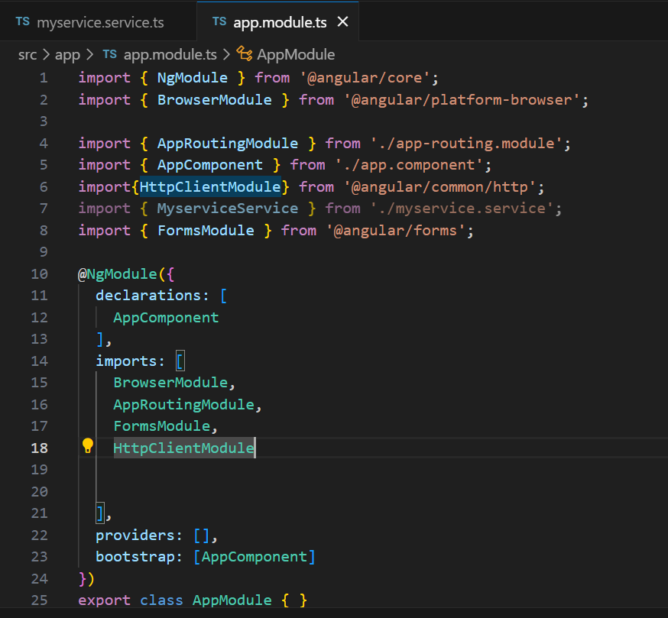

Then open Service Page:

Import this

import { HttpClient } from '@angular/common/http';

import { Observable } from 'rxjs';

Observable:

rxjs-Reactive extension Javascript

* Same as entity class
* Property to beset as same in table with field

export interface WebApiTab{

  Id: number;

  Name:string;

  Age:number;

  mark:number;

}

Create a constat variable to save the localhost address

const endpoint='http://localhost:60387/api/WebAPI/';

export class MyserviceService {

  constructor(private http: HttpClient) { }

  addWebApiTab(product:any): Observable<any>{

  return this.http.post(endpoint+'postwebapitab',product);

  }

}

To Add A component

ng g c InsertTab(Component name)

Open insert-tab.component.ts

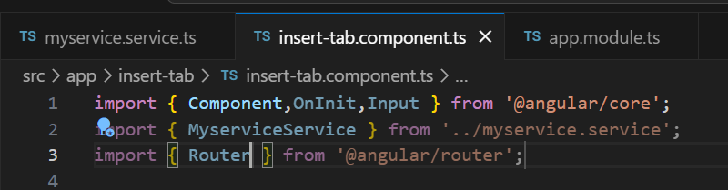

OnInit Equal to Pageload

Input:-Toget input values to the property

export class InsertTabComponent implements OnInit {

@Input() userData ={Name:'',Age:0,mark:0};

constructor(public rest:MyserviceService,private router:Router){}

}

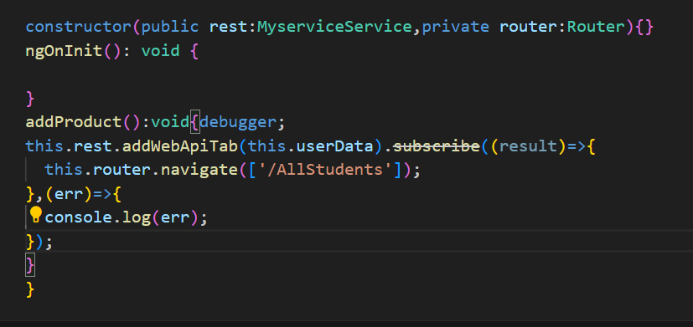

**28-05-2024**

Open The **MVCAPI**(E:/MVC:/ MVC_API) Application Then Run The Application And Miminize it,After open angular application in VSCode then design in VSCode insert-tab.component.html page

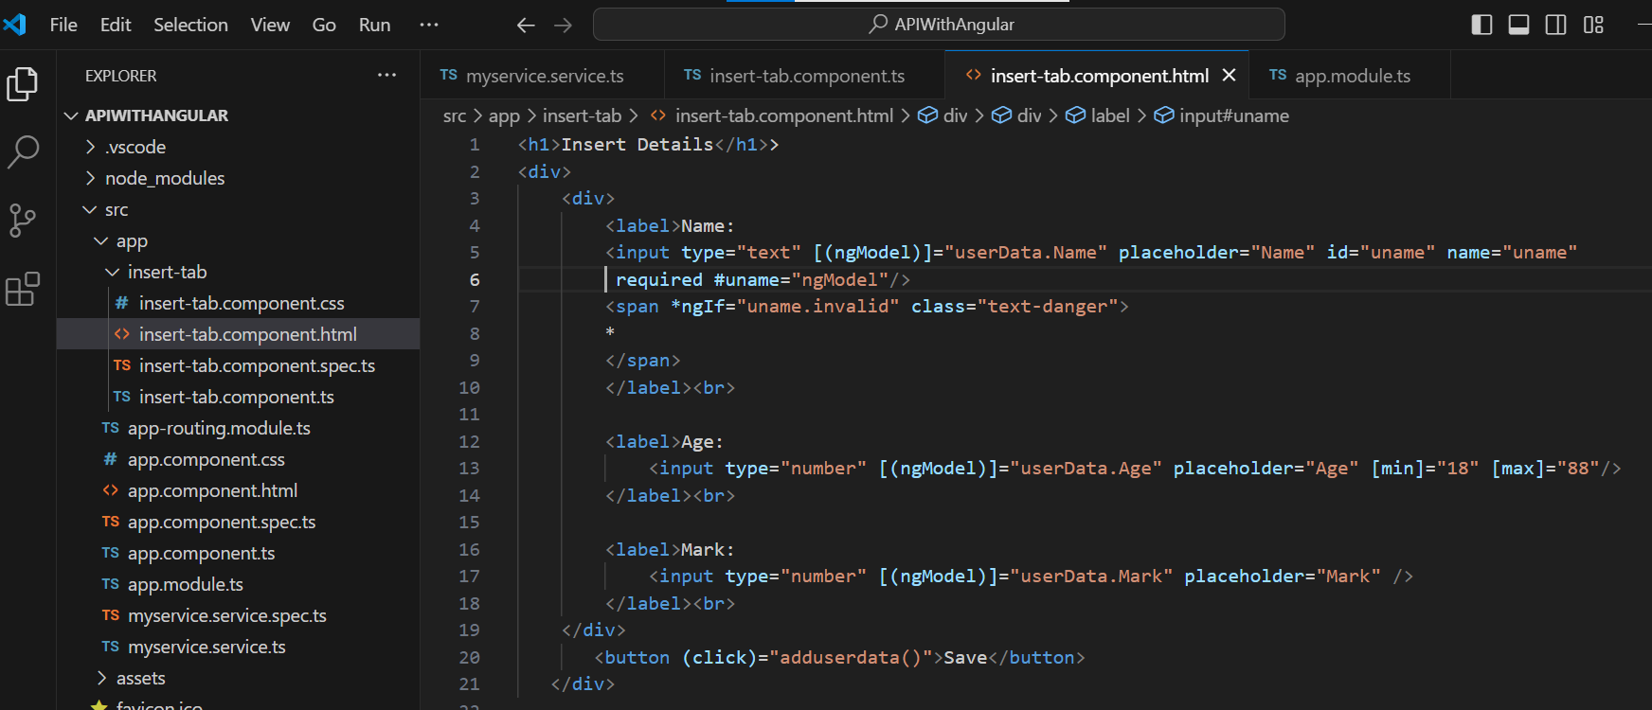

Then routing is done in Approuting module

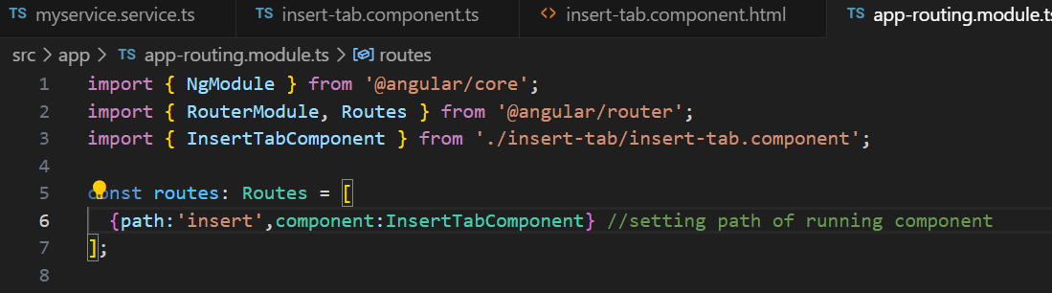

Roter is set

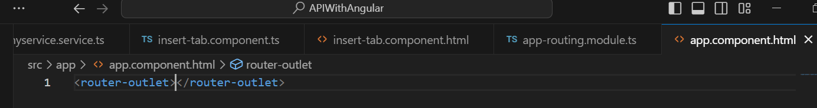

After writing this run the vscode

Terminal🡪new terminal🡪ng server-o

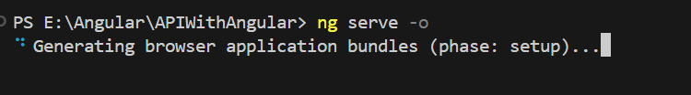

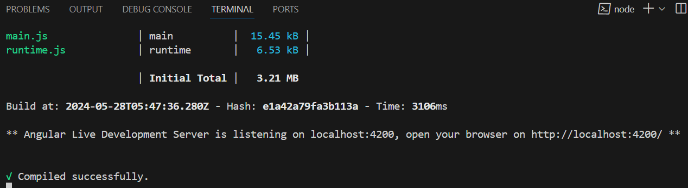

After compile successfully

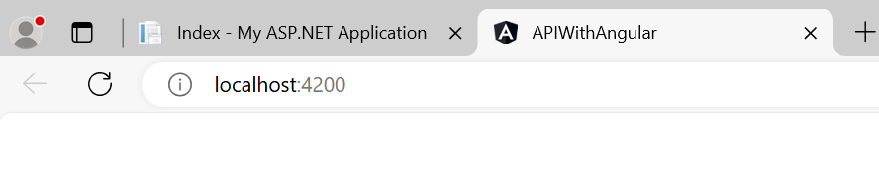

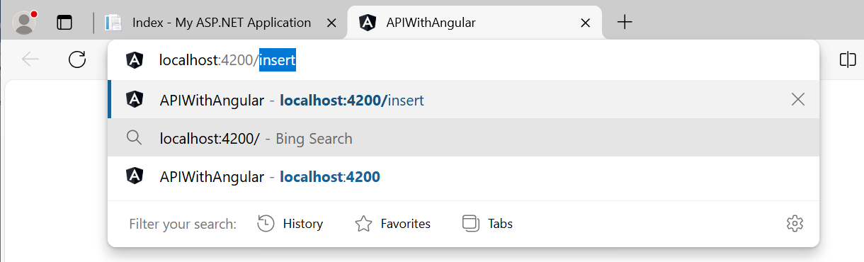

Type this over /insert

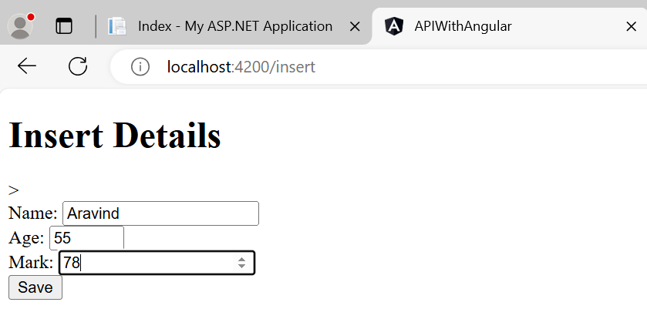

After this check the mvc running page and refresh it

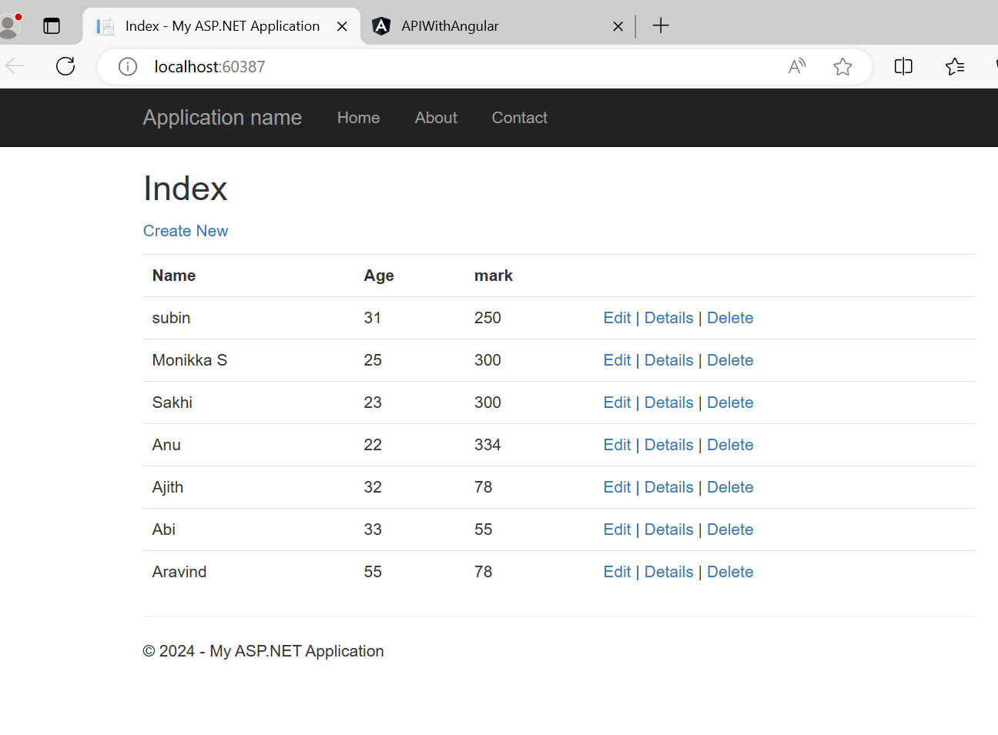

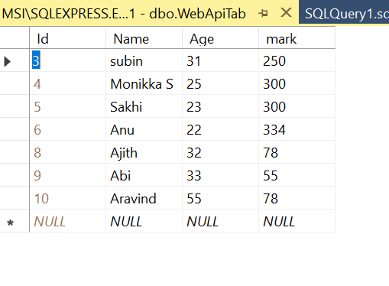

Todisplay all the values in the table

getAllWebApiTabs(): Observable<any>{

    return this.http.get<WebApiTab>(endpoint+'getwebapitabs');

  }

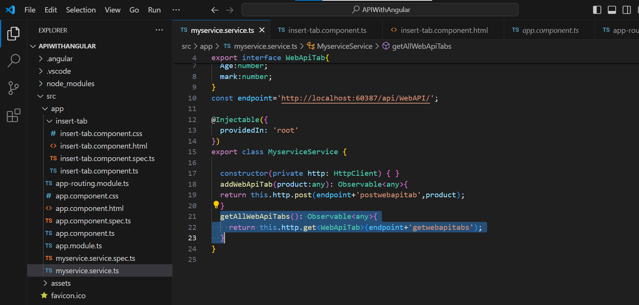

Then Add Component to using the code

PS E:\Angular\APIWithAngular> ng g c SelectAllDetails

Theopen src🡪 SelectAllDetails🡪 select-all-details.component.ts

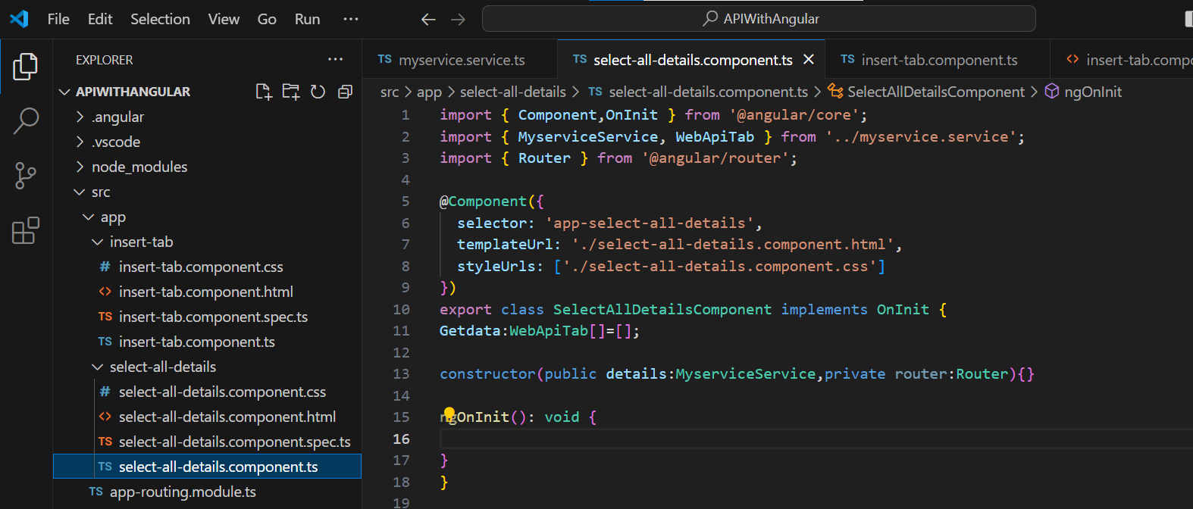

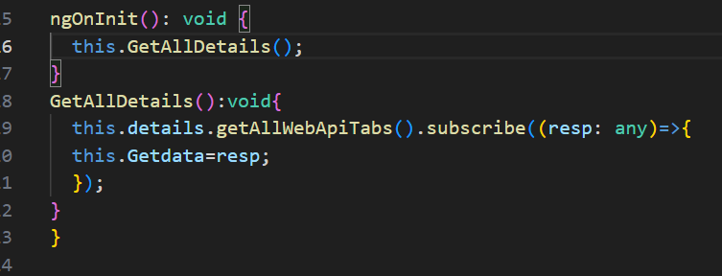

Design the page

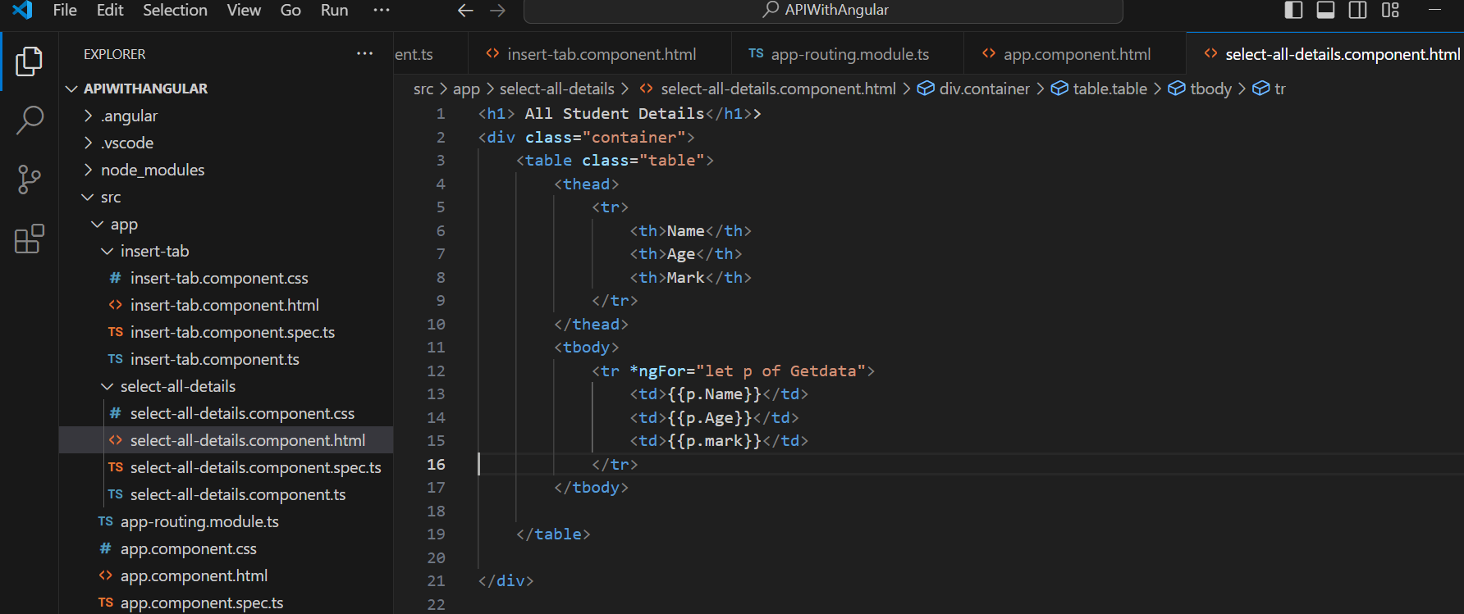

Import the path in app-routing-module.ts

Then set the path

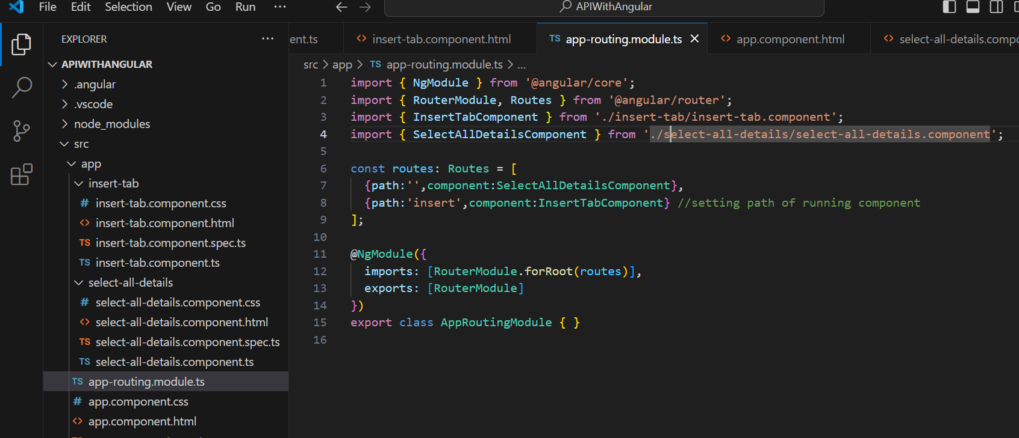

Run by using the code

PS E:\Angular\APIWithAngular> ng serve -o

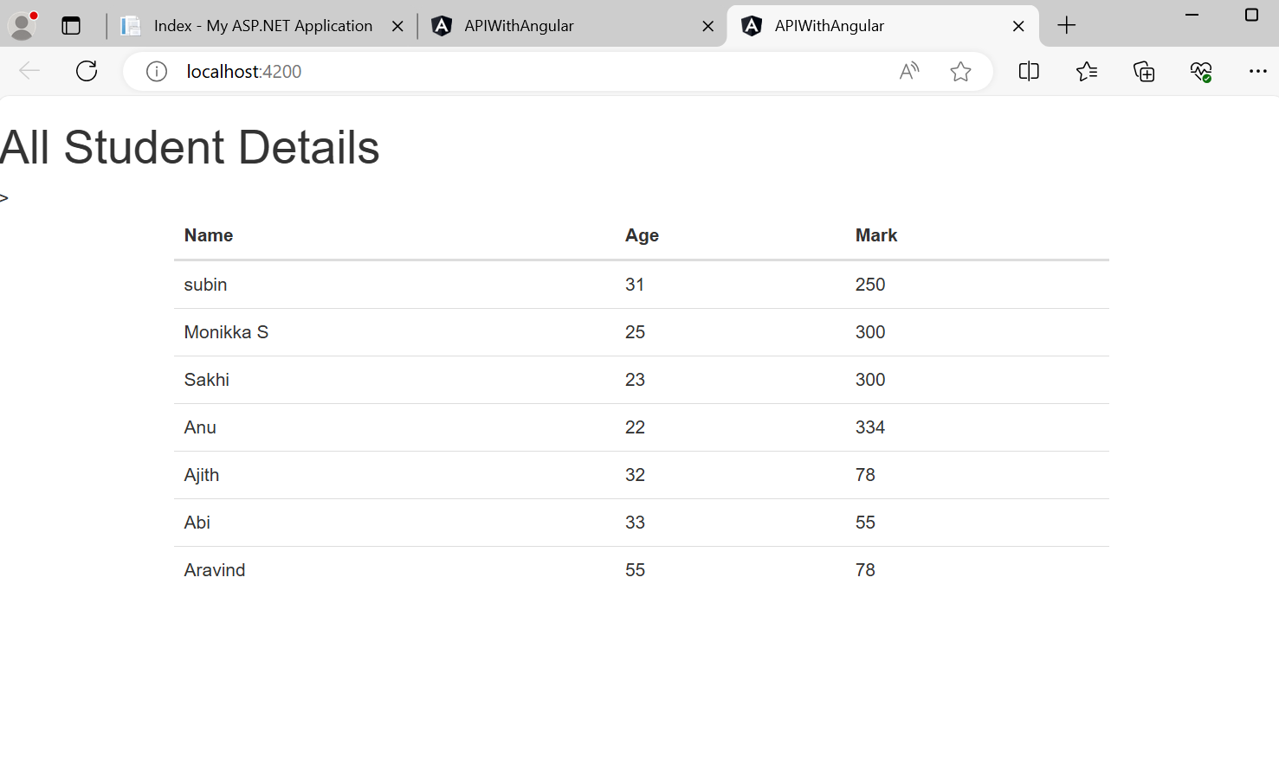

**29-05-2024**

Add component or page by using the code

PS E:\Angular\APIWithAngular> **ng g c DisplayDetailsWithId**

Then selectect **display-details-with-id.component.ts**

import { Component,OnInit } from '@angular/core';

import { MyserviceService,WebApiTab } from '../myservice.service';

import { ActivatedRoute,Router } from '@angular/router';

then implement oninit

export class DisplayDetailsWithIdComponent implements OnInit{

  student:WebApiTab | undefined;

  id:number=0;

  constructor(public rest:MyserviceService,private route:ActivatedRoute, private router:Router){}

}

ngOnInit(): void {

    var paramId=this.route.snapshot.paramMap.get("id");//id get from querystring or url

    if(paramId!==null && paramId!=undefined){

      this.id=paramId;

    }

    this.rest.getIdWebApiTab(this.id).subscribe(

      (data:WebApiTab)=>this.student={...data}

    );

  }

}

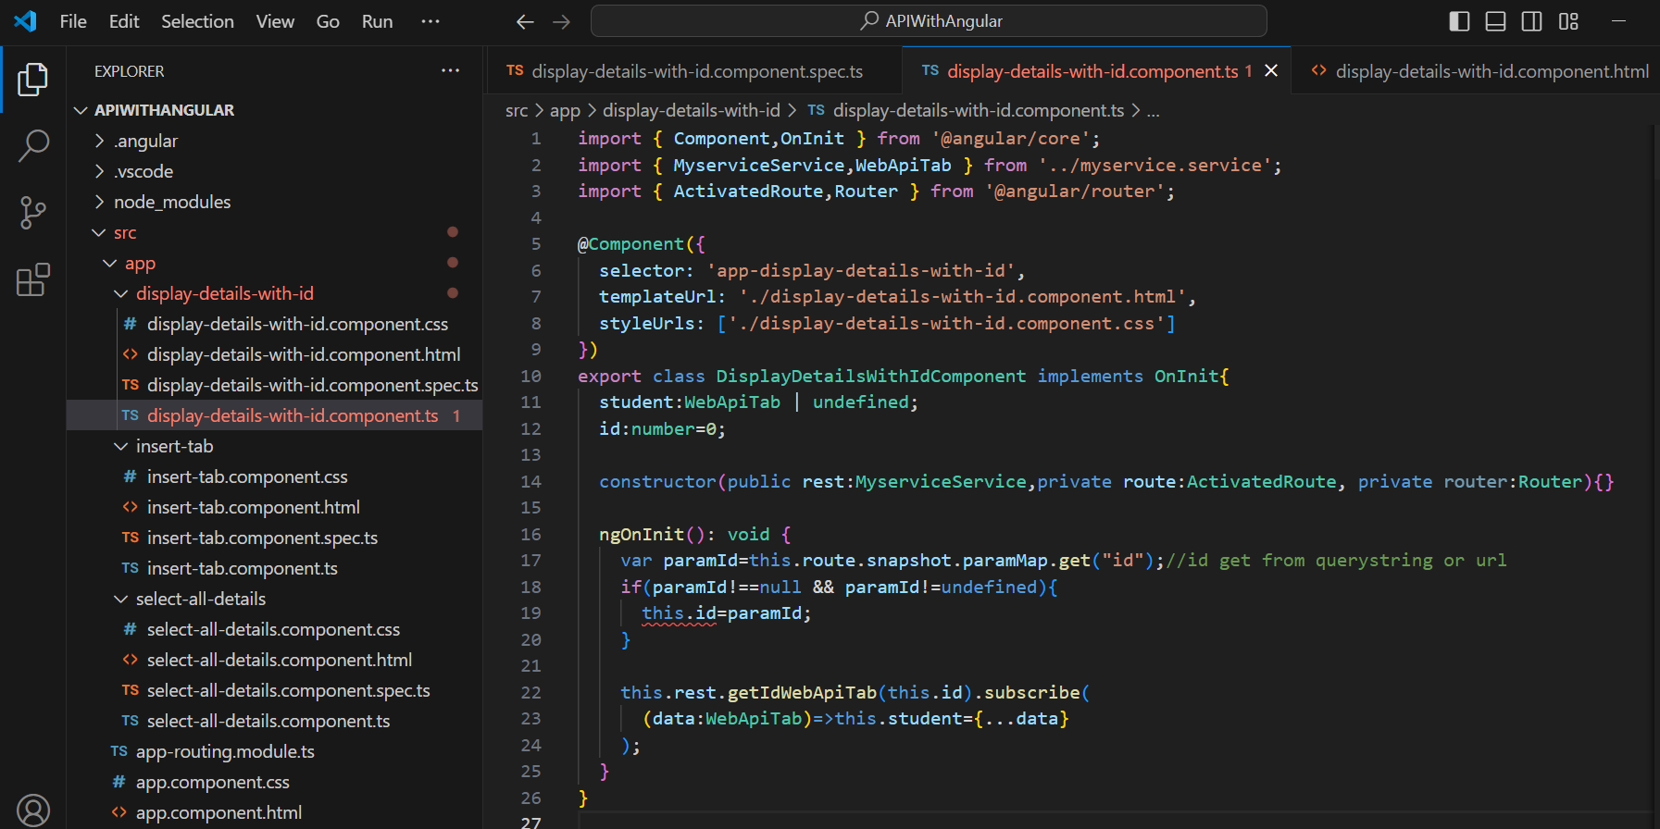

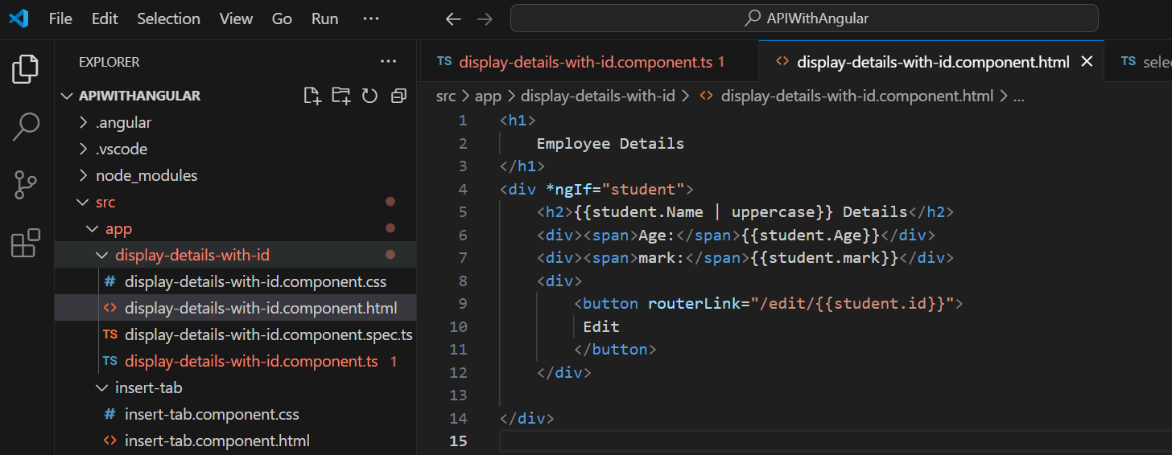

Type this code in **select-all-details.component.html**

<td>

                    <button routerLink="/details/{{p.id}}">  Details  </button>

                </td>

Import this in ApprotingModule.ts

import { DisplayDetailsWithIdComponent } from './display-details-with-id/display-details-with-id.component';

{path:'details',component:DisplayDetailsWithIdComponent}

**30-05-2024**

Add component for Edit

PS E:\Angular\APIWithAngular> ng g c **EditDBDetails**

**Then import**

import { MyserviceService } from '../myservice.service';

import { ActivatedRoute,Router } from '@angular/router';

