**Spotify and Youtube Analysis**

**Objective**

The project analyzes user behavior on two most popular platforms Spotify and Youtube. It uncovers insights from the given data and identifies key patterns that reveal user preferences and listening habits. It explores how audio features such as energy, danceability, acousticness correlate with song popularity providing valuable knowledge for artist and music recommendation system.

**Results:**

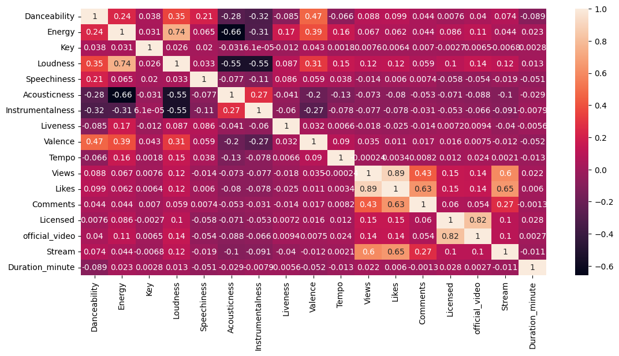

Correlation matrix used to describe relationship between different features. It is apparent that Likes and Views are highly correlated. Furthermore, [Likes, Comment] and [Stream, Likes] possess similar behavior.

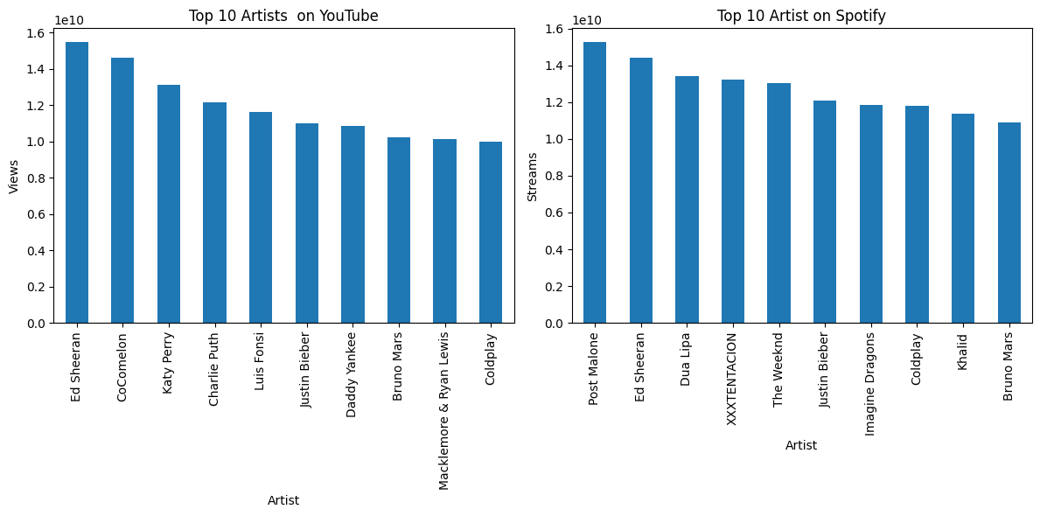

On Youtube, Ed sheeeran was most viewed artist while for Spotify Post Malone hold the first position for most streamed artist.

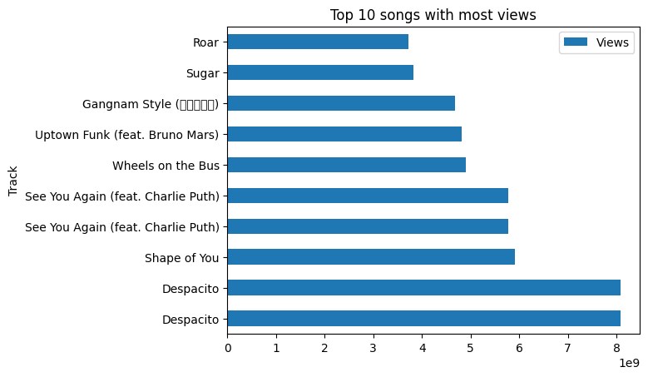

Despacito was the most viewed songs followed by Shape of you.

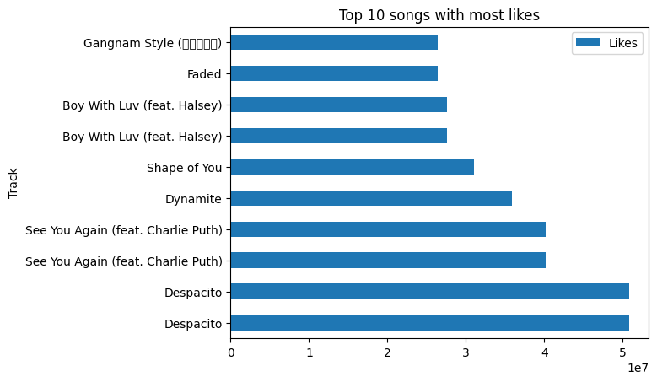

Represents bar graph for top 10 artist with most likes on these platforms.

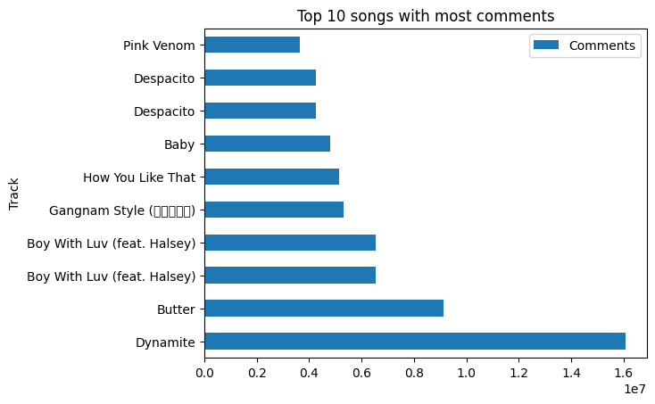Illustrates bar graph with top 10 songs based on comments. Dynamite was most commented track followed by Butter and others.

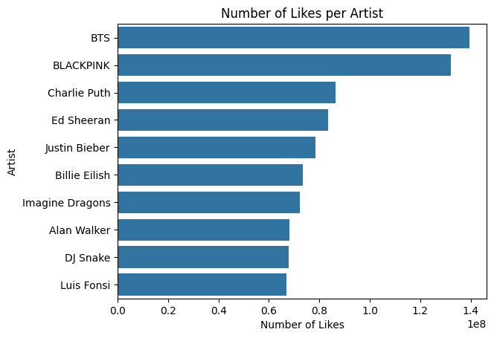

Represents top 10 artist with most likes. BTS being the most liked artist followed by Blackpink.

