Explain command with screenshot

1. Command pwd - This command is used to display the current working directory. Screenshot is as below:

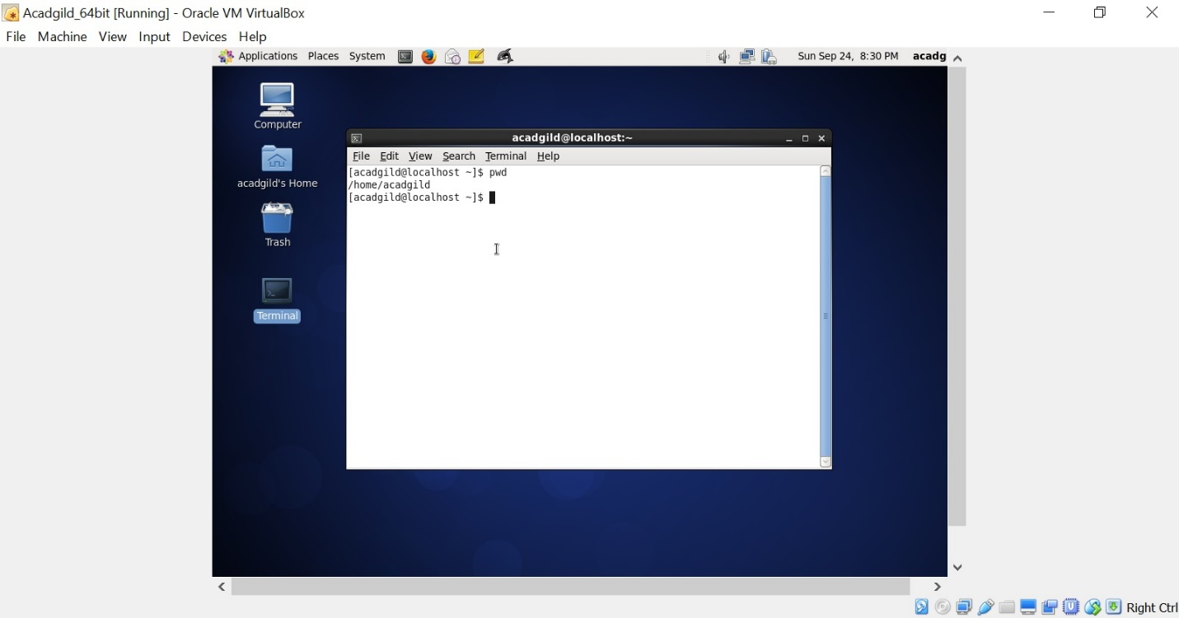

2. vi – Using this command interactive editor vi is used to add/modify/delete text in a file. Screenshot is as below:

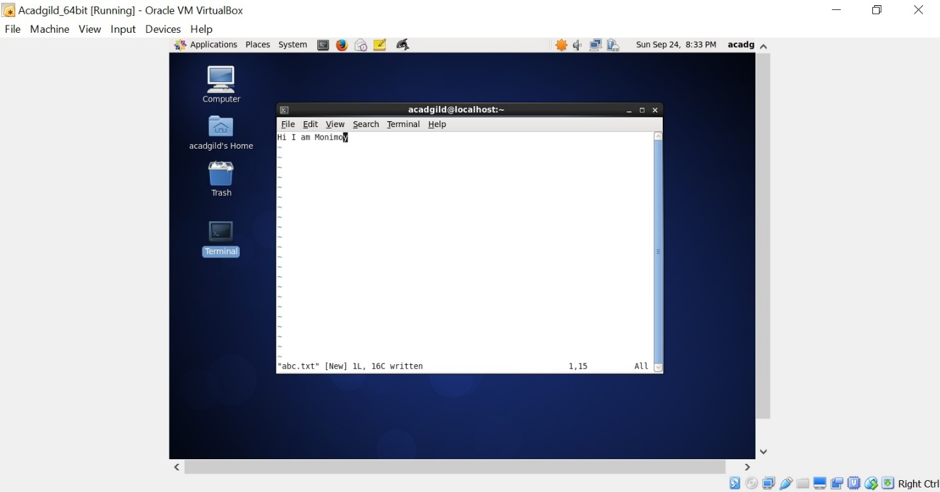

1. touch – This command is used to create a empty file if not exists. If the file already exists, it changes the timestamp of file. Screenshot is as below:

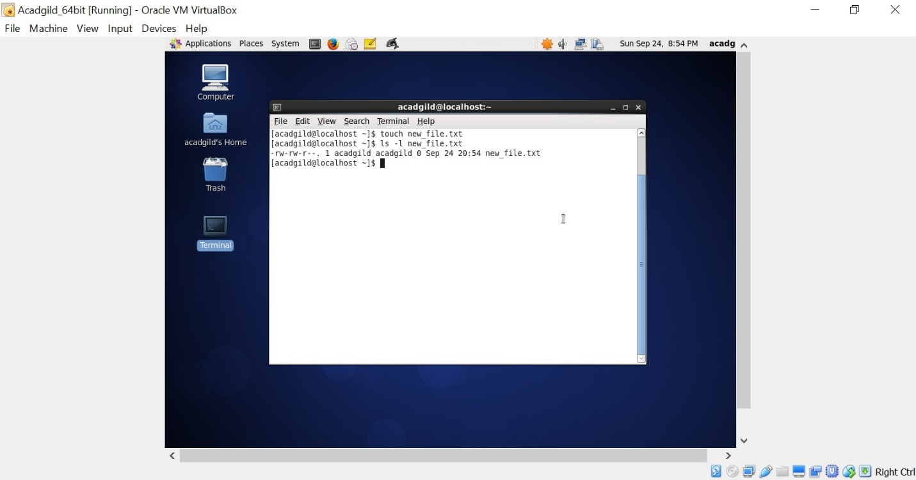

4. mkdir – This command is used to create a new directory. Screenshot is as below:

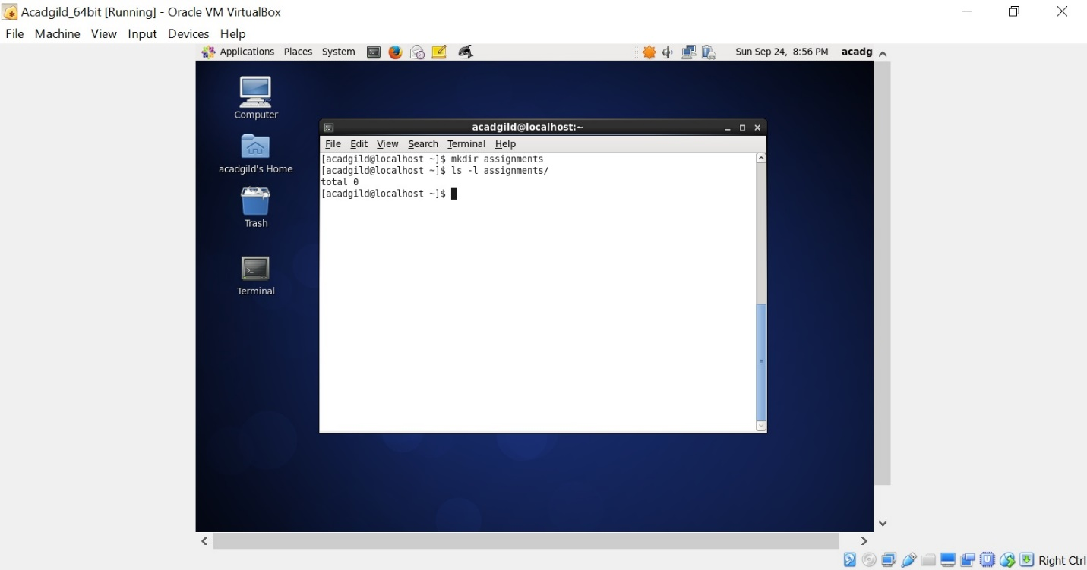

5. rm – This command is used to remove a existing file. If the file does not already exists, it gives error “No such file or directory”

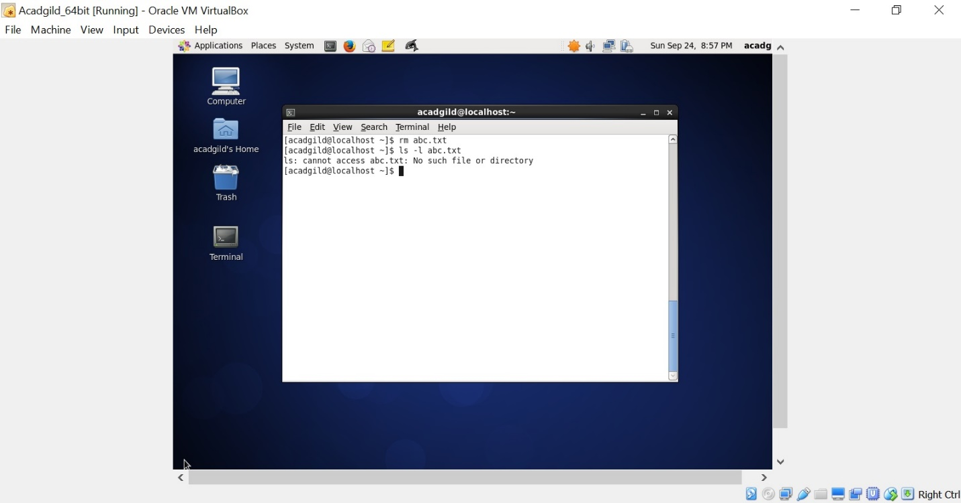

6. ls – This command is used to display list of files in a directory. If directory is not specified, it will display list of files in current directory

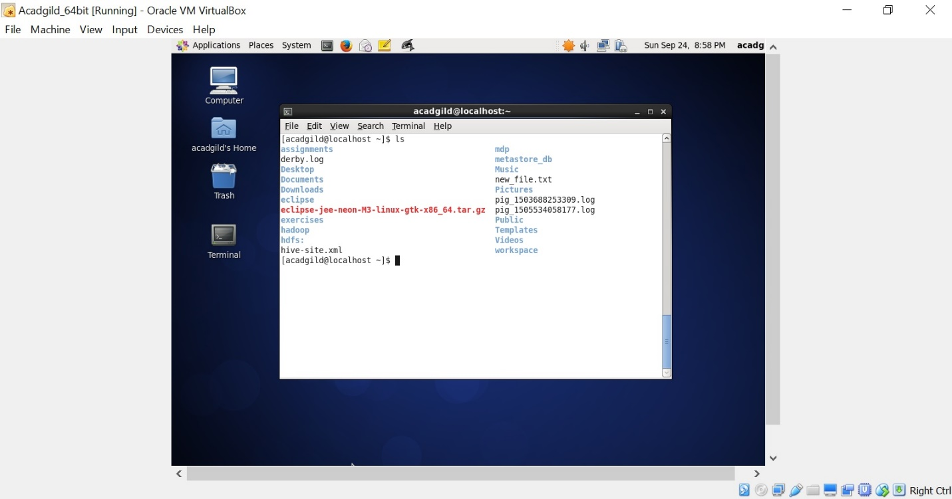

7. echo – This command is used to echo a text back to console. Screenshot is as below:

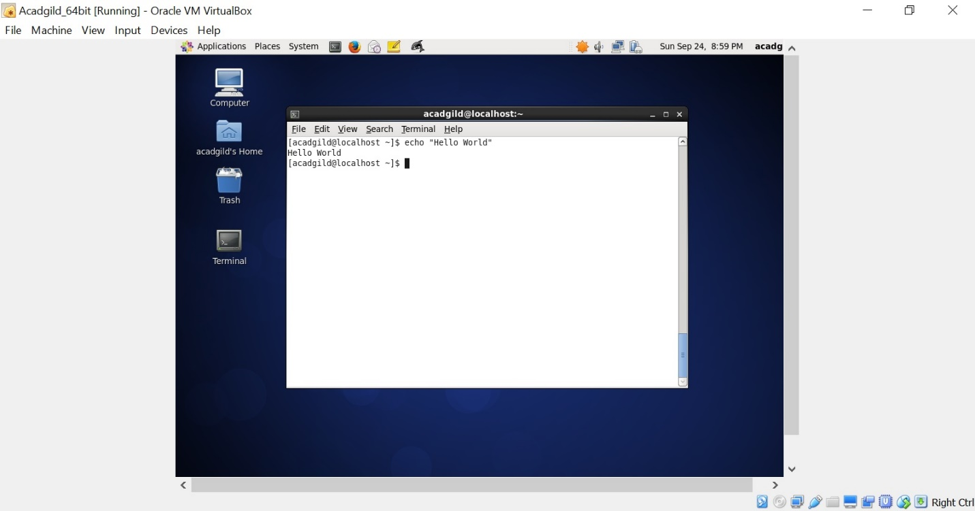

8. cat – This command is used to display the contents of file. Screenshot is shown below:

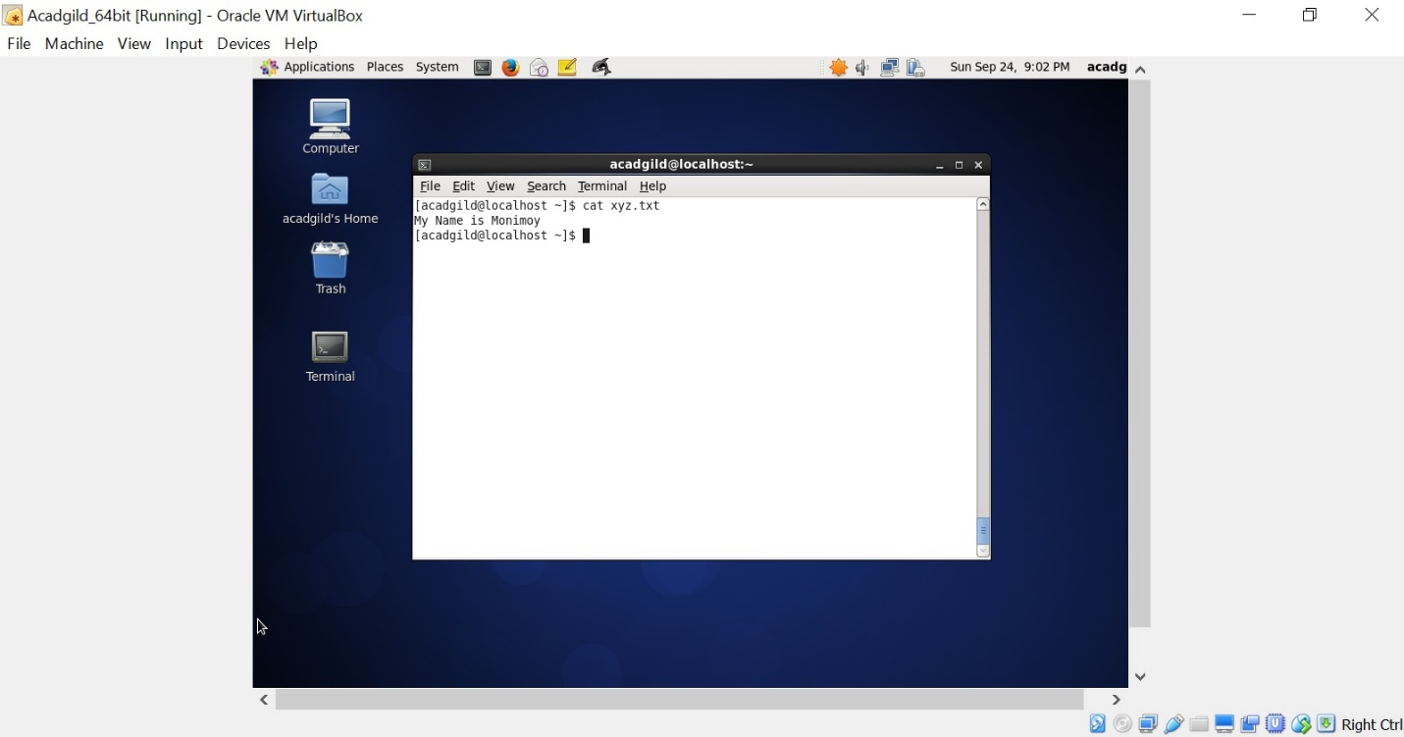

9. who – This command is used to show users who are logged in to the system. Screenshot is as below:

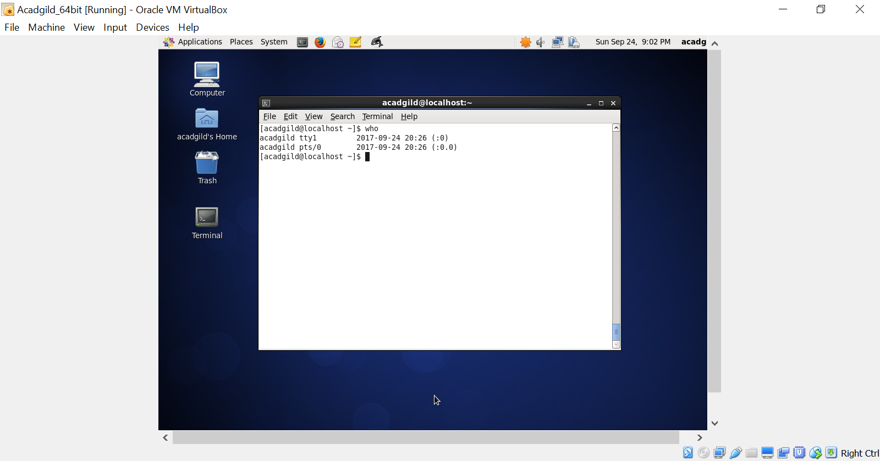

10. cd – This command is used to change the directory. Screenshot is as below:

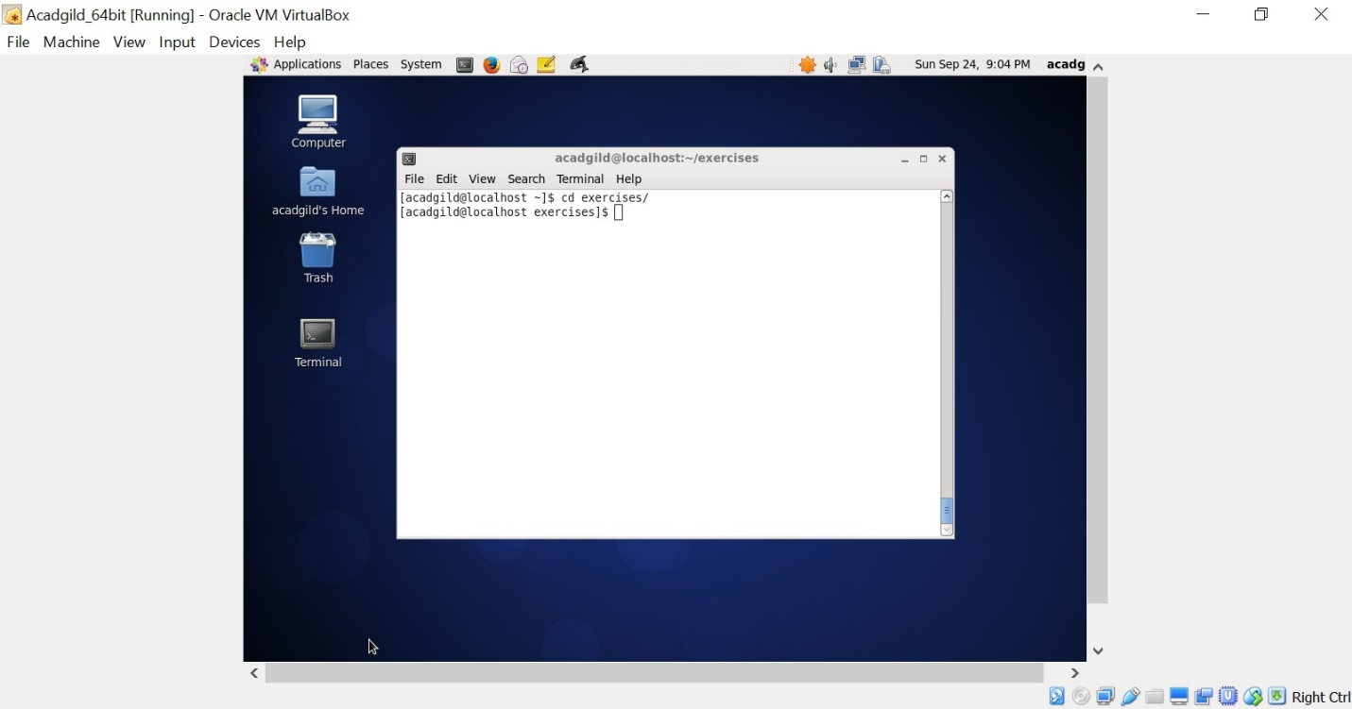

11. date – Displays current system time. Screenshot is as below:

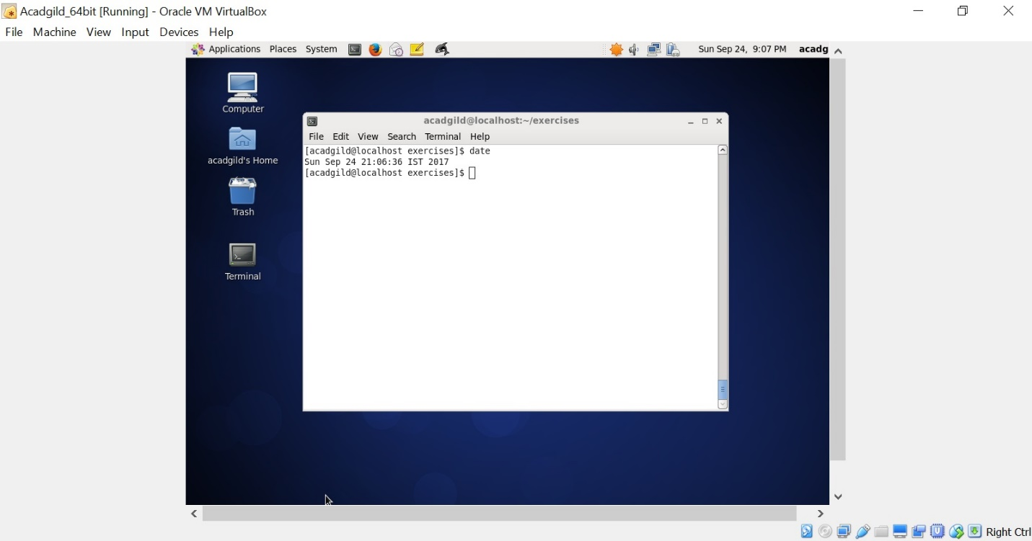

12. cal – This command is used to display the calendar. Screenshot is as below:

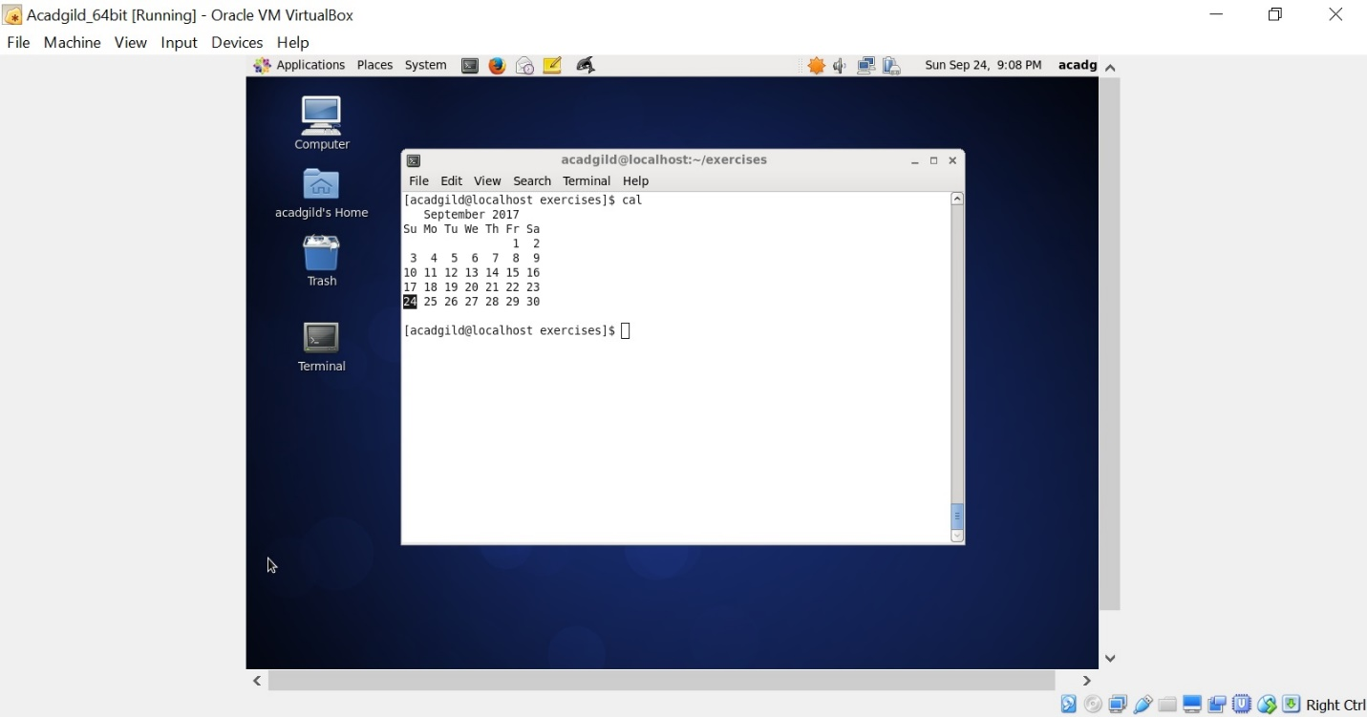

13. mv – This command is used to move a file. Screenshot is as below:

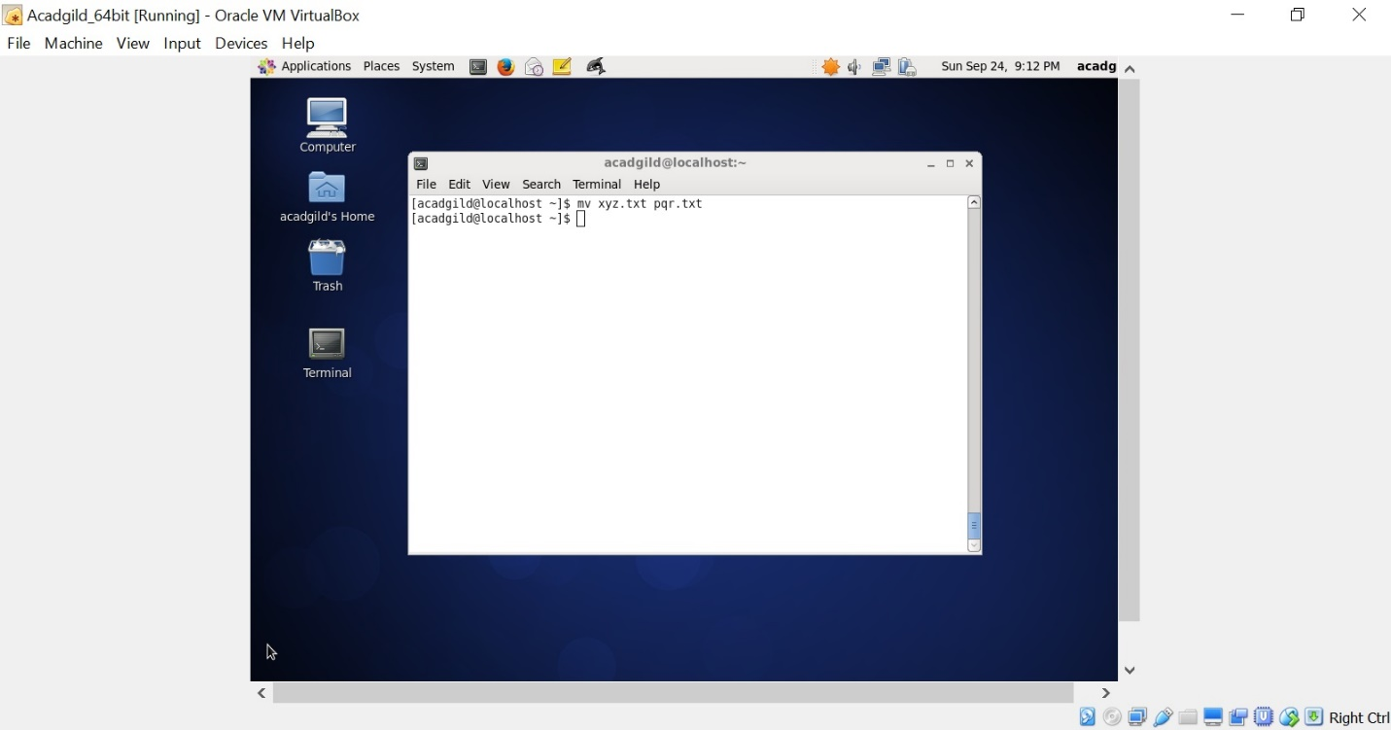

14. cp – This command is used to copy file. Screenshot is as below:

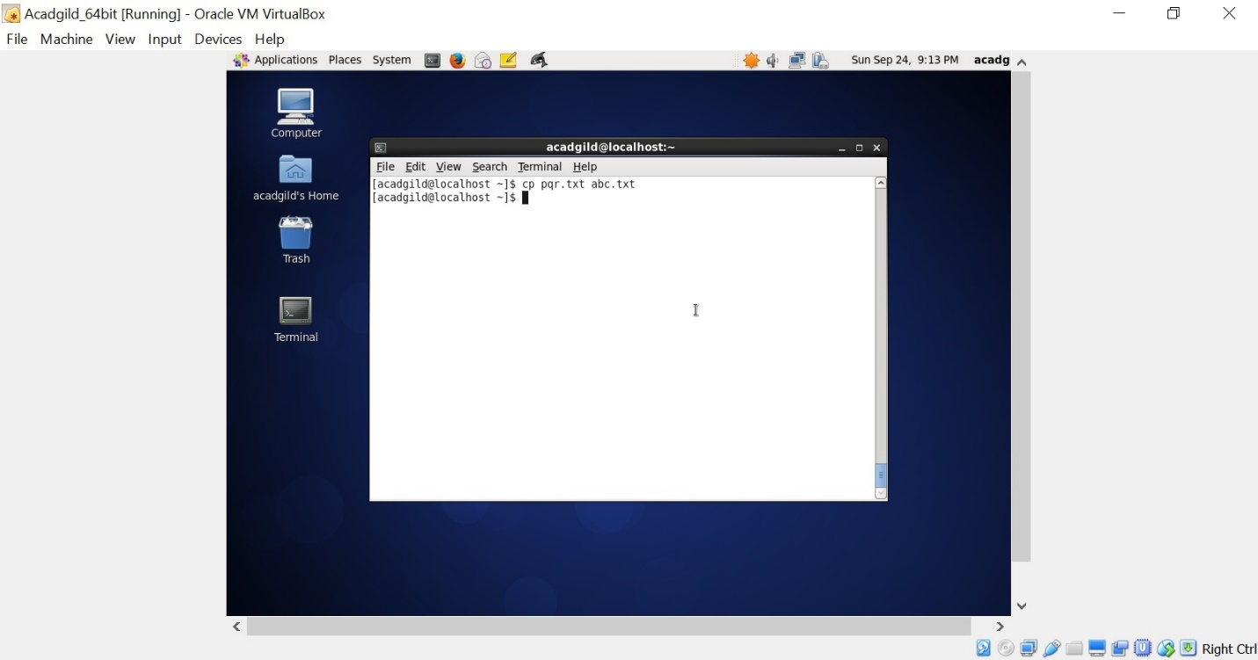

15. which – This command is used to show the path of command. Screenshot is as below:

