Assignment 11.1 ( Sqoop and Flume)

Task1: Import data to HDFS from mysql

Step1: Create employee table in mysql

Start mysql using command:

sudo service mysqld restart

Login to mysql using command:

mysql -u root

Create database in mysql:

create database demo;

Create table employee in demo database:

use demo;

create table employee (

id int,

name varchar(20),

location varchar(20),

department varchar(20)

);

Screenshot is as below:

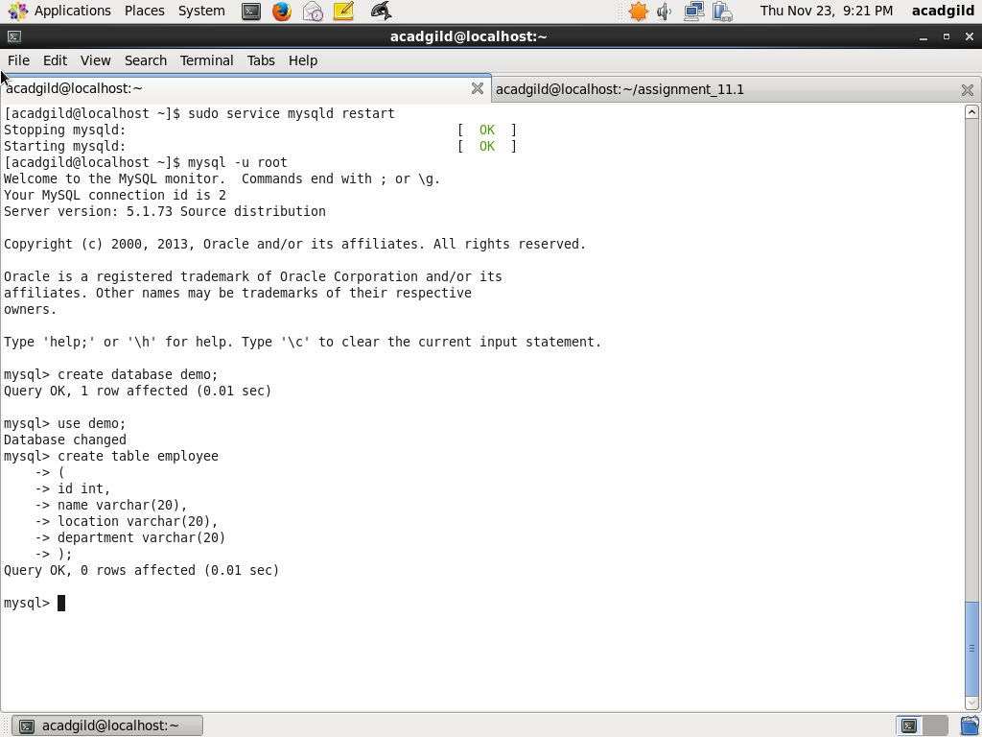

Step2: Insert Records to table employee

Import a few records to table employee using the INSERT command below:

insert into employee values(1, 'S Kumar', 'New Delhi', 'Finance');

insert into employee values(2, 'Om Kale', 'Mumbai', 'Human Resources');

insert into employee values(3, 'Naveen Jain', 'Bangalore', 'Engineering');

insert into employee values(4, 'Vinita Kumari', 'Bangalore', 'Engineering');

insert into employee values(5, 'Tapas Das', 'Bangalore', 'Engineering');

insert into employee values(6, 'Hari Hirani', 'Mumbai', 'Operations');

insert into employee values(7, 'Roshin Nair', 'Bangalore', 'Operations');

insert into employee values(8, 'Alok Singh', 'New Delhi', 'Finance');

Next set privilege to database using the command below:

grant all on *.* to 'root'@'localhost' with grant option;

flush privileges;

commit;

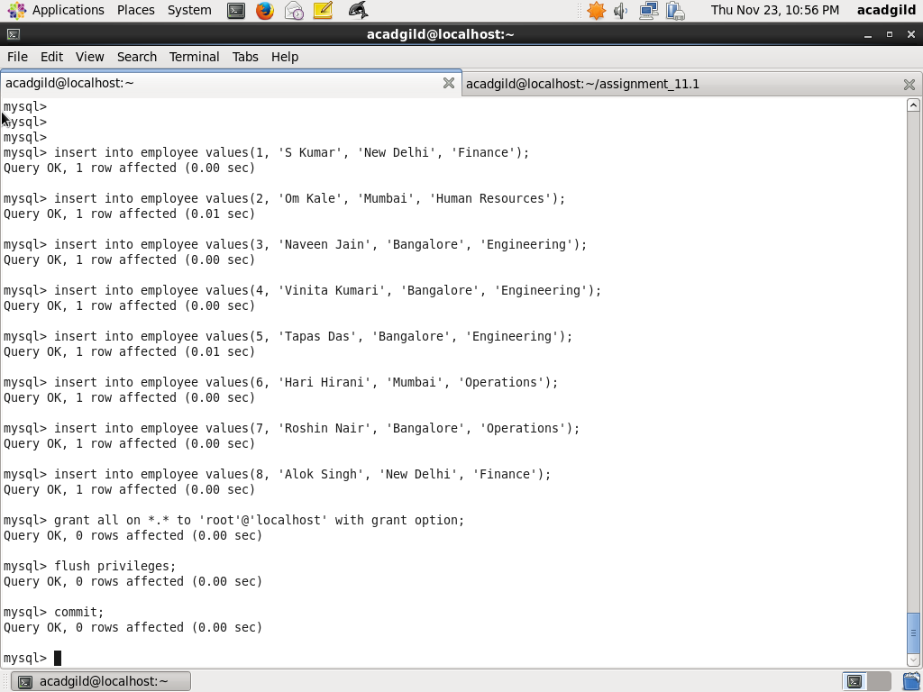

Step3 : Use sqoop to Import data to HDFS

Use sqoop to import data inot HDFS using command below:

sqoop import --connect jdbc:mysql://localhost/demo \

--username 'root' -P --table 'employee' --target-dir /sqoop_output_employee \

-m 1

Screenshot is as below:

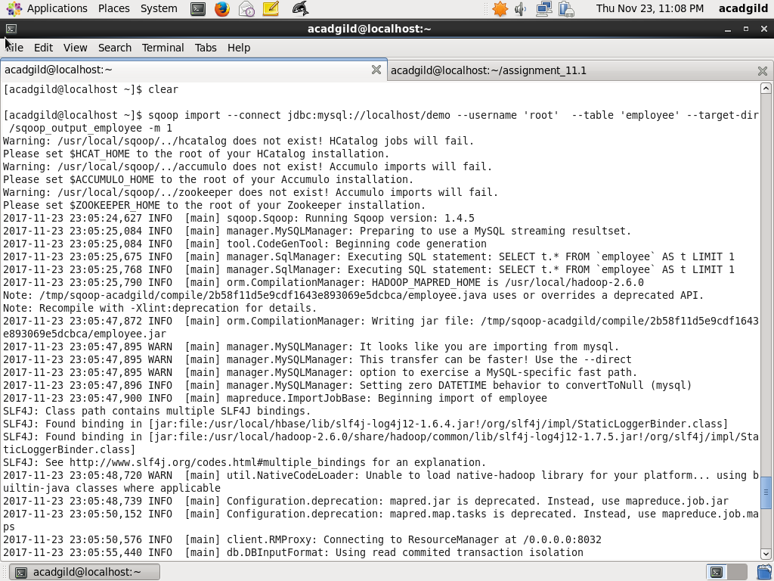

Step4 : Display imported data in HDFS

Display imported data in HDFS using the commands below:

hadoop fs -ls /sqoop_output_employee

hadoop fs -cat /sqoop_output_employee/part-m-00000

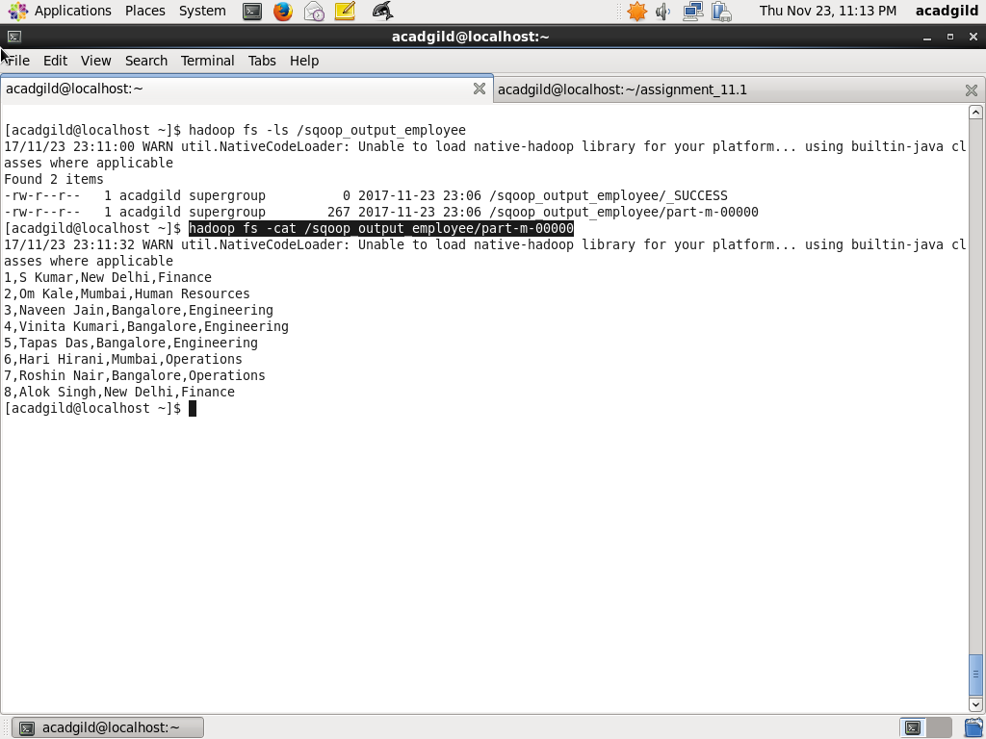

Taks2: Exporting data from HDFS inot mysql

Step1: Export Records from HDFS into mysql employee table

Exports records from HDFS to mysql table using the command below:

sqoop export --connect jdbc:mysql://localhost/demo --username 'root' \

--table 'employee' --export-dir '/sqoop_output_employee' --input-fields-terminated-by ',' -m 1 \

--columns id,name,location,department

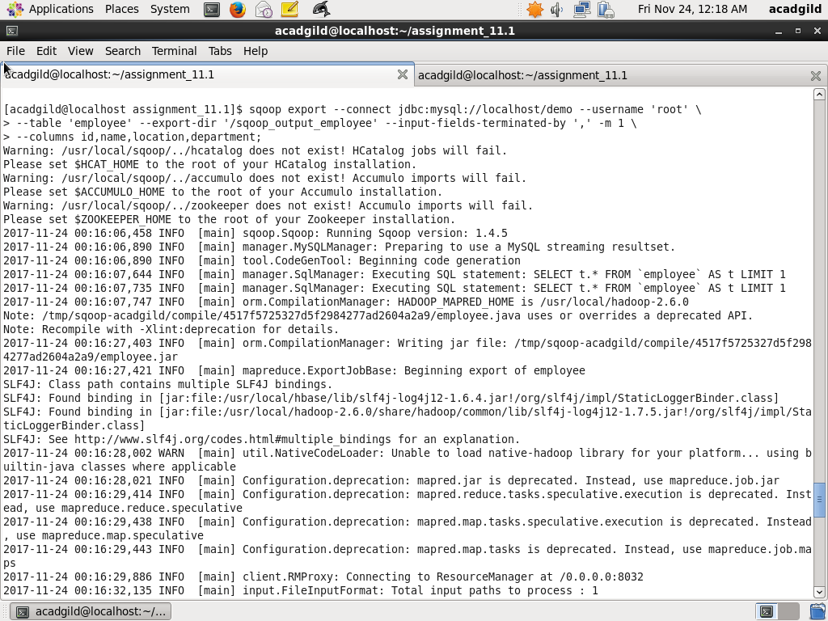

Step2: Display employee records in mysql

Display employee records of mysql using the command below:

Select * from employee

(NOTE: that each record has a duplicate, this is because I used the same employee table in task1 and when I exported from HDFS, the duplicate records are generated

Screenshot is as below:

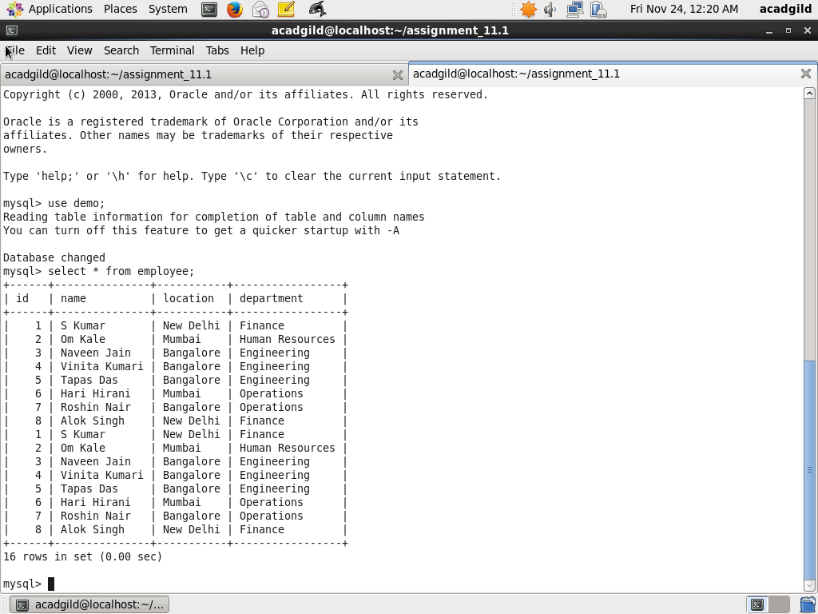

Task3: Importing records from Mysql to Hive

Step1:

Import records from mysql employee table in demo database inot Hive table employee with targer directory /user/hive/warehouse/employee using command below:

sqoop import --connect jdbc:mysql://localhost/demo --username root --split-by id \

--columns id,name,location,department --table employee --target-dir /user/hive/warehouse/employee \

--fields-terminated-by "," --hive-import --create-hive-table --hive-table employee

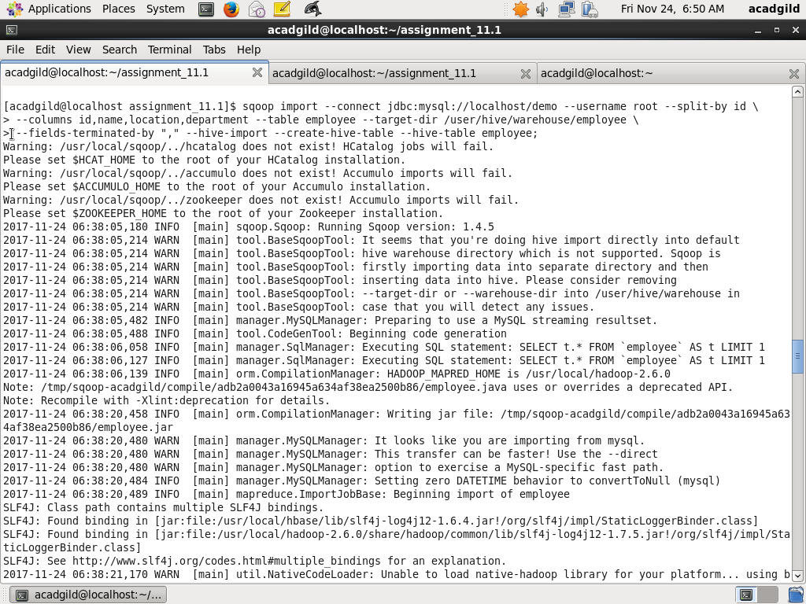

Step2: Show the imported records in hive repository

Show the records in Hive repository /user/hive/warehouse/employee in HDFS using command below:

hadoop fs –ls /user/hive/warehouse/employee

hadoop fs –cat /user/hive/warehouse/employee/part-m-00000

hadoop fs –cat /user/hive/warehouse/employee/part-m-00001

hadoop fs –cat /user/hive/warehouse/employee/part-m-00002

hadoop fs –cat /user/hive/warehouse/employee/part-m-00003

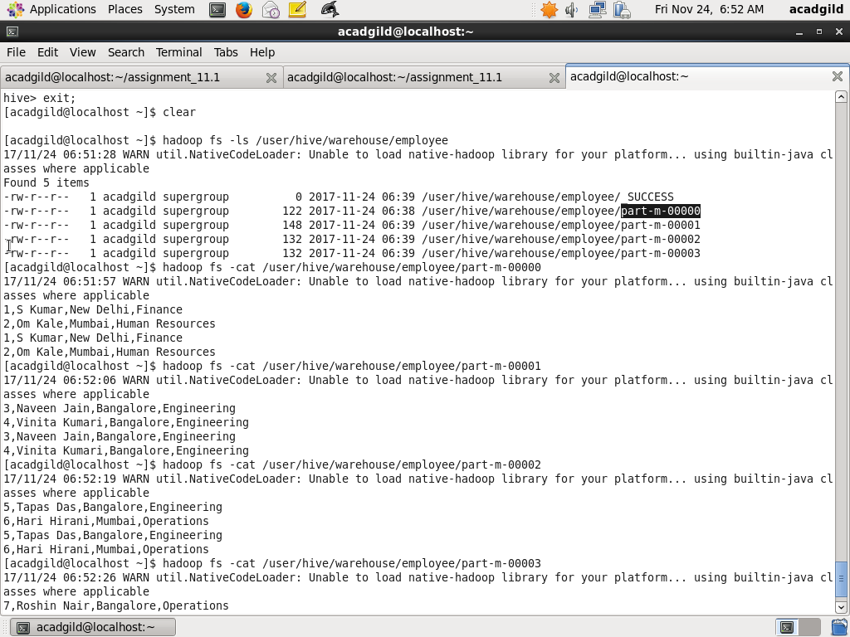

Tas4: Export records from Hive into mysql

Step1:

In Hive, table employee_details is already created and has data loaded and displayed using command

Describe employee_details;

Select * from employee_details

The screenshot is as below:

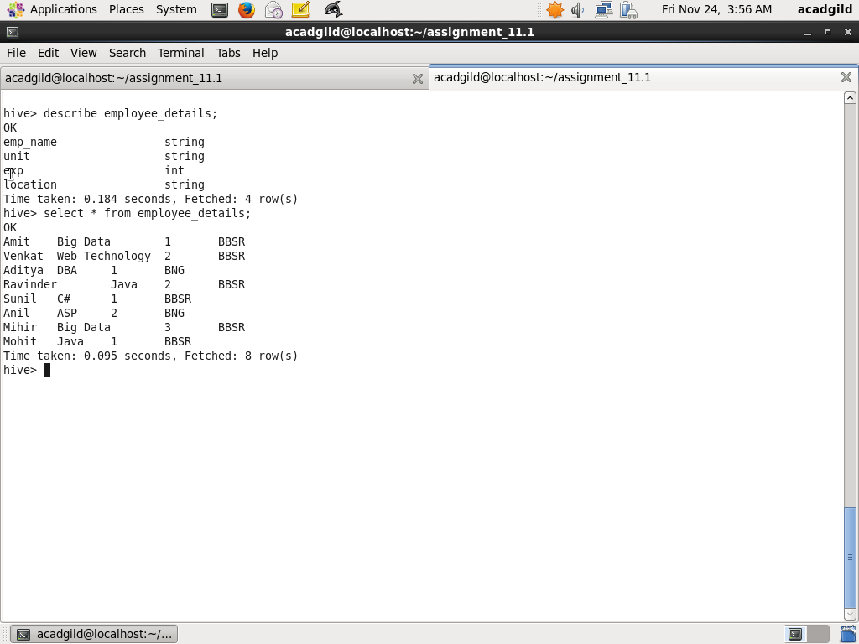

Step2: Create table in mysql

In mysql Create a database export and the create a table employee_details using commands below:

create database export;

use export;

create table employee_details

(

emp_name varchar(20),

unit varchar(20),

exp int,

location varchar(20)

);

Screenshot are given in step4 below

Step3: Export records from Hive into mysql

Using sqoop command export records from Hive into mysql using command below:

sqoop export --connect jdbc:mysql://localhost/export --username root --table employee_details --direct \

--export-dir /user/hive/warehouse/employee_details --driver com.mysql.jdbc.Driver

Screenshots are as below:

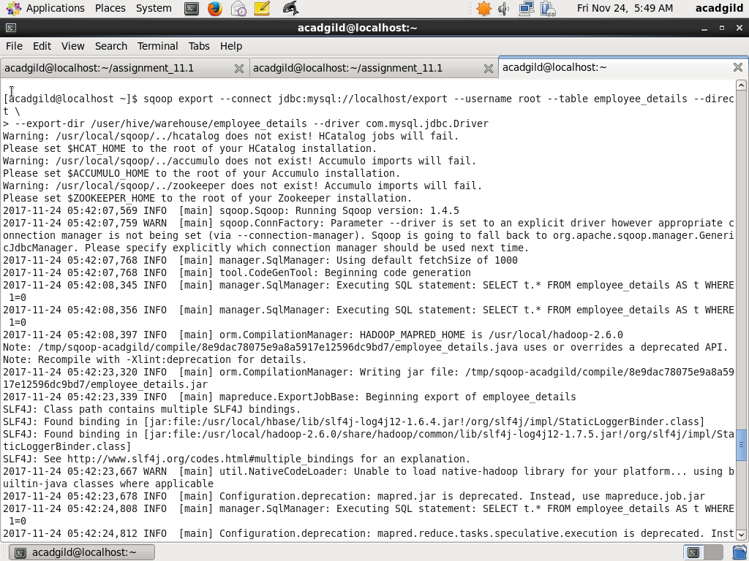

Step3: Display records in mysql

Use the commad below to display records in employee_details table in mysql database export

Use export;

Select * from employee_details;

Screesshot is as beow

