Assignment 11.2 ( Sqoop and Flume)

Read from mysql table and load into Hive table with incremental append and create table if does not exist

Step1: Create table players in mysql

In mysql create a database sports and then create a table players with commands given below:

create database sports;

use sports;

create table players (

id int,

name varchar(20),

age int,

sports_name varchar(20)

);

Screenshot is as below:

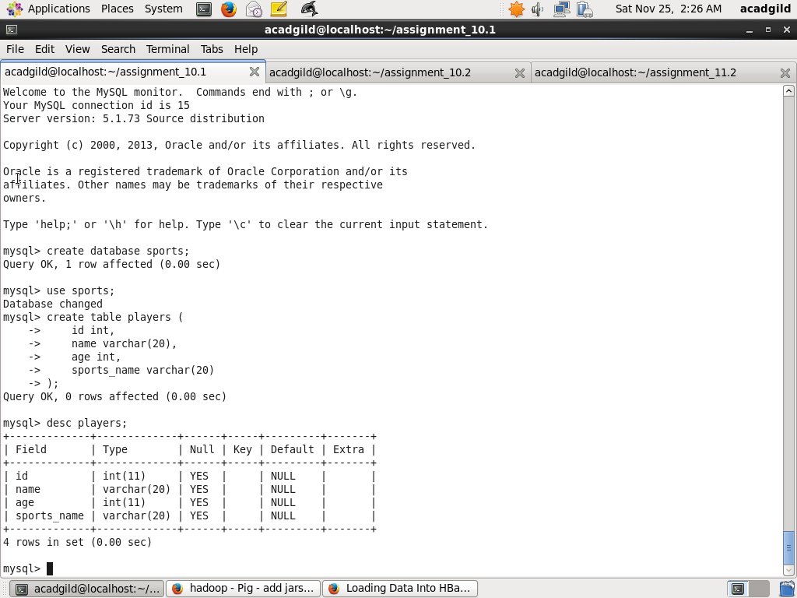

Step2: Insert Records to table players and give privilege

Insert a few records into players using insert into command below:

insert into players values (1,'Virat Kohli', 27, 'Cricket');

insert into players values (2,'MS Dhoni', 35, 'Cricket');

insert into players values (3,'Saina Nehwal', 27, 'Badminton');

insert into players values (4,'Sania Mirza', 30, 'Tennis');

insert into players values (5,'Ashish Nehra', 39, 'Cricket');

insert into players values (6,'R Aswin', 32, 'Cricket');

insert into players values (7,'KS Singh', 29, 'Hockey');

Next set privilege to database using the command below:

grant all on *.* to 'root'@'localhost' with grant option;

flush privileges;

commit;

Screenshots are as below:

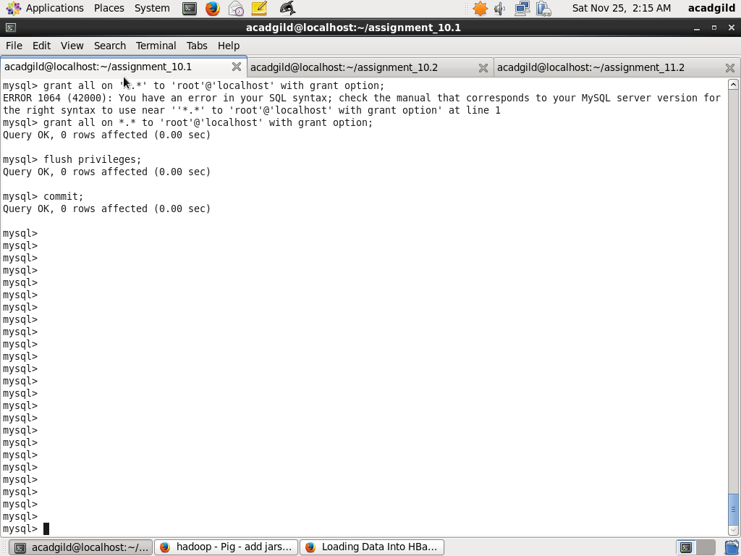

Step3 : Use sqoop to Import records from mysql to Hive

Use sqoop to import records from mysql table players in database sports inot Hive. The opion

–incremental apend is used to append new records. Option --create-hive-table

is used to create new table if it does not exits

sqoop import --connect jdbc:mysql://localhost/sports --username root --split-by id \

--columns id,name,age,sports_name --table players --target-dir /user/hive/warehouse/players \

--fields-terminated-by "," --hive-import --create-hive-table --hive-table players \

--check-column id --incremental append

Screenshot is as below:

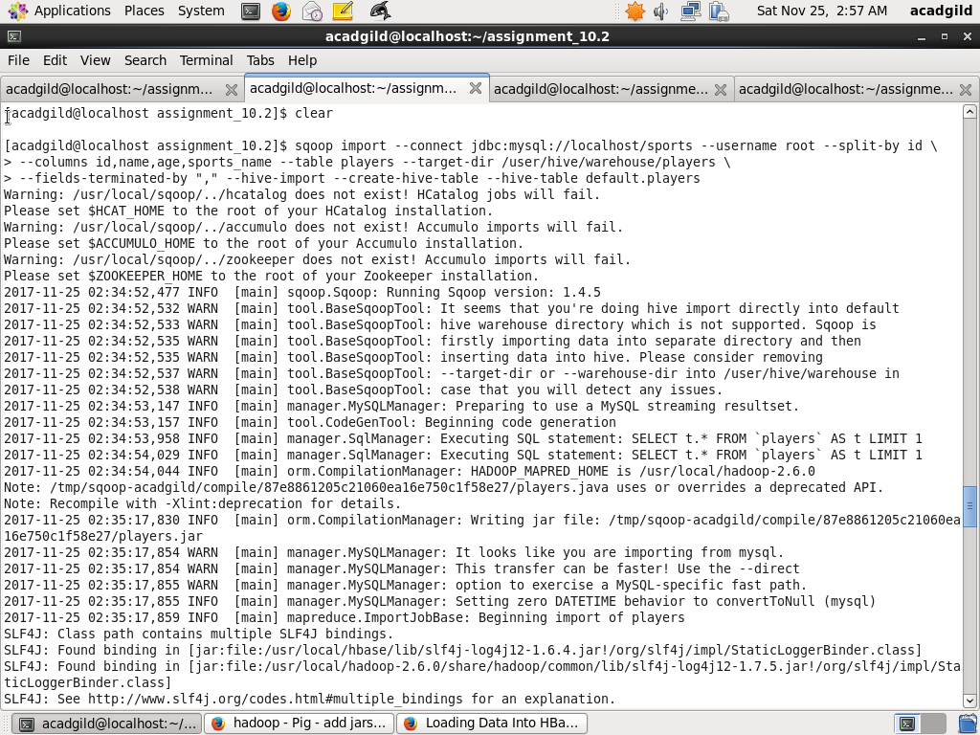

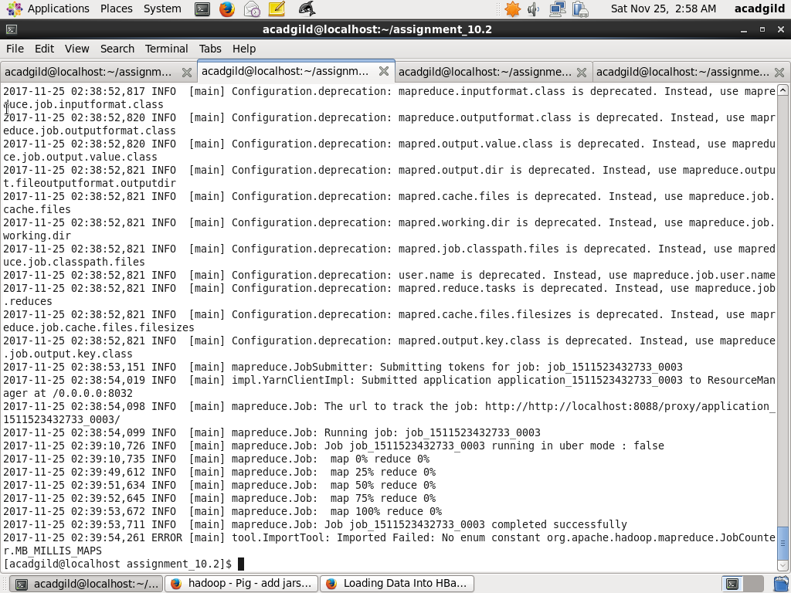

Step4 : Display the records in Hive

Display imported data in Hive using command below

Select * from players

Screenshot is as below:

