Assignment12.2

Create the List

val list = List[String} (“alpha”, “gamma”, “omega”, “zeta”, “beta”)

Task1: find count of all strings with length 4

Use count function as below

list.count(s=> s.length == 4)

Screenshot is as below:

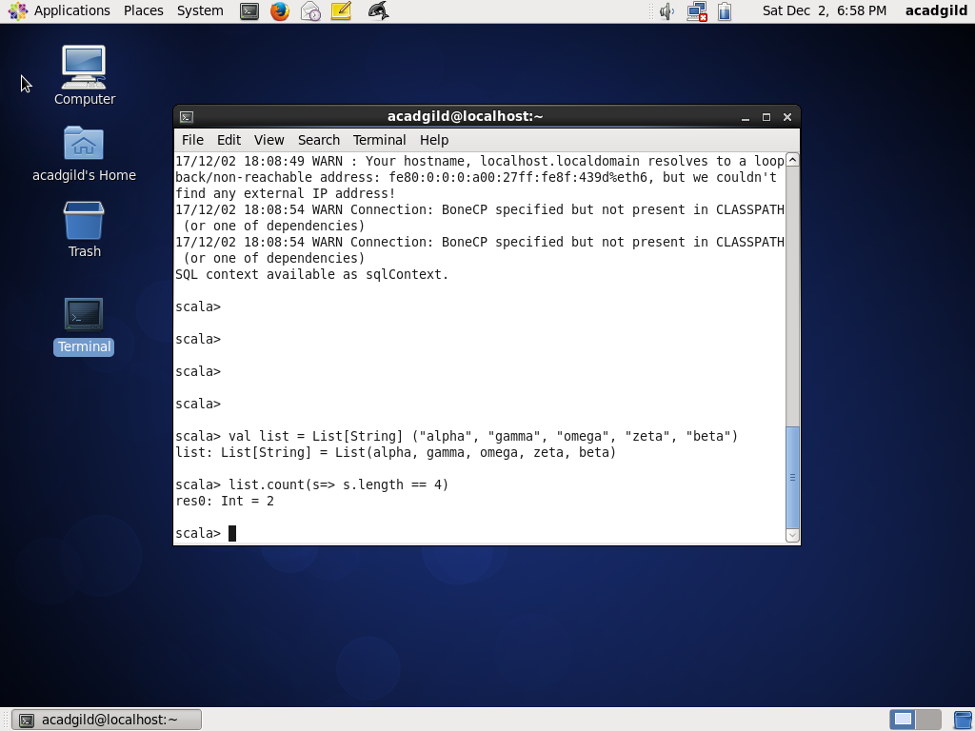

Task2: convert the list of string to a list of integers, where each string is mapped to its

corresponding length

Use map functions as below:

list.map(s=> s.length)

Screenshot is as below:

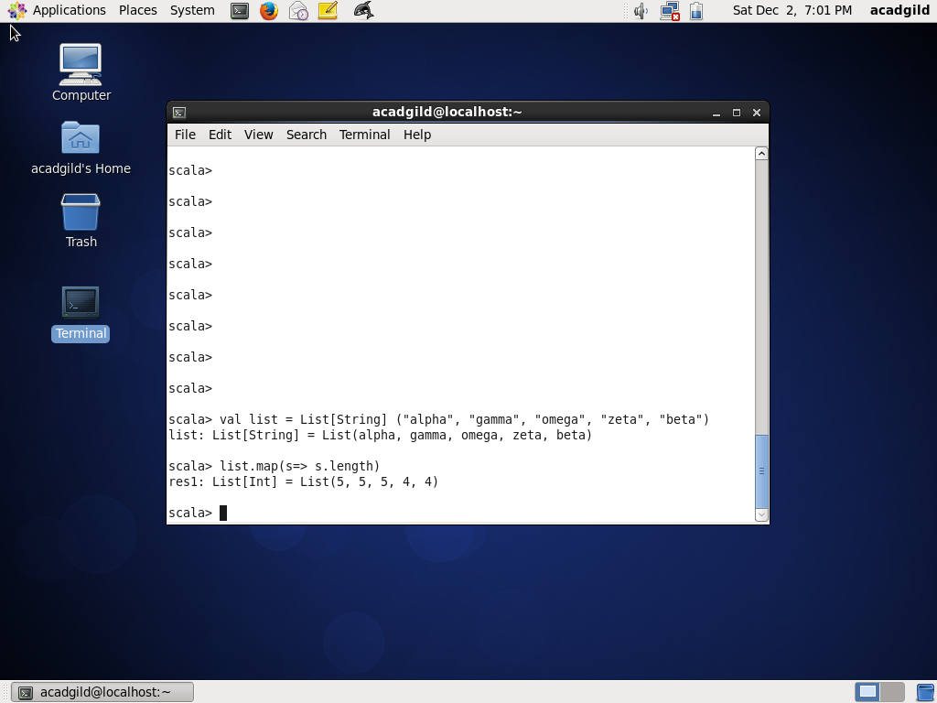

Task3: find count of all strings which contain alphabet ‘m’

Use count function as below:

list.count(s=> s.contain(‘m’))

Screenshot is as below

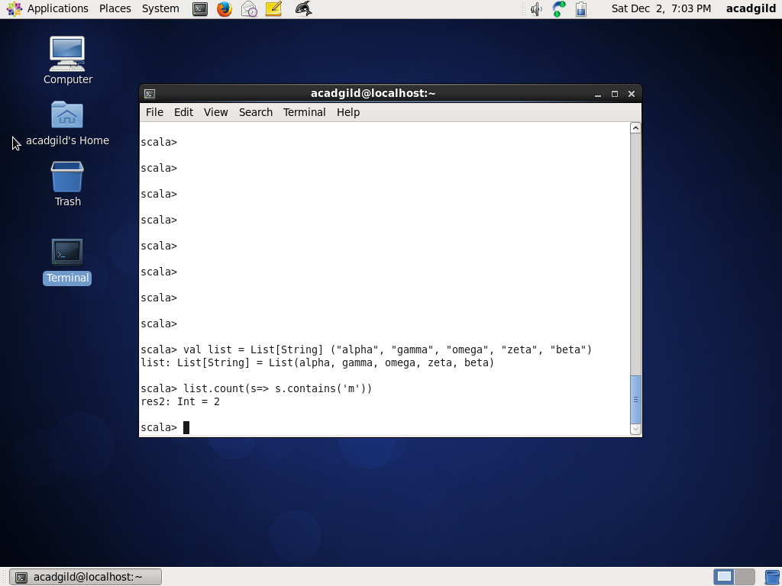

Task4: find the count of all strings which start with the alphabet ‘a’

Use count function as below:

list.count(s=> s(0) == ‘a’)

Screenshot as below:

