Assignment12.3

Task1: print the numbers where the corresponding string length is 4

Step1: Create a list_of_tuple using command below:

val list_of_tuple = List[(Int, String)] ((1,"alpha"), (2,"beta"), (3, "gamma"), (4, "zeta"), (5, "omega"))

Step2: Use foreach to iterate over the list of tuples, print the number for which string length is 4 as below

list_of_tuple.foreach(t=> if (t._2.length == 4) println(t._1))

Screenshot is as below:

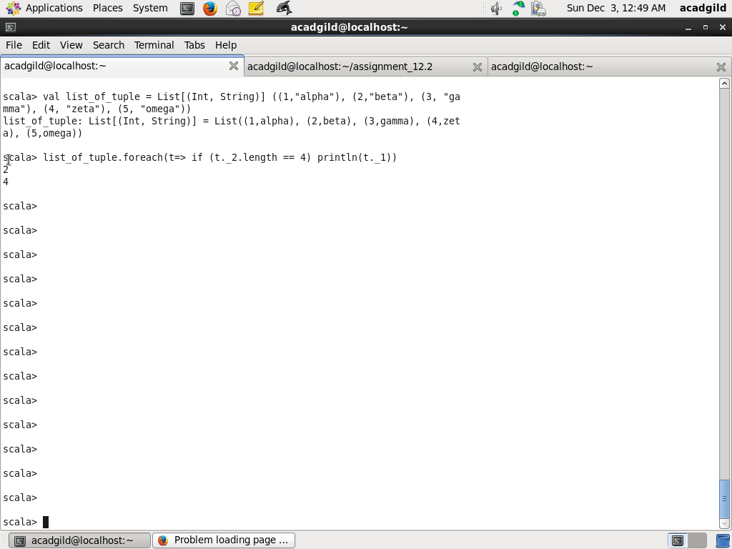

Task2:

Find the average of all numbers, where the corresponding string contains alphabet ‘m’

or alphabet ‘z’

Step1: Create a list_of_tuple using command below:

val list_of_tuple = List[(Int, String)] ((1,"alpha"), (2,"beta"), (3, "gamma"), (4, "zeta"), (5, "omega"))

Step2:

Create two variables sum and no_of_matching_elements and initialize them to 0

var sum = 0

var no_of_matching_elements = 0

Step3: Iterate over the list of tuples and sum the numbers and increment no_of_matching_elements the for which string value contains either alphabet ‘m’ or ‘z’

list_of_tuple.foreach{t=> if (t._2.contains('m') || t._2.contains('z')) {

| sum += t._1

| no_of_matching_elements += 1

| }

| }

Step4: Calculate average by dividing sum by no_of_matching_element and print the average

val average = sum.toFloat / no_of_matching_elements.toFloat

println(average)

Screenshot is as below:

