Task 1: Write a simple program to show inheritance

Step1: I defined a abtract class Shape which has one method printArea.

abstract class Shape {

def printArea()

}

Step2: Class Rectangle extends from Shape having attributes length and breadth and overrides the method printArea. Area is calculated using length\*breadth

class Rectangle(val param1:Float, val param2:Float) extends Shape {

val length:Float = param1

val breadth:Float = param2

override def printArea() = println("Area of Rectangle =" + (length \* breadth))

}

Step3: Class Triangle extends from Shape having attributes base and height and overrides the method printArea. area is calculated by 0.5\* base\*height

class Triangle(val param1:Float, val param2:Float) extends Shape {

val base:Float = param1

val height:Float = param2

override def printArea() = println("Area of Triangle =" + (0.5 \* base \* height))

}

Class Circle extends from Shape having attributes radius and overrides method printArea. area is calculated by 3.14\*radius\* radius

class Circle(val param:Float) extends Shape {

val radius:Float = param

override def printArea() = println("Area of Circle =" + (3.14 \* radius \* radius))

}

Next, I called created oblect Rectangle, Triangle and Circle and call its printArea method

var p: Shape = new Rectangle(4, 3)

p.printArea

p= new Triangle(4,3)

p.printArea

p= new Circle(4)

p.printArea

Screenshot is as below:

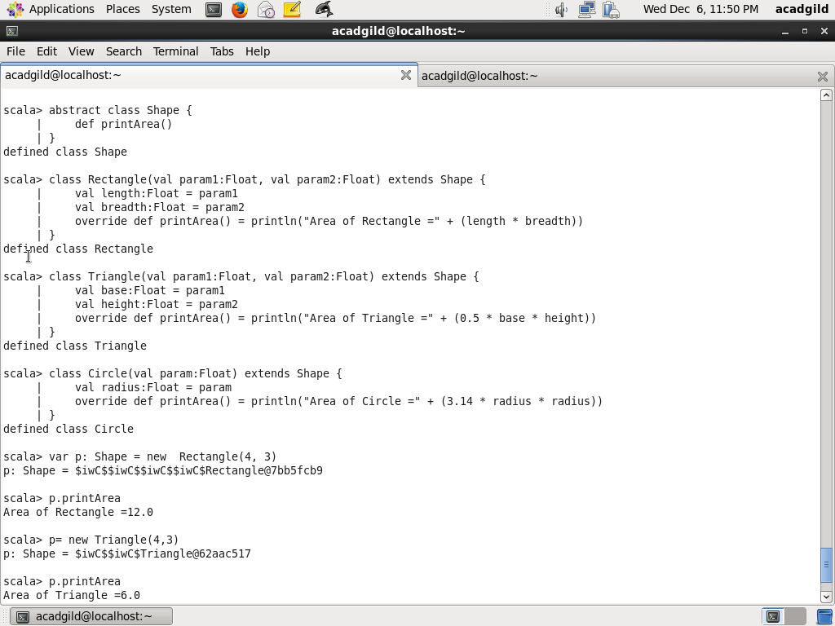

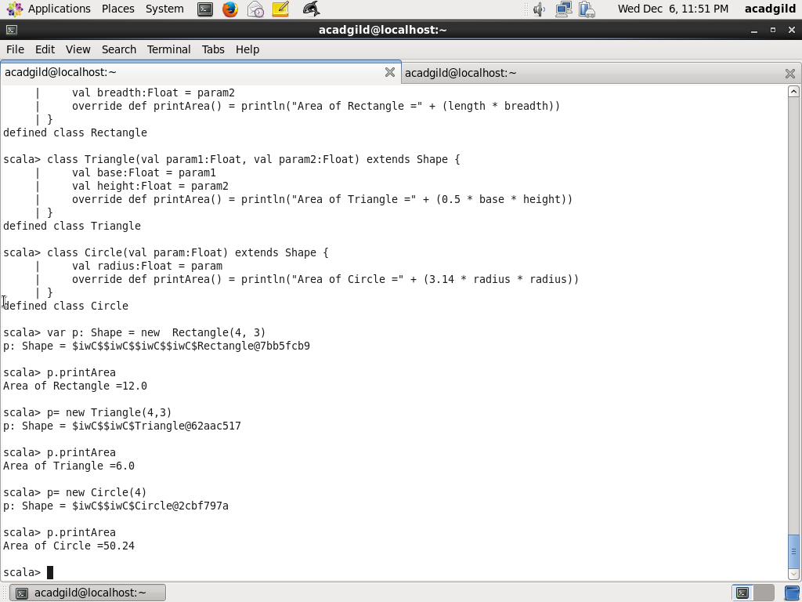

Task2: Write a simple program to show multiple inheritance

Multiple inheritance can be achieved using trait.

Step1: I defined BaseTrait which has a method print.

trait BaseTrait {

def print() { println("Trait: BaseTrait") }

}

Step2:

Traits A and B extends from BaseTrait and override method print:

trait A extends BaseTrait {

override def print() { println("Trait: A") }

}

trait B extends BaseTrait{

override def print() { println("Trait: B") }

}

Step3: Defined a class BaseClass which has method print

class BaseClass {

def print() { println("Class: BaseClass") }

}

Step4: Defined a class C which extends from class BaseClass and also exends traits A and B and overrides method print:

class C extends BaseClass with A with B {

override def print() { println("Class: C") }

}

Step5; Create a object of C and call print method

(new C).print()

Screenshot is as below:

