Assignment 16.1 (Introduction to Spark)

Task1: Find sum of numbers in the list

Define a variable sum initialized to 0. Iterate over the list using foreach and sum them

The scala code is as below:

val list = List[Int] (1, 2, 3, 4, 5, 6, 7, 8, 9, 10)

var sum:Int = 0

list.foreach(elem => sum += elem)

println(sum)

Screenshot is:

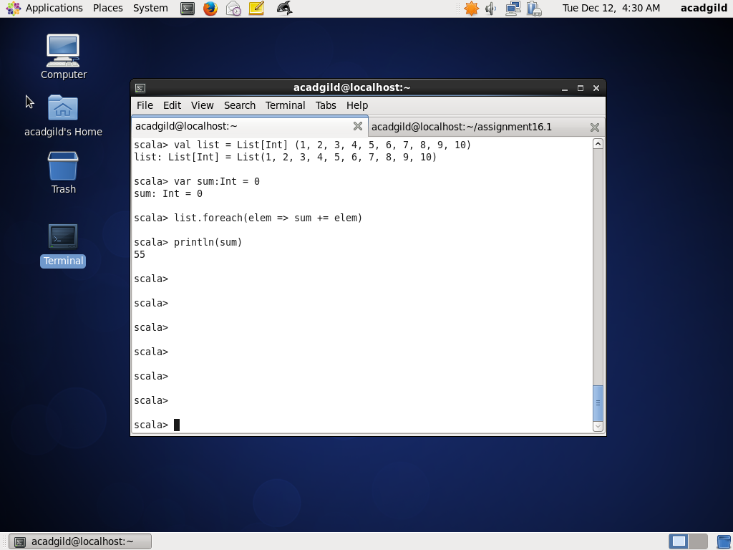

Task2: Find number of element in the list

Define a variable total_elements and initialize to list.length

The scala code is as below:

val total_elements = list.length

println(total_elements)

Screenshot is as below:

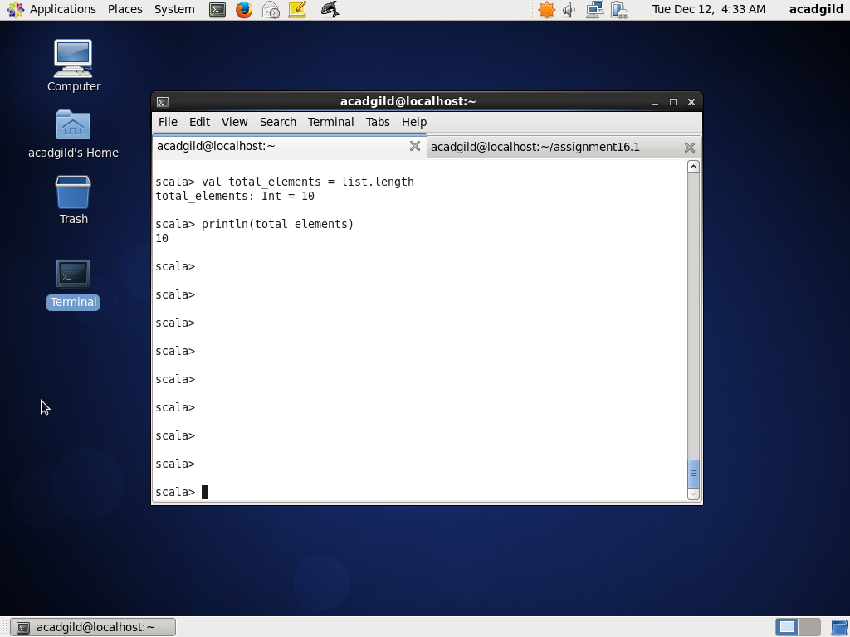

Task3: Find average of all the numbers

Use sum calculated from task1 and total_elements from task2. Convert sum to Float and total_elements to Float and divide and then initialize to average and print

Code is as below:

val average = sum.toFloat / total_elements.toFloat

println(average)

Screenshot is as below:

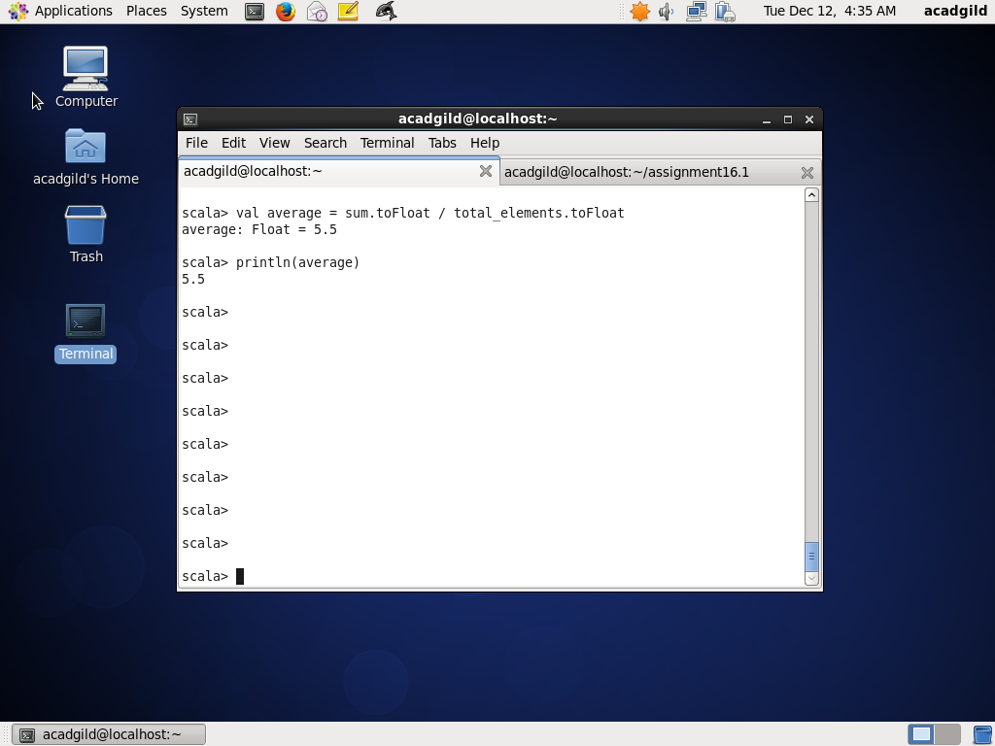

Task4: Find sum of event numbers in the list

Intialize a variable sum_even to 0. Then iterate over the list using foreach and element which is even (modulo 2 is 0) add to sum_even. Print sum_even

Scala code is as below:

var sum_even = 0

list.foreach(element => if (element % 2 == 0) sum_even += element)

println(sum_even)

Screenshot is as below:

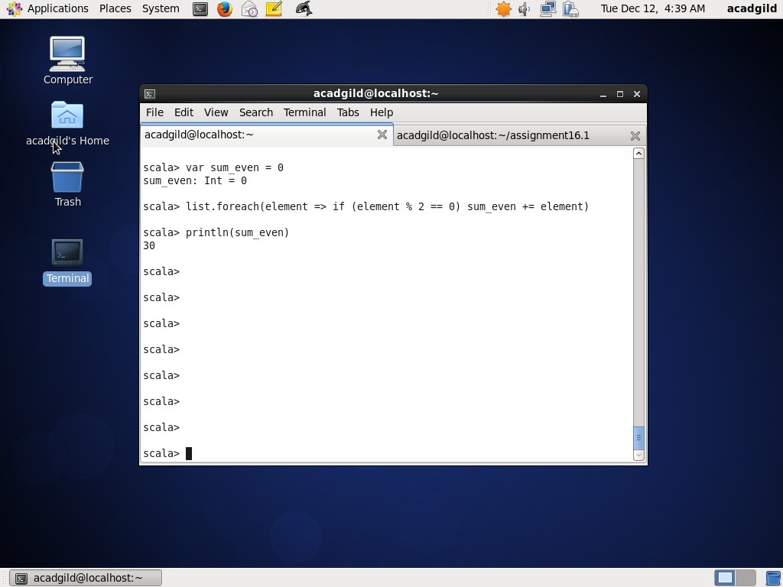

Task5: Find count of numbers divisible by both 3 and 5

Initialize a variable count_elements_divisible_by_3_5 to 0. Then iterate over the list using foreach and if a element which is divisible by both 3 and 5 (modulo 3 is 0 and modulo 5 is ) , increment count_elements_divisible_by_3_5 by 1

Scala code is as below:

var count_elements_divisible_by_3_5 = 0

list.foreach(element => if (element % 3 == 0 && element % 5 == 0) count_elements_divisible_by_3_5 += 1)

println(count_elements_divisible_by_3_5)

Screenshot is as below:

