Task1: Write a program to read a text file and count number of rows

Step1:

First copy the wordcount_input_file. Contents of file is displayed below

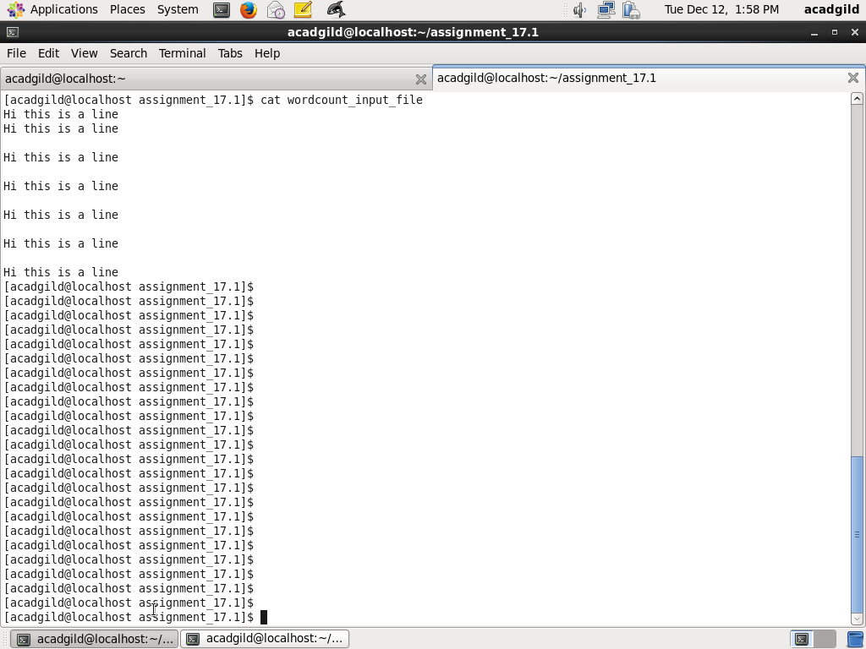

Step2:

Create a RDD using the text file. Count number of lines in rdd and put to line_count. Print line_count.

The code is as below:

val rdd = sc.textFile("/home/acadgild/assignment_17.1/wordcount_input_file")

val line_count = rdd.count

println(line_count)

Screenshot is as below:

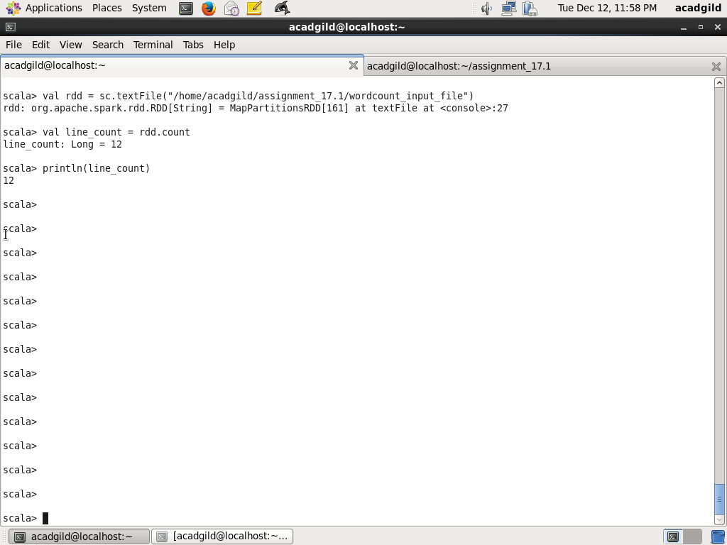

Task2 : Write a program to read a text file and count number of words

Create a rdd from the input file wordcount_input_file. Create a rdd_words by splitting line based on blank space and using flatMap on rdd. Count the number of words using count method and assign to word_count. Print word_count

Code is as below:

val rdd = sc.textFile("/home/acadgild/assignment_17.1/wordcount_input_file")

val rdd_words = rdd.flatMap(line=> line.split(" "))

rdd_words.collect()

val word_count = rdd_words.count

println(word_count)

Screenshot is as below:

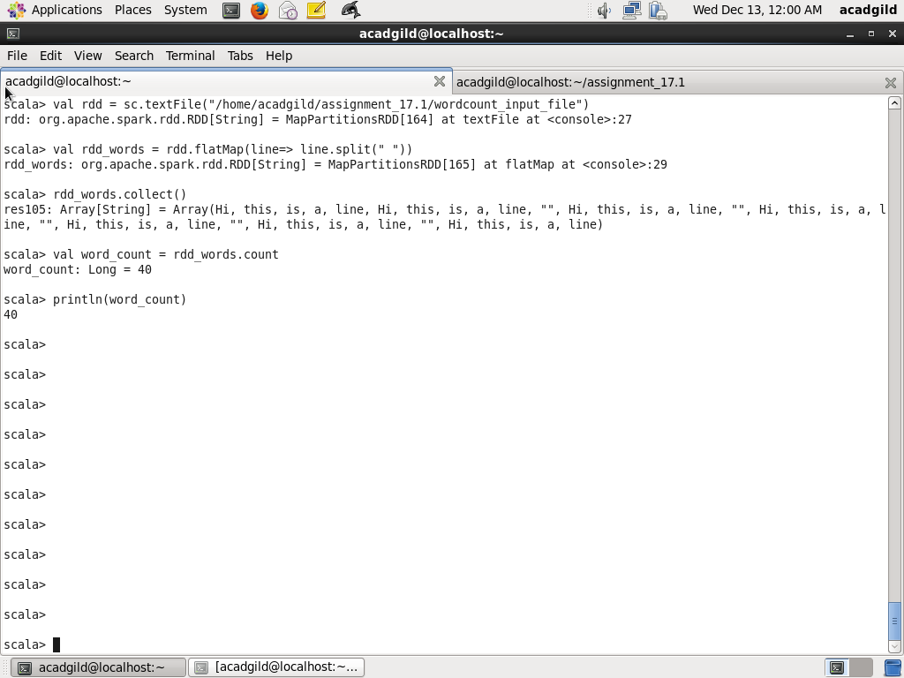

Task3: Write a program to read a text and count number of words when separator is hyphen (-)

Step1:

Copy the file wordcount_hyphen_separated to /home/acadgild/assignment_17.1

Contents are as below:

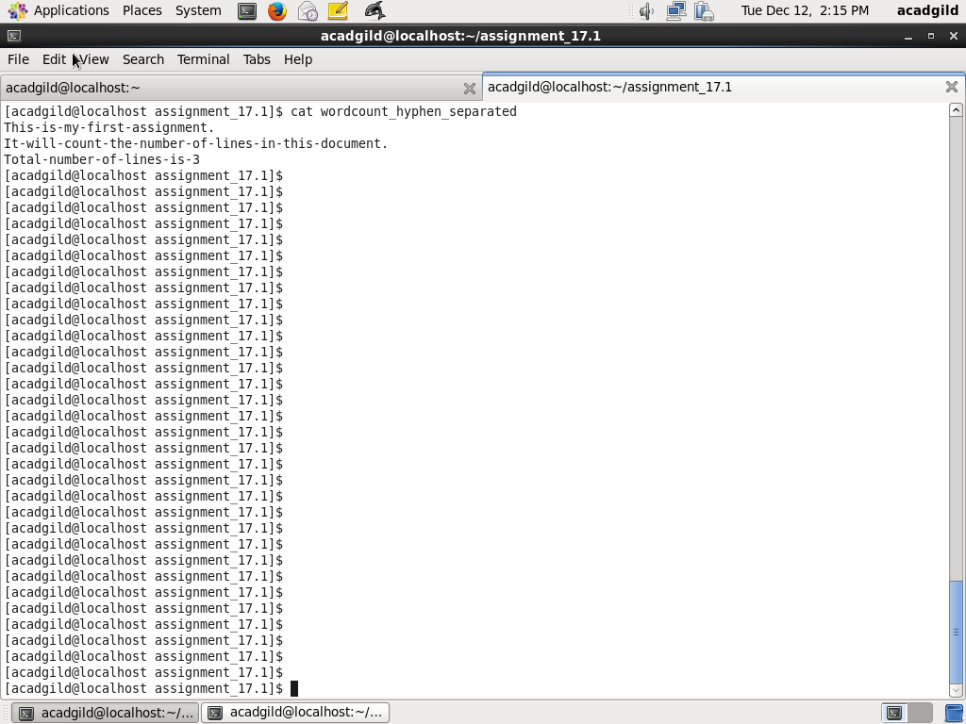

Step2:

Create a RDD rdd_hyphen from the wordcount_hyphen_separated file. Split each line based on separator hyphen (-) and use flatMap to combine the results. Use count method to get the count of works and assign to word_hyphen_separator_count and print word_hyphen_separator_count

Code is as below:

val rdd_hyphen = sc.textFile("/home/acadgild/assignment_17.1/wordcount_hyphen_separated")

val rdd_hyphen_words = rdd_hyphen.flatMap(line=> line.split("-"))

rdd_hyphen_words.collect

val word_hyphen_separator_count = rdd_hyphen_words.count

println(word_hyphen_separator_count)

Screenshot is as below:

