Assignment 18.1

Initial Steps:

Step1: Create a temporary table User

Read dataset from /home/acadgild/assignment_18.1/S18_Dataset_User_details.txt and create RDD user_rdd. Create case class User with field user_id, name. Create dataframe user_df by mapping records splitting fields by and populating the User class object. Next create temporary table User

Code is as below:

import org.apache.spark.sql.types.{StructType, StringType, IntegerType, StructField}

val user_rdd = sc.textFile("/home/acadgild/assignment_18.1/S18_Dataset_User_details.txt")

case class User(user_id:Int, name:String, age:Int)

val user_df = user_rdd.map(_.split(",")).map(x=> User(x(0).toInt, x(1).toString, x(2).toInt)).toDF

user_df.registerTempTable("User")

sqlContext.sql("SELECT * From User").show()

Screenshot is as below:

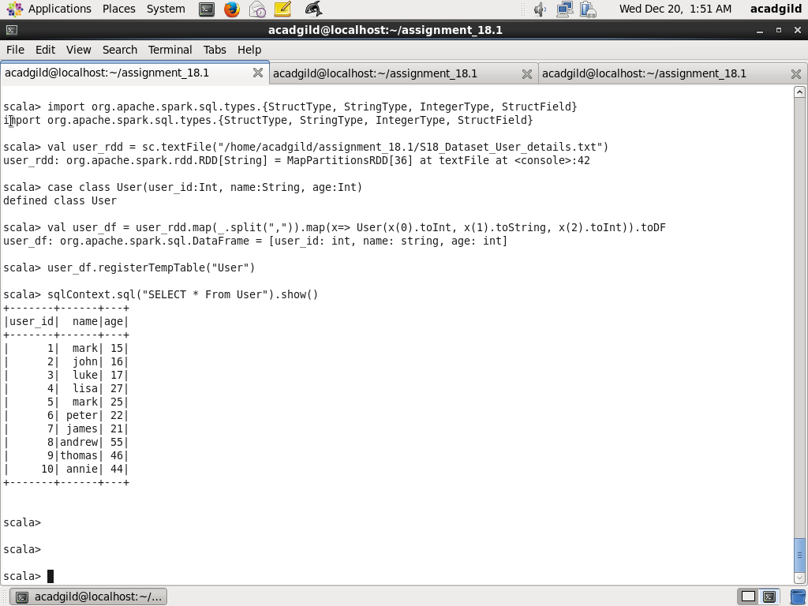

Step2: Create a temporary table Travel

Read dataset from /home/acadgild/assignment_18.1/S18_Dataset_ Holidays.txt and create RDD user_rdd. Create case class Travel with field user_id, src, dest, travel_mode distance, year_of_travel Create dataframe travel_df by mapping records splitting fields by , and populating the Travel class object. Next create temporary table Travel

Code is as below:

val travel_rdd = sc.textFile("/home/acadgild/assignment_18.1/S18_Dataset_Holidays.txt")

case class Travel(user_id:Int, src:String, dest:String, travel_mode:String, distance:Float, year_of_travel:Int)

val travel_df = travel_rdd.map(_.split(",")).map(x=> Travel(x(0).toInt, x(1).toString, x(2).toString, x(3).toString, x(4).toFloat, x(5).toInt)).toDF

travel_df.registerTempTable("Travel")

sqlContext.sql("SELECT * From Travel").show()

Screenshot is as below:

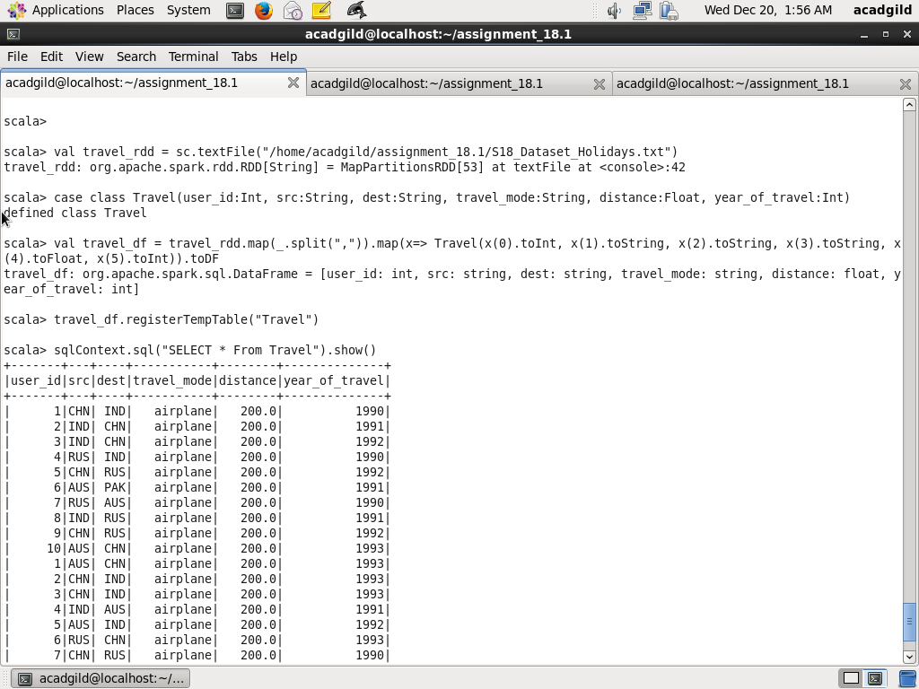

Step3:

Read dataset from /home/acadgild/assignment_18.1/S18_Dataset_ Transport.txt and create RDD transport_rdd. Create case class Transport with fields travel_mode,cost_per_unit Create dataframe transport_df by mapping records splitting fields by , and populating the Transport class object. Next create temporary table Transport

val transport_rdd = sc.textFile("/home/acadgild/assignment_18.1/S18_Dataset_Transport.txt")

case class Transport(travel_mode:String, cost_per_unit:Float)

val transport_df = transport_rdd.map(_.split(",")).map(x=> Transport(x(0).toString, x(1).toFloat)).toDF

transport_df.registerTempTable("Transport")

sqlContext.sql("SELECT * From Transport").show()

Screenshot is as below:

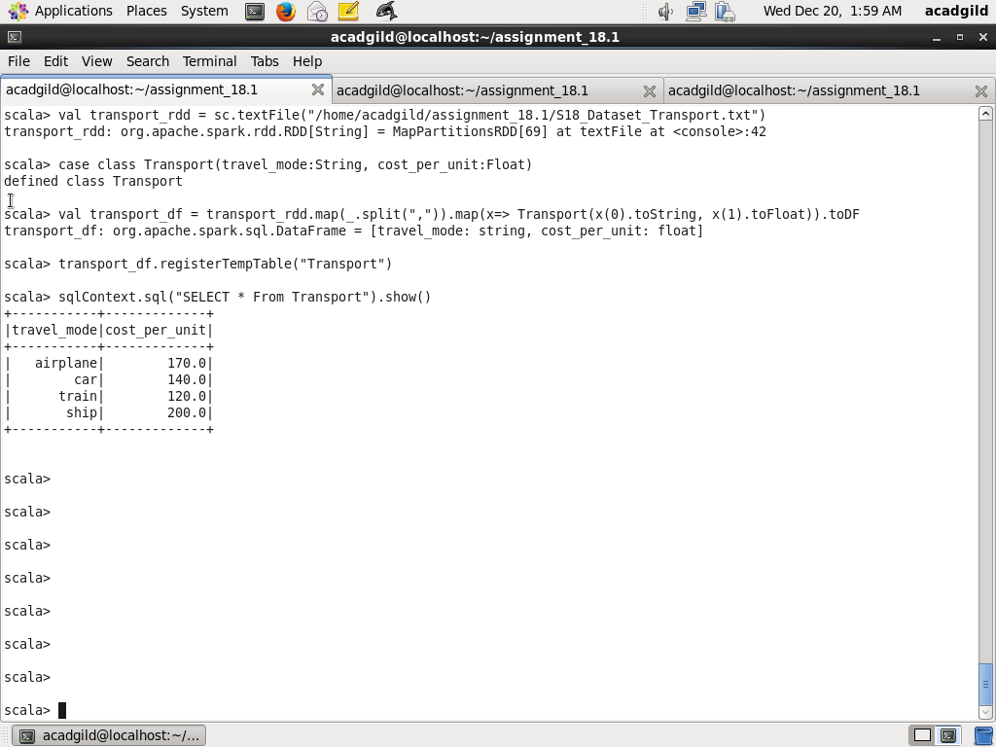

Task1: Distribution of total number of air travelers

Here using count(*) number of travels grouped by year calculated

Code is as below:

sqlContext.sql("SELECT year_of_travel, COUNT(*) as distribution FROM Travel WHERE travel_mode='airplane' GROUP BY year_of_travel").show()

Screenshot is as below:

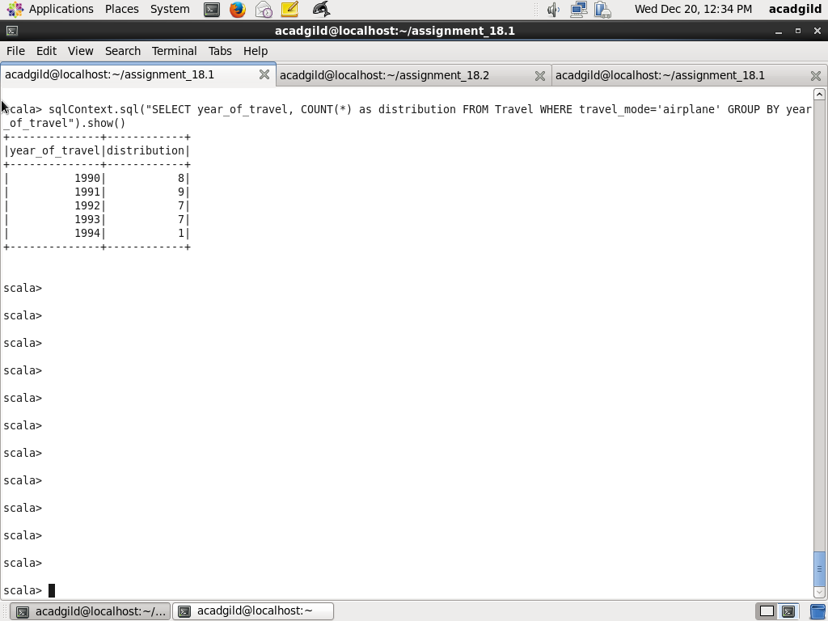

Task2: Total air distance covered by each user per year

Here all the distance are summed using SUM function group by user_id by joining the temporary tables Travel and User on user_id column

Code is as below:

sqlContext.sql("SELECT us.user_id, us.name, trav.year_of_travel, SUM(distance) AS total_air_distace FROM Travel trav JOIN User us on trav.user_id=us.user_id WHERE travel_mode='airplane' GROUP BY us.user_id,us.name,trav.year_of_travel ORDER BY us.user_id, us.name, trav.year_of_travel").show()

(NOTE: I have used both user_id and user_name as there are two different users who have same name but different id. For example, user_id 1 and 5 both have name as Mark)

Screenshot is as below:

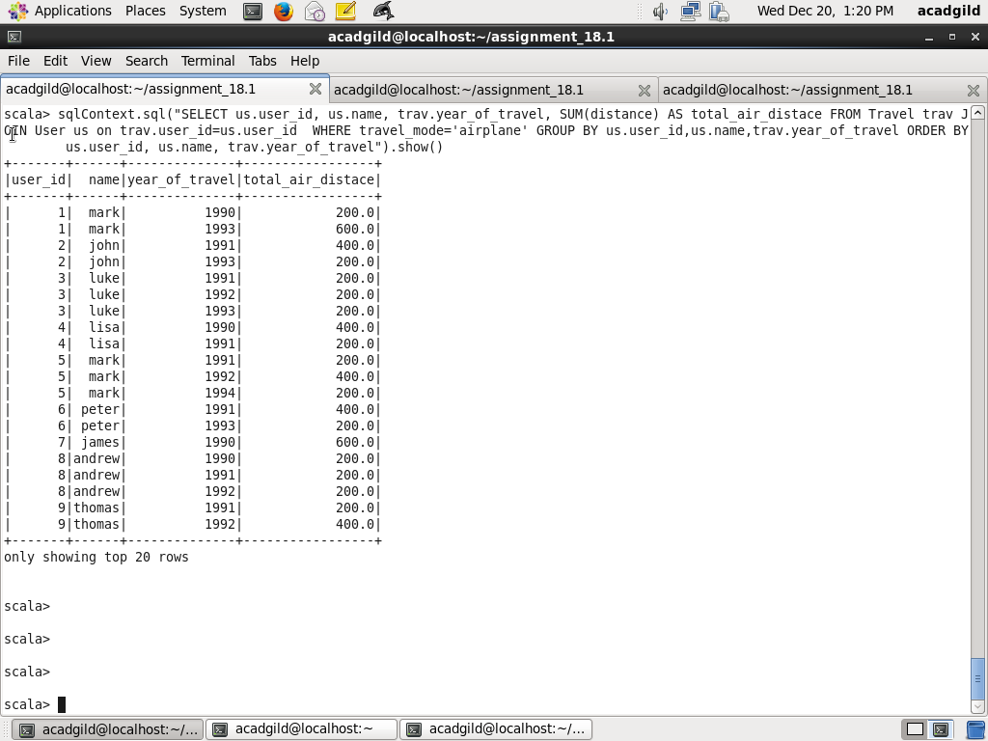

Task3: Which user has travelled largest distance till date

Here all the distance are summed using SUM function group by name, user_id by joining tables Travel, User column user_id then sorted in descending order by total_air_distance and first record is taken using LIMIT 1

Code is as below:

sqlContext.sql("SELECT us.user_id, us.name, SUM(trav.distance) AS total_distance FROM Travel trav JOIN User us ON trav.user_id= us.user_id GROUP BY us.user_id,us.name ORDER BY total_distance DESC LIMIT 1").show()

Screenshot is as below:

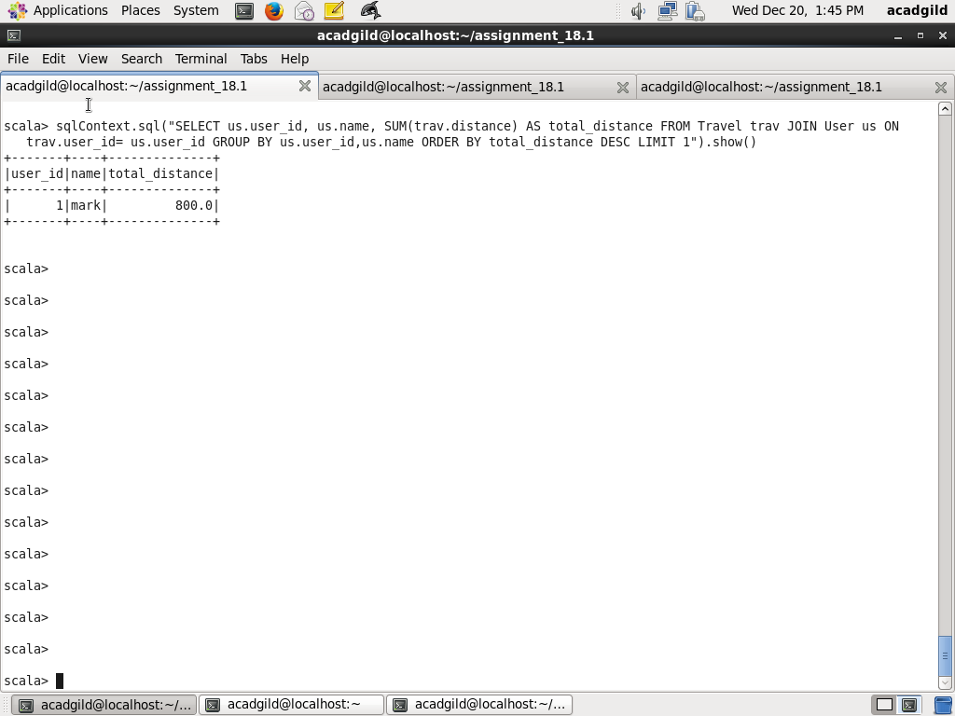

Task4: What is the most preferred destination of all users

Here using count(*) number of travels as distributed grouped by dest calculated and sorted by distribution and first record is taken

Code is as below:

sqlContext.sql("SELECT dest, COUNT(*) AS distribution FROM Travel GROUP BY dest ORDER BY distribution DESC LIMIT 1").show()

Screenshot is as below:

