Assignment 18.2

Initial Steps:

Step1: Create a temporary table User

Read dataset from /home/acadgild/assignment_18.1/S18_Dataset_User_details.txt and create RDD user_rdd. Create case class User with field user_id, name. Create dataframe user_df by mapping records splitting fields by and populating the User class object. Next create temporary table User

Code is as below:

import org.apache.spark.sql.types.{StructType, StringType, IntegerType, StructField}

val user_rdd = sc.textFile("/home/acadgild/assignment_18.1/S18_Dataset_User_details.txt")

case class User(user_id:Int, name:String, age:Int)

val user_df = user_rdd.map(_.split(",")).map(x=> User(x(0).toInt, x(1).toString, x(2).toInt)).toDF

user_df.registerTempTable("User")

sqlContext.sql("SELECT * From User").show()

Screenshot is as below:

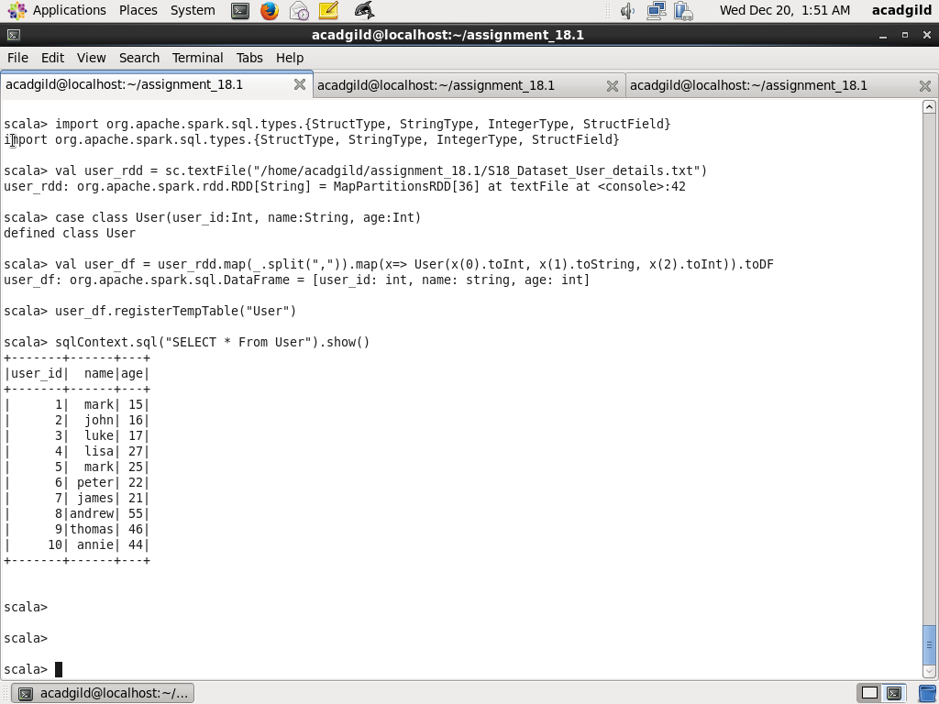

Step2: Create a temporary table Travel

Read dataset from /home/acadgild/assignment_18.1/S18_Dataset_ Holidays.txt and create RDD user_rdd. Create case class Travel with field user_id, src, dest, travel_mode distance, year_of_travel Create dataframe travel_df by mapping records splitting fields by , and populating the Travel class object. Next create temporary table Travel

Code is as below:

val travel_rdd = sc.textFile("/home/acadgild/assignment_18.1/S18_Dataset_Holidays.txt")

case class Travel(user_id:Int, src:String, dest:String, travel_mode:String, distance:Float, year_of_travel:Int)

val travel_df = travel_rdd.map(_.split(",")).map(x=> Travel(x(0).toInt, x(1).toString, x(2).toString, x(3).toString, x(4).toFloat, x(5).toInt)).toDF

travel_df.registerTempTable("Travel")

sqlContext.sql("SELECT * From Travel").show()

Screenshot is as below:

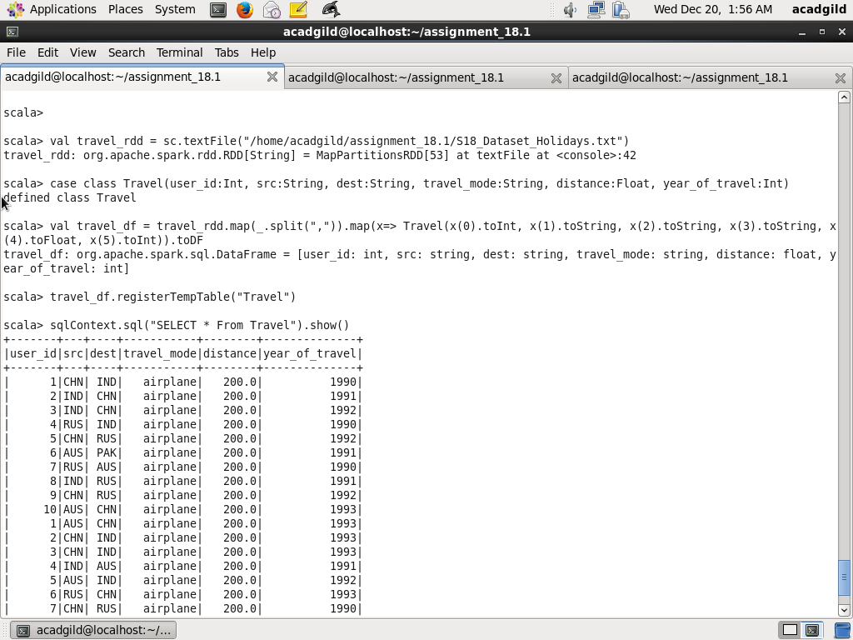

Step3:

Read dataset from /home/acadgild/assignment_18.1/S18_Dataset_ Transport.txt and create RDD transport_rdd. Create case class Transport with fields travel_mode,cost_per_unit Create dataframe transport_df by mapping records splitting fields by , and populating the Transport class object. Next create temporary table Transport

val transport_rdd = sc.textFile("/home/acadgild/assignment_18.1/S18_Dataset_Transport.txt")

case class Transport(travel_mode:String, cost_per_unit:Float)

val transport_df = transport_rdd.map(_.split(",")).map(x=> Transport(x(0).toString, x(1).toFloat)).toDF

transport_df.registerTempTable("Transport")

sqlContext.sql("SELECT * From Transport").show()

Screenshot is as below:

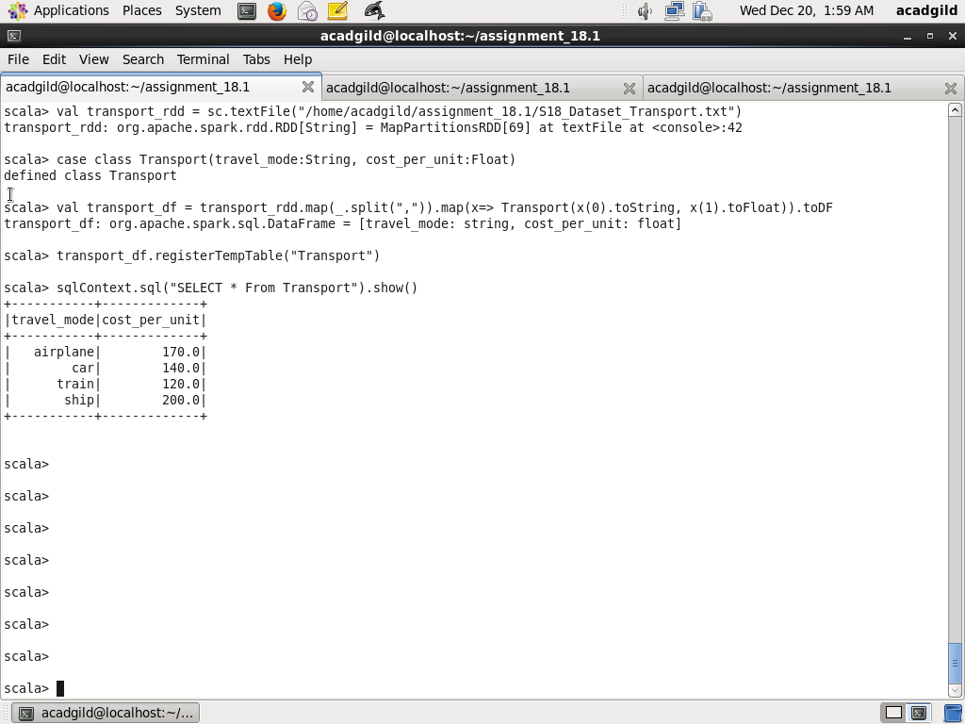

Task1: Which route is generating the most revenue per year

Note: This is a complex query as view was not working in this installation of acadgild VM. I first find the revenue by route per year and create a alias revenue_by_route_per_year. Next I find the maximum revenue per year and create alias max_revenue_per_year. Next I join both the table aliases revenue_by_route_per_year and max_revenue_per_year on year_of_travel and total_revenue and order them by year

Code is as below:

sqlContext.sql("SELECT revenue_by_route_per_year.year_of_travel, revenue_by_route_per_year.src, revenue_by_route_per_year.dest, revenue_by_route_per_year.total_revenue FROM (SELECT trav.year_of_travel, trav.src, trav.dest, sum(trans.cost_per_unit) AS total_revenue FROM Travel trav JOIN Transport trans ON trav.travel_mode= trans.travel_mode GROUP BY trav.year_of_travel, trav.src, trav.dest) revenue_by_route_per_year, (SELECT year_of_travel, max(total_revenue) AS total_revenue FROM (SELECT trav.year_of_travel, trav.src, trav.dest, sum(trans.cost_per_unit) AS total_revenue FROM Travel trav JOIN Transport trans ON trav.travel_mode= trans.travel_mode GROUP BY trav.year_of_travel, trav.src, trav.dest) travel_revenue_per_year2 GROUP BY year_of_travel) max_revenue_per_year WHERE revenue_by_route_per_year.year_of_travel = max_revenue_per_year.year_of_travel AND revenue_by_route_per_year.total_revenue=max_revenue_per_year.total_revenue ORDER BY revenue_by_route_per_year.year_of_travel").show()Screenshot is as below:

Screenshot is as below:

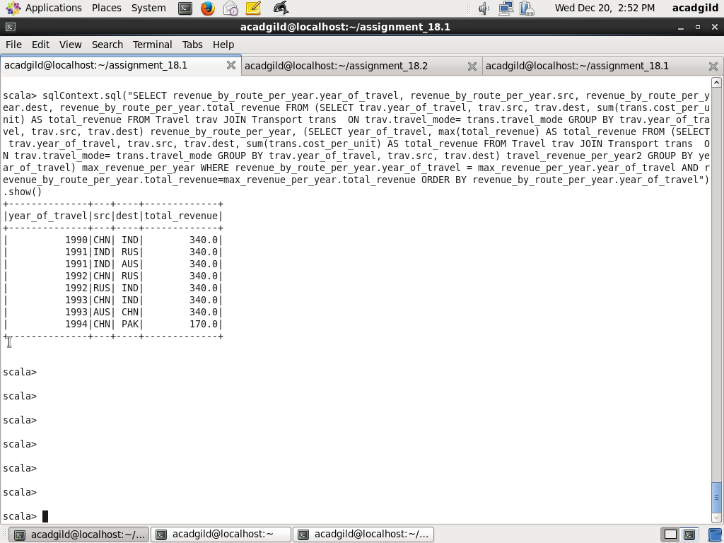

Task2: What is the total amount spent by each user on air travel per year

Here I have joined temporary tables Travel, User, Transport using the common fields (travel_mode between Travel and Transport, user_id between Travel and User) and using sum function on cost_per_unit group by user_id, name, with travel_mode as airplane

Code is as below:

sqlContext.sql("SELECT us.user_id, us.name, trav.year_of_travel, sum(trans.cost_per_unit) AS total_amount_spent FROM Travel trav JOIN Transport trans ON trav.travel_mode= trans.travel_mode JOIN user us ON trav.user_id=us.user_id WHERE trav.travel_mode= 'airplane' GROUP BY us.user_id, us.name, trav.year_of_travel ORDER BY us.user_id").show()

(NOTE: I have used both user_id and user_name as there are two different users who have same name but different id. For example, user_id 1 and 5 both have name as Mark)

Screenshot is as below:

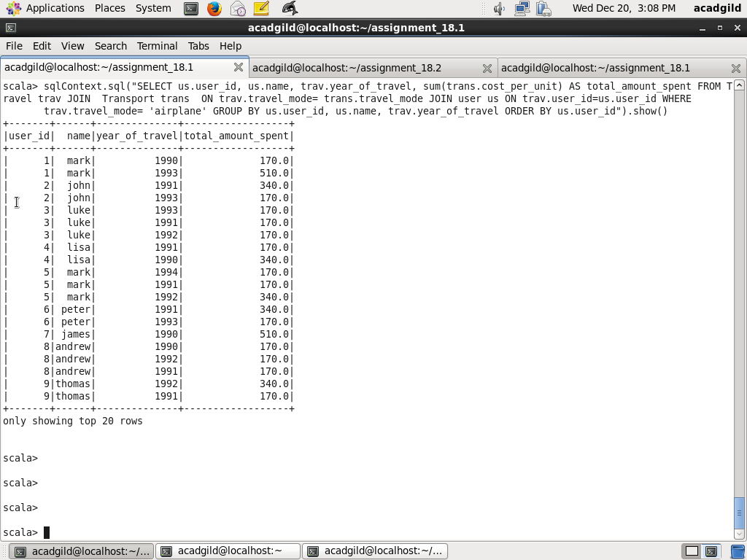

Task3: Considering age group < 20, 20-35 , > 35. Which age group has travelled most every yeat

Using CASE WHEN first filter the age groups (<20, 20-35, > 35) joining tables User and Travel on common field user_id. Next find count number of travels per year per age group and create a table alias just_travel_count. Also found the maximum count of number of travels per year and create table alias max_travel_count. Next join these two aliases on field on travel_count and year_of_travel

(Note: As view is not working in this setup, I have to use complex query to solve this problem)

Code is as below:

sqlContext.sql("SELECT DISTINCT just_travel_count.year_of_travel, just_travel_count.age_group FROM (SELECT age_group_count.year_of_travel,age_group_count.age_group, COUNT(*) AS travel_count FROM (SELECT trav.year_of_travel,CASE WHEN us.age < 20 THEN '< 20' WHEN age >= 20 AND age <= 35 THEN '20-35' WHEN age >35 THEN '> 35' END AS age_group FROM Travel trav JOIN User us ON trav.user_id=us.user_id) age_group_count GROUP BY age_group_count.year_of_travel, age_group_count.age_group) just_travel_count, (SELECT year_agegroup_travel_count.year_of_travel, max(year_agegroup_travel_count.travel_count) AS travel_count FROM (SELECT age_group_count.year_of_travel AS year_of_travel,age_group_count.age_group, COUNT(*) travel_count FROM (SELECT trav.year_of_travel,CASE WHEN us.age < 20 THEN '< 20' WHEN age >= 20 AND age <= 35 THEN '20-35' WHEN age >35 THEN '> 35' END AS age_group FROM Travel trav JOIN User us ON trav.user_id=us.user_id) age_group_count GROUP BY age_group_count.year_of_travel, age_group_count.age_group) year_agegroup_travel_count GROUP BY year_agegroup_travel_count.year_of_travel) max_travel_count WHERE just_travel_count.year_of_travel = max_travel_count.year_of_travel AND just_travel_count.travel_count = max_travel_count.travel_count ORDER BY just_travel_count.year_of_travel").show()

Screenshot is as below:

