Assignment 18.3

Initial Steps:

Step1: Create a temporary table User

Read dataset from /home/acadgild/assignment_18.1/S18_Dataset_User_details.txt and create RDD user_rdd. Create case class User with field user_id, name. Create dataframe user_df by mapping records splitting fields by and populating the User class object. Next create temporary table User

Code is as below:

import org.apache.spark.sql.types.{StructType, StringType, IntegerType, StructField}

val user_rdd = sc.textFile("/home/acadgild/assignment_18.1/S18_Dataset_User_details.txt")

case class User(user_id:Int, name:String, age:Int)

val user_df = user_rdd.map(_.split(",")).map(x=> User(x(0).toInt, x(1).toString, x(2).toInt)).toDF

user_df.registerTempTable("User")

sqlContext.sql("SELECT * From User").show()

Screenshot is as below:

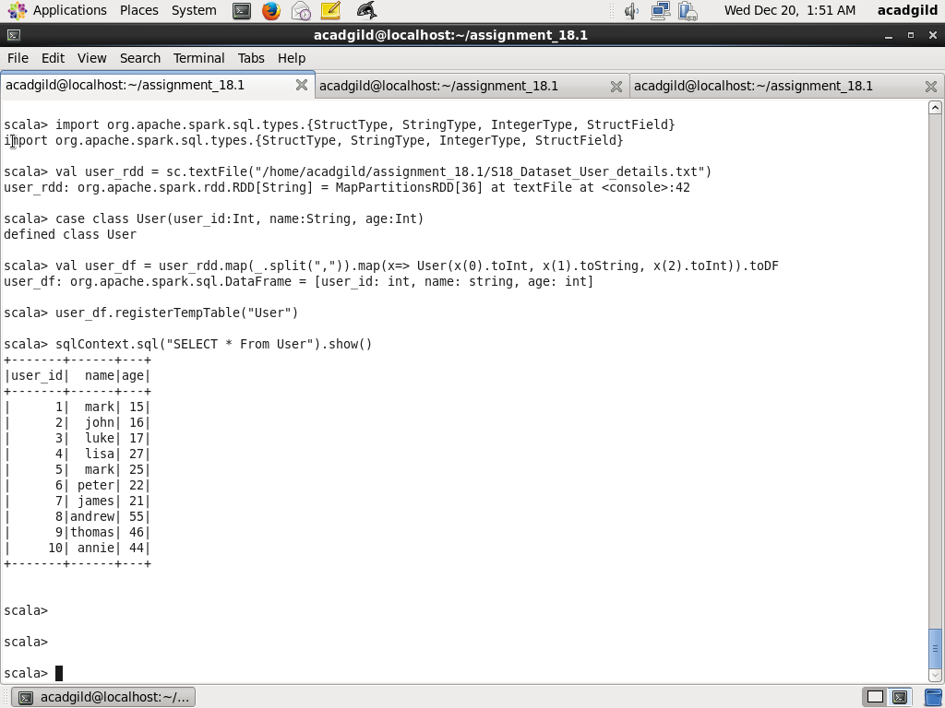

Step2: Create a temporary table Travel

Read dataset from /home/acadgild/assignment_18.1/S18_Dataset_ Holidays.txt and create RDD user_rdd. Create case class Travel with field user_id, src, dest, travel_mode distance, year_of_travel Create dataframe travel_df by mapping records splitting fields by , and populating the Travel class object. Next create temporary table Travel

Code is as below:

val travel_rdd = sc.textFile("/home/acadgild/assignment_18.1/S18_Dataset_Holidays.txt")

case class Travel(user_id:Int, src:String, dest:String, travel_mode:String, distance:Float, year_of_travel:Int)

val travel_df = travel_rdd.map(_.split(",")).map(x=> Travel(x(0).toInt, x(1).toString, x(2).toString, x(3).toString, x(4).toFloat, x(5).toInt)).toDF

travel_df.registerTempTable("Travel")

sqlContext.sql("SELECT * From Travel").show()

Screenshot is as below:

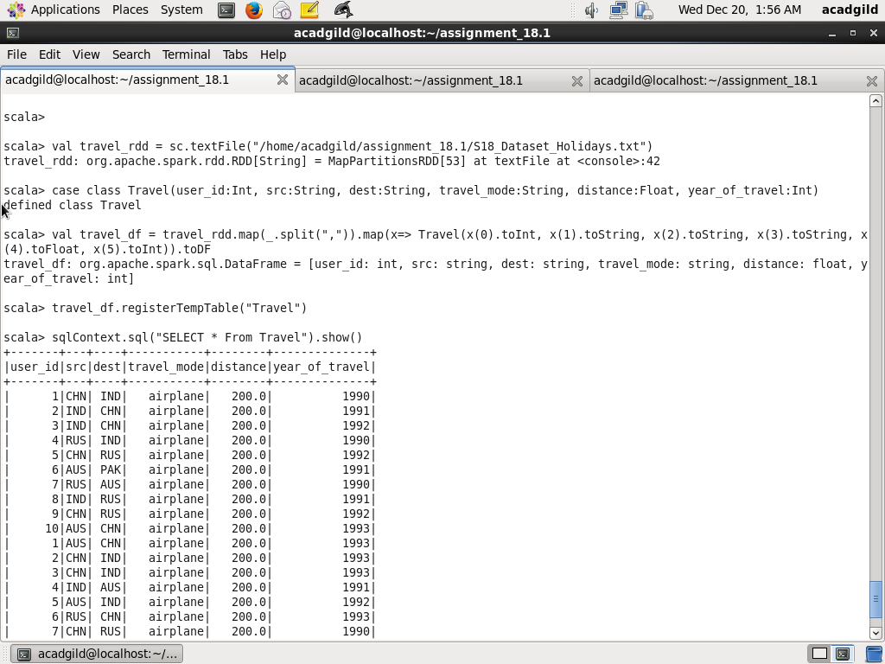

Step3:

Read dataset from /home/acadgild/assignment_18.1/S18_Dataset_ Transport.txt and create RDD transport_rdd. Create case class Transport with fields travel_mode,cost_per_unit Create dataframe transport_df by mapping records splitting fields by , and populating the Transport class object. Next create temporary table Transport

val transport_rdd = sc.textFile("/home/acadgild/assignment_18.1/S18_Dataset_Transport.txt")

case class Transport(travel_mode:String, cost_per_unit:Float)

val transport_df = transport_rdd.map(_.split(",")).map(x=> Transport(x(0).toString, x(1).toFloat)).toDF

transport_df.registerTempTable("Transport")

sqlContext.sql("SELECT * From Transport").show()

Screenshot is as below:

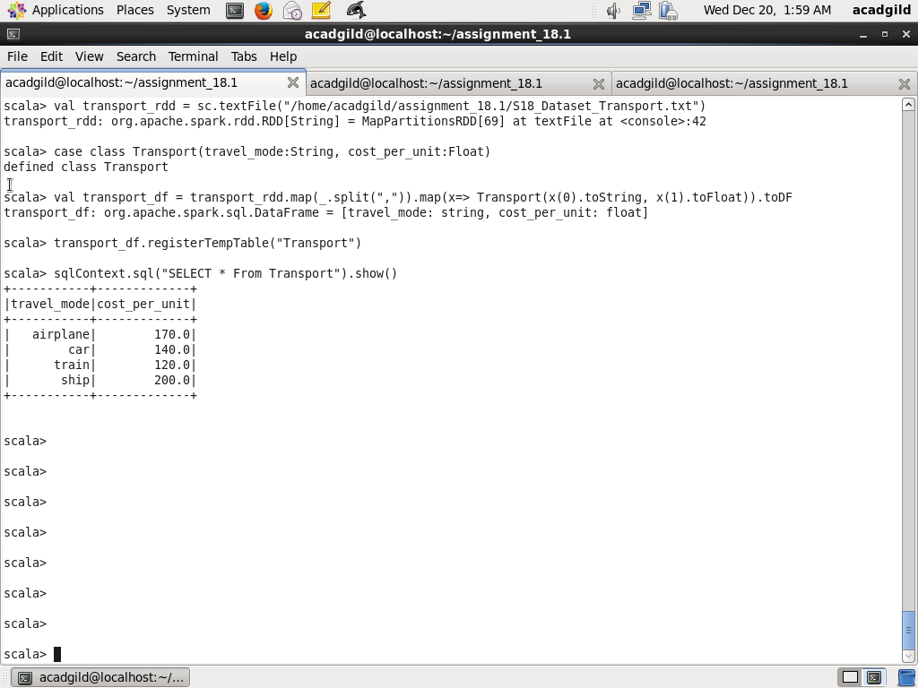

Task1: Which age group spent most amount in travelling

Here I joined temporary tables Travel and User on user_id field and filter the age groups (<20, 20-35, >35) and using the sum function on cost_per_unit, calculate total_money_spent, group by age group and order by age_group and take the first record using LIMIT 1

Code is as below:

sqlContext.sql("SELECT age_group_money_spent.age_group, SUM(age_group_money_spent.money_spent) AS total_money_spent FROM (SELECT CASE WHEN us.age < 20 THEN '< 20' WHEN age >= 20 AND age <= 35 THEN '20-35' WHEN age >35 THEN '> 35' END AS age_group, trans.cost_per_unit as money_spent FROM Travel trav JOIN User us ON trav.user_id=us.user_id JOIN Transport trans ON trav.travel_mode = trans.travel_mode) age_group_money_spent GROUP BY age_group_money_spent.age_group ORDER BY total_money_spent DESC LIMIT 1").show()

Screenshot is as below:

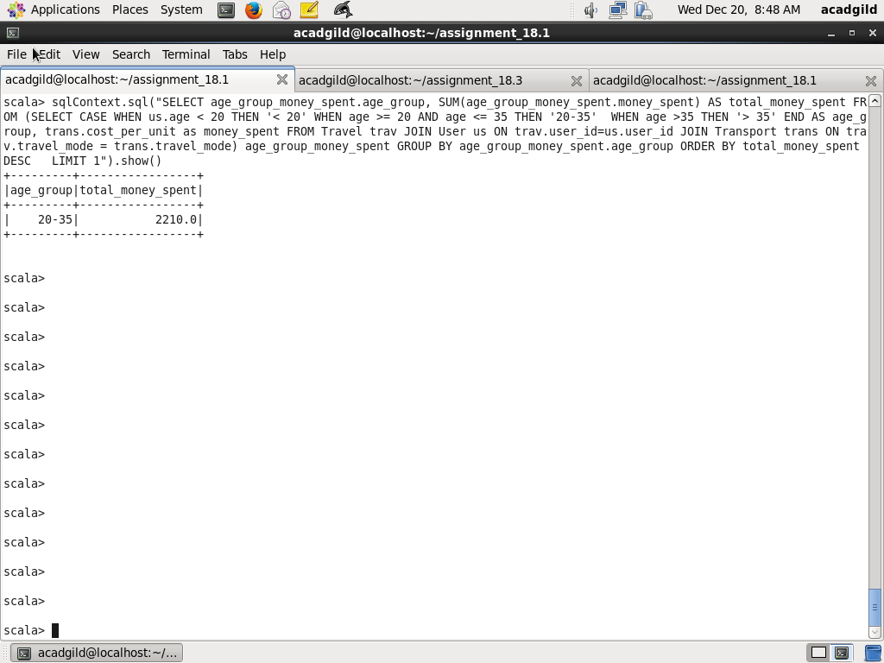

Task2: What is the amount spent by each age group every year in travelling

Here I joined temporary tables Travel and User on user_id field and filter the age groups (<20, 20-35, >35) and using the sum function on cost_per_unit, calculate total_money_spent, group by year and age group

Code is as below:

sqlContext.sql("SELECT age_group_money_spent.year_of_travel, age_group_money_spent.age_group, SUM(age_group_money_spent.money_spent) AS total_money_spent FROM (SELECT trav.year_of_travel, CASE WHEN us.age < 20 THEN '< 20' WHEN age >= 20 AND age <= 35 THEN '20-35' WHEN age >35 THEN '> 35' END AS age_group, trans.cost_per_unit as money_spent FROM Travel trav JOIN User us ON trav.user_id=us.user_id JOIN Transport trans ON trav.travel_mode = trans.travel_mode) age_group_money_spent GROUP BY age_group_money_spent.year_of_travel, age_group_money_spent.age_group ORDER BY age_group_money_spent.year_of_travel, age_group_money_spent.age_group ").show()

Screenshot is as below:

