Assignment 19.1

Initial Steps:

* Load the Dataset Sport_data.txt into RDD sports_data_with_header
* Get the header from the sports_data_with_header
* Remove the header from sports_data_with_header by filtering and create RDD sports_data
* Create class SportData with schema firstname, lastname,sports,medal_type,age,year,country
* Splitting the fields of sports_data records base on field separator comma (,) Populate SportsData class and convert to Data Frame sports_data_df
* Create temporary table SportsData based on sports_data_df

Code is as below:

val sports_data_with_header = sc.textFile("/home/acadgild/assignment_19.1/Sports_data.txt")

val header = sports_data_with_header.first()

val sports_data = sports_data_with_header.filter(row => row != header)

case class SportsData(firstname:String,lastname:String,sports:String,medal_type:String,age:Int,year:Int,country: String)

val sports_data_df = sports_data.map(_.split(",")).map(x=> SportsData(x(0), x(1), x(2), x(3), x(4).toInt, x(5).toInt, x(6))).toDF

sports_data_df.registerTempTable("SportsData")

Screenshot is as below:

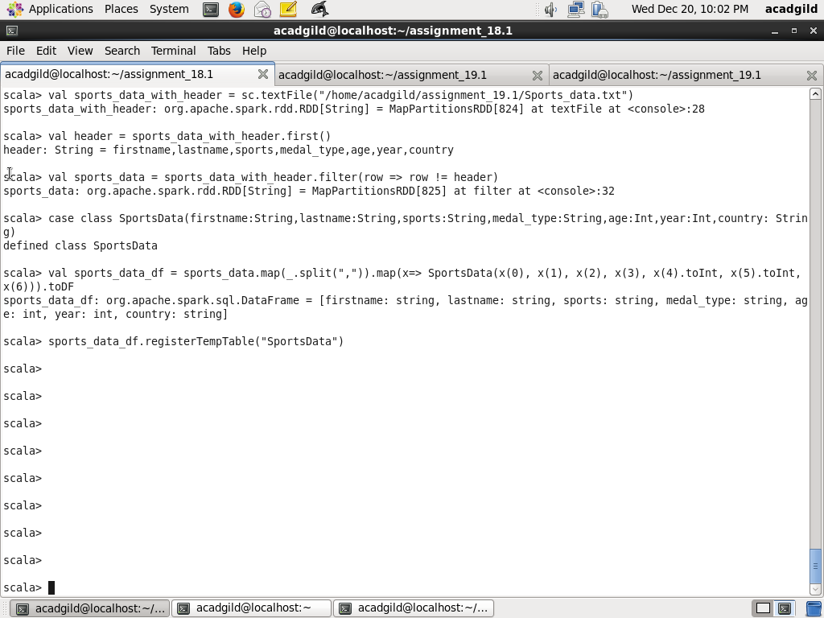

Task1: What are the total number of gold medal winners every year

Using count function on SportsData table, select total number of gold medal by having query criteria medal_type as gold and group by year

Code is as below:

sqlContext.sql("SELECT year, count(*) AS no_of_gold_medals FROM SportsData WHERE medal_type='gold' GROUP BY year ORDER BY year").show()

Screenshot is as below:

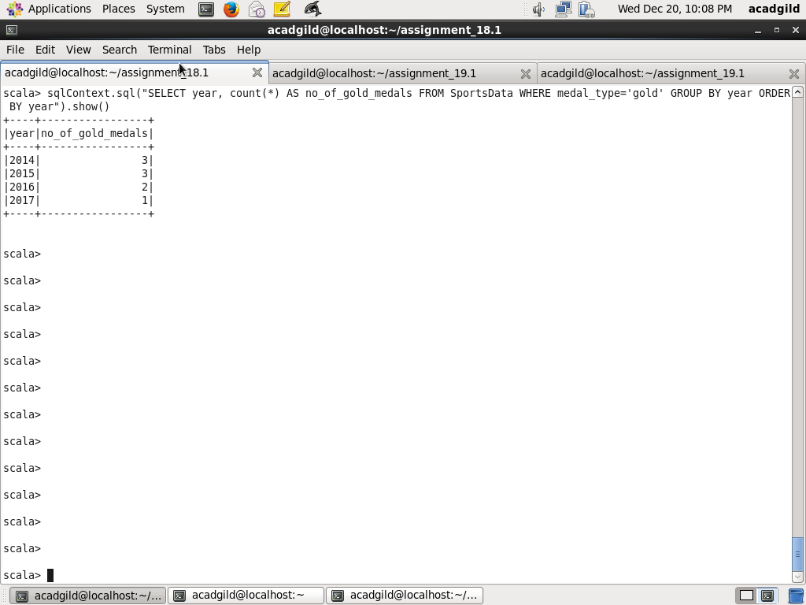

Task2: How many silver medal won by US in each sports

Using count function on SportsData table, select total number of silver medal by having query criteria medal_type as gold, country as USA and group by sports

Code is as below:

sqlContext.sql("SELECT sports, count(*) AS no_of_silver_medals FROM SportsData WHERE country='USA' and medal_type='silver' GROUP BY sports ORDER BY sports").show()

Screenshot is as below:

