Steps below are followed to develop and run Map Reduce program to filter invalid records:

**Step1:** Using Eclipse create a project FilterNA, and create a class FilterNARecords, which will process the records by tokenizing each recording using | as separator and will do filtering of records by not including all the invalid records which either NA in company or product field. The screenshots of source code and the steps to run these are below. This is a map only program. After this Export the project to FilterNARecords.jar.

Screenshots of source code is as below:

: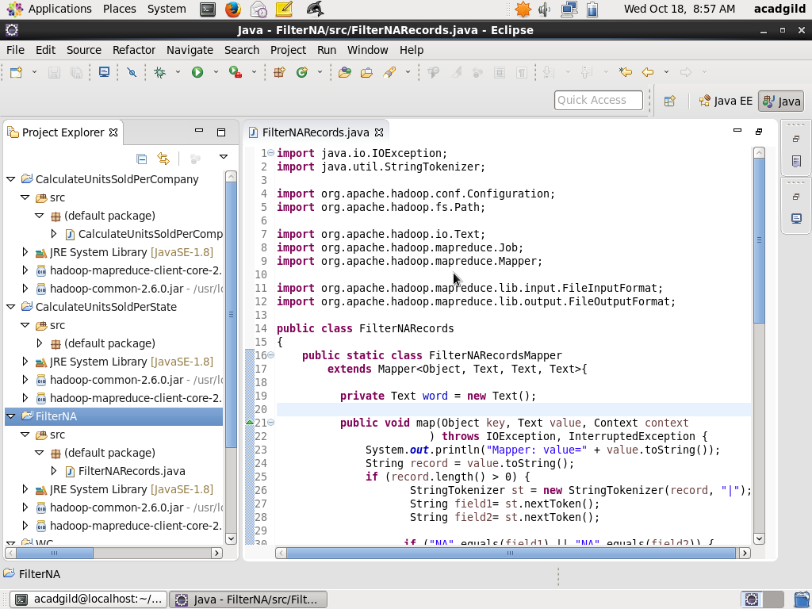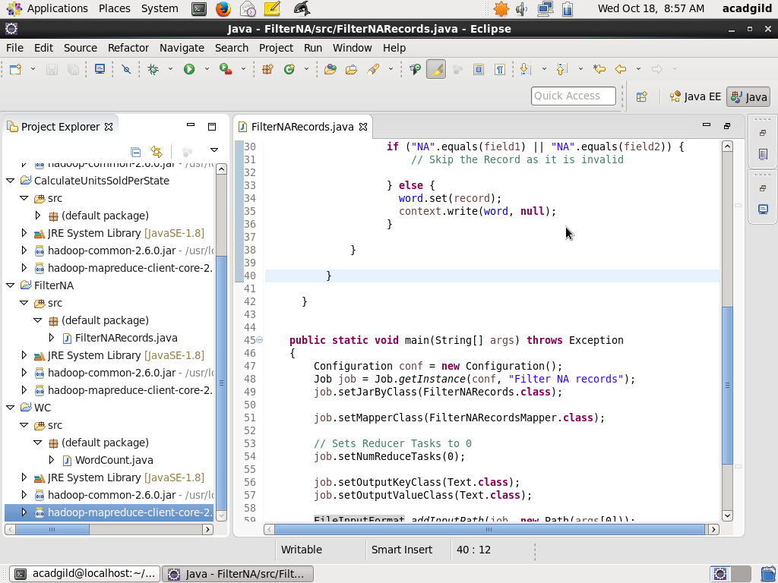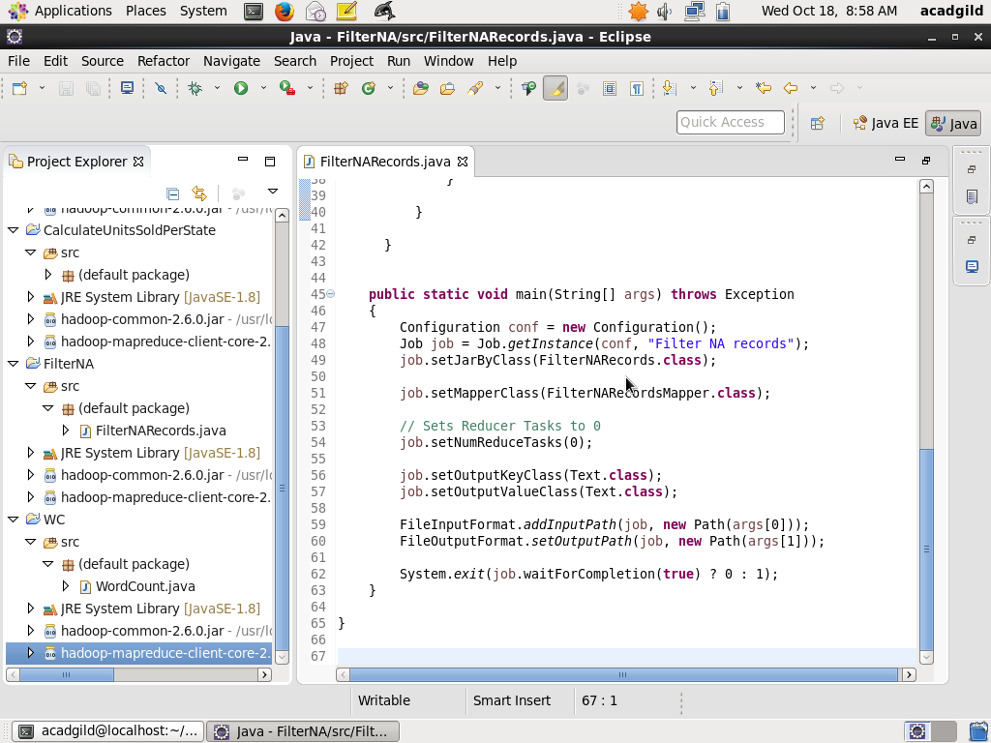

**Step2**: Copy the file television.txt to HDFS folder /user/acadgild/Hadoop using command:

Hadoop fs –copyFromLocal television.txt /user/acadgild/hadoop

Screen shot is as below:

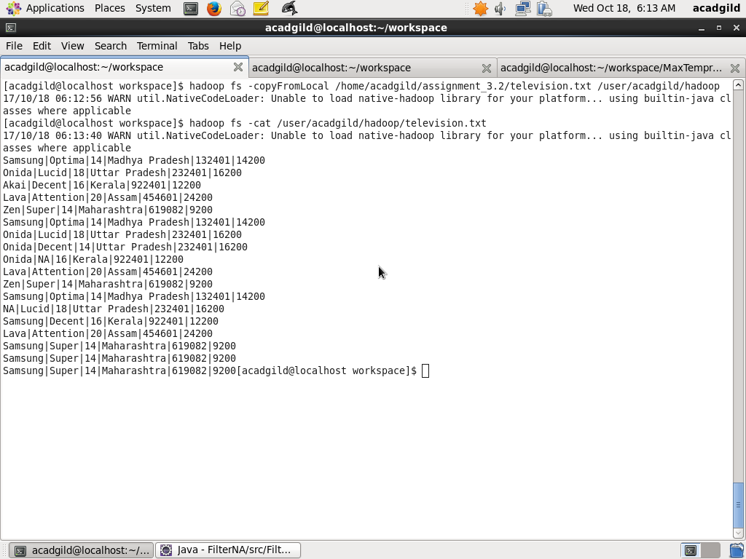

**Step3**: Run the program using the command below

hadoop jar FilterNARecords.jar FilterNARecords /user/acadgild/hadoop/television.txt /user/acadgild/hadoop/output_filter_na_records

Screenshot is as below:

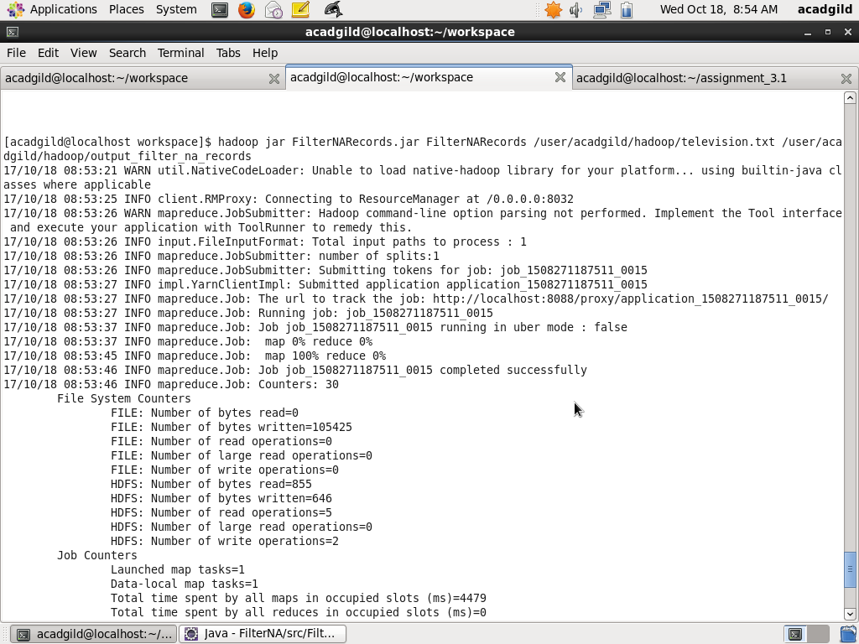

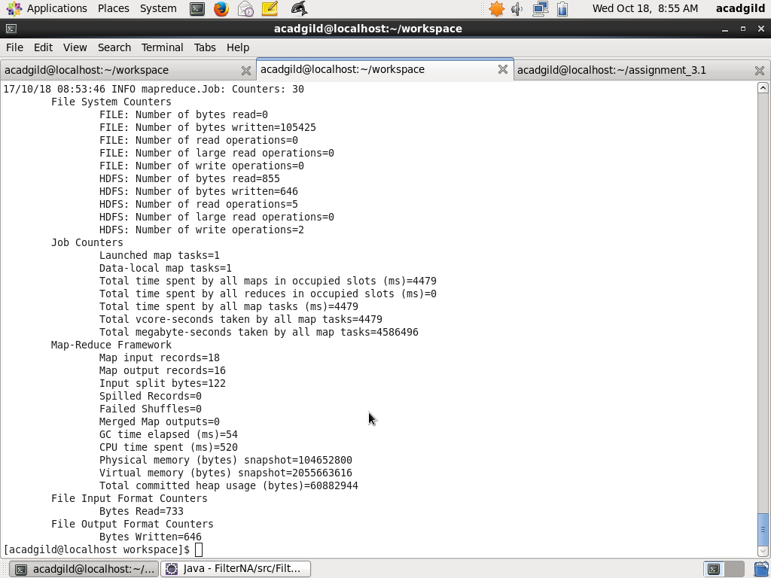

**Step3**: Finally, look at the output by using command

hadoop fs –ls /user/acadgild/hadoop/output_filter_na_records

