Steps below are followed to develop and run Map Reduce program to calculate the total units sold for each Company :

**Step1:** Using Eclipse create a project CalculateUnitsSoldPerCompany, and create a class CalculateUnitsSoldPerCompany, mapper static class CalculateUnitsSoldPerCompanyMapper which will process the records by tokenizing each recording using | as separator and will do filtering of records by not including all the invalid records which either NA in company or product field and creating a map with key as company, value as count. The reducer static class CalculateUnitsSoldPerCompanyReducer calculates total number of units sold by company. The screenshots of source code and the steps to run these are below. This is a map only program. After this Export the project to CalculateUnitsSoldByCompany.jar.

Screenshots of source code is as below:

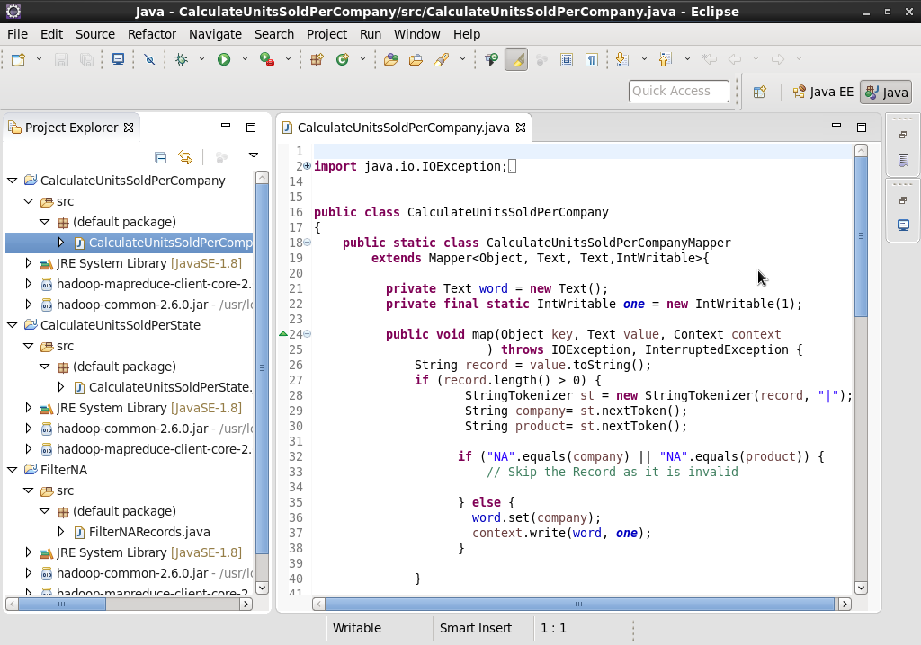

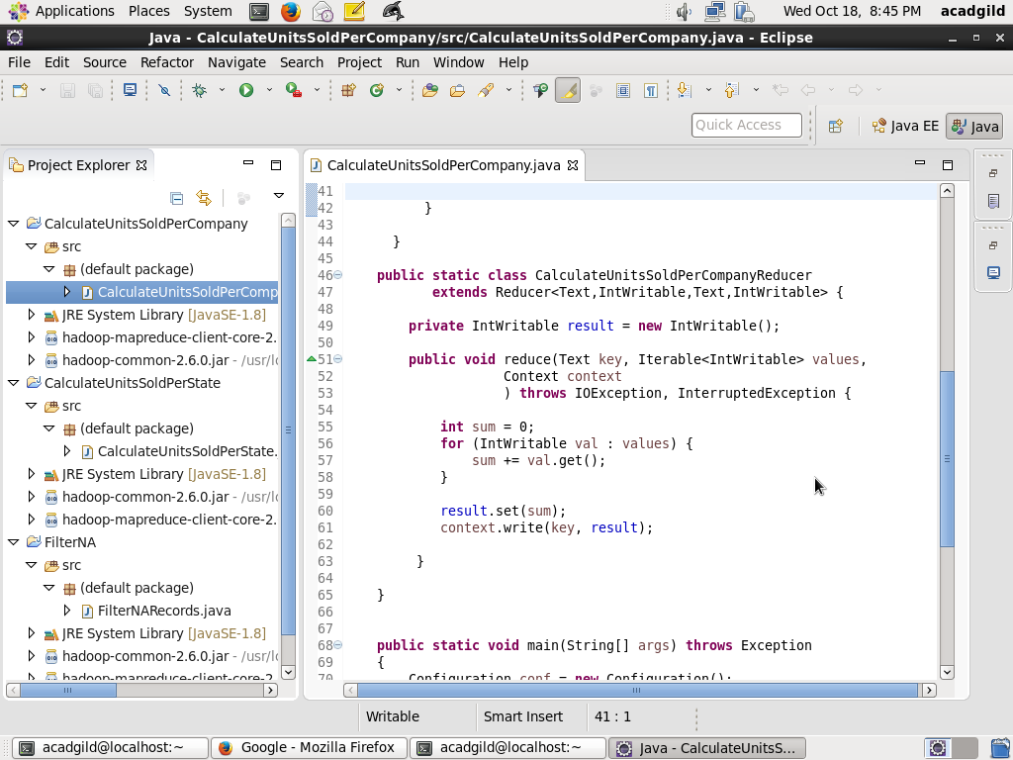

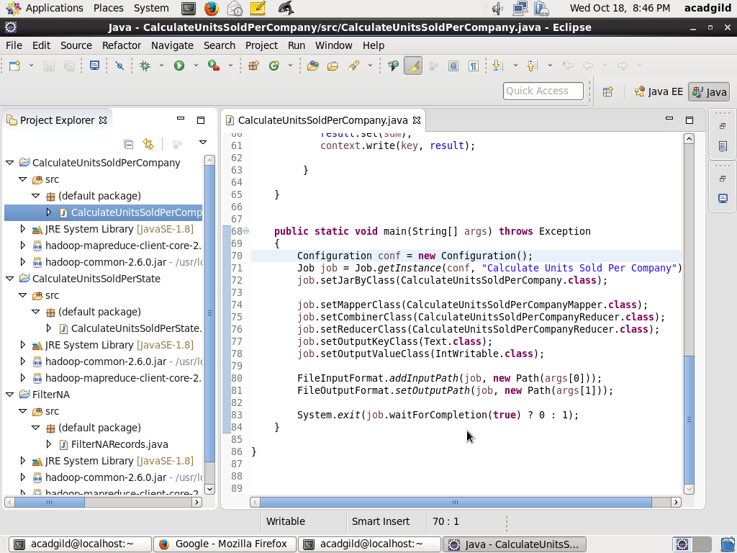

:

**Step2**: Copy the file television.txt to HDFS folder /user/acadgild/hadoop using command:

Hadoop fs –copyFromLocal television.txt /user/acadgild/hadoop

Screen shot is as below:

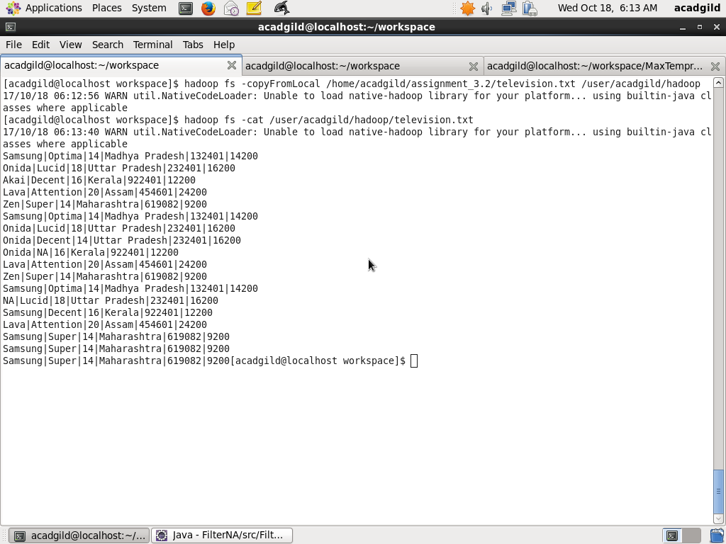

**Step3**: Run the program using the command below

hadoop jar CalculateUnitsSoldPerCompany.jar CalculateUnitsSoldPerCompany /user/acadgild/hadoop/television.txt /user/acadgild/hadoop/output_filter_units_sold_per_company

Screenshot is as below:

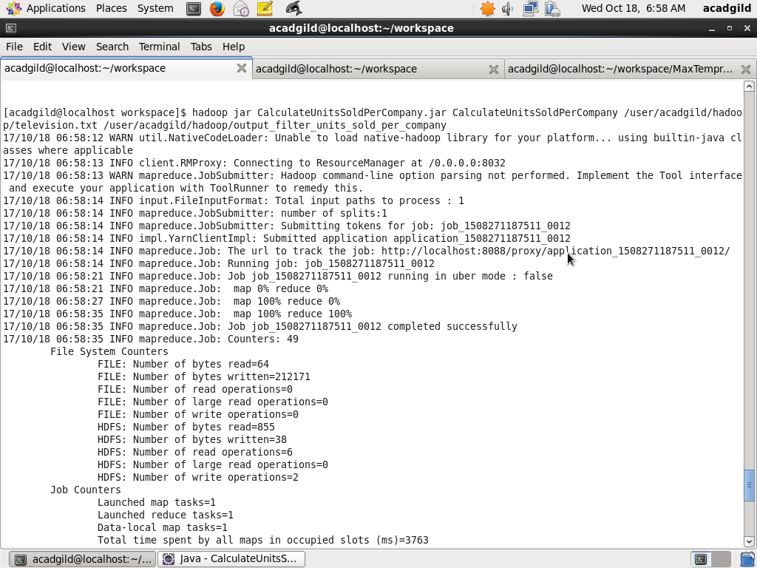

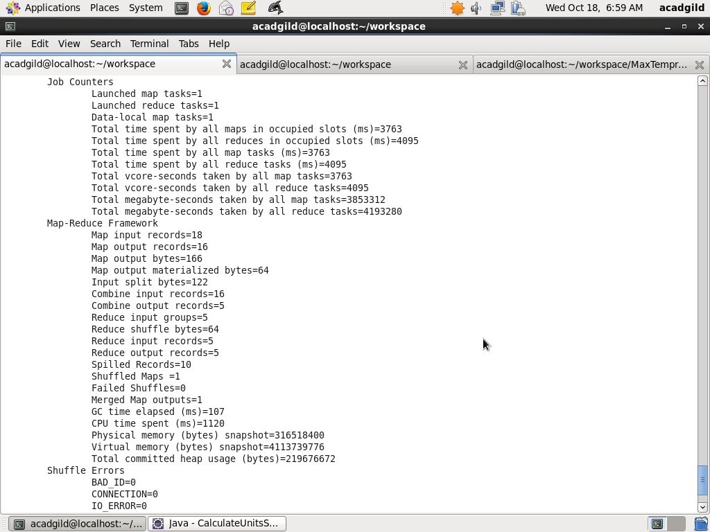

**Step3**: Finally, look at the output by using command

hadoop fs –ls /user/acadgild/hadoop/output_filter_units_sold_per_company

hadoop fs –cat /user/acadgild/hadoop/output_filter_units_sold_per_company/part-r-00000

