Steps below are followed to develop and run Map Reduce program to calculate the total units sold in each state for Onida:

**Step1:** Using Eclipse create a project CalculateUnitsSoldPerState, and create a class CalculateUnitsSoldPerState, mapper static class CalculateUnitsSoldPerStateMapper which will process the records by tokenizing each recording using | as separator and will do filtering of records by not including all the invalid records which either NA in company or product field, also filtering records which have company as Onida and creating a map with key as state, value as count. The reducer static class CalculateUnitsSoldPerStateReducer calculates total number of units sold in each state. The screenshots of source code and the steps to run these are below.. After this Export the project to CalculateUnitsSoldByState.jar.

Screenshots of source code is as below:

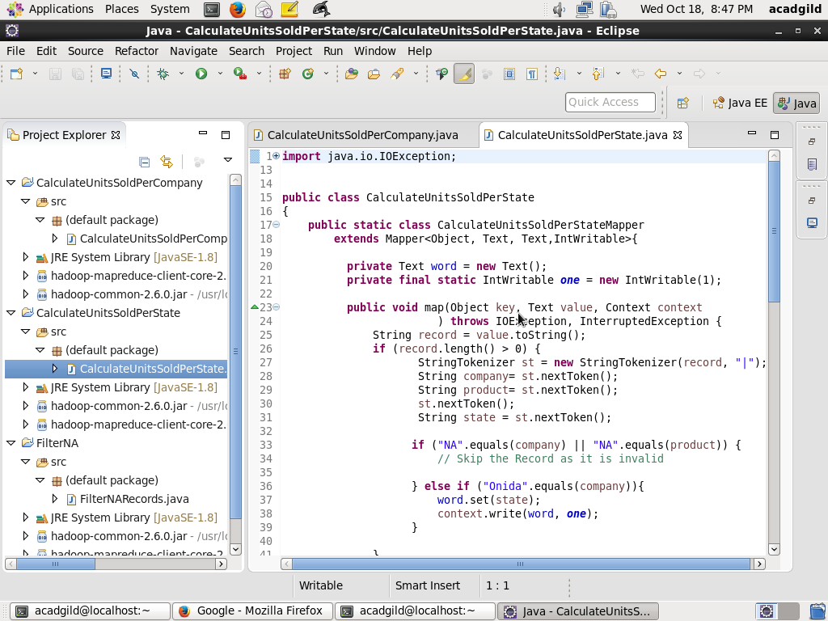

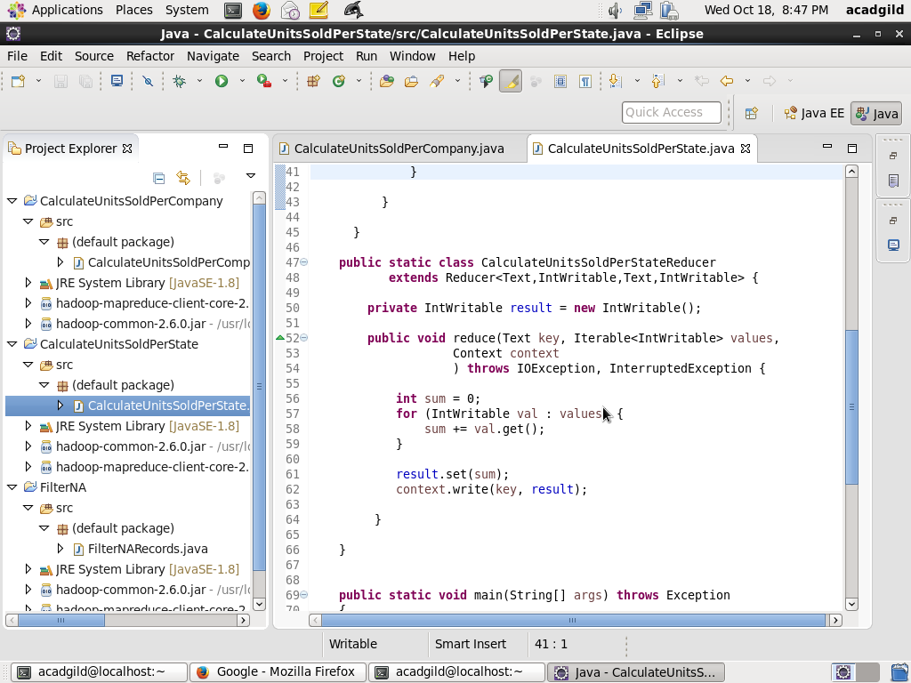

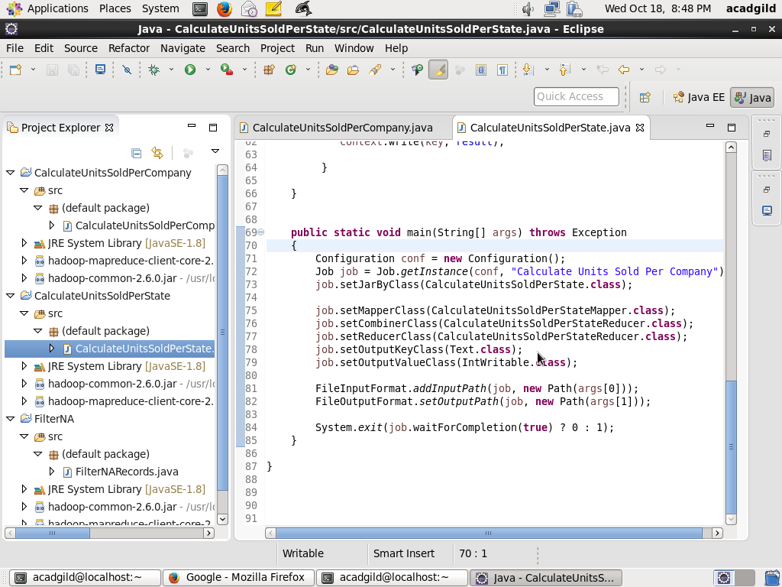

**Step2**: Copy the file television.txt to HDFS folder /user/acadgild/hadoop using command:

Hadoop fs –copyFromLocal television.txt /user/acadgild/hadoop

Screen shot is as below:

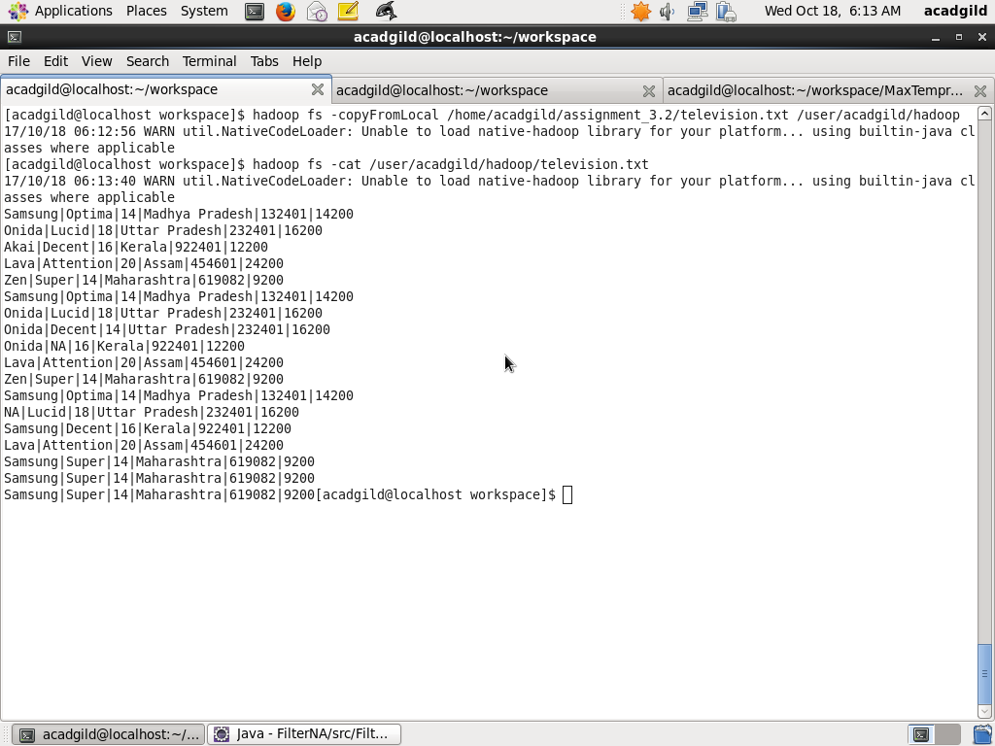

**Step3**: Run the program using the command below

hadoop jar CalculateUnitsSoldPerState.jar CalculateUnitsSoldPerState /user/acadgild/hadoop/television.txt /user/acadgild/hadoop/output_filter_units_sold_per_state

Screenshot is as below:

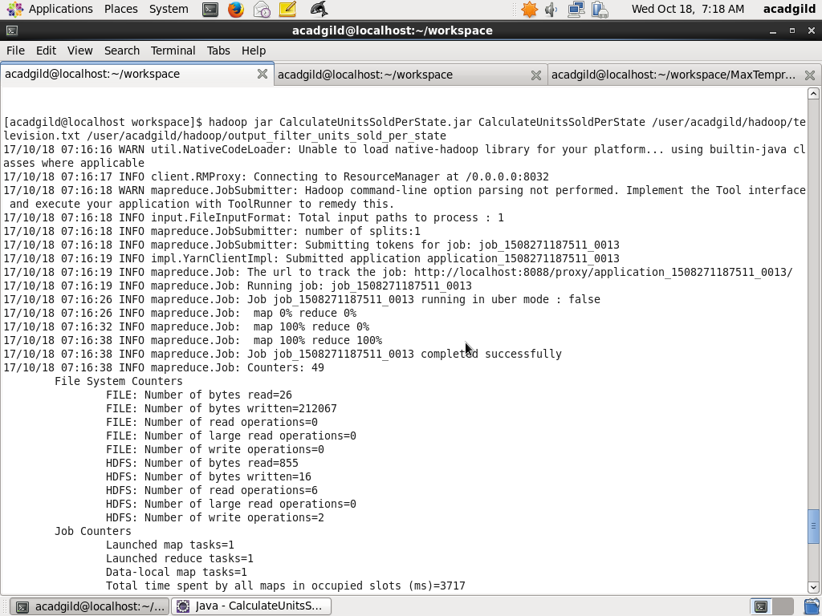

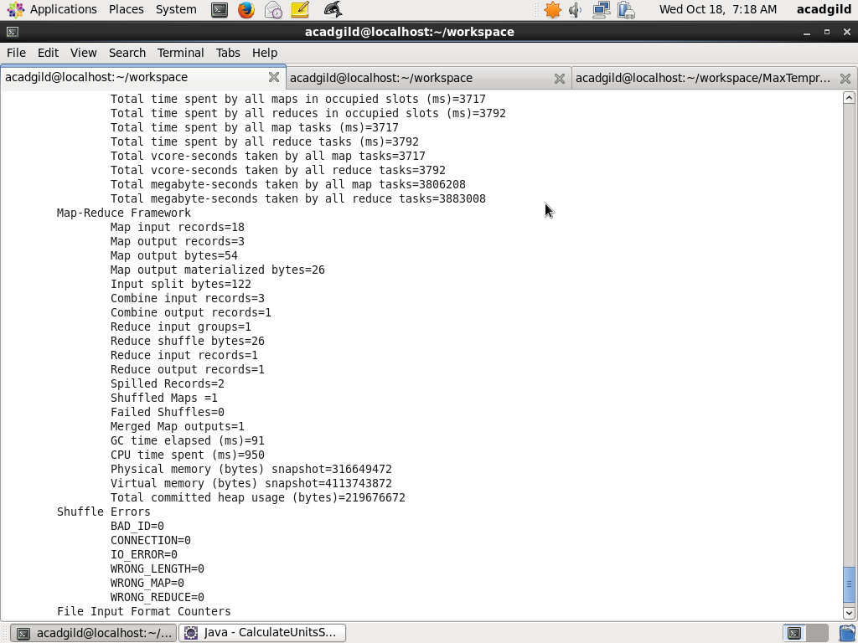

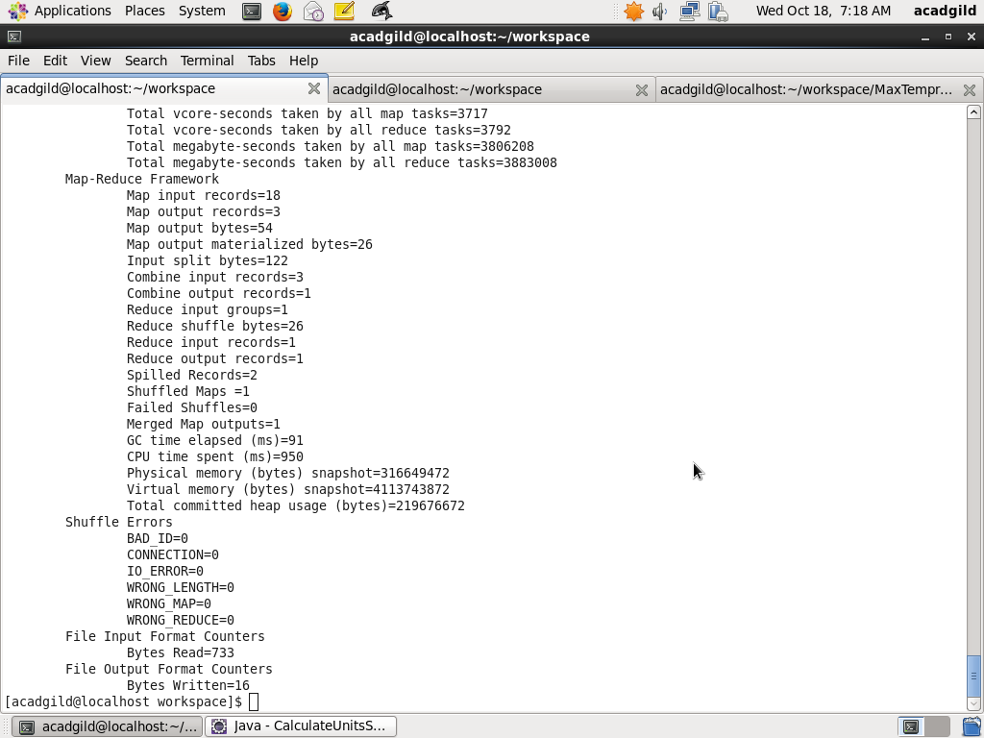

**Step3**: Finally, look at the output by using command

hadoop fs –ls /user/acadgild/hadoop/output_filter_units_sold_per_state

hadoop fs –cat /user/acadgild/hadoop/output_filter_units_sold_per_state/part-r-00000

