1. Write a class name with class named ‘acad’ an method main to compute the sum of two numbers

In the screenshot below, I created a class named acad in the main method sum interger numbers num1 and num2 and put them into interger variable sum. Next I executed the program

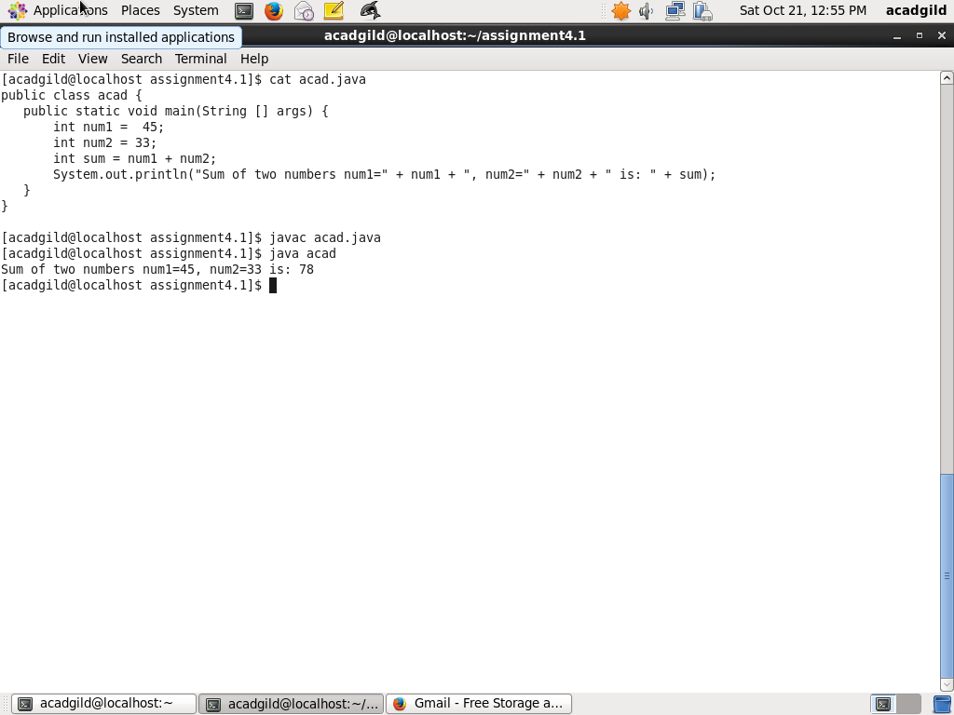

1. Rewrite above code when input is provided by user

In the screenshot below, I created a class named acad2, which takes arguments from command line and sum them together.

Next I executed the program

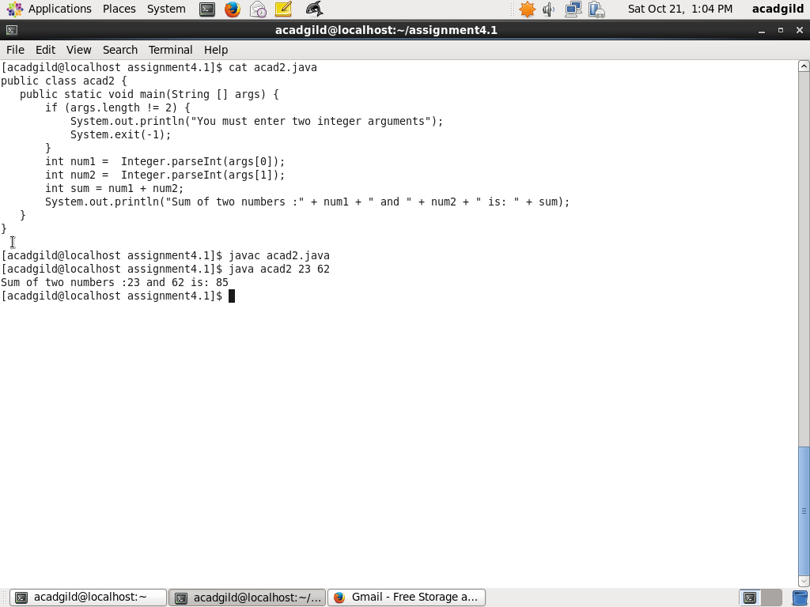

1. Write a program with method name sum() that accepts two parameters from user and print

the sum of two numbers. Output format should be as:

First number is:

Second number is:

Sum is:

In the screenshot below I created a java class acad3 and in the main method two numbers can be input form keyboard.

These numbers are sum together

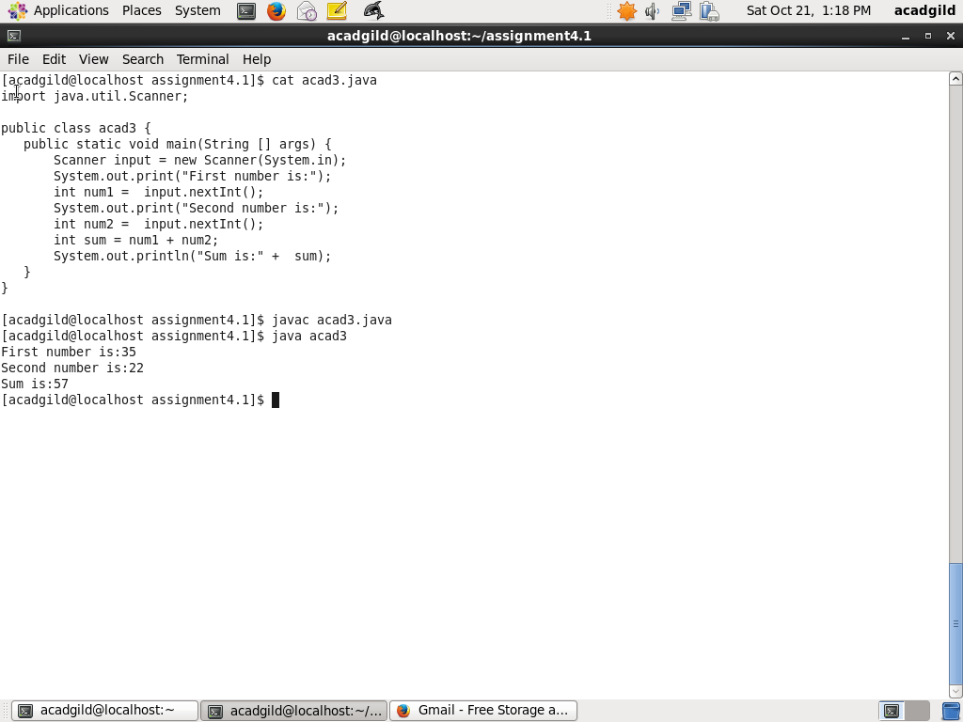

1. Write a program to accepts two numbers from stdin and find all the odd as well as even

numbers present in between them.

In the screenshot below, I created a java class acad4, which takes two numbers from stdin and find all the

Odd numbers and even numbers between them. Next I execute the program

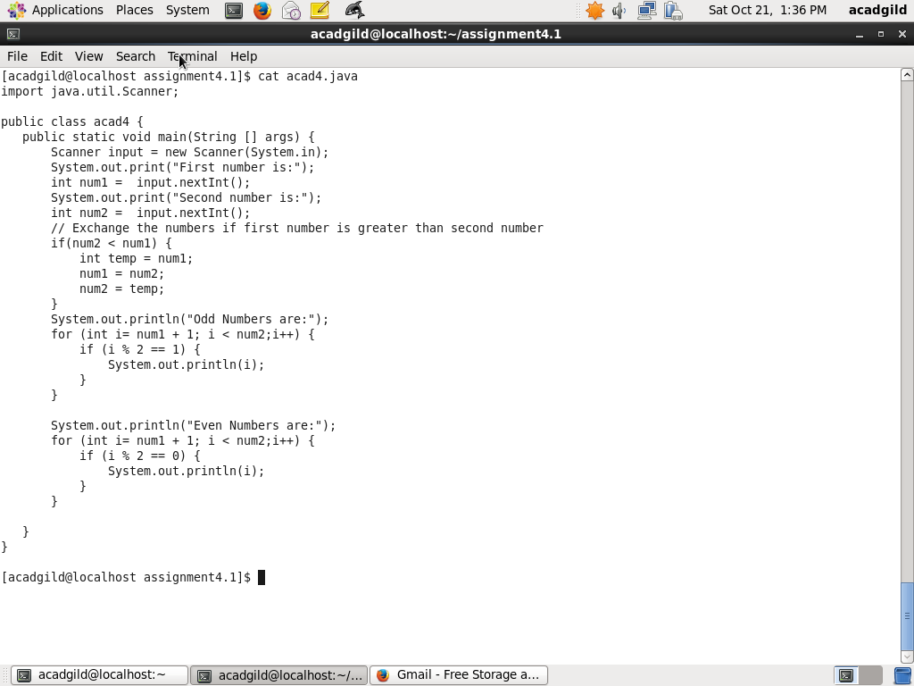

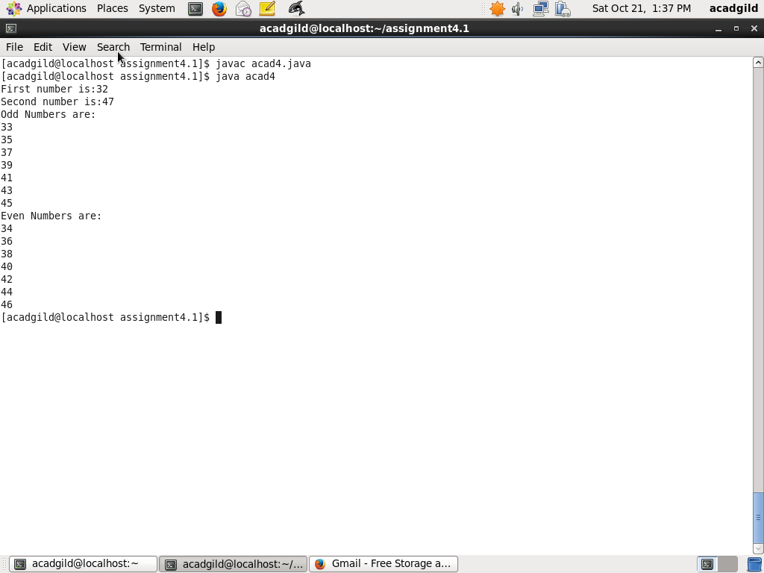

1. First 10 multiples of a given number

In the screenshot below I created a java class acad5 and in the main method, take input from stdin and calculate first 10 multiples of the given number. Next I execute the program

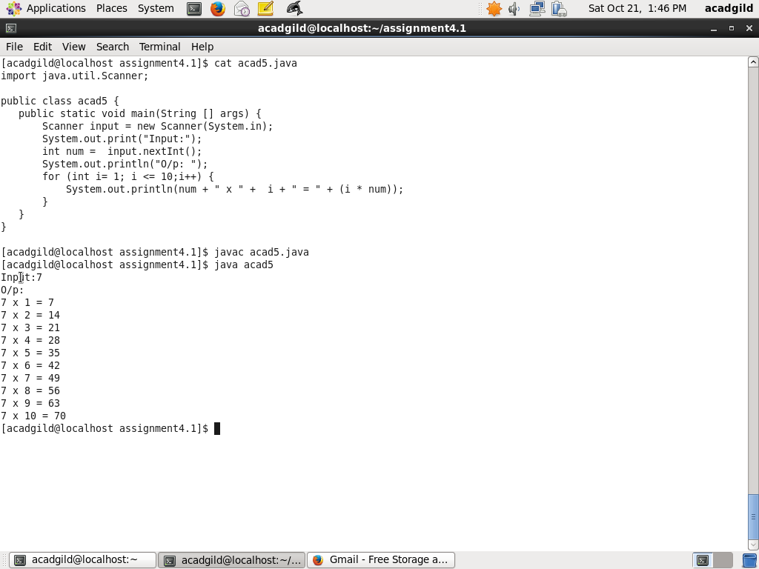

1. Write a program consisting method sum() and demonstrate the concept of method

overloading using this method.

Method Overloading is a feature that allows a class to have more than one method having the same name, if their argument lists are different.

Each of methods can have different type of argument or number of arguments

Can also vary.

In the example screenshot below, in the java class acad6, I created two sum methods, one take two integer arguments and another take two float arguments

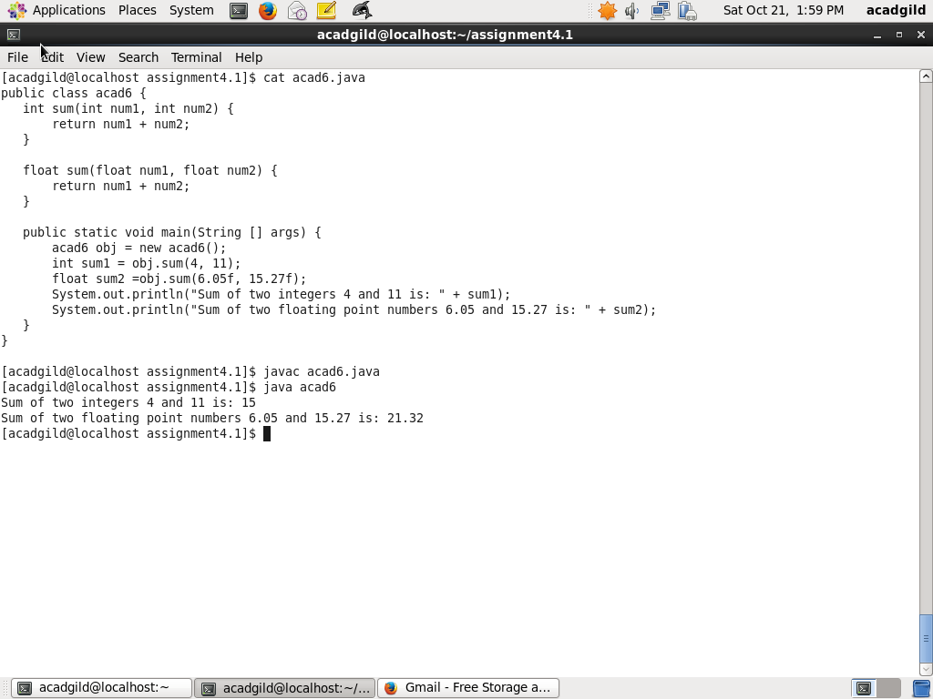

1. Can you overload a method with same return type.? Explain your answer with proper logic.

Yes, you can overload method with same return type but arguments can vary.

Method Overloading is a feature that allows a class to have more than one method having the same name, if their argument lists are different. Each of methods can have different type of argument or number of arguments

Can also vary.

1. Write a program in java using Arrays, that sorts the element in descending order.

In the screenshot below, I created a class acad8 where created a array named array. I also created a method sortDescending which

Takes integer array as argument and sort using bubble sort. Next I execute program





