Write a program to implement word count using Pig

The steps are given below

Step1: I created a file word-count.txt, also start pig in local mode

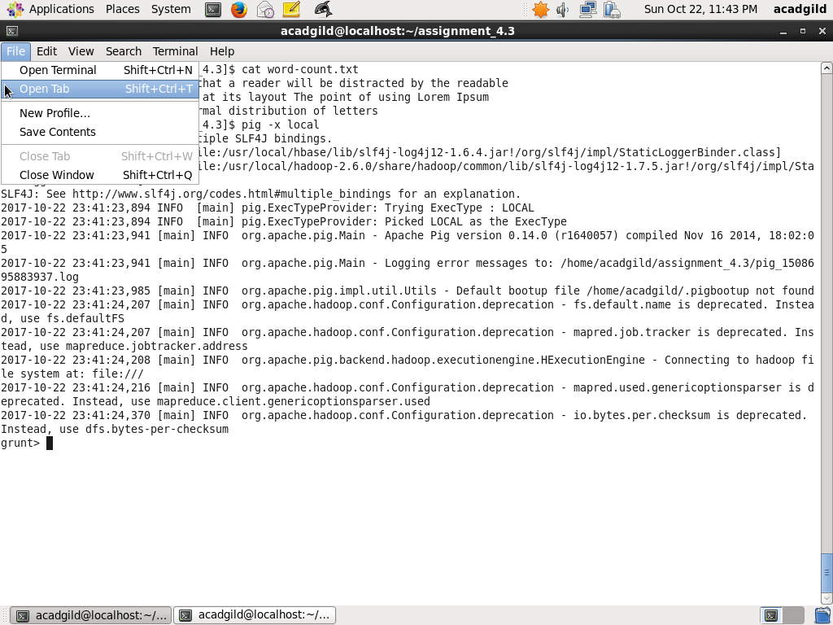

Step2:

I run the following commands in pig

lines = LOAD '/home/acadgild/assignment_4.3/word-count.txt' AS (line:chararray);

words = FOREACH lines GENERATE FLATTEN(TOKENIZE(line)) as word;

grouped_words = GROUP words by word;

word_and_count = FOREACH grouped_words GENERATE group, COUNT(words) as word_count;

dump word_and_count;

The screenshot is as below:

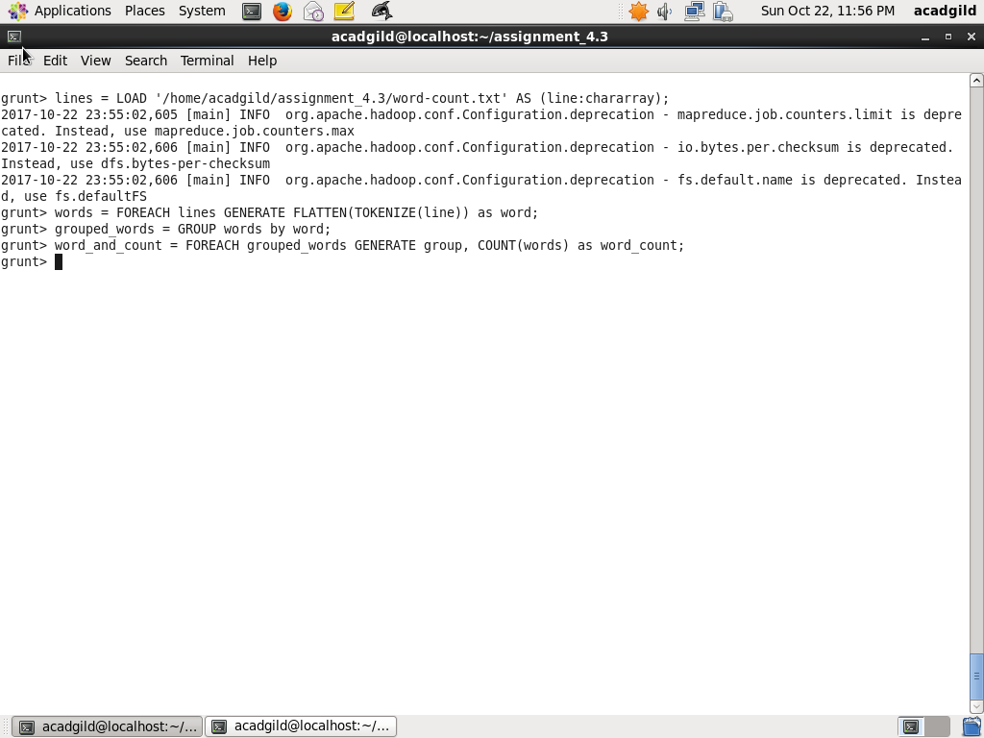

Step3:

Next I use the following command to dump the word and its count

dump word_and_count

