First Load the employee_details.txt into a PIG tuples have schema

employee_id:int

name: chararray

salary: float

rating: int

Using the command as below:

employee_details = LOAD '/home/acadgild/assignment_5.1/employee_details.txt' USING PigStorage(',') AS (employee_id:int, name:chararray, salary:float, rating: int);

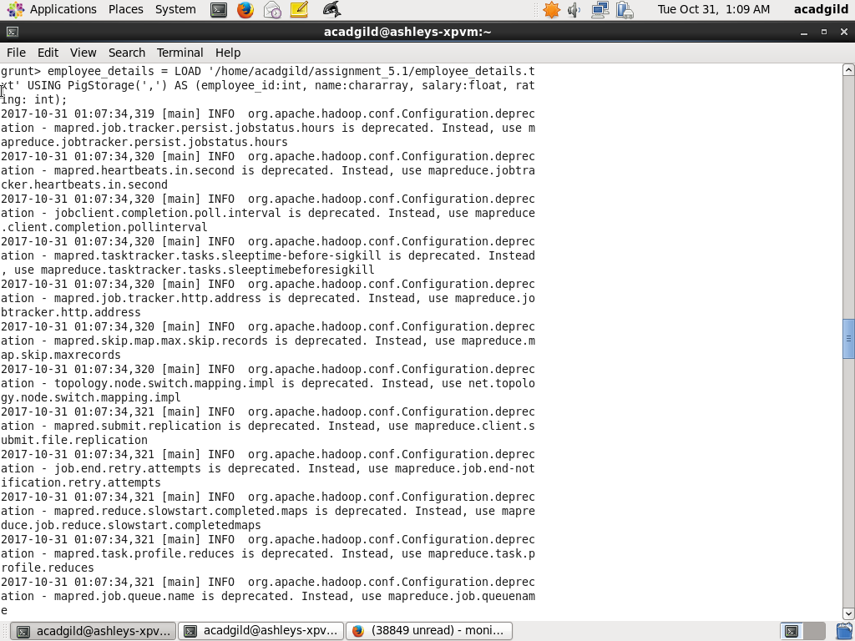

Next load employee_expenses into tuples having schema:

employee_id: int

expense:float

Using the command:

employee_expenses = LOAD '/home/acadgild/assignment_5.1/employee_expenses.txt' USING PigStorage('\t') AS (employee_id:int, expenses:float);

The screenshot is shown below:

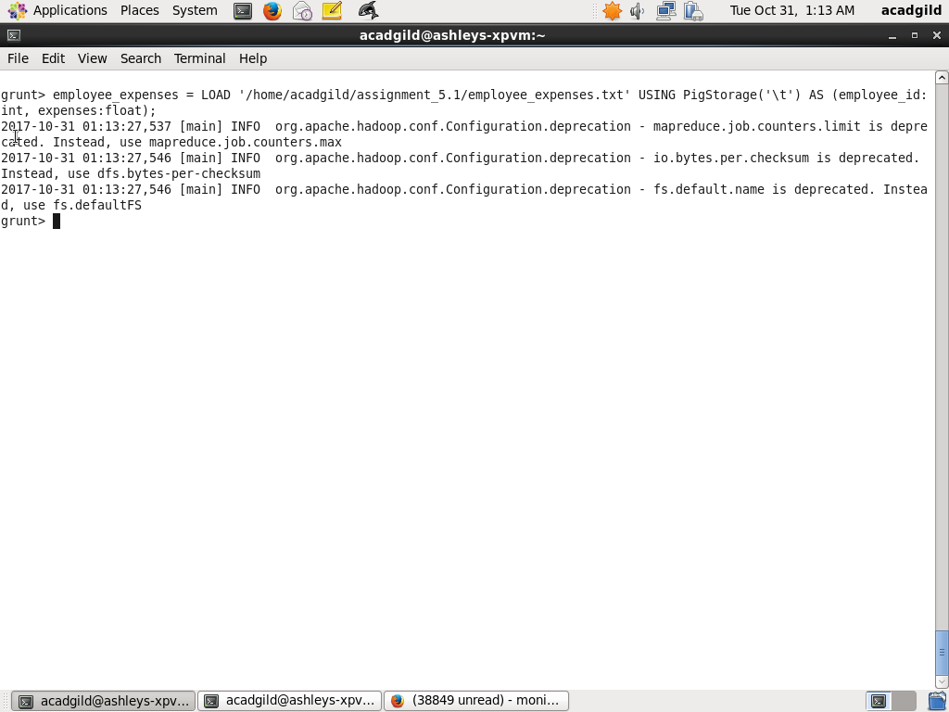

Task a. Top 5 employees with highest rating.

The following PIG script will first sort employees by rating, next select columns employee_id,name.. Next first 5 are taken using LIMIT 5 statement

Step1:

will first sort employee_details by rating and form the relation employee_sort_by_rating

employee_sort_by_rating = ORDER employee_details BY rating, name;

Step2:

Select only fields employee_id, name and form the relation rated_employess

rated_employees = FOREACH employee_sort_by_rating GENERATE employee_id, name;

Step3 :

Get only first 5 tuples using LIMIT 5

top5_rated_employees = LIMIT rated_employees 5;

Screenshot is as below:

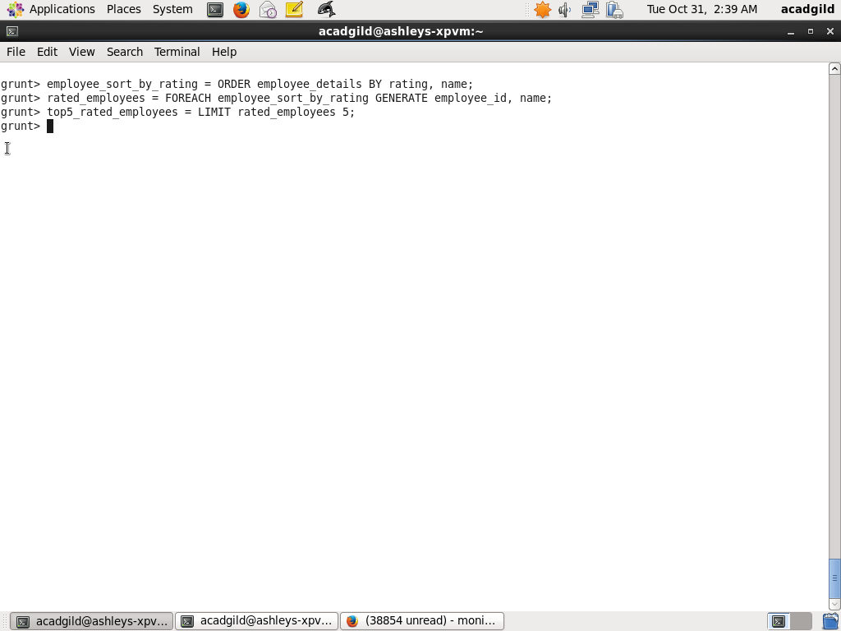

Output of Pig script is as below:

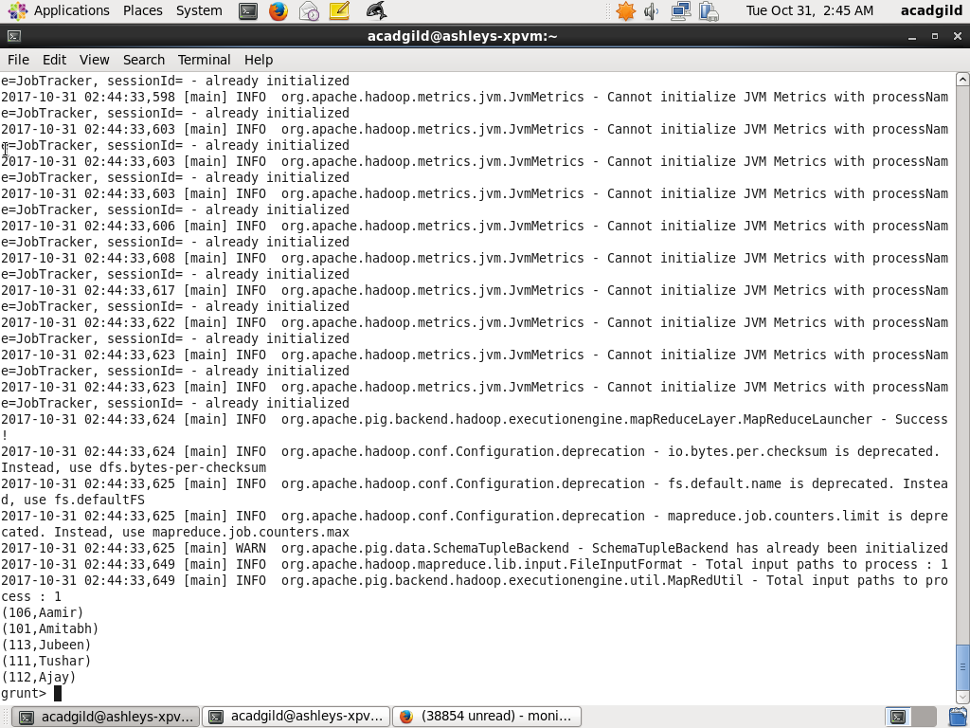

Task b. Top 3 employees with highest salary whose employee id is odd

The following script will first filter odd numbered employees by using modulus of employee_id and checking value is 1. Next sort them using saraly descending and name acending. Next select first 3 tuples by using LIMIT 3 statement

Step1:

Filter odd numbered employee_id by using modulus operator (%) on

Employee_id and check for value aas 1 and forming the relation odd_numbered_employees

odd_numbered_employees = FILTER employee_details BY employee_id % 2 == 1;

Step2:

Sort the odd numbered employees by salary descending and name ascending and derive relation odd_numbered_employees_sorted_by_salary

odd_numbered_employees_sorted_by_salary = ORDER odd_numbered_employees BY salary DESC, name;

Step3:

Slect only fields employeed_id, name from odd_numbered_employees_sorted_by_salary and form the new relation odd_numbered_employees_id_name_sorted_by_salary

odd_numbered_employees_id_name_sorted_by_salary = FOREACH odd_numbered_employees_sorted_by_salary GENERATE employee_id, name;

Step4:

Get only first 3 tuples using LIMIT

top3_odd_numbered_employees_id_name_sorted_by_salary = LIMIT odd_numbered_employees_id_name_sorted_by_salary 3;

Screenshot is as below

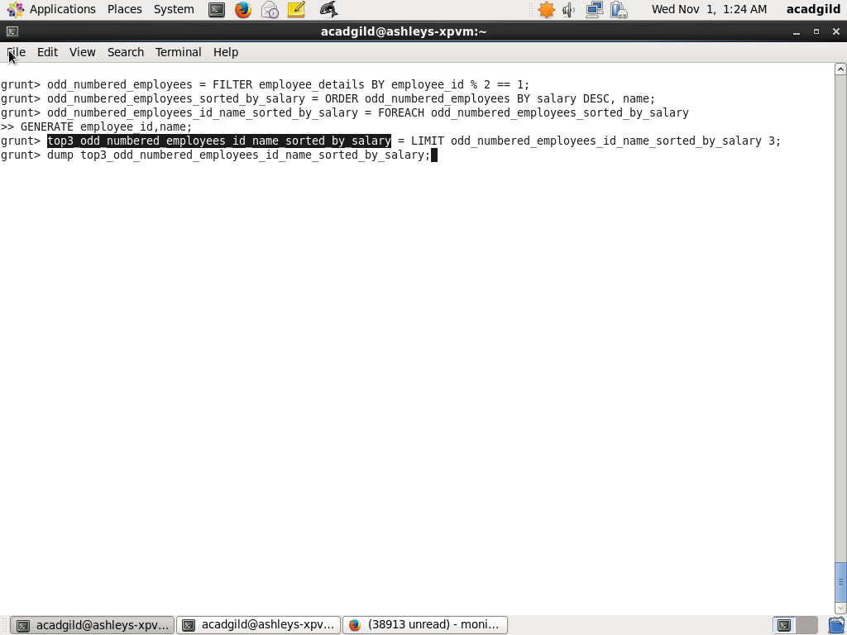

When I dump top3_odd_numbered_employees_id_name_sorted_by_salary, the output is as below (Amitabh, Salman, Akshay)

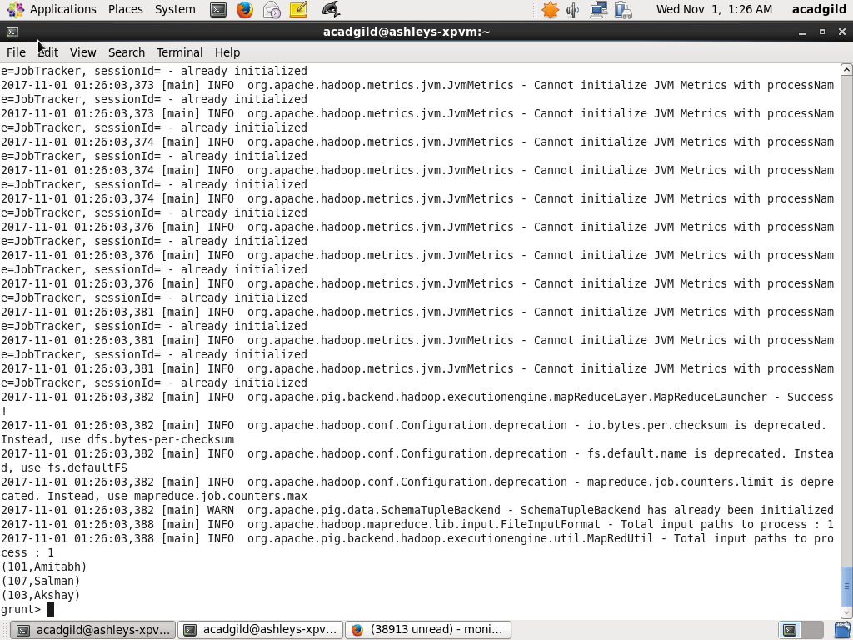

Task c

Employee with maximum expense

The following script below first join employee_details and employee_expenses using COGROUP on employee_id. Next calculate total expenses for each employee using SUM operator. Next, group all employees by ALL and get the maximum total expenses. This relation is again joined with employee_details_expenses relation by total_expenses. From this relation select only employee_id and name. Next flatten the list. Last step, sort by name

Step1:

Join employee_details and employee_expenses by employee_id using COGROUP and form relation employee_details_expenses

employee_details_expenses = COGROUP employee_details BY employee_id, employee_expenses BY employee_id;

Step2:

Sum expenses on each employee and select name as emp_name, employee_id as emp_id and sum of expenses as total_expenses and form the relation employee_details_total_expenses

employee_details_total_expenses = FOREACH employee_details_expenses GENERATE employee_details.name AS emp_name, employee_details.employee_id AS emp_id, SUM(employee_expenses.expenses) AS total_expenses;

Step3:

Group employee_details_total_expenses by all

employee_details_total_expenses_group_all = GROUP employee_details_total_expenses ALL;

Step4:

Calculate maximum total expense on employee_details_total_expenses_group_all and form the relation max_total_expenses

max_total_expenses = FOREACH employee_details_total_expenses_group_all GENERATE group AS grp, MAX(employee_details_total_expenses.total_expenses) AS total_expenses;

Step5:

Join the relations employee_details_total_expenses, max_total_expenses by total_expenses and form the new relation employee_details_total_expenses_join_max_total_expenses

employee_details_total_expenses_join_max_total_expenses = JOIN employee_details_total_expenses BY total_expenses, max_total_expenses BY total_expenses;

Step6:

From relation employee_details_total_expenses_join_max_total_expenses, select only em_id and emp_name and form the relation employee_id_name_with_max_total_expenses

employee_id_name_with_max_total_expenses = FOREACH employee_details_total_expenses_join_max_total_expenses GENERATE $0 AS emp_id, $1 AS emp_name;

Step7:

Flatten fields n relation employee_id_name_with_max_total_expenses and form relation employee_id_name_with_max_total_expenses_flatten

employee_id_name_with_max_total_expenses_flatten = FOREACH employee_id_name_with_max_total_expenses GENERATE FLATTEN($1), FLATTEN($0) ;

Step8:

Sort employee_id_name_with_max_total_expenses_flatten by employee name

employee_id_name_with_max_total_expenses_sorted = ORDER employee_id_name_with_max_total_expenses_flatten BY $1;

Step9:

Dump the relation employee_id_name_with_max_total_expenses_sorted

dump employee_id_name_with_max_total_expenses_sorted;

Screenshot is as below:

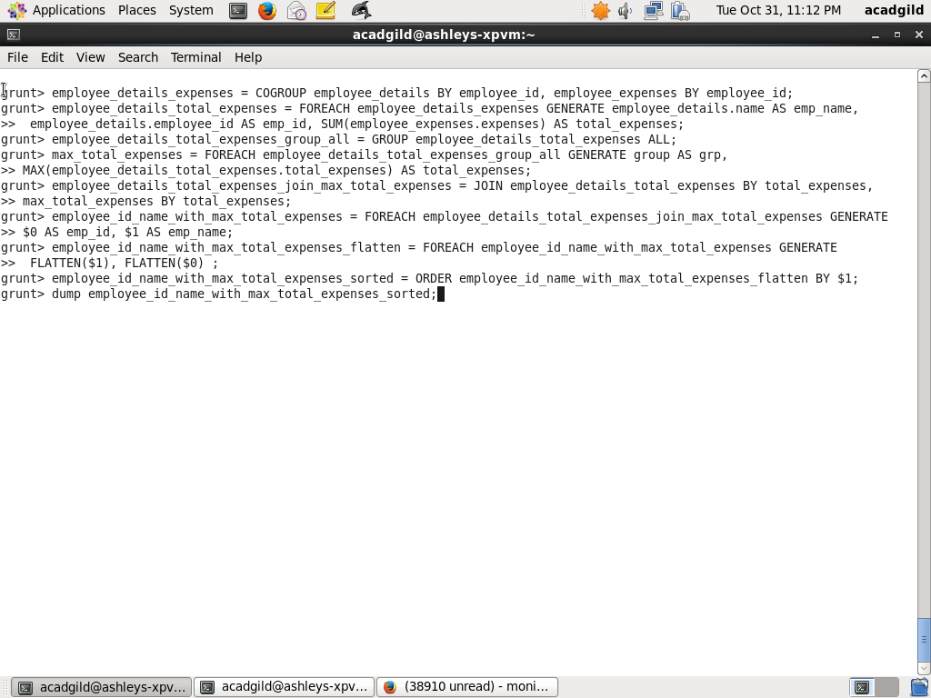

Screenshot of last page of output of dump employee_id_name_with_max_total_expenses_sorted is as where employee_id: 102, name: Shahrukh has maximum expenses

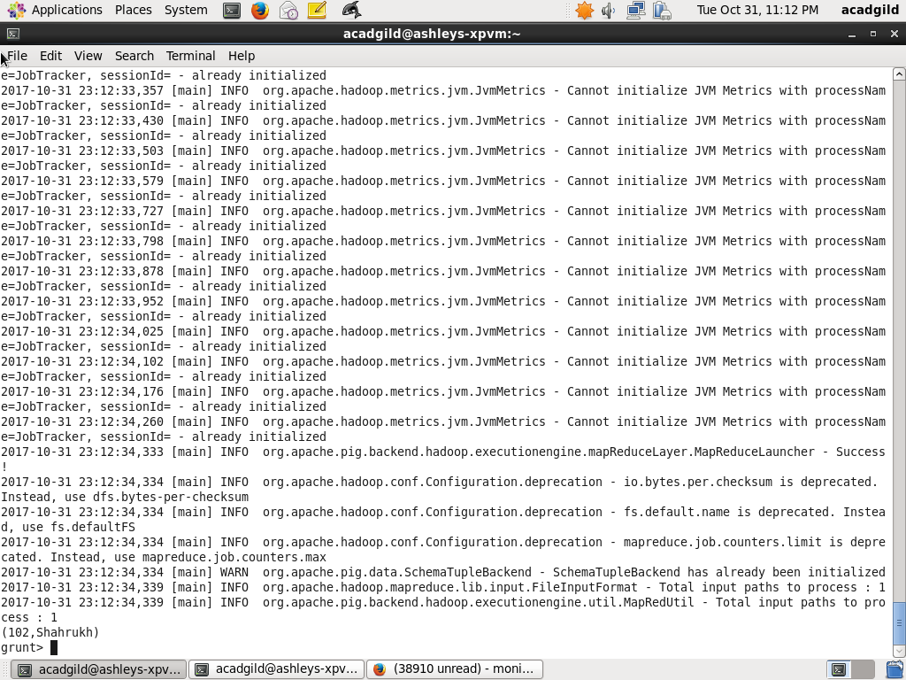

Task d. List of employees who have entries in employee_expenses file is as below:

Step1: Join is done between employee_details and employee_expenses and relation employee_details_expenses relation is formed.

employee_details_expenses = COGROUP employee_details BY employee_id, employee_expenses BY employee_id;

Step2: Next, FILTER those records in employee_details_expenses which has employee_expenses is not empty by checking IsEmpty function returning false

employee_details_expenses_non_empty = FILTER employee_details_expenses BY IsEmpty(employee_expenses) == false;

Step3. select only fields employee_id and name and form the relation employee_id_name_expenses_non_empty

employee_id_name_expenses_non_empty = FOREACH employee_details_expenses_non_empty GENERATE employee_details.employee_id, employee_details.name;

Step4

dump employee_id_name_expenses_non_empty

Screenhosts are as below

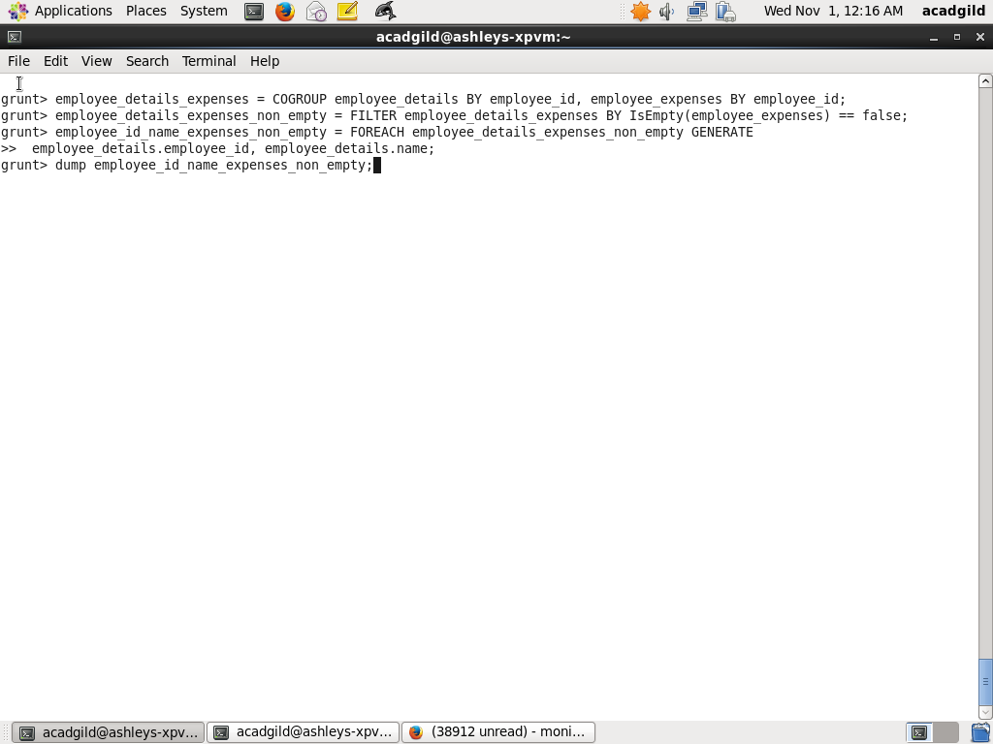

When I dump employee_id_name_expenses_non_empty I get the following screenshot which shows Amitabh, Shahrukh, Anubhav, Pawan, Priyanka, Madhuri

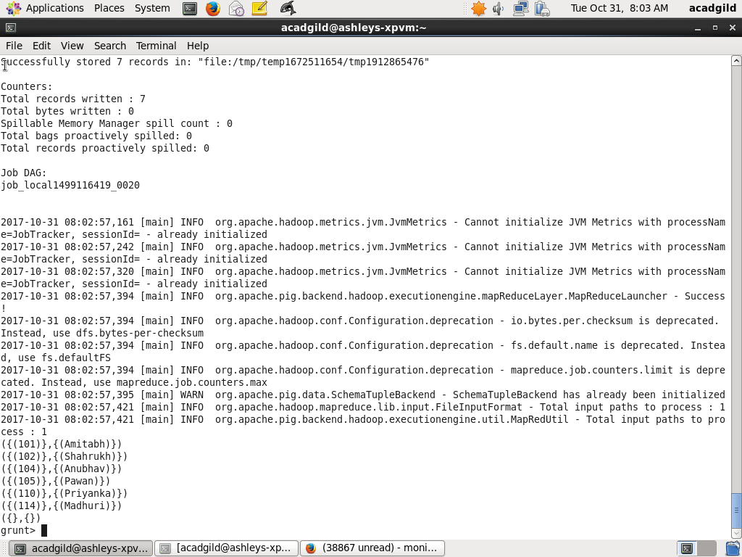

Task e. List of employees who have no entries in employee_expenses file is as below:

Step1: Join is done between employee_details and employee_expenses using COGROUP and relation employee_details_expenses relation is formed.

employee_details_expenses = COGROUP employee_details BY employee_id, employee_expenses BY employee_id;

Step2: Next, FILTER those records in employee_details_expenses which has employee_expenses has IsEmpty function returning true

employee_details_expenses_empty = FILTER employee_details_expenses BY IsEmpty(employee_expenses);

Step3. select only fields employee_id and name and form the relation employee_id_name_expenses_non_empty

employee_id_name_expenses_empty = FOREACH employee_details_expenses_empty GENERATE employee_details.employee_id, employee_details.name;

Step4

dump employee_id_name_expenses_empty

Screenhosts are as below

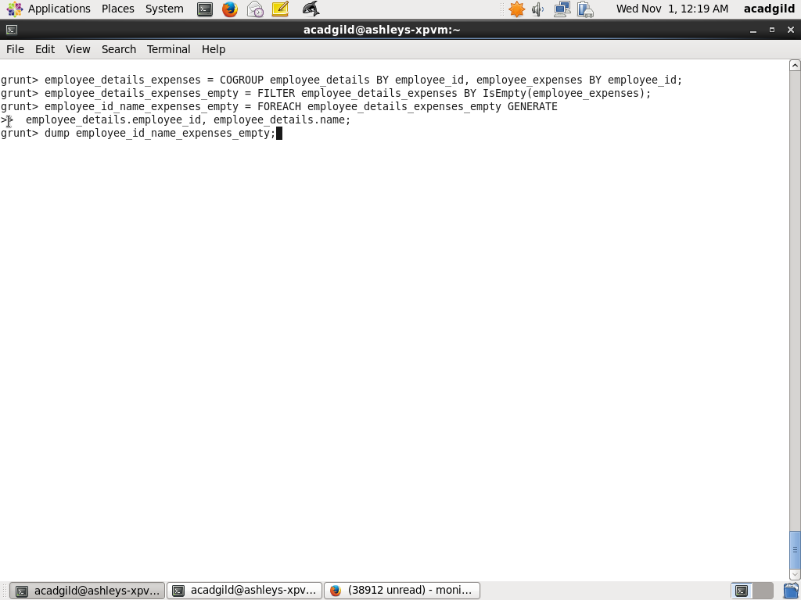

When I issue dump on employee_id_name_expenses_empty, the screenshot is as below:

