Assignment 5.3 ( Exploring PIG)

Load Dataset from Pokemon.csv into relation Load_Data

Load_Data = LOAD ‘/home/acadgild/assignment_5.3/Pokémon.csv’ USING PigStorage(‘,’) AS(Sno:int,Name:chararray,Type1:chararray,Type2:chararray,Total:int,HP:int,Attack:int, Defense:int, SpAtk:int, SpDef:int, Speed:int)

Load Screenshot of query is as below:

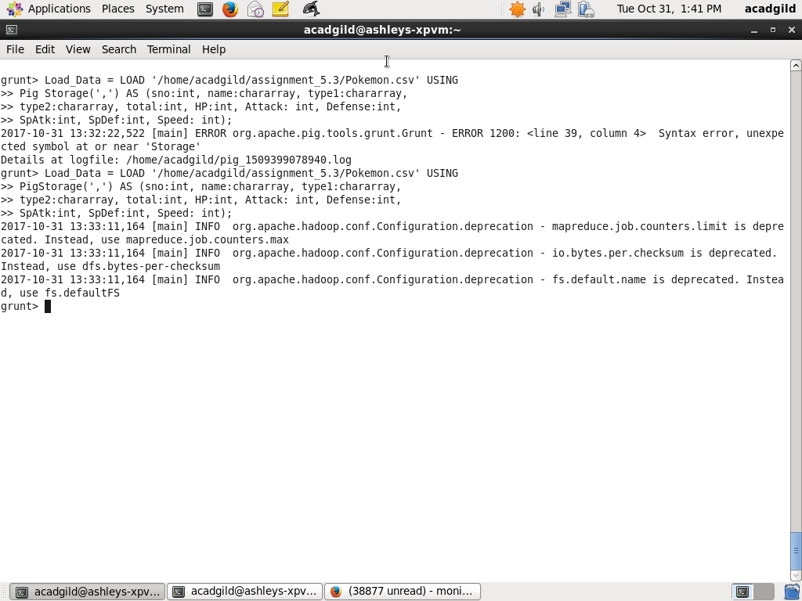

Dump Load_Data

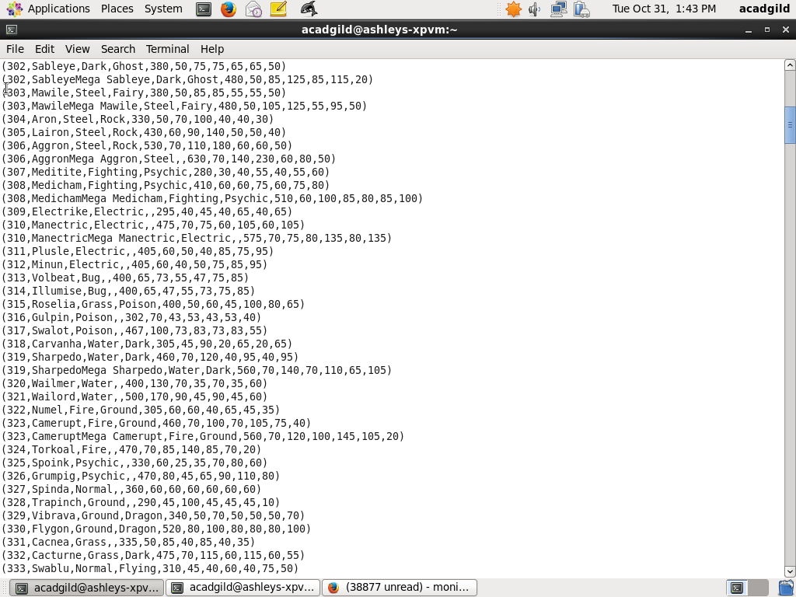

Ques 1: Find the list of players that have been selected in the qualifying round (DEFENCE>55).

selected_list = FILTER Load_Data BY Defense>55;

dump selected_list

The screenshot of query and dump is as below:

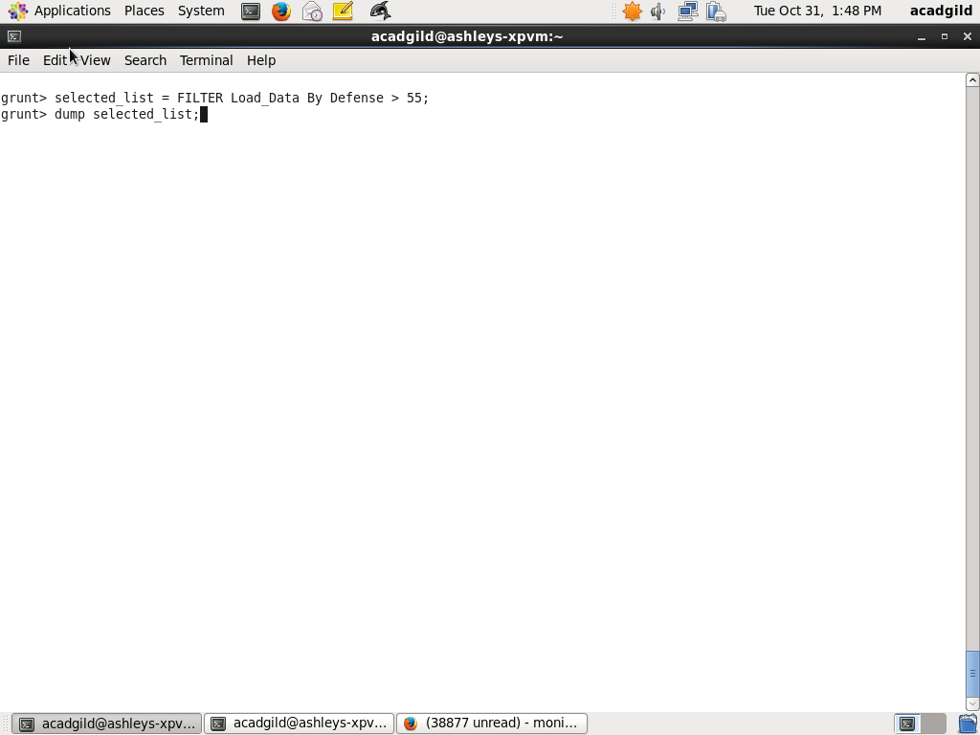

Question2: State the number of players taking part in the competition after getting selected in the qualifying round.

Step1: Group selected list by ALL

group_selcted_list = Group selected_list All;

Step2: For the group count how many are there in selected list

count_selcted_list = foreach group_selcted_list GENERATE COUNT(selected_list);

Step3:

dump count_selcted_list;

Screenshots of query and output are as below:

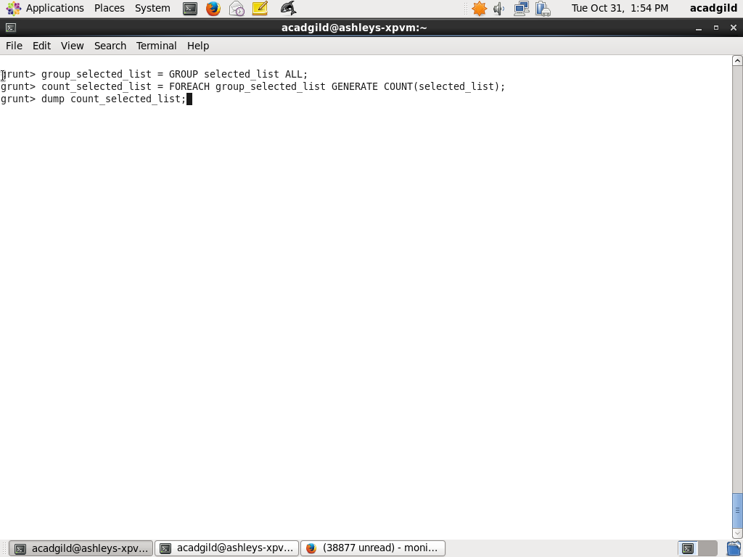

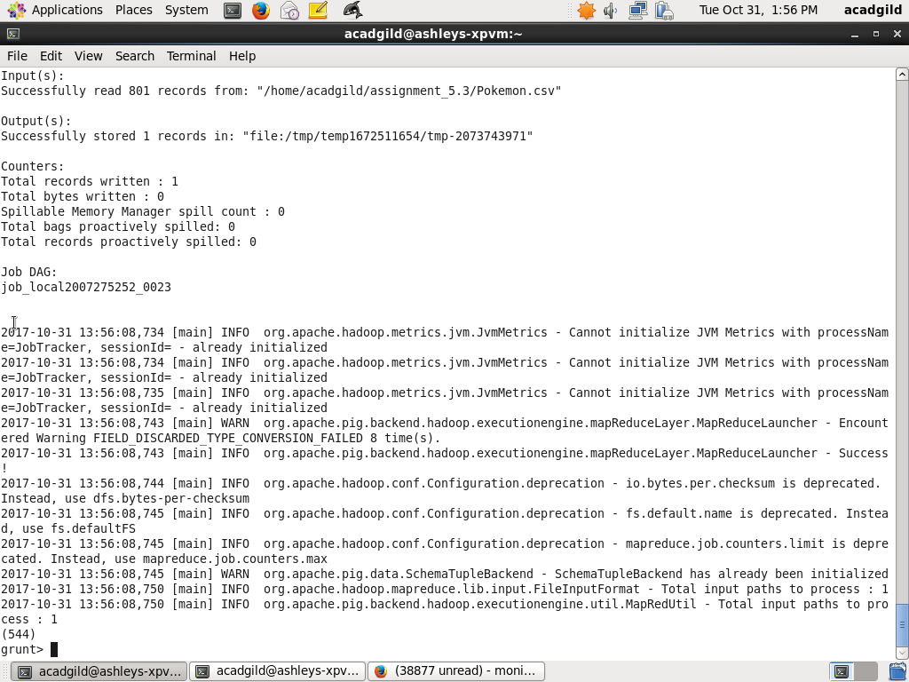

Ques 3: Using random() generate random numbers for each Pokémon on the selected list.

From the relation selected_list select fields and associate a random using RANDOM() function and form relation random_include1

random_include1 = foreach selected_list GENERATE RANDOM(),Name,Type1,Type2,Total,HP,Attack,Defense,SpAtk,SpDef,Speed;

Screenshot and output is as below

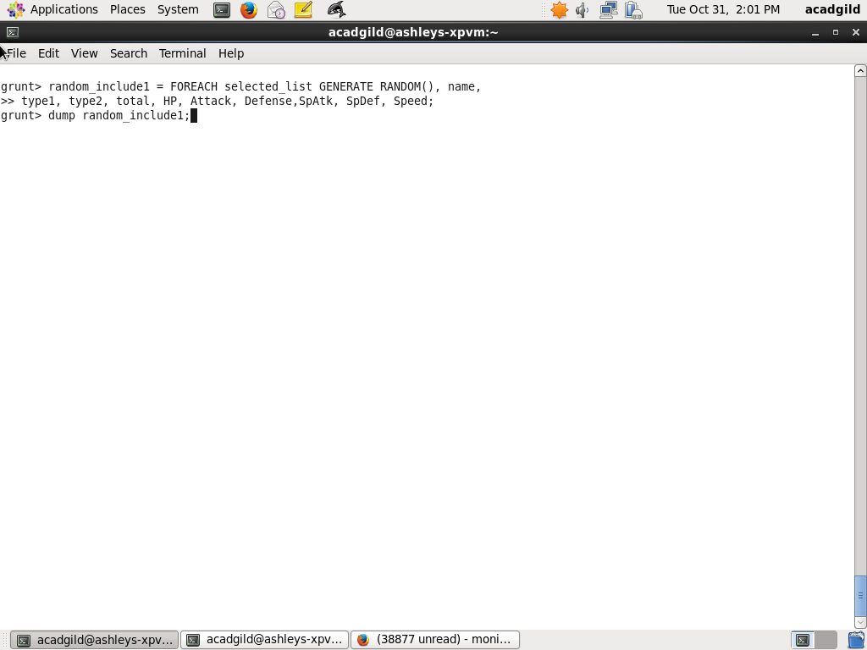

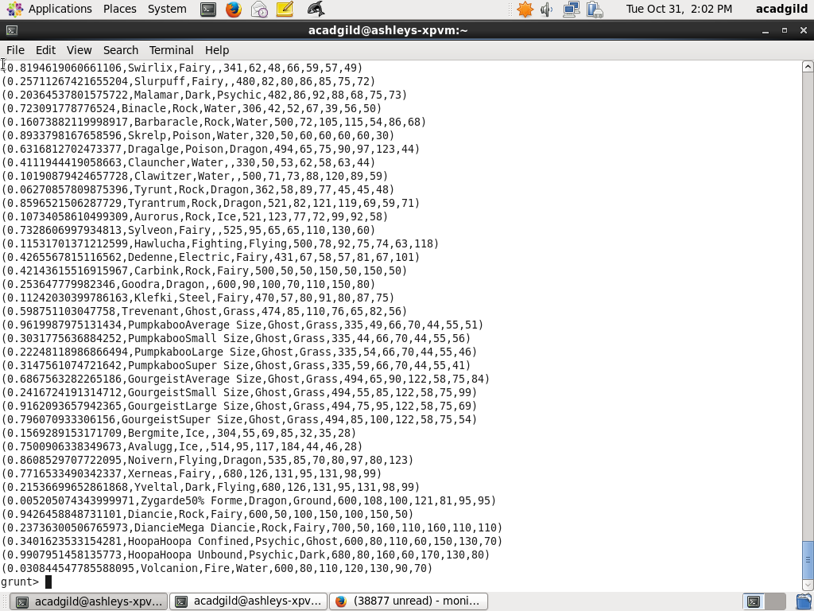

Ques 4: Arrange the new list in a descending order according to a column randomly

Random numbers in relation random_include1 are arranged in descending order and relation random1_descending is formed

random1_desending = ORDER random_include1 BY $0 DESC;

The screenshot of query and result is as below:

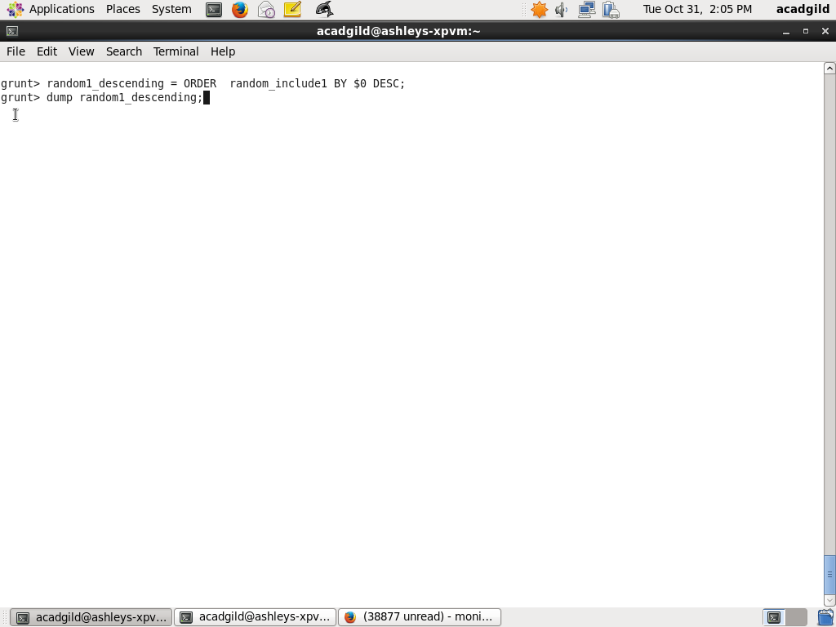

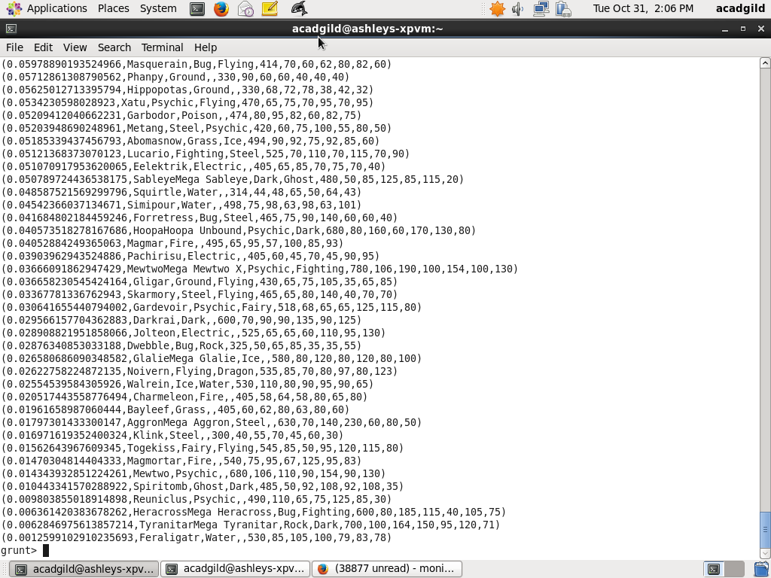

Ques 4: Arrange the new list in a descending order according to a column randomly

Random numbers in relation random_include1 are arranged in descending order and relation random1_descending is formed

random1_desending = ORDER random_include1 BY $0 DESC;

The screenshot of query and result is as below:

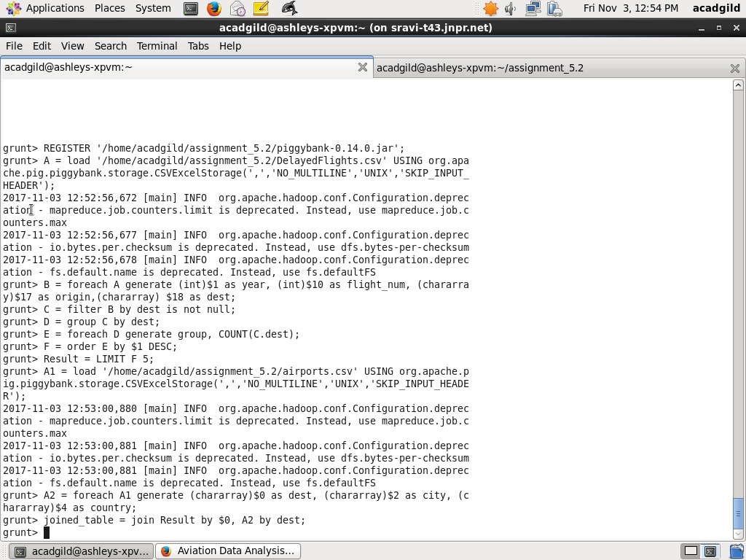

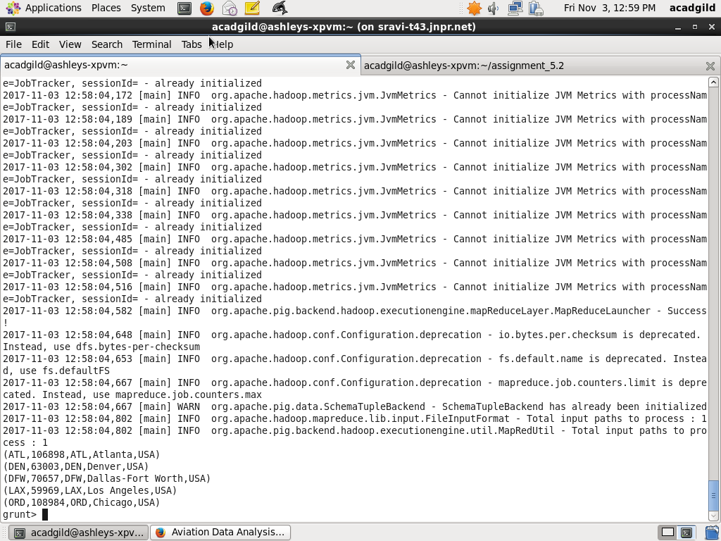

Ques 5: Now on a new relation again associate random numbers for each Pokémon and arrange in descending order according to column random.

Step1: Generate fields in relation selected_list and associate to a random number using RANDOM() and form relation random_include2

random_include2 = foreach selected_list GENERATE RANDOM(),Name,Type1,Type2,Total,HP,Attack,Defense,SpAtk,SpDef,Speed;

Step2: Order random_include2 in descending order of random number and form relation random_include2

random2_desending = ORDER random_include2 BY $0 DESC;

Step3:

dump random2_desending

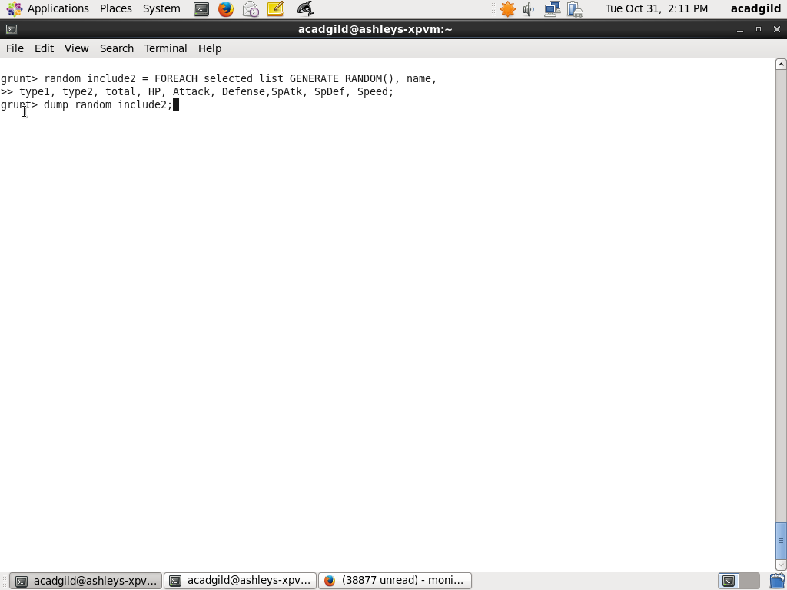

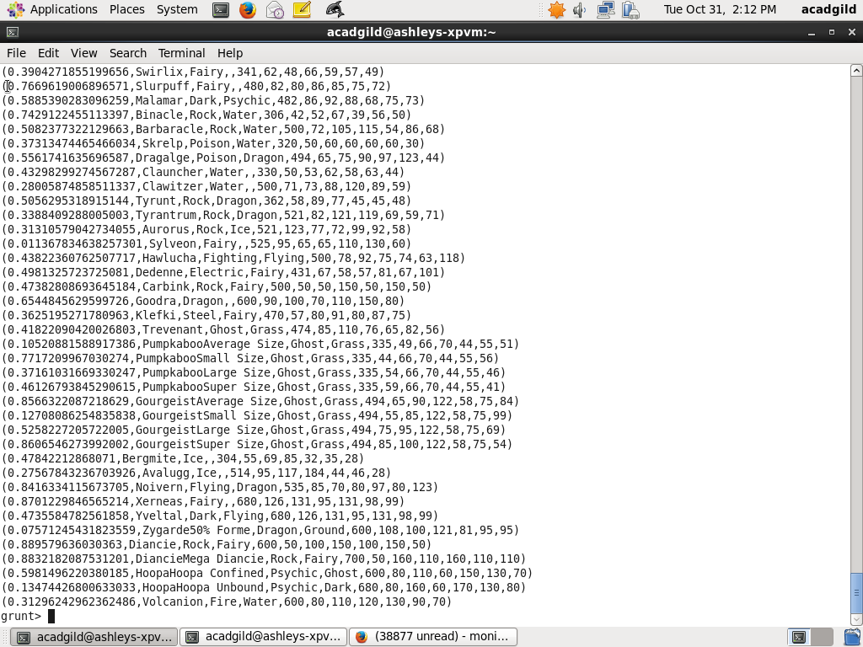

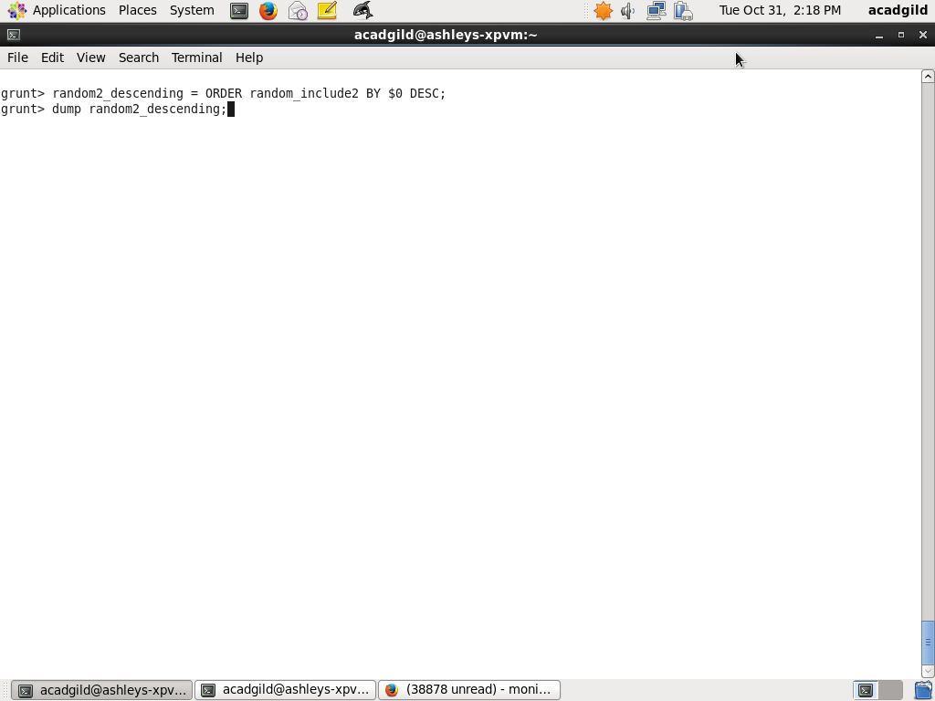

Ques6: From the two different descending lists of random Pokémons, select the top 5 Pokémons for 2 different players.

Step1: get 5 top players using LIMIT 5 on random1_desending

limit_data_random1_desending = LIMIT random1_desending 5 ;

Step2: get 5 top players using LIMIT 5 on random1_desending

limit_data_random2_desending = LIMIT random2_desending 5 ;

Screenshots and output are as below:

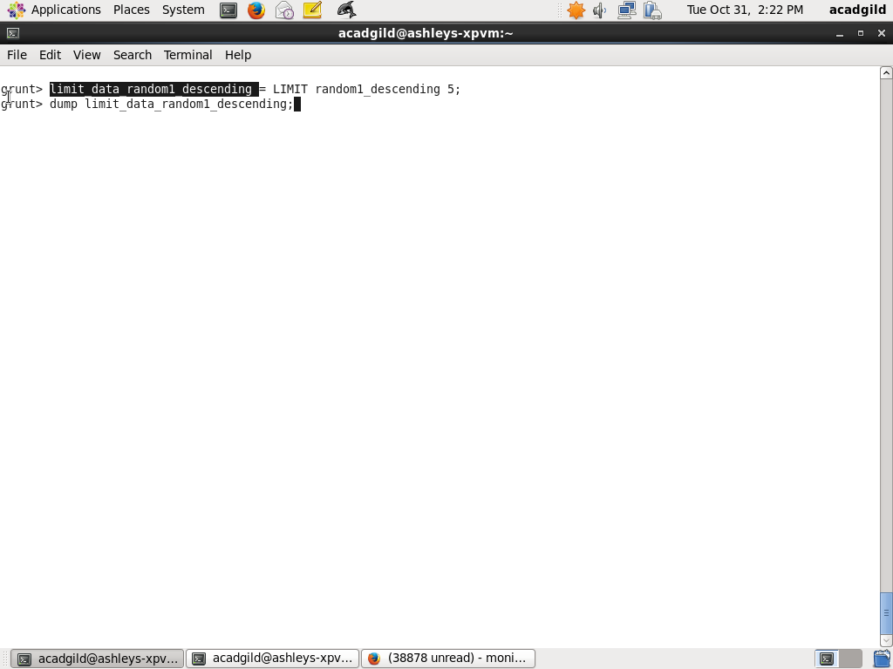

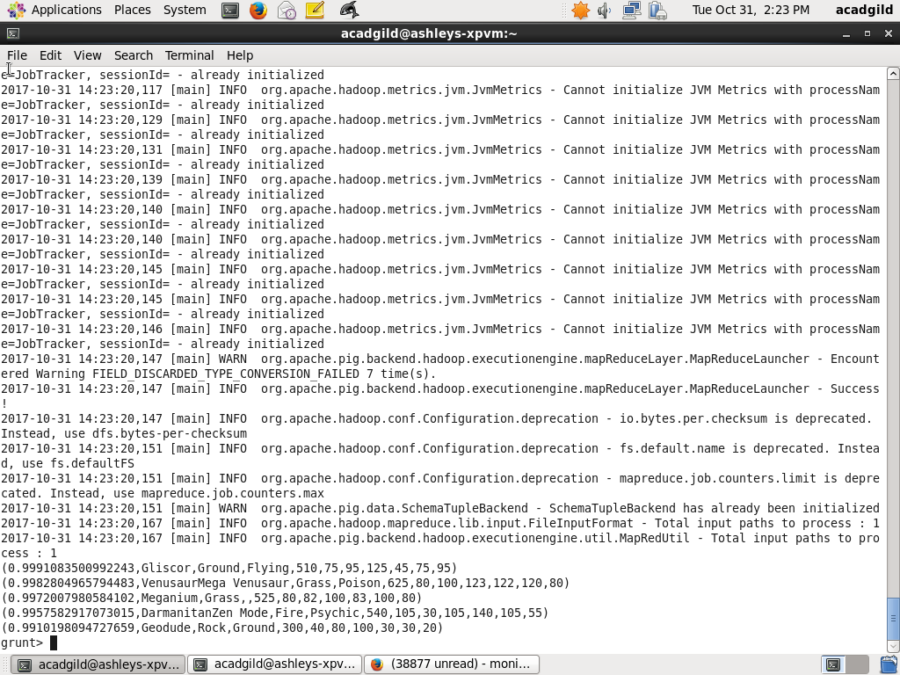

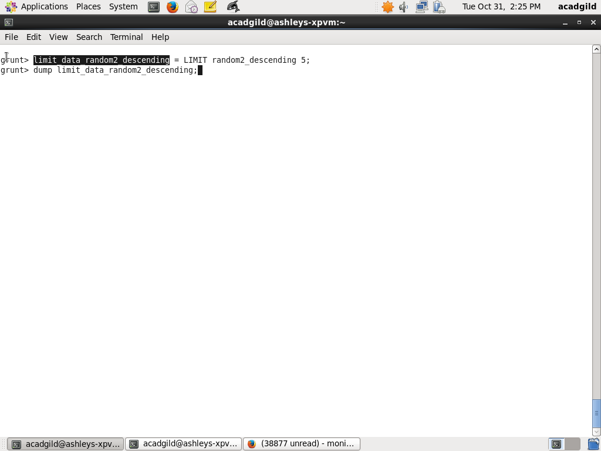

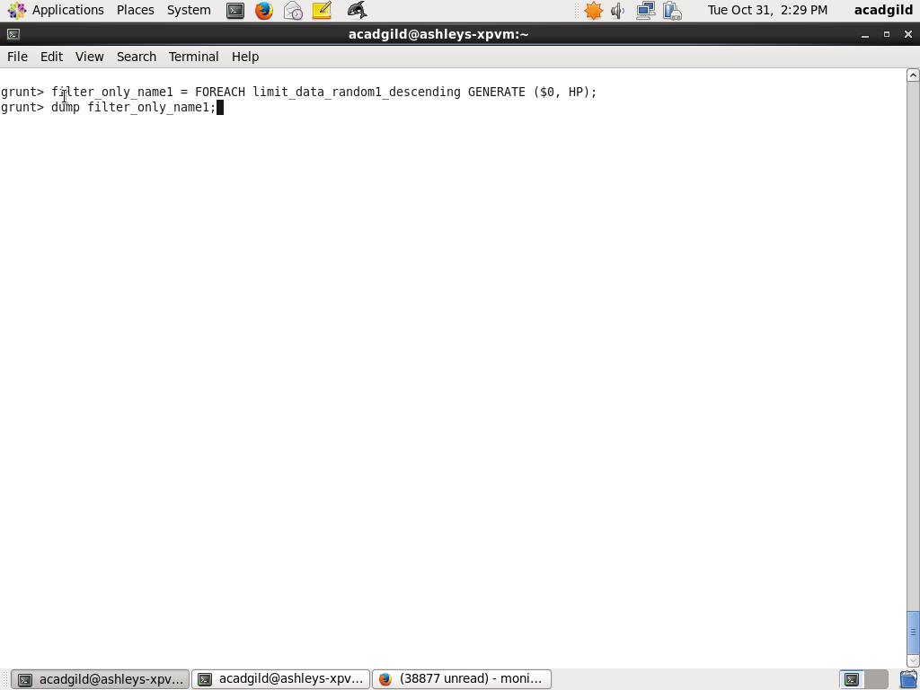

Ques: Store the data on a local drive to announce for the final match. By the name player1 and player2 (only show the NAME and HP).

Step1:

For relation limit_data_random1_desending generate fields name and HP

filter_only_name1 = foreach limit_data_random1_desending Generate ($1,HP);

Step2:

For relation limit_data_random1_desending generate fields name and HP

filter_only_name2 = foreach limit_data_random2_desending Generate ($1,HP);

Step3:

Store the tuples in relation limit_data_random1_desending into ‘/home/acadgild/assignment_5.3/player1.txt

STORE limit_data_random1_desending INTO ‘/home/acadgild/assignment_5.3/player1.txt’;

Step4:

Store the tuples in relation limit_data_random2_desending into ‘/home/acadgild/assignment_5.3/player2.txt

STORE limit_data_random1_desending INTO ‘/home/acadgild/assignment_5.3/player2.txt’;

Screenshots of Step1 to Step4 are as below:



