Assignment 6.1 ( Hive Introduction)

Step1: The following hive command is used to create database named custom

CREATE DATABASE custom;

Step2: The following command is used to show database custom created successfully

SHOW DATABASES;

Step3:

The table temperature_data is created with schema

date type string, zip_code string, temperature float

Using the command below:

CREATE TABLE IF NOT EXISTS temperature_data

(

date string,

zip_code string,

temperature float

)

ROW FORMAT DELIMITED FIELDS TERMINATED BY ',';

Note: The dataset given has date in the format dd-MM-yyyy as we have data like 02-14-1991, 14 can only be day (not month). But data is displayed, it will be displayed in MM-dd-yyyy

Step4:

Use the following command to check that table temperature_data is created

DESCRIBE temperature_data;

Screenshot of Step1 to Step4 is as below

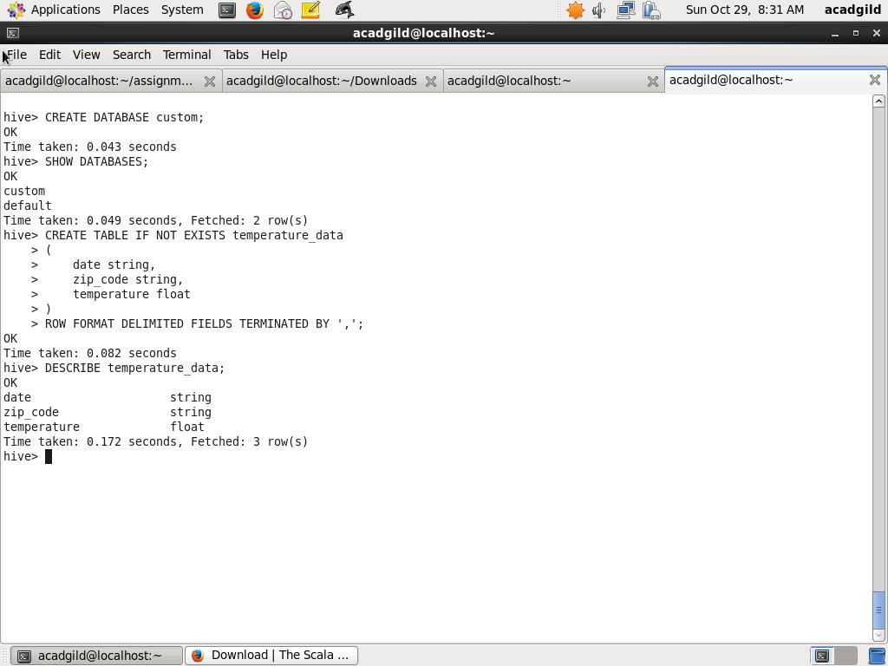

Step5:

Use the following command to switch to newly created database custom

USE custom;

Step6:

Use the following LOAD DATA LOCAL INPATH command to load data from given dataset dataset_Session 14.txt

LOAD DATA LOCAL INPATH '/home/acadgild/assignment_6.1/dataset_Session 14.txt' OVERWRITE INTO TABLE temperature_data;

Step7:

Use the following SELECT command to display all the records of table temperatute_data. Note date will be displayed in MM-dd-yyyy format

SELECT from_unixtime(UNIX_TIMESTAMP(date, 'dd-MM-yyyy'),'MM-dd-yyyy'), zip_code, temperature FROM temperature_data;

Screenshot of Steps 5 to 7 is as below:

