Assignment 6.2 ( Hive Introduction)

Task1: Fetch date and temperature from temperature_data where zip code is greater an 300000 and less than 399999

The following query will perform this task zip code is checked if it is between

300000 and 399999

SELECT from_unixtime(UNIX_TIMESTAMP(date, 'dd-MM-yyyy'), 'MM-dd-yyyy'),temperature FROM temperature_data

WHERE cast(zip_code as int) > 300000 AND cast(zip_code as int) < 399999;

Screenshot of query with output is as below:

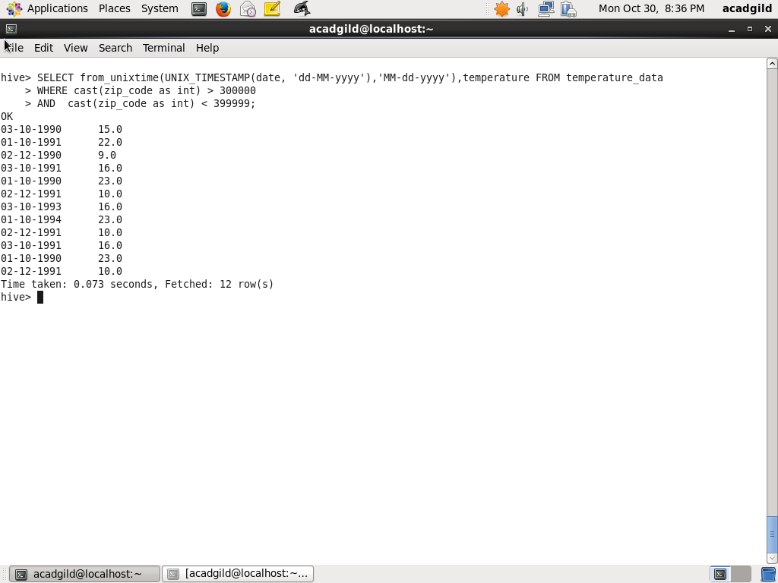

Task2: Calculate maximum temperature of each year

The following query will do the task, YEAR function is to get Year and max function is used

To get the maximum temperature group by year

SELECT YEAR(from_unixtime(UNIX_TIMESTAMP(date, 'dd-MM-yyyy'))), max(temperature) FROM temperature_data

GROUP BY YEAR(from_unixtime(UNIX_TIMESTAMP(date, 'dd-MM-yyyy')));

Screenshot of Hive query and output is as below:

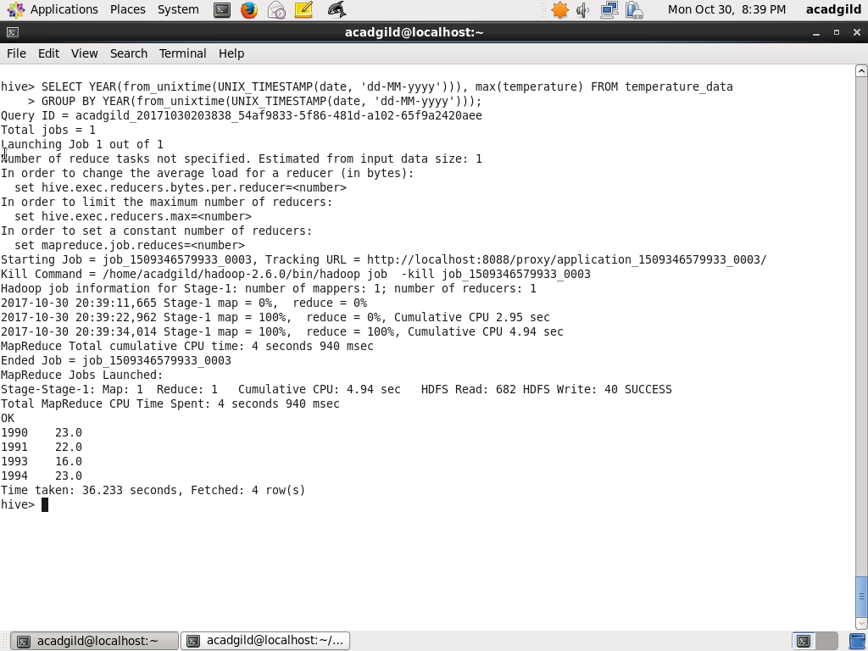

Task3:

Calculate maximum temperature corresponding to each year having at least 2 entries

The following query will do the task, YEAR function is to get Year and max function is used

To get the maximum temperature group by year and count function is used to check number

Of records of year is equal to or greater than 2

SELECT YEAR(from_unixtime(UNIX_TIMESTAMP(date, 'dd-MM-yyyy'))), max(temperature) FROM temperature_data

GROUP BY YEAR(from_unixtime(UNIX_TIMESTAMP(date, 'dd-MM-yyyy')))

HAVING COUNT(*) >= 2;

Screenshot of Hive query and output is as below:

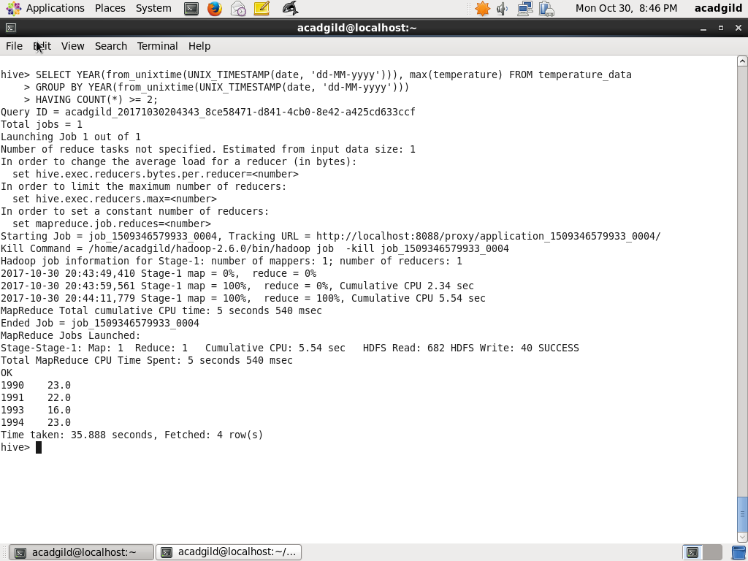

Task 4: Create a view of last query and store it as temperature_data_dw

Using CREATE VIEW temperature_data_vw with last query the view is created. Query is as below:

CREATE VIEW temperature_data_vw AS

SELECT YEAR(from_unixtime(UNIX_TIMESTAMP(date, 'dd-MM-yyyy'))), max(temperature) FROM temperature_data

GROUP BY YEAR(from_unixtime(UNIX_TIMESTAMP(date, 'dd-MM-yyyy')))

HAVING COUNT(*) >= 2;

The records of temperature_data_vw are selected using SELECT query as below

SELECT * FROM temperature_data_vw

The screenshot of query and output is as below:

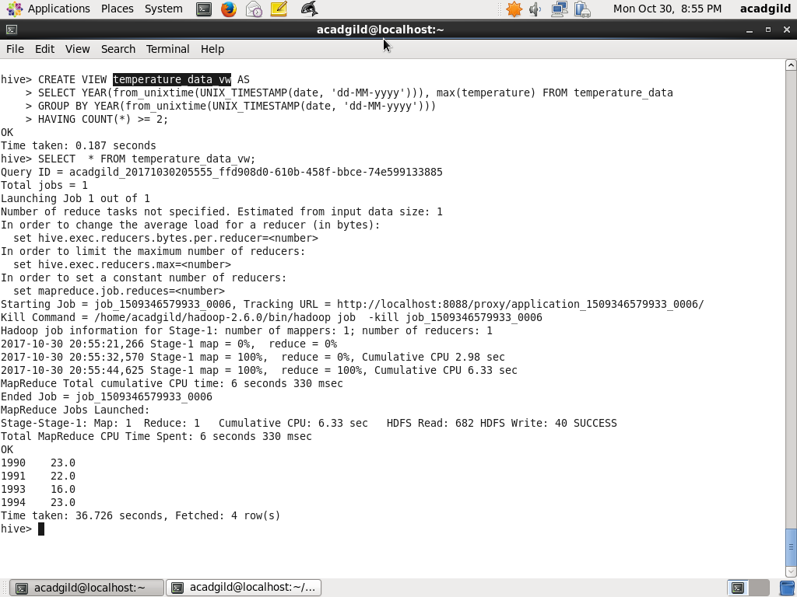

Task5:

Export contents from view temperature_data_vw to local file system with | delimited

Using the query below contents of temperature_data_vw is saved to local directory

/home/acadgild/assignment_6.2/output with | delimited

INSERT OVERWRITE LOCAL DIRECTORY ‘/home/acadgild/assignment_6.2/output' ROW FORMAT DELIMITED

FIELDS TERMINATED BY '|'

SELECT * FROM temperature_data_vw;

The list of files under /home/acadgild/assignment_6.2/output is viewed

!ls –l /home/acadgild/assignment_6.2/output

The content is displayed using:

!cat /home/acadgild/assignment_6.2/output/000000_0

Screenshot for the query and content is as below:

