Assignment 7.1 ( Hive Operation)

Step1: Create table employee

Following Hive DDL command is used to create table employee

CREATE TABLE IF NOT EXISTS employee

(

name string,

skill string,

department_id int,

location string

);

Step2: Load data into table employee

Following Hive Query is d is used to load data into table employee

LOAD DATA LOCAL INPATH '/home/acadgild/assignment_7.1/emp_details.txt'

OVERWRITE INTO TABLE employee;

Screenshots of step1 and step2 are as below

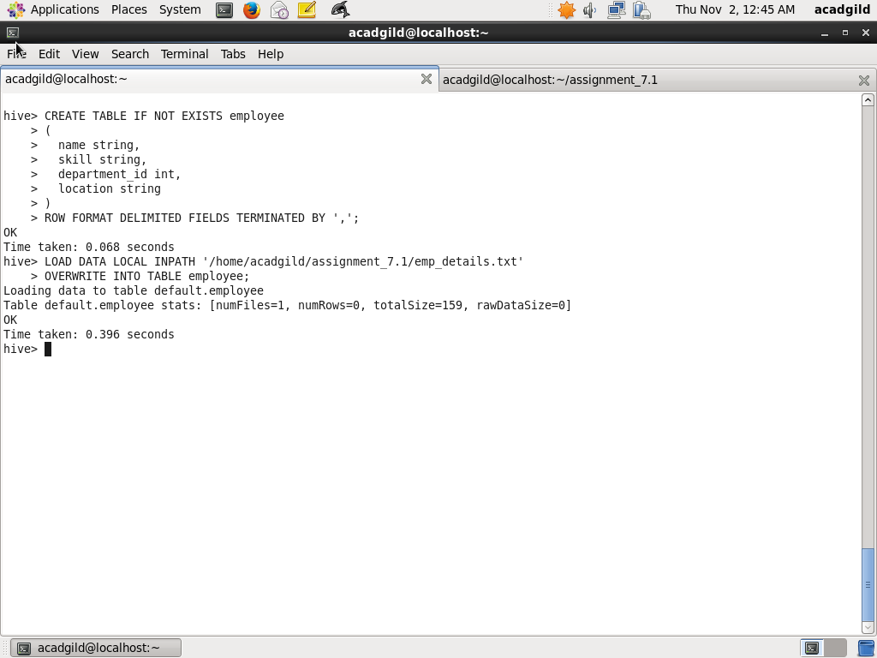

Step3 :Calculate Number of Employees of each skill

The following query records are grouped by skill and count is calculated for each group

SELECT skill, count(*)

FROM employee

GROUP BY skill;

The screenshot with query and output is as below:

