Assignment 8.3

Step1:Set the properties for enabling transaction in Hive

Set the following properties in Hive Shell for enabling transaction in Hive

set hive.support.concurrency = true;

set hive.enforce.bucketing = true;

set hive.exec.dynamic.partition.mode = true;

set hive.txn.manager = org.apache.hadoop.hive.ql.lockmgr.DbTxnManager;

set hive.compactor.initiator.on = true;

set hive.compactor.worker.threads = 1;

Screenshot is as below:

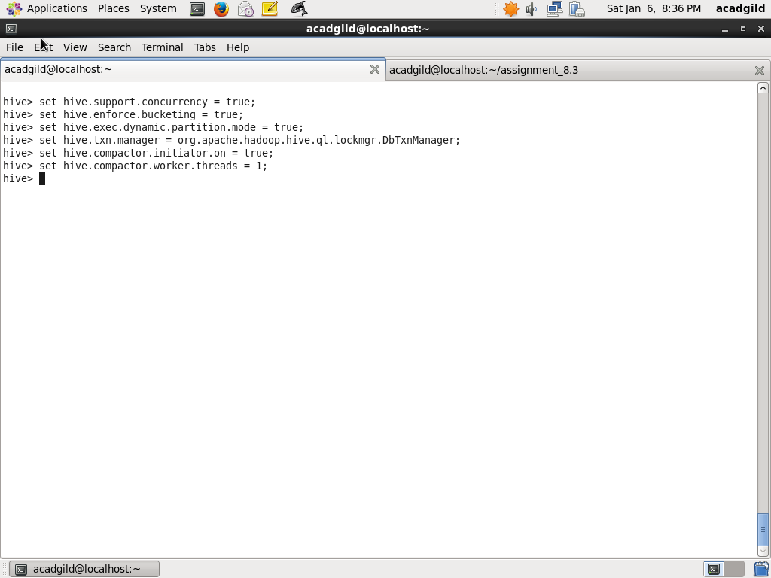

Step2: Create table college

Create table college with the fields clg_id, clg_name, clg_loc.

CREATE TABLE college(clg_id int, clg_name string, clg_loc string) clustered by (clg_id) into 5 buckets stored as orc TBLPROPERTIES('transactional'='true');

We are bucketing the table by ‘clg_id’ and table format is orc. Also, enabling transaction by TBLPROPERTIES('transactional'='true')

Screenshot is as below:

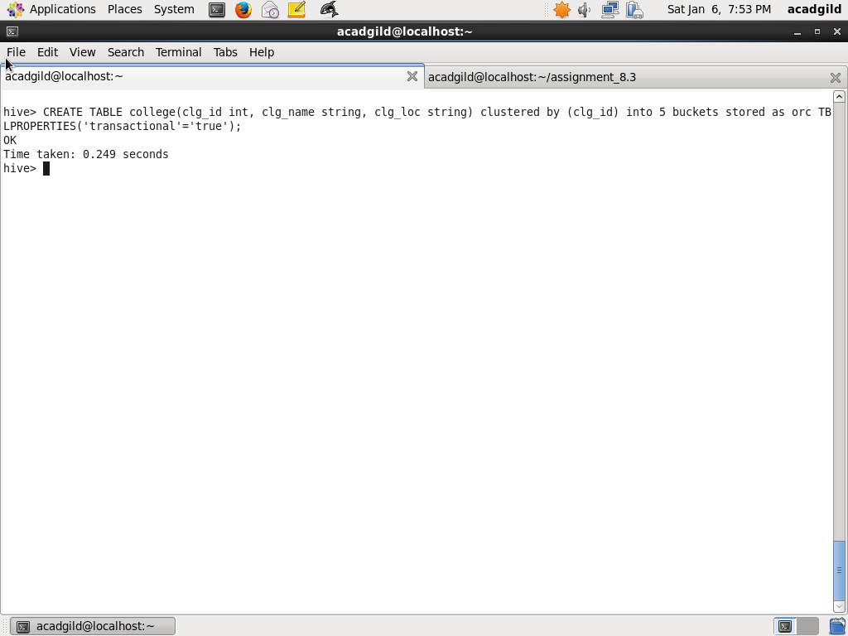

Step3: Insert records to table college

Insert records to table college

INSERT INTO table college values(1,'nec','nlr'),(2,'vit','vir'),(3,'srm','chen'),(4,'lpu','del'),(5,'stanford','uk'),(6,'JNTUA','atp'),(7,'cambridge','us');

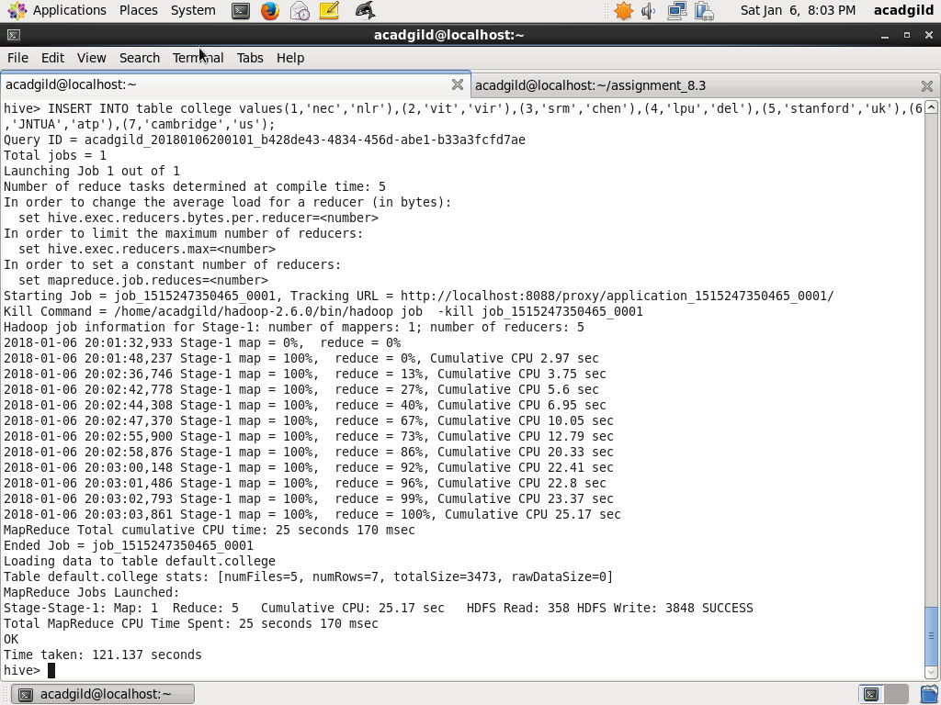

Step4: Use select to show the records

select * from college;

Screenshot is as below:

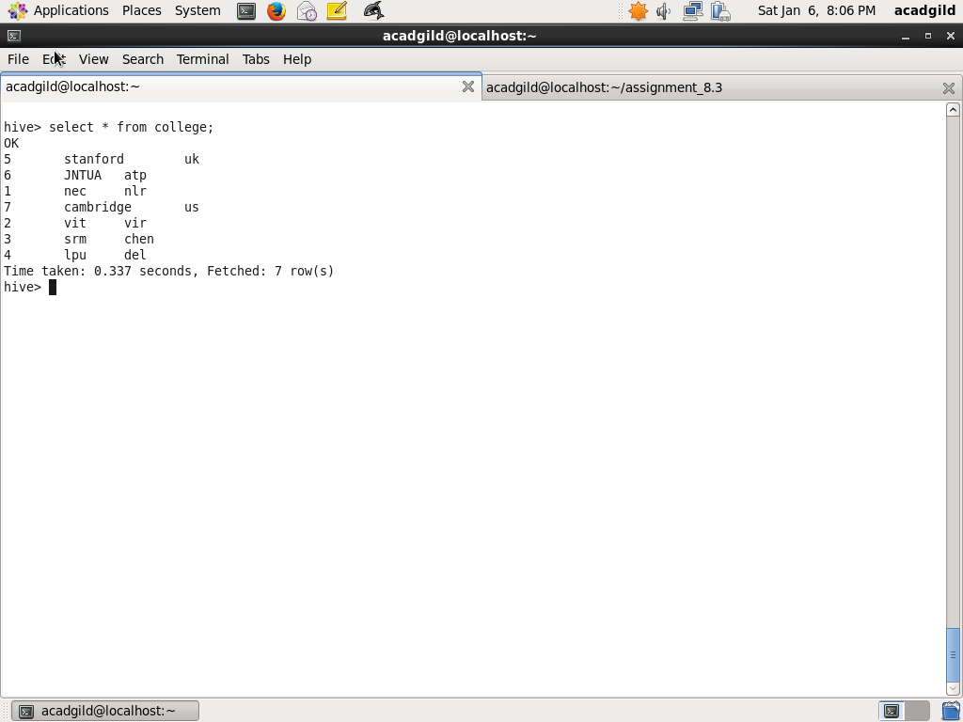

Step5: Insert same records to table college

INSERT INTO table college values(1,'nec','nlr'),(2,'vit','vir'),(3,'srm','chen'),(4,'lpu','del'),(5,'stanford','uk'),(6,'JNTUA','atp'),(7,'cambridge','us');

Screenshot is as below:

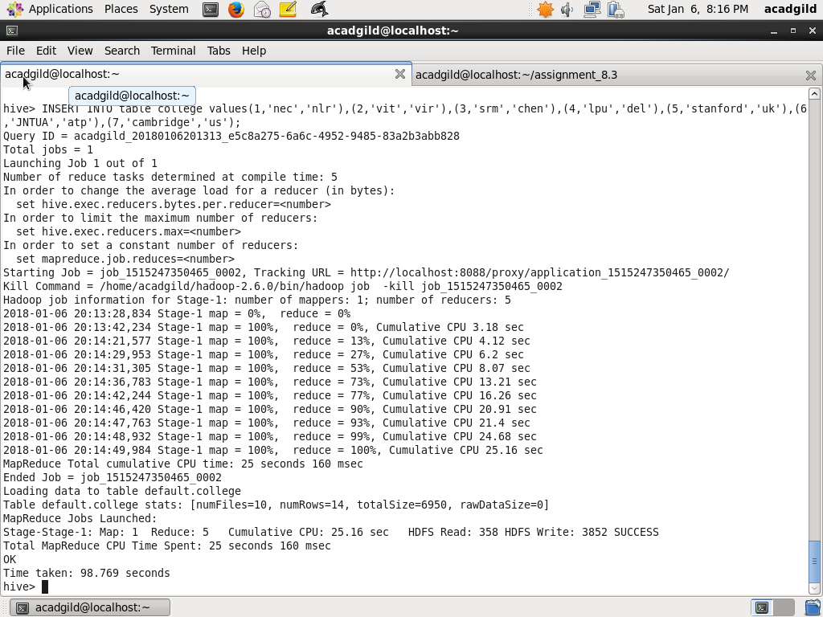

Step6: Use select to show the records

select * from college;

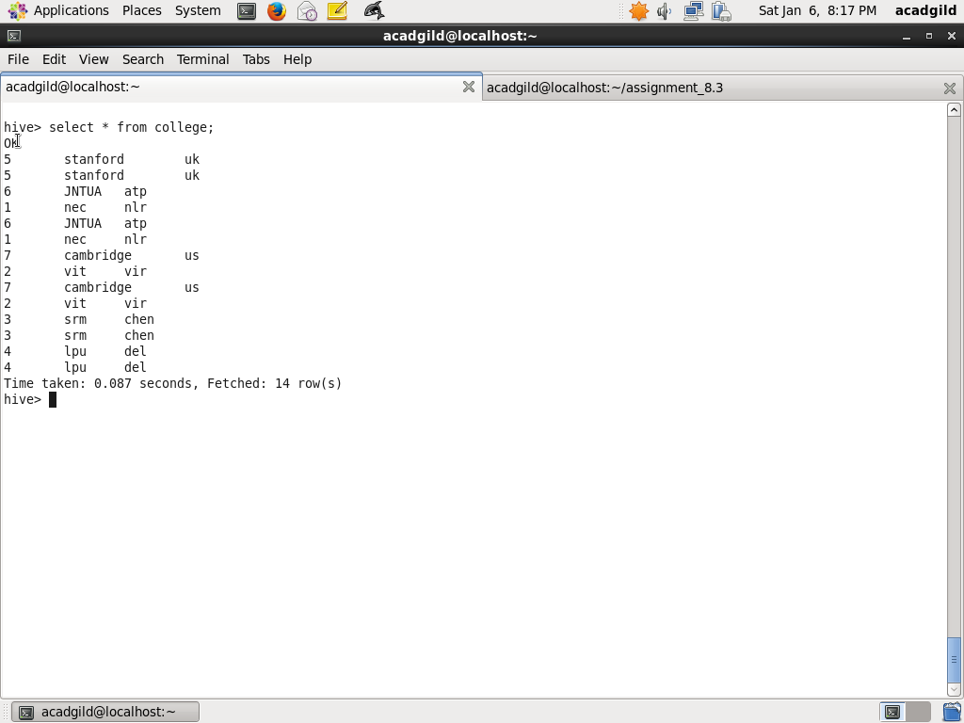

Step7: Use update on the college on bucketed field

update college set clg_id=8 where clg_id=7;

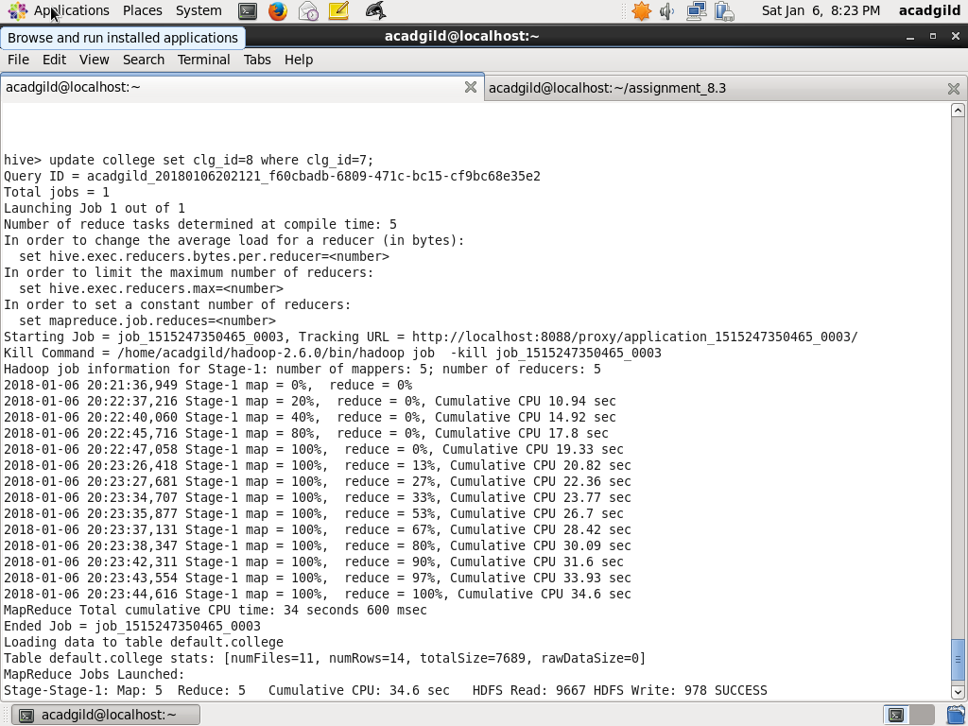

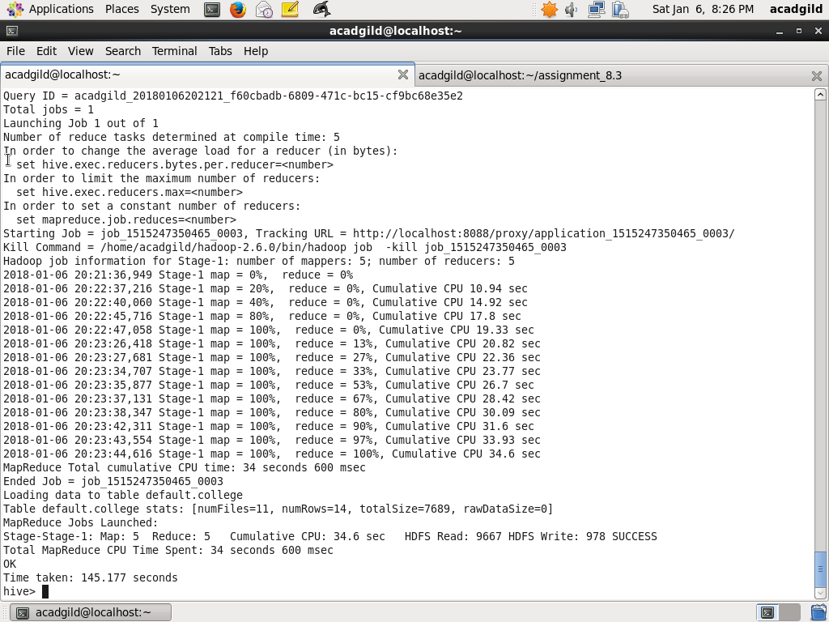

(Note: Ideally bucketed column clg_id should not allowed to update and it will return SematicException, but there seems to be bug as it allows)

Step8: Use select on table college

select * from college;

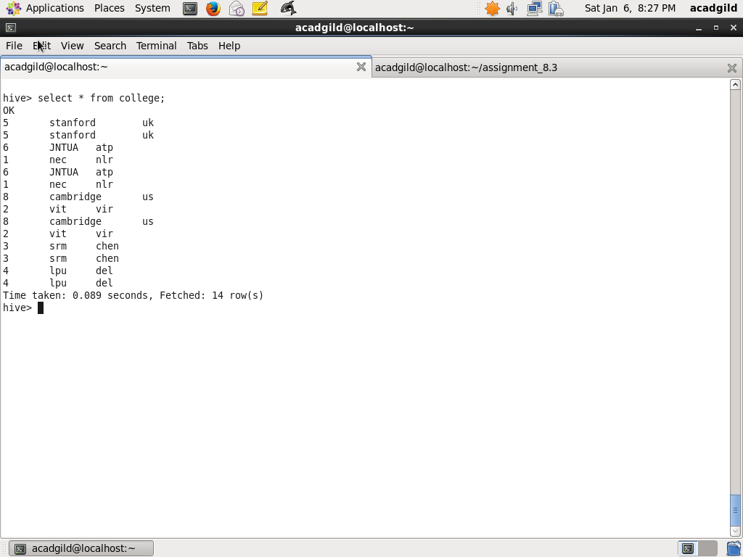

Step9: Use update on the college on non bucketed column clg_name

Use update on the college on non bucketed column clg_name. Non bucketed column clg_name should be updated

update college set clg_name='IIT' where clg_id=6;

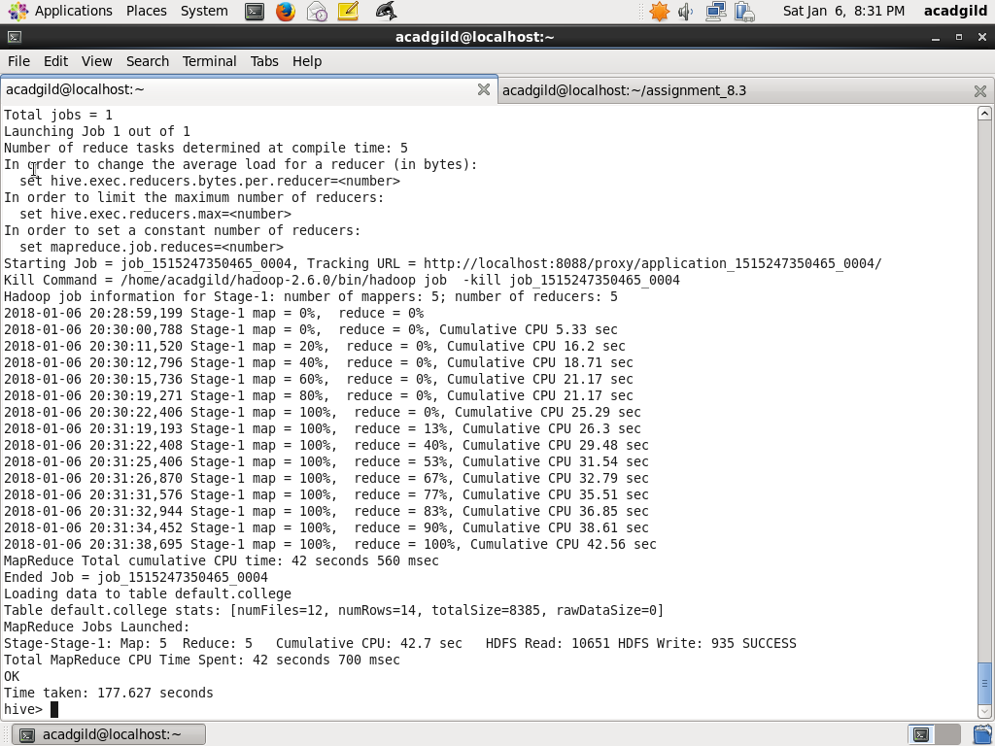

Step10: Use select on the college

The no bucketed column should be updated

