Assignment 9.2 (HBASE)

Step1: Create a HBASE table click with column family hit which can have 5 versions

|  |
| --- |
| HBASE Command to create table: clicks with column family hits is as below: |
|  |

|  |
| --- |
|  |
|  |

create 'clicks', {NAME =>'hits', version => 5}

To verify the table is created using the following commands:

|  |
| --- |
| list |
|  |

describe 'clicks'

Screenshot is as below:

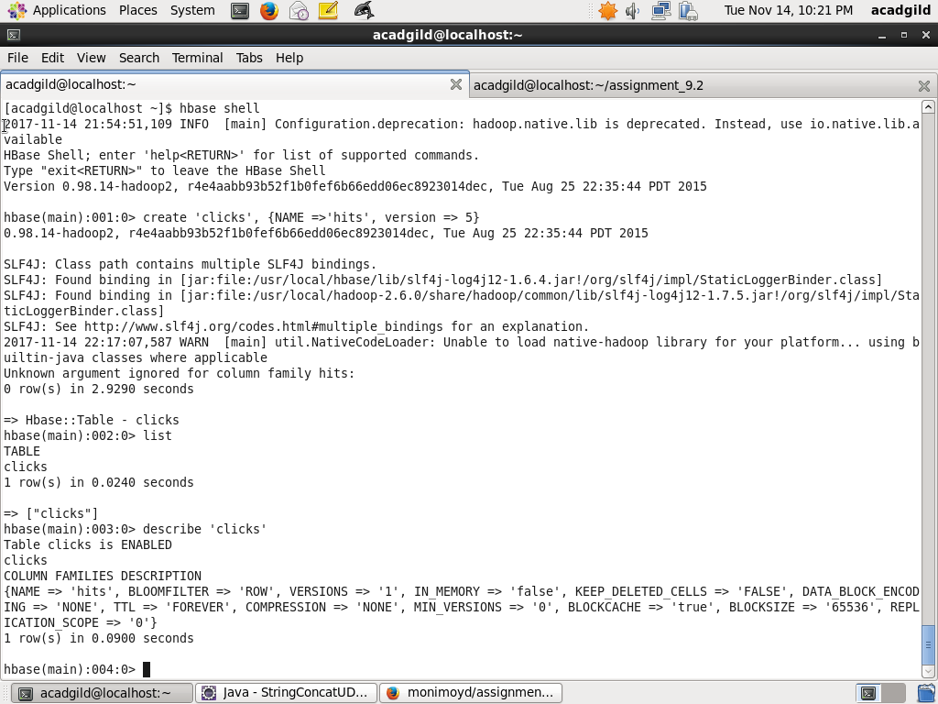

Step2: Populate Data

I used two columns total_hits and users_visited and row key as IP address. A few updates

Are done so that multiple versions are created

put 'clicks', '10.5.2.15','hits:total_hits', '3'

put 'clicks', '10.5.2.15','hits:users_visited', 'rob,tom,harry'

put 'clicks', '10.5.2.18','hits:total_hits', '2'

put 'clicks', '10.5.2.18','hits:users_visited', 'reid,roy'

put 'clicks', '10.5.2.15','hits:total_hits', '5'

put 'clicks', '10.5.2.15','hits:users_visited', 'rob,tom,harry,john,larry'

put 'clicks', '10.5.2.18','hits:total_hits', '4'

put 'clicks', '10.5.2.18','hits:users_visited', 'reid,roy,ashok,sheetal'

put 'clicks', '10.5.2.15','hits:total_hits', '6'

put 'clicks', '10.5.2.15','hits:users_visited', 'rob,tom,harry,john,larry,sachin'

Screenshot is as below:

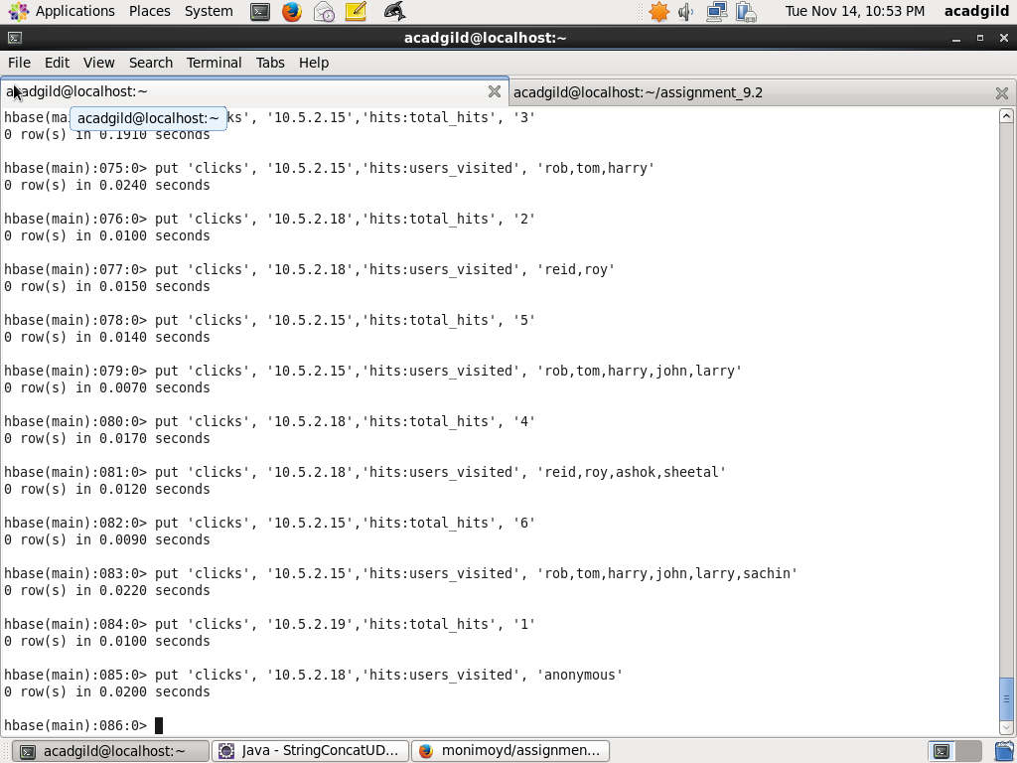

Step2: Updating more data

put 'clicks', '10.5.2.19','hits:total_hits', '1'

put 'clicks', '10.5.2.19','hits:users_visited', 'anonymous'

Screenshot is as below:

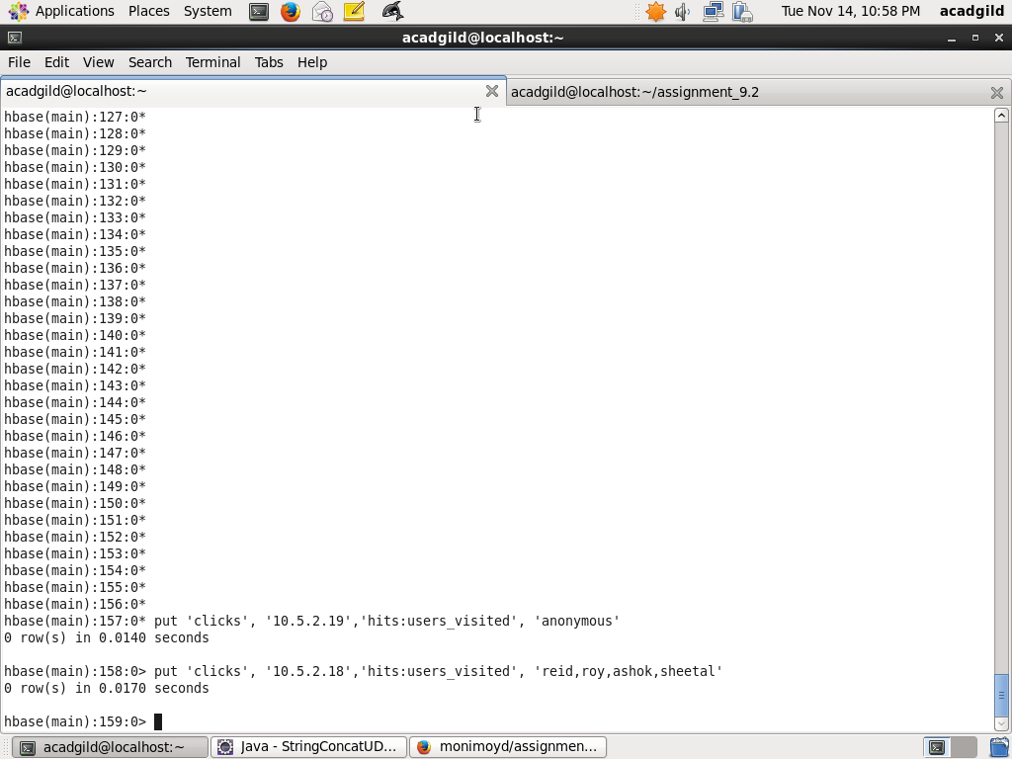

Step4: Show all the versions of clicks

The following command is used to show all the version

scan 'clicks', {RAW => true, VERSIONS => 5 }

Screenshot with output is as below:

