Step1:

Create Flume Config file filecopy.conf as below and copy to folder /home/acadgild/project2

Screenshot is as below:

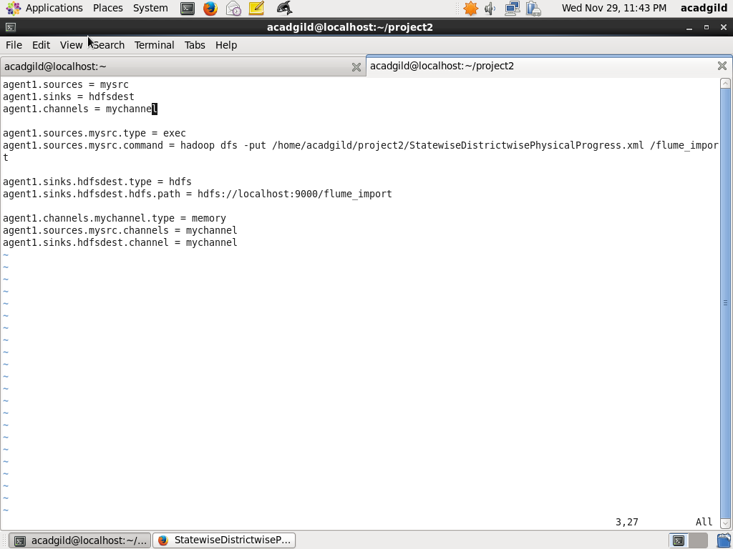

Step 2: Copy dataset from local file system to HDFS using flume.

flume-agent agent –n agent1 –c /home/acadgild –f /home/acadgild/project2/filecopy.conf

Screenshot is as below:

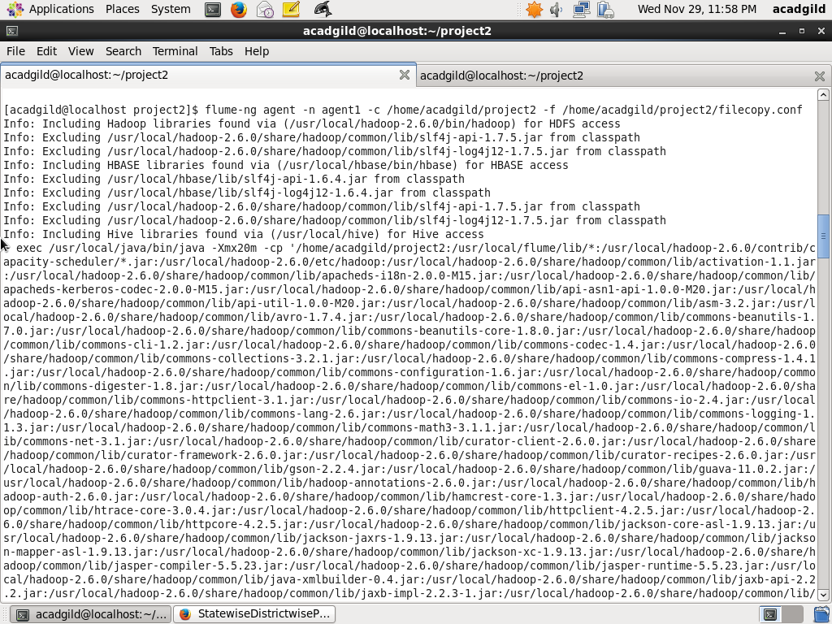

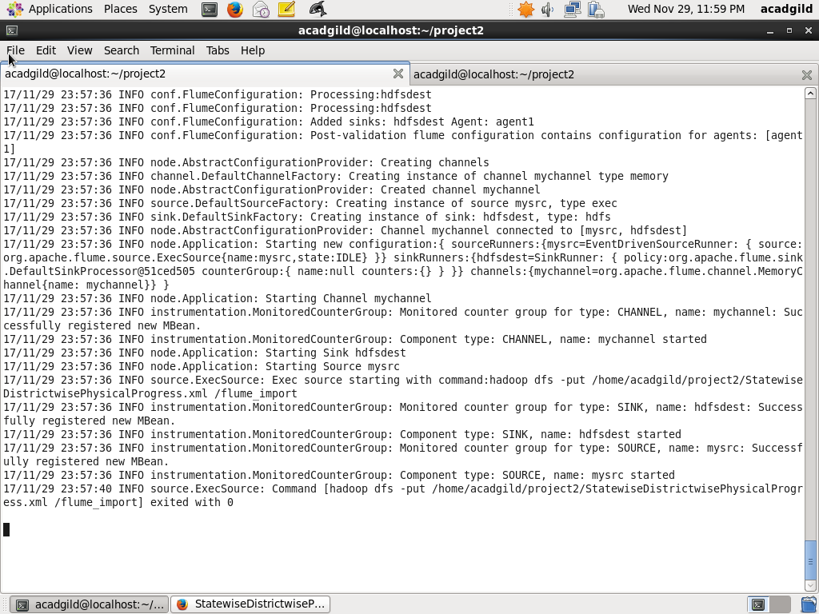

Step 3: Verify that file is copied using the HDFS commands below

The command below confirms the directory is created

hadoop fs –ls /flume_import

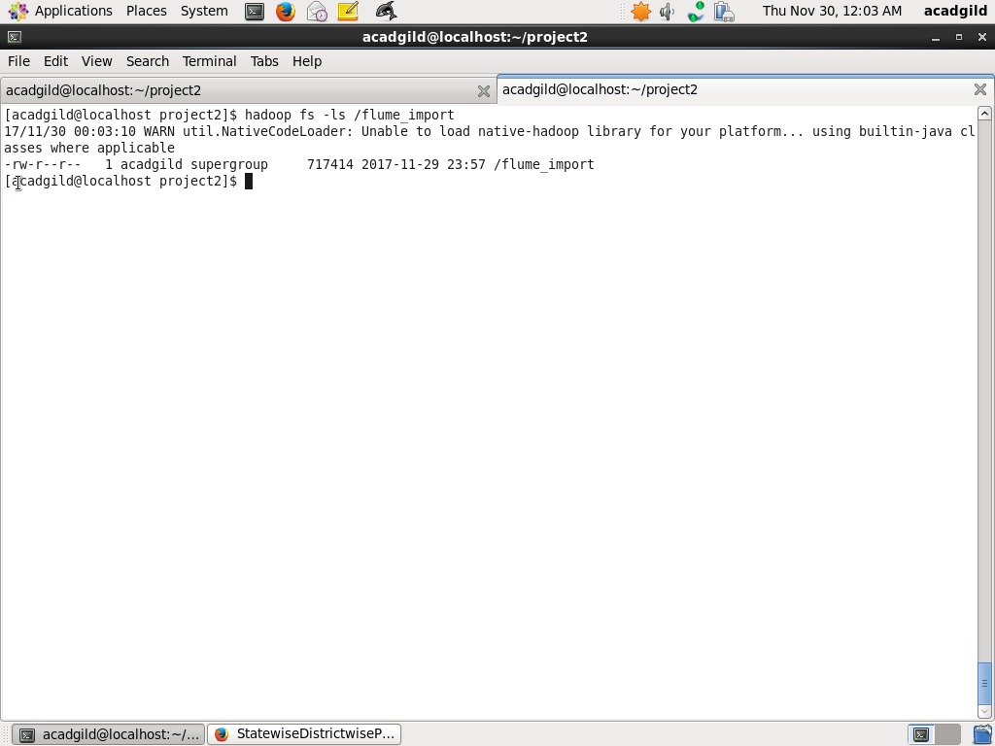

Step4: Create folders in HDFS to store query outputs

Create two folders districts_having_100percent_objectives and districts_having_80percent_objectives in HDFS.

hadoop fs –mkdir folders districts_having_100percent_objectives

hadoop fs –mkdir folders districts_having_80percent_objectives

Screenshots are as below:

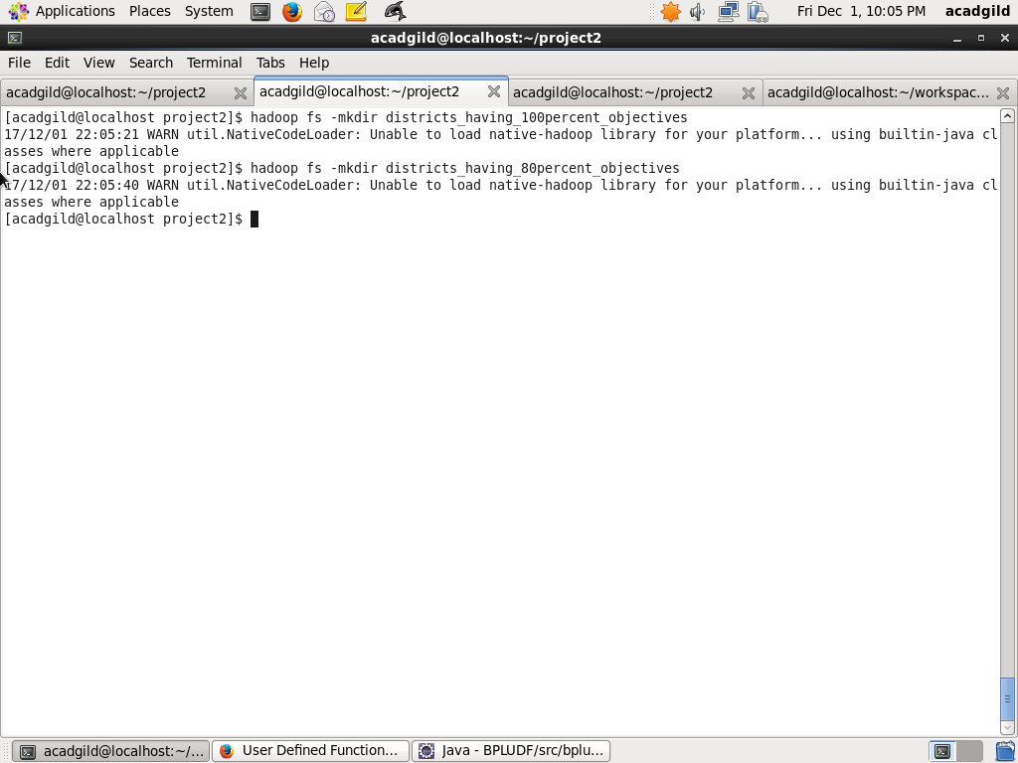

Step5: Create mysql table to store the results of query

Start mysql using command

sudo service mysqld start

Login to mysql using

mysql –u root

Create Database bpl_results

create database bpl_results

use bpl_results

Create tables districts_having_100percent_objectives and districts_having_80percent_objectives as below:

create table districts_having_100percent_objectives

(

name varchar(40)

);

create table districts_having_80percent_objectives

(

name varchar(40)

);

Screenshot is as below:

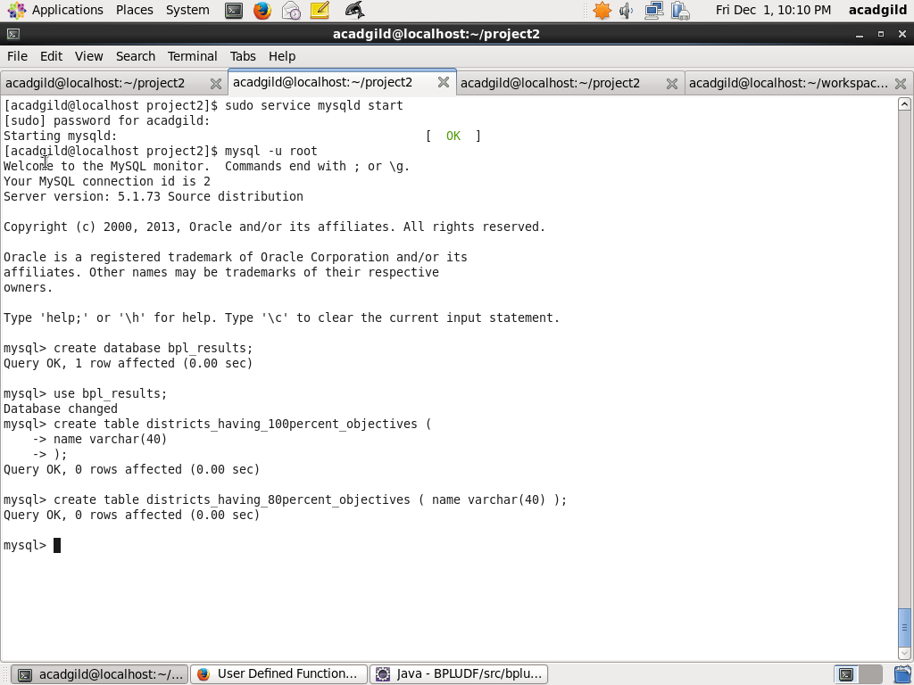

Step6: PIG query to process XML and store into PIG table

From HDFS LOAD to PIG alias row_physical_progress using XMLLoader as below

DEFINE XPath org.apache.pig.piggybank.evaluation.xml.XPath;

row_physical_progress = LOAD 'hdfs://localhost:9000/flume_import' USING org.apache.pig.piggybank.storage.XMLLoader('row') as (row:chararray);

Next, iterate over each row and load into alias physical_progress which has schema fields same as XML schema hyphen(-) are replaced with underscore (_)

physical_progress = FOREACH row_physical_progress GENERATE XPath(row, 'row/State_Name') AS State_Name,

XPath(row, 'row/District_Name') AS District_Name,

XPath(row, 'row/Project_Objectives_IHHL_BPL') AS Project_Objectives_IHHL_BPL,

XPath(row, 'row/Project_Objectives_IHHL_APL') AS Project_Objectives_IHHL_APL,

XPath(row, 'row/Project_Objectives_IHHL_TOTAL') AS Project_Objectives_IHHL_TOTAL,

XPath(row, 'row/Project_Objectives_SCW') AS Project_Objectives_SCW,

XPath(row, 'row/Project_Objectives_Anganwadi_Toilets') AS Project_Objectives_Anganwadi_Toilets,

XPath(row, 'row/Project_Objectives_RSM') AS Project_Objectives_RSM,

XPath(row, 'row/Project_Objectives_PC') AS Project_Objectives_PC,

XPath(row, 'row/Project_Performance-IHHL_BPL') AS Project_Performance_IHHL_BPL,

XPath(row, 'row/Project_Performance-IHHL_APL') AS Project_Performance_IHHL_APL,

XPath(row, 'row/Project_Performance-IHHL_TOTAL') AS Project_Performance_IHHL_TOTAL,

XPath(row, 'row/Project_Performance-SCW') AS Project_Performance_SCW,

XPath(row, 'row/Project_Performance-School_Toilets') AS Project_Performance_School_Toilets,

XPath(row, 'row/Project_Performance-Anganwadi_Toilets') AS Project_Performance_Anganwadi_Toilets,

XPath(row, 'row/Project_Performance-RSM') AS Project_Performance_RSM,

XPath(row, 'row/Project_Performance-PC') AS Project_Performance_PC;

Screenshot is as below:

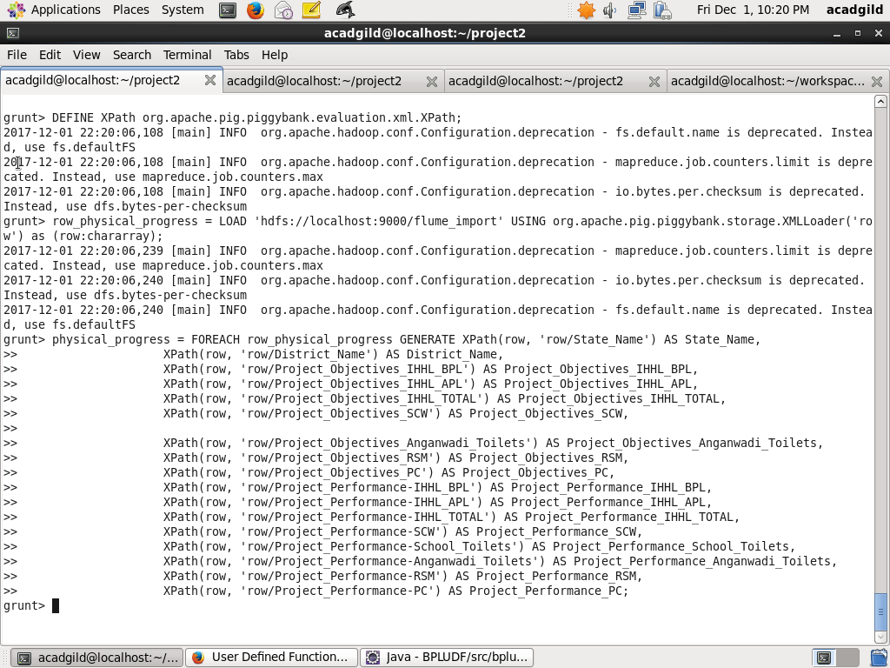

Step7: PIG Query to find out the districts who achieved 100 percent objective in BPL cards

Here first filter the records where Project_Objectives_IHHL_BPL is equal to Project_Performance_IHHL_BPL

physical_progress_100_percent_bpl = FILTER physical_progress BY Project_Objectives_IHHL_BPL == Project_Performance_IHHL_BPL;

Next, Select only District_Name field using command below:

district_100_percent_bpl = FOREACH physical_progress_100_percent_bpl GENERATE District_Name;

Next, Store into HDFS directory districts_having_100percent_objectives using command below:

STORE district_100_percent_bpl INTO 'hdfs://localhost:9000/districts_having_100percent_objectives'

Screenshot is as below:

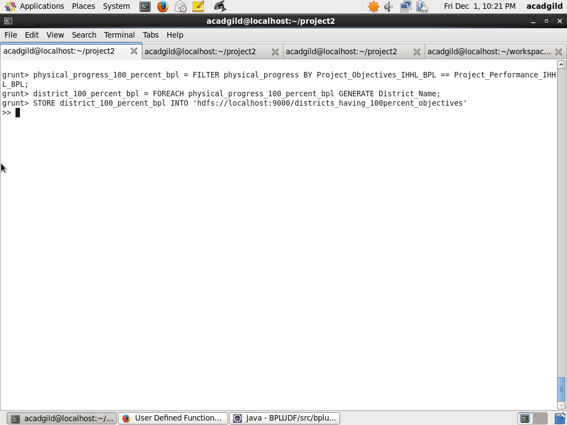

Step8: Verify that results are stored in HDFS

The following command shows that folders are created under districts_having_100percent_objectives

hadoop fs –ls /districts_having_100percent_objectives

Next, use the following HDFS command to show the results

hadoop fs –ls /districts_having_100percent_objectives/part-m-00000

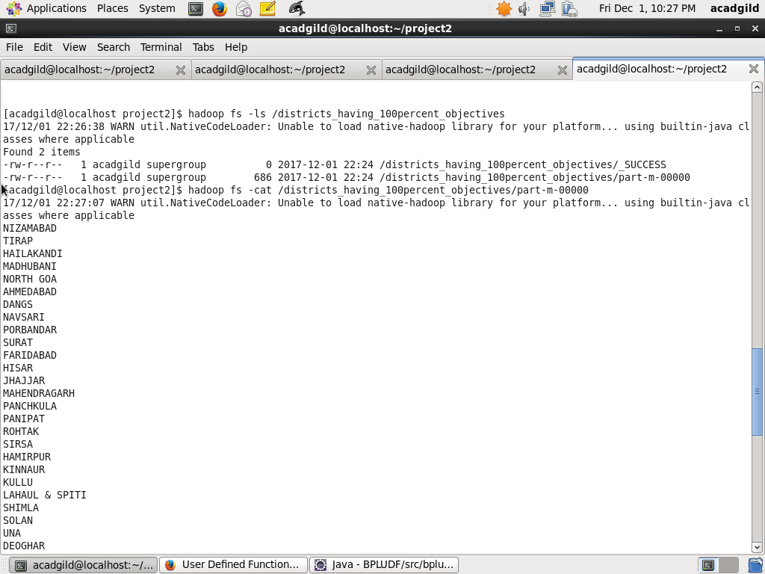

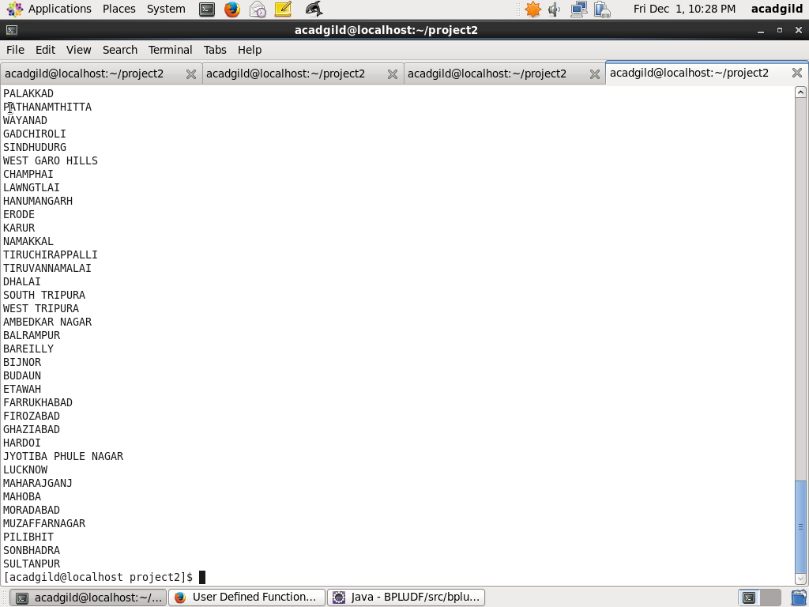

Step9 : Use sqoop command to export data from HDFS into mysql table districts_having_100percent_objectives in database bpl_results

The following sqoop command is used to export data from HDFS folder districts_having_100percent_objectives into already created mysql table 'districts_having_100percent_objectives

sqoop export --connect jdbc:mysql://localhost/bpl_results --username 'root' --table 'districts_having_100percent_objectives' --export-dir '/districts_having_100percent_objectives' --input-fields-terminated-by ',' -m 1 --columns name

Screenshots are as below:

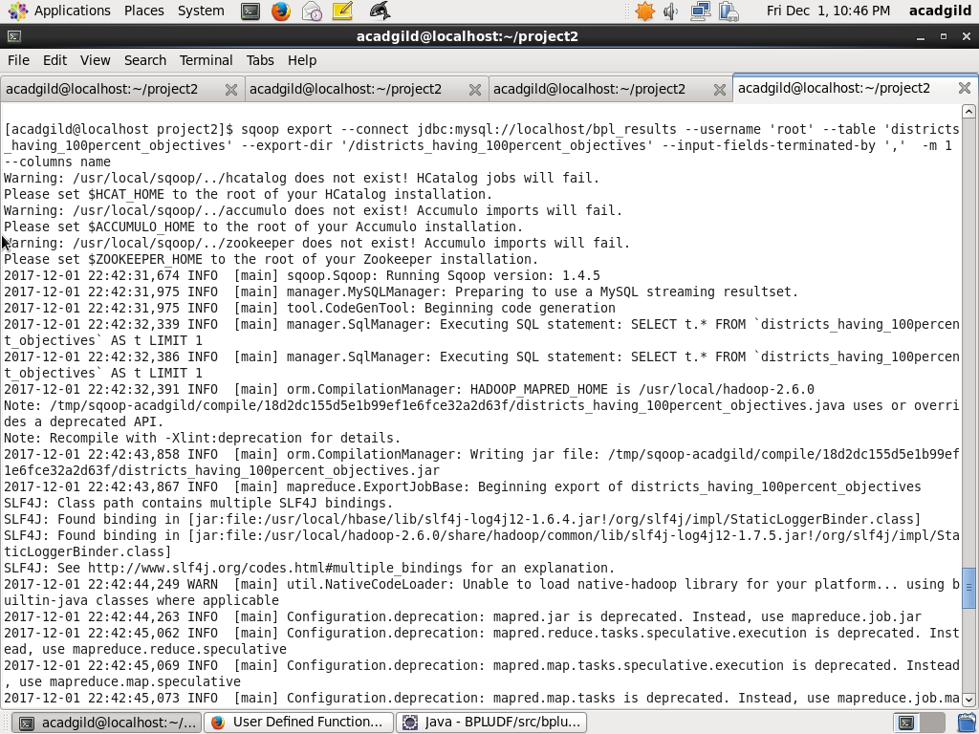

Step10: Verify Result in Mysql

Use the following command in mysql to verify results in mysql

select * from districts_having_100percent_objectives

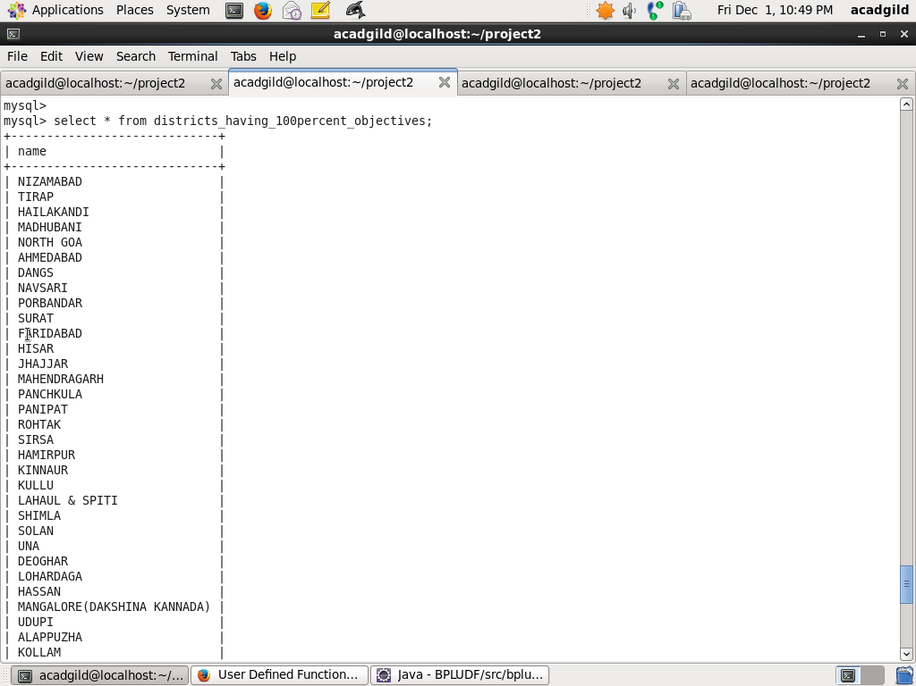

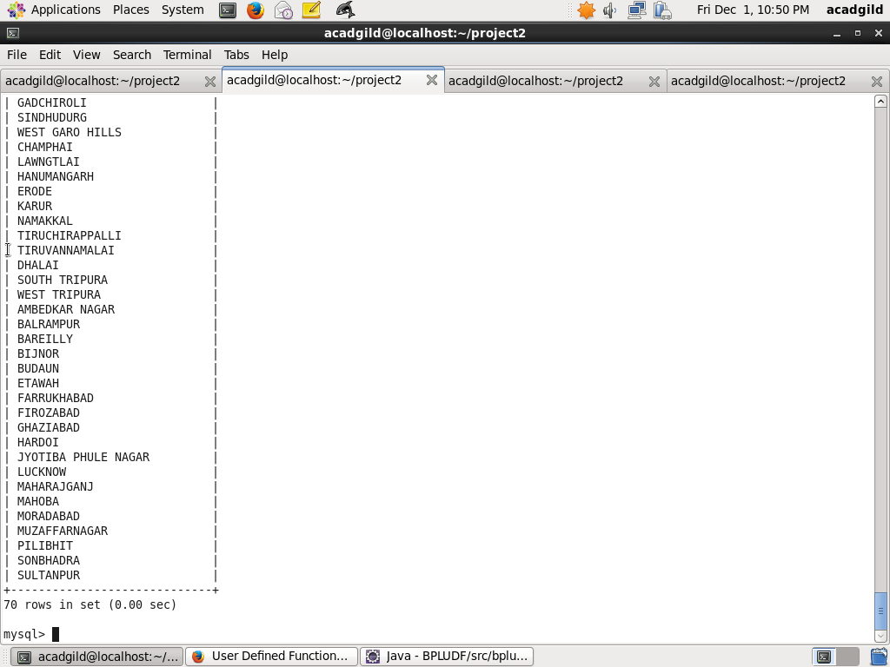



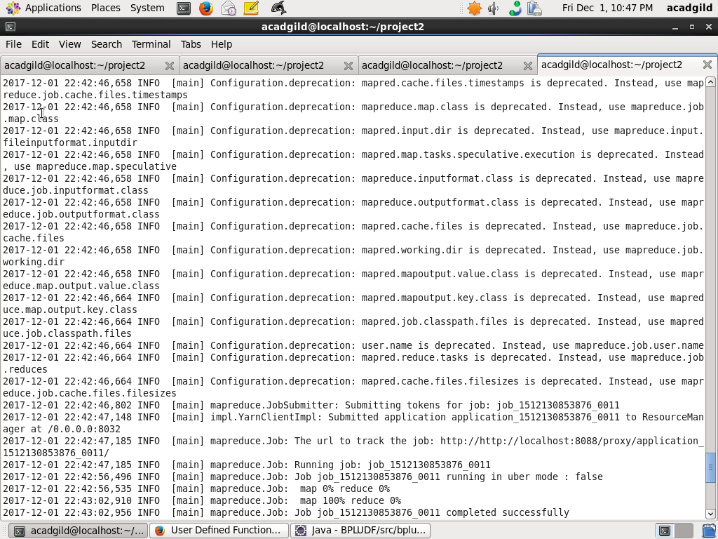

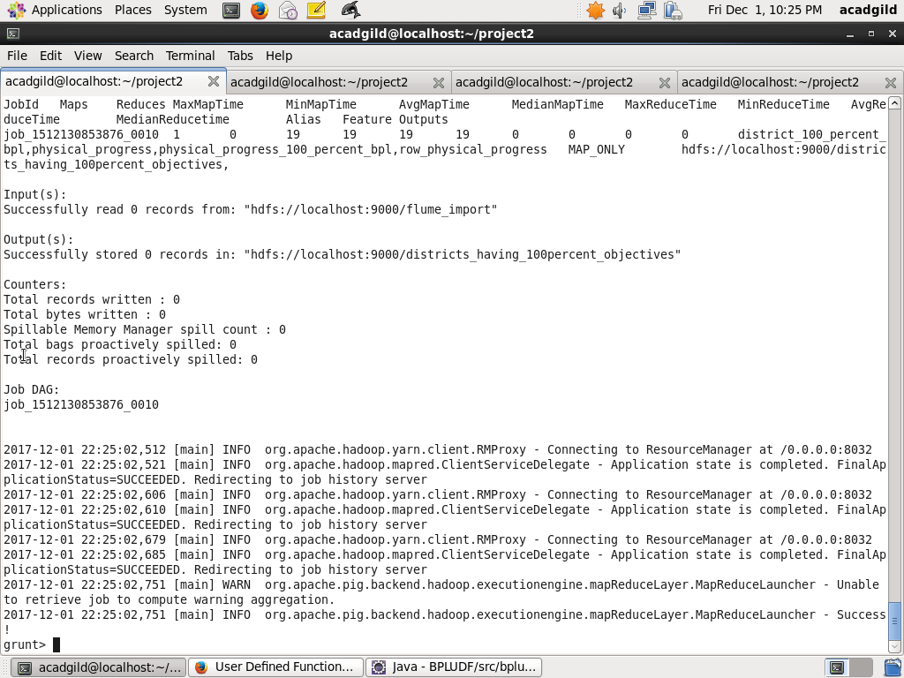

Step11: PIG UDF to find out the districts who achieved 80 percent objective in BPL cards

Create a Java project BPLUDF and Write a Java class FilterDistrictsHavingEightyPercentBPL in eclipse which will filter those tuples for which 80 percent objective in BPL cards are achieved. The logic put in exec method is value of Project_Performance_IHHL_BPL is equal to more than 80% of Project_Objectives_IHHL_BPL.

Export the project to BPLUDF.jar

Screenshot is given as below:

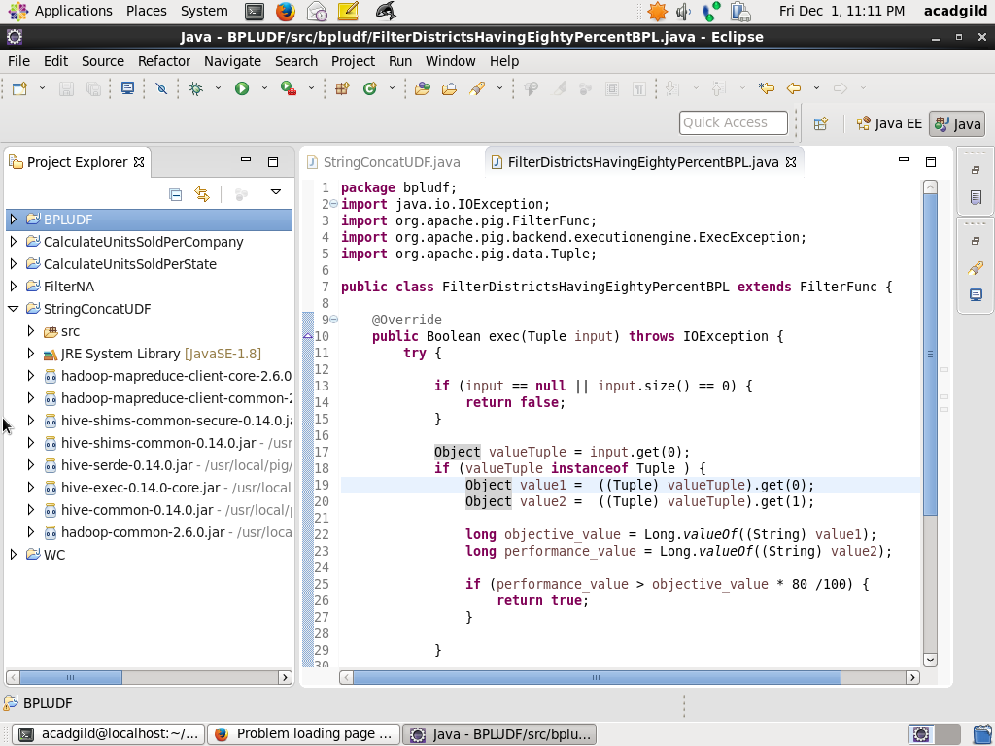

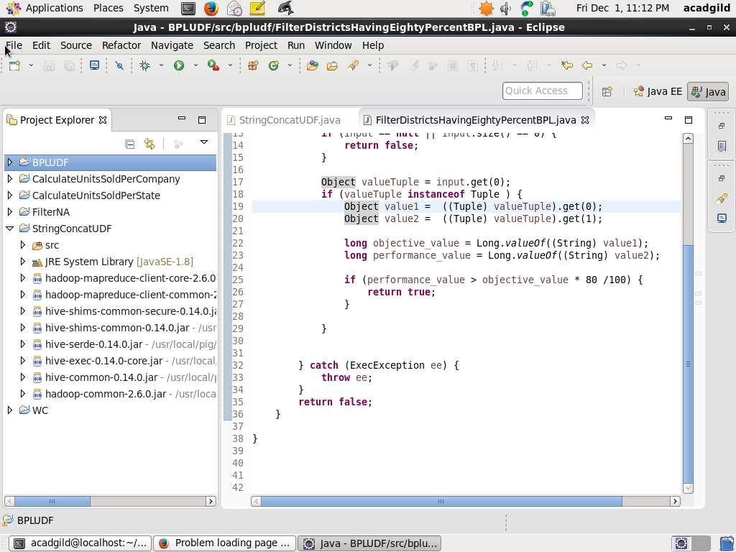

Step12: Write PIG query to find out the districts who achieved 80 percent objective in BPL cards

Register the Jar BPLUDF.jar for the UDF created in step11

REGISTER /home/acadgild/project2/BPLUDF.jar;

Next, using the UDF filter those tuple for which Project_Performance_IHHL_BPL is equal to more than 80% of Project_Objectives_IHHL_BPL

physical_progress_80_percent_bpl = FILTER physical_progress BY bpludf.FilterDistrictsHavingEightyPercentBPL(TOTUPLE(Project_Objectives_IHHL_BPL, Project_Performance_IHHL_BPL));

Next, Select only District_Name field using command below:

district_80_percent_bpl = FOREACH physical_progress_80_percent_bpl GENERATE District_Name;

Next, Store into HDFS directory districts_having_100percent_objectives using command below:

STORE district_80_percent_bpl INTO 'hdfs://localhost:9000/districts_having_80percent_objectives';

Screenshot is as below:

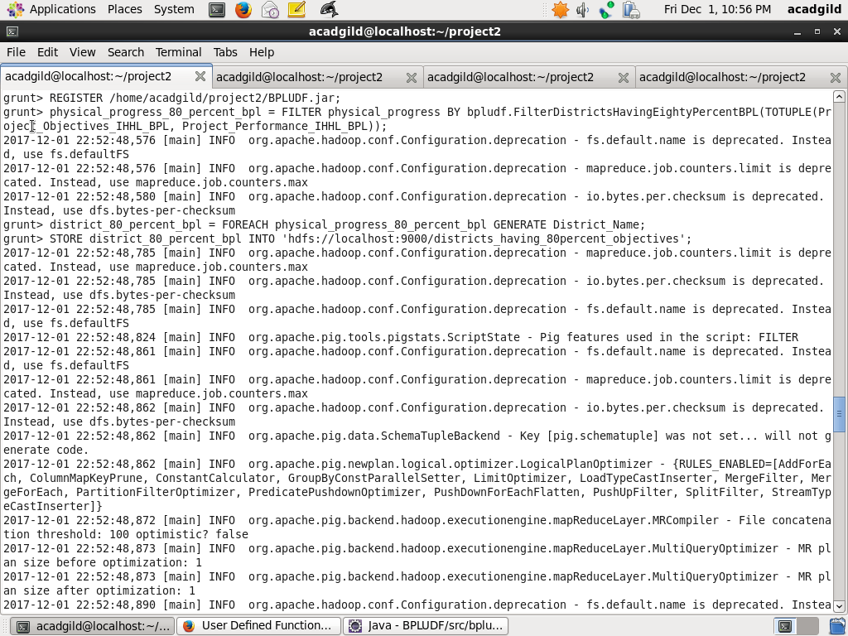

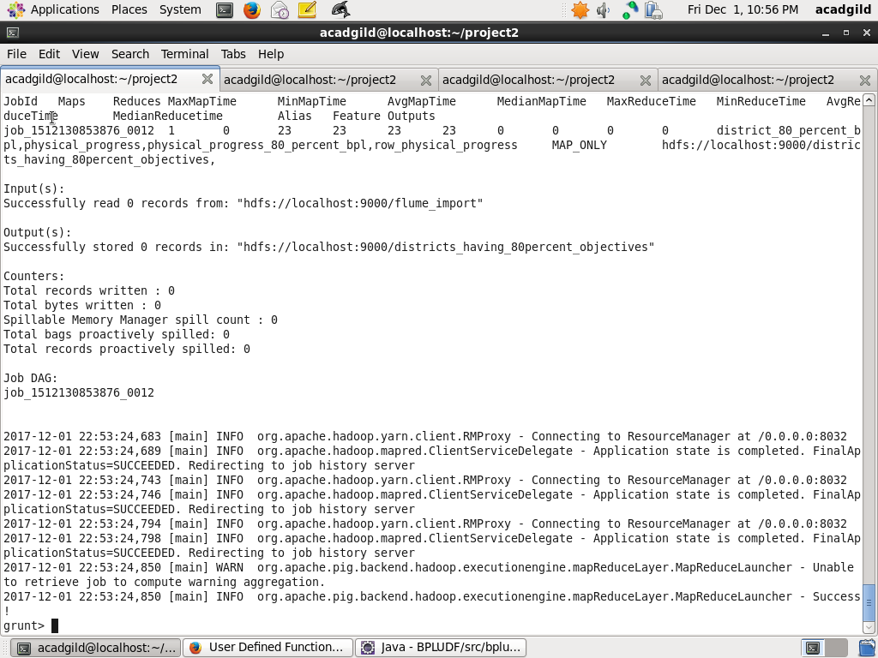

Step13: Verify that results are stored in HDFS

The following command shows that folders are created under districts_having_100percent_objectives

hadoop fs –ls /districts_having_80percent_objectives

Next, use the following HDFS command to show the results

hadoop fs –ls /districts_having_80percent_objectives/part-m-00000

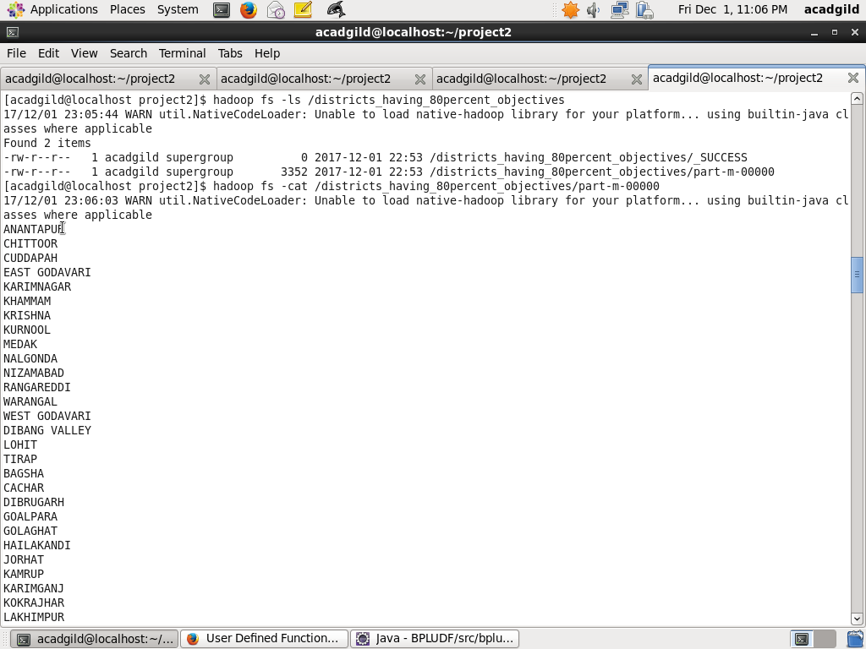

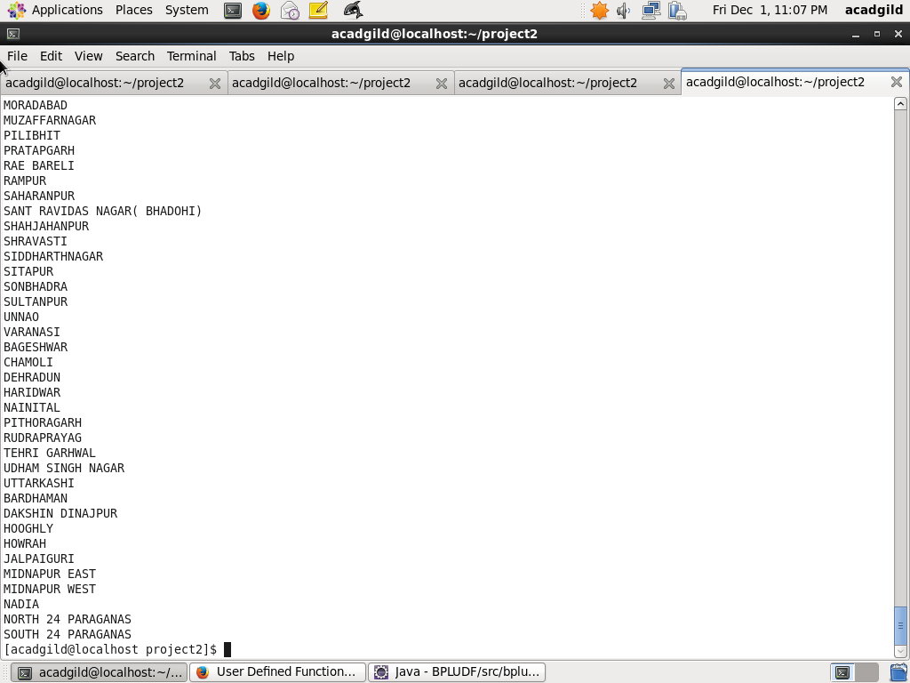

Step14 : Use sqoop command to export data from HDFS into mysql table districts_having_80percent_objectives in database bpl_results

The following sqoop command is used to export data from HDFS folder districts_having_80percent_objectives into already created mysql table 'districts_having_80percent_objectives

Screenshots are as below:

sqoop export --connect jdbc:mysql://localhost/bpl_results --username 'root' --table 'districts_having_80percent_objectives' --export-dir '/districts_having_80percent_objectives' --input-fields-terminated-by ',' -m 1 --columns name

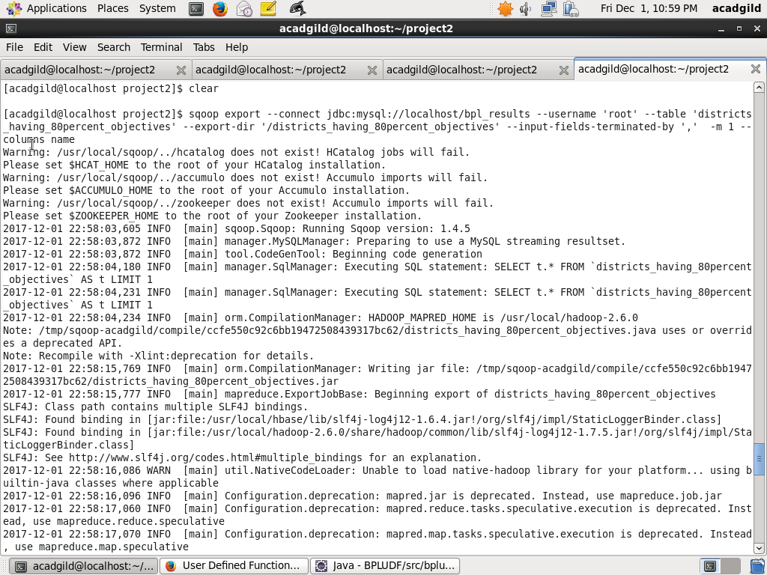

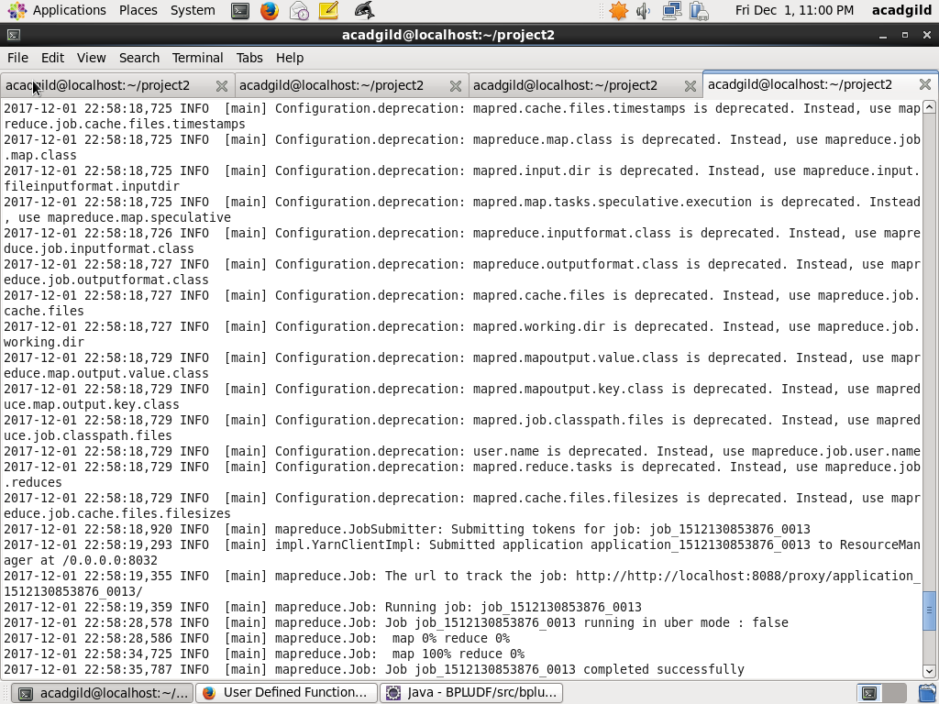

Ste15: Verify Result in Mysql

Use the following command in mysql to verify results in mysql

select * from districts_having_80percent_objectives

