USA Crime Analysis

Step1:

Load into PIG schema with alias crime_details with fields ID, CaseNumber, Date, Block, IUCR, PrimaryType, Description, LocationDescription, Arrest, Domestic, Beat, District, Ward, CommunityArea, FBICode, extra, XCordinate, YCoordinate, Year, UpdatedOn, Latitude, Longitude, Location)

The PIG script is as below:

crime_details = LOAD '/home/acadgild/project1/Crimes_-_2001_to_present.csv'

USING PigStorage(',') AS (ID:long, CaseNumber:chararray, Date:chararray,

Block:chararray, IUCR:chararray, PrimaryType:chararray, Description:chararray,

LocationDescription:chararray,Arrest:chararray, Domestic:chararray,

Beat:chararray, District:chararray, Ward:chararray, CommunityArea:chararray,

FBICode:chararray, extra:chararray, XCoordinate:chararray,

YCoordinate:chararray,Year:chararray, UpdatedOn:chararray, Latitude:chararray,

Longitude:chararray, Location:chararray);

Screenshot is as below:

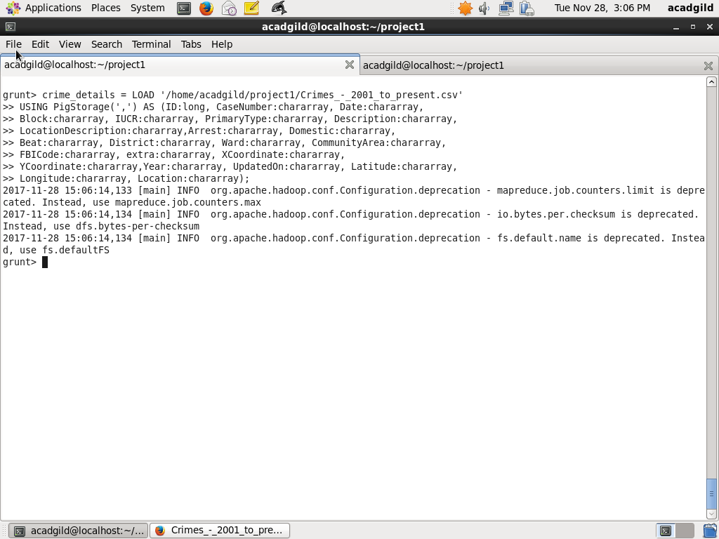

Task1: Write a MapReduce/Pig program to calculate the number of cases investigated under each

FBI code

1. Group crime_details by FBICode

crime_details_group_by_fbi_code = GROUP crime_details BY FBICode;

1. For each group count number of cases registered using CaseNumber and put to alias no_of_cases_count_by_fbi_code

no_of_cases_count_by_fbi_code = FOREACH crime_details_group_by_fbi_code GENERATE group AS grp, COUNT(crime_details.CaseNumber);

1. Dump the alias no_of_cases_count_by_fbi_code

dump no_of_cases_count_by_fbi_code;

Screenshot is as below:

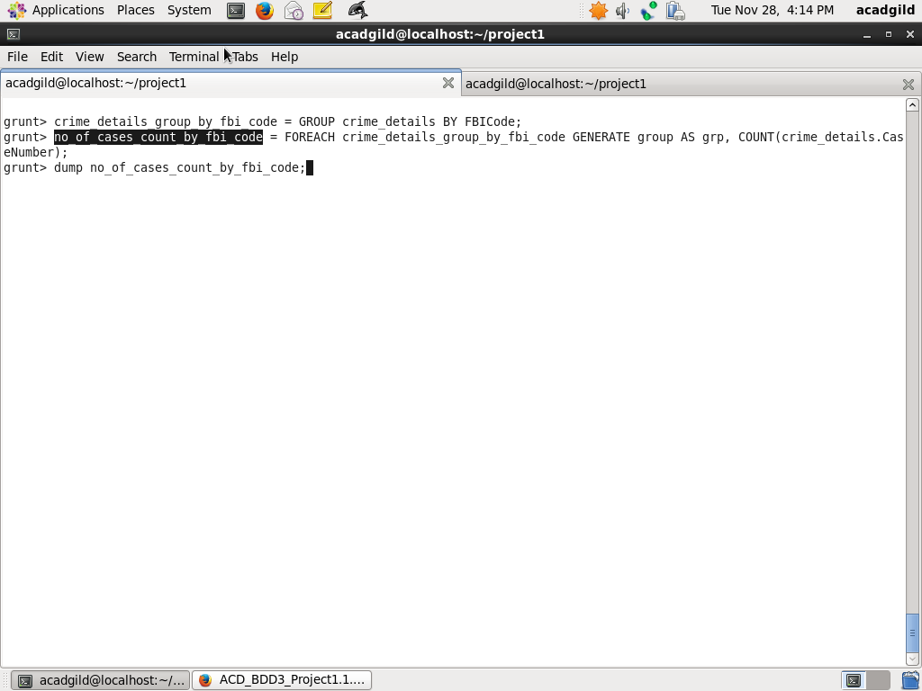

Output is given in screenshot below:

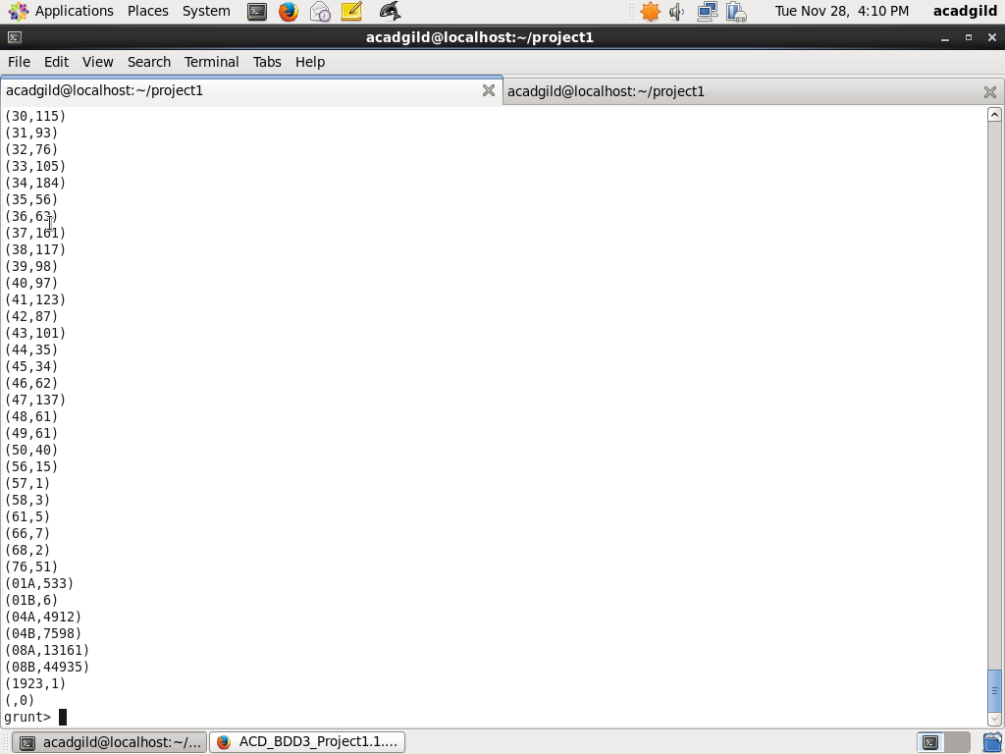

Task2. Write a MapReduce/Pig program to calculate the number of cases investigated under FBI

code 32.

Filter the cases count by FBI Code 32 and put to alias no_of_cases_count_fbi_code_32

no_of_cases_count_fbi_code_32 = FILTER no_of_cases_count_by_fbi_code BY grp=='32';

dump no_of_cases_count_fbi_code_32;

Screenshot is as below:

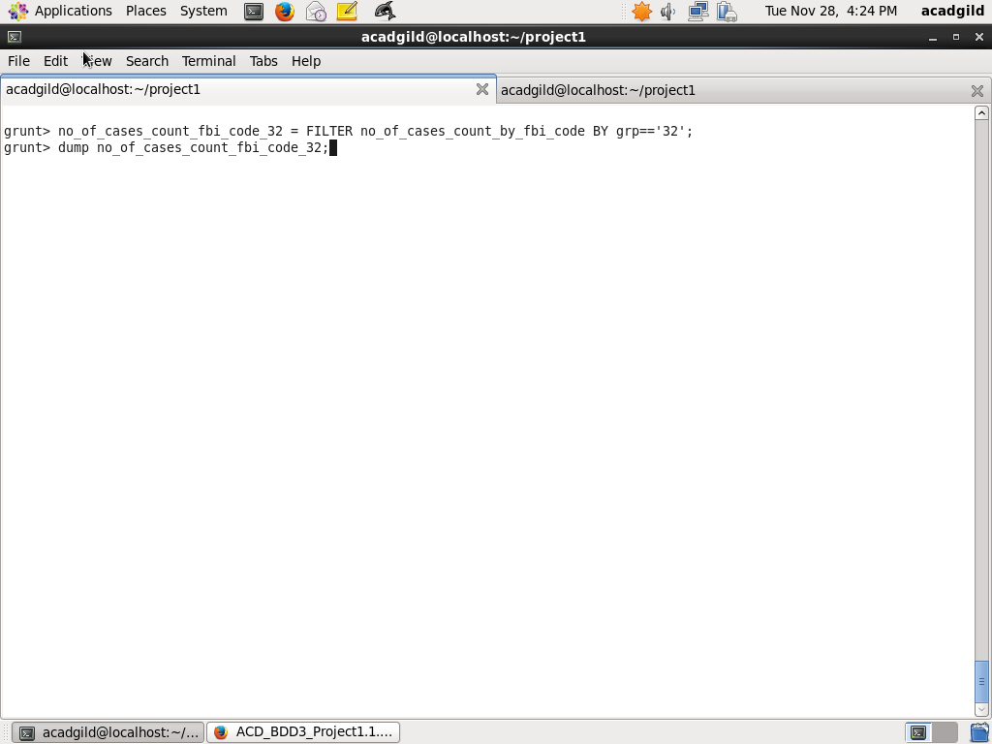

Output is as below:

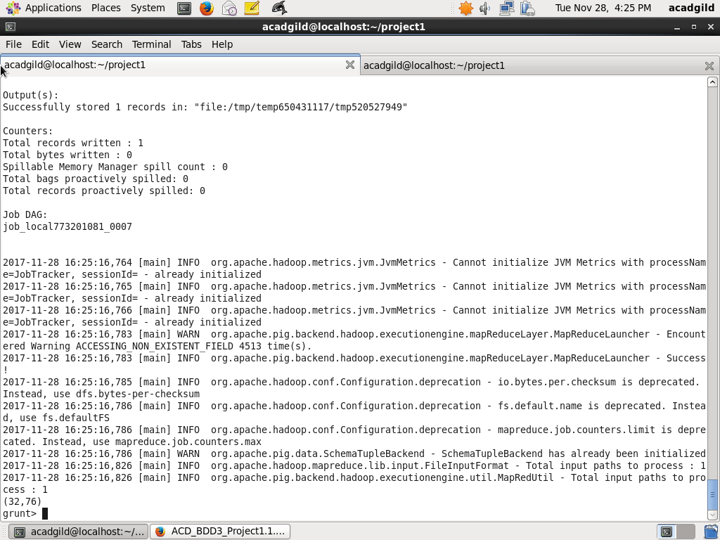

3. Write a MapReduce/Pig program to calculate the number of arrests in theft district wise.

i. Filter crime_details for which PrimaryType is THEFT and ARREST is true and put to alias crime_details_theft_arrested. PIG script is as below:

crime_details_theft_arrested = FILTER crime_details BY PrimaryType == 'THEFT' AND Arrest == 'true';

ii. Group crime_details_theft_arrested by District and put to alias crime_details_theft_arrested_by_district

crime_details_theft_arrested_by_district = GROUP crime_details_theft_arrested BY District;

iii. For each group in crime_details_theft_arrested_count_by_district, determine number of cases

crime_details_theft_arrested_count_by_district = FOREACH crime_details_theft_arrested_by_district GENERATE group AS grp, COUNT(crime_details_theft_arrested.CaseNumber);

Screenshot is as below:

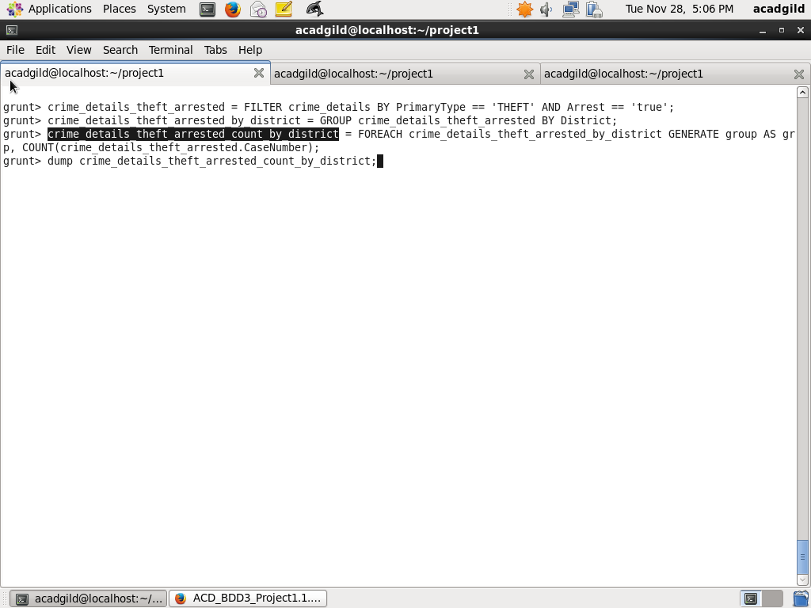

Output is as below:

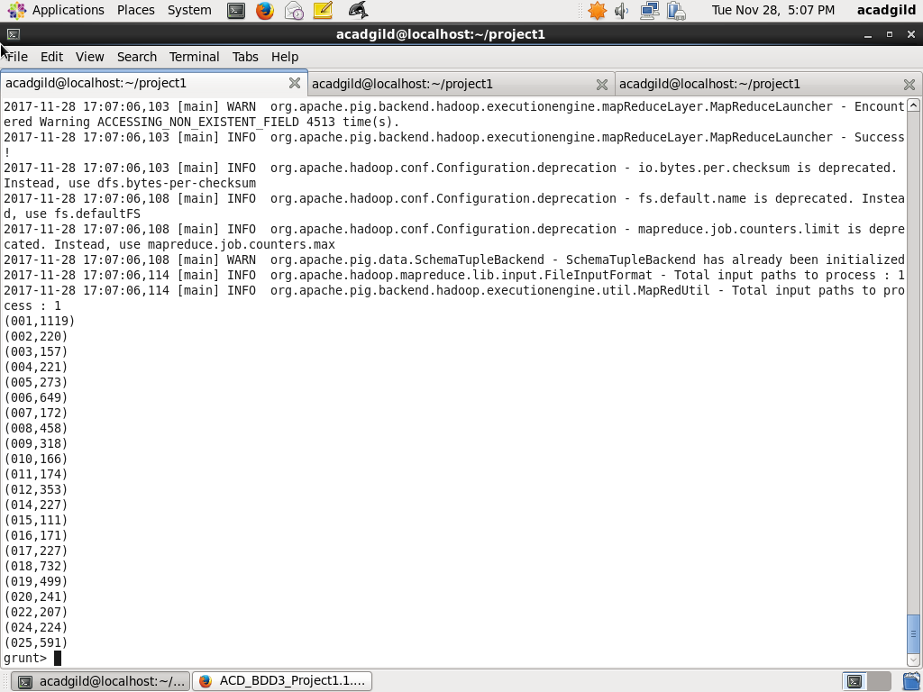

4. Write a MapReduce/Pig program to calculate the number of arrests done between October

2014 and October 2015.

1. Find list of arrested by filtering Arrest for true and put to alias crime_details_arrested

crime_details_arrested = FILTER crime_details BY Arrest == 'true';

1. Find list of arrests between October 1, 2014, 12:00:00 AM and October 31, 2015, 11:59:59PM and put to alias crime_details_arrested_between_dates

crime_details_arrested_between_dates = FILTER crime_details_arrested BY ToDate(Date, 'MM/dd/yyyy hh:mm:ss a') >= ToDate('10/01/2014 12:00:00 AM', 'MM/dd/yyyy hh:mm:ss a') AND ToDate(Date, 'MM/dd/yyyy hh:mm:ss a') <= ToDate('10/31/2015 11:59:59 PM', 'MM/dd/yyyy hh:mm:ss a');

1. Group crime_details_arrested_between_dates by ALL

crime_details_arrested_between_dates_all = GROUP crime_details_arrested_between_dates ALL;

1. Find number of arrests using COUNT function on CaseNumber field and put to alias crime_details_no_of_arrests

crime_details_no_of_arrests = FOREACH crime_details_arrested_between_dates_all GENERATE COUNT(crime_details_arrested_between_dates.CaseNumber) AS no_of_arrests;

1. Dump crime_details_no_of_arrests

dump crime_details_no_of_arrests;

Screenshot is as below:

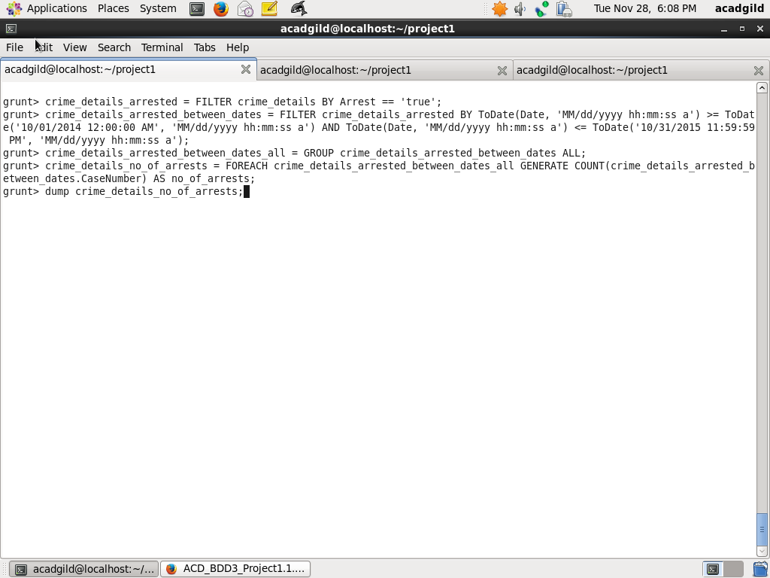

Output is as below:

