**Project Report on**

**Video Popularity Analysis**

Submitted by:

**Jaspreet Kaur Gill**

**Monika Pandey**

**In partial fulfillment of completion of the course**

**Advanced Diploma in IT, Networking and Cloud Computing.**

**Under Guidance of:**

|  |  |  |
| --- | --- | --- |
| IBM-Logo - Chicago Innovation | DGT introduces high end diploma courses - digitalLEARNING Magazine | Edunet Foundation-Delhi- CSR Organization profile |

**Year 2022-2023**

**Abstract**

This project aims to comprehensively analyze the factors influencing the popularity of videos across diverse platforms. The dataset encompasses key metrics such as views, likes, and comments, as well as intrinsic video characteristics like duration and upload date.

**Acknowledgement**

We express our sincere gratitude to all those who contributed to the successful completion of this video popularity data analysis project. This project wouldn't have been possible without the collaborative efforts and support from various individuals and organizations.

Special thanks to the research team members who dedicated their time and expertise to collecting, processing, and analyzing the data. Their commitment and attention to detail have greatly enriched the quality of this project.

We are grateful for the guidance and mentorship provided by [**Mrs. Mala Mishra & Ms. Ankita Shukla**,]. Their insights and recommendations played a crucial role in shaping the direction of the analysis and ensuring its rigor.

**ADVANCE DIPLOMA IN IT NETWORKING**

**& CLOUD COMPUTING**

**_______________________________________________**

The Advanced Diploma in IT Networking and Cloud Computing program offered by NSTI (W) Noida in collaboration with Edunet Foundation is a comprehensive course designed to equip students with advanced skills in information technology and cloud computing. This program covers a wide range of topics, including Computer Networking, Database Management, Virtualization, Cloud Technologies, and Cybersecurity. Students will gain hands-on experience through practical labs, workshops, and real-world projects, enabling them to excel in the rapidly evolving IT industry. Upon completion of the program, Graduates will have a strong foundation in both IT Fundamentals and Cloud Computing, making them highly sought-after professionals in the field.

**Project Requirements**

|  |  |
| --- | --- |
| **Project Name** | **Pollution Data Analysis** |
| **Languages Used** | **Python** |
| **Editor** | **Jupyter Notebook, Google Colab** |
| **Web Browser** | **Google Chrome, Microsoft Edge** |

**Team Composition and Workload Division**

|  |  |
| --- | --- |
| Jaspreet Kaur Gill | Data Analysis, Synopsis |
| Monika Pandey | Data Analysis, Synopsis |

**Tables of Content**

|  |  |  |
| --- | --- | --- |
| **SNO** | **TOPIC** | **Page No** |
| 1. | PROBLEM STATEMENT | 5 |
| 2. | REQUIREMENTS SPECIFICATION | 4 |
| 3. | OVERVIEW | 5 |
| 4. | PROJECT MODULE | 5 |
| 5. | SAMPLE SCREENSHOTS | 6 |
| 6. | FUTURE SCOPE | 7 |
| 7. | CONCLUSION | 7 |
| 8. | REFERENCES | 7 |

1. **Introduction to Problem**

In the digital era, the explosion of online video content has given rise to a dynamic landscape where creators strive for visibility and engagement. Understanding the factors that contribute to the popularity of videos on platforms such as YouTube and others has become a pivotal challenge for content creators, marketers, and platform managers alike.

The overarching problem addressed in this analysis revolves around deciphering the intricacies of video popularity. It involves unraveling the multifaceted elements that influence a video's success, transcending mere view counts. Factors such as user engagement, temporal trends, content characteristics, and external influences all play integral roles in shaping the destiny of a video in the online sphere.

1. **Requirements**

**3.1 Technology Stack**

**Python:** High-level programming language used for server-side scripting.

**Jupyter Notebook:** Jupyter Notebook is an open-source web application that allows you to create and share documents containing live code, equations, visualizations, and narrative text, providing an interactive and collaborative environment for data science and analysis.

**3.2 Hardware**

Laptop/ Computer

**3.3 Software**

Operating System (OS)

Version Control System

Text Editors and Integrated Development Environments (IDEs)

1. **Overview**

The data analysis project aims to investigate and derive meaningful insights from a specific dataset. It involves collecting, cleaning, and processing raw data to uncover patterns, trends, and correlations. Using statistical methods and visualization tools, the project seeks to provide a comprehensive understanding of the data, enabling informed decision-making. The analysis may involve exploring relationships between variables, identifying outliers, and creating predictive models. Throughout the project, a systematic approach is followed, including hypothesis testing and validation of results. The ultimate goal is to offer actionable recommendations or conclusions based on the data findings. The project typically employs programming languages such as Python or R, along with tools like Jupyter Notebooks, to facilitate a transparent and reproducible analytical workflow. Overall, the data analysis project serves to extract valuable insights, enhance understanding, and support evidence-based decision-making in a given domain.

1. **Project Module**
   1. Import the required libraries.
   2. Load/ Read the Dataset
   3. Prepare EDA
   4. Do Visualizations
   5. Time Series Analysis
   6. Prepare Heatmap/ Confusion Matrix
   7. Linear regression

**6 Sample Screenshots**

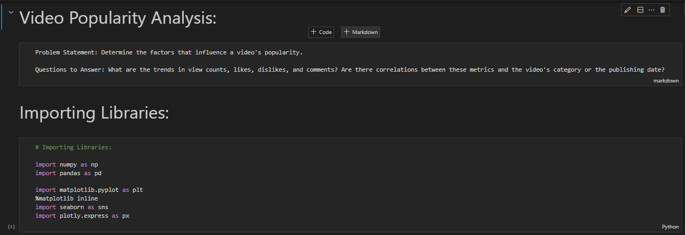

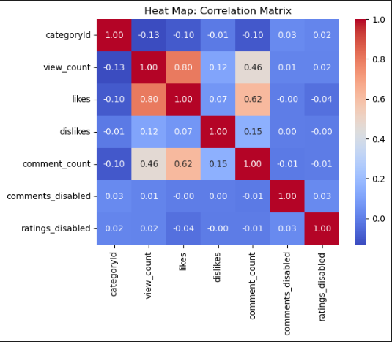

**7 Future Scope**

The future scope of a Video Popularity Analysis project can encompass various enhancements and expansions to further refine insights and adapt to the evolving landscape of online video content.

the Video Popularity Analysis project can continue to evolve, providing valuable insights and tools for content creators, marketers, and platform managers in the ever-changing landscape of online video content.

**8 Conclusion**

In conclusion, this Video Popularity Data Analysis project has offered a comprehensive exploration into the multifaceted factors influencing the success of online videos. Through meticulous examination of user behavior, content characteristics, and external influences, valuable insights have been gleaned to guide content creators and stakeholders in optimizing their strategies.

The analysis revealed intricate patterns in video popularity trends over time, allowing for a deeper understanding of the dynamics that contribute to audience engagement. Content categories were dissected, shedding light on the preferences that resonate most strongly with viewers. The relationships between video duration and engagement, as well as the impact of external factors like influencer collaborations, were scrutinized to provide actionable recommendations for creators.

**10 References**

<https://www.kaggle.com/datasets>

**Thank You**