**Project Flight**

**This project have five classes using MVC pattern:**

1.ConnectTo_DataBase class: I use singleton pattern to have only one instance variable. Any class can use this to get connect. For the database url, I have set to relative path. So anyone can run the code on his side.

}

2.F light class: this is the model, it contains the application data for the flight.

3.ViewFlight class: the view to presents the model’s data to the user.

4.FlightController class: the controller exist between the view and the model.it has all the methods to read, add, remove, modify the flight information and show the sorted flight information and onboard information

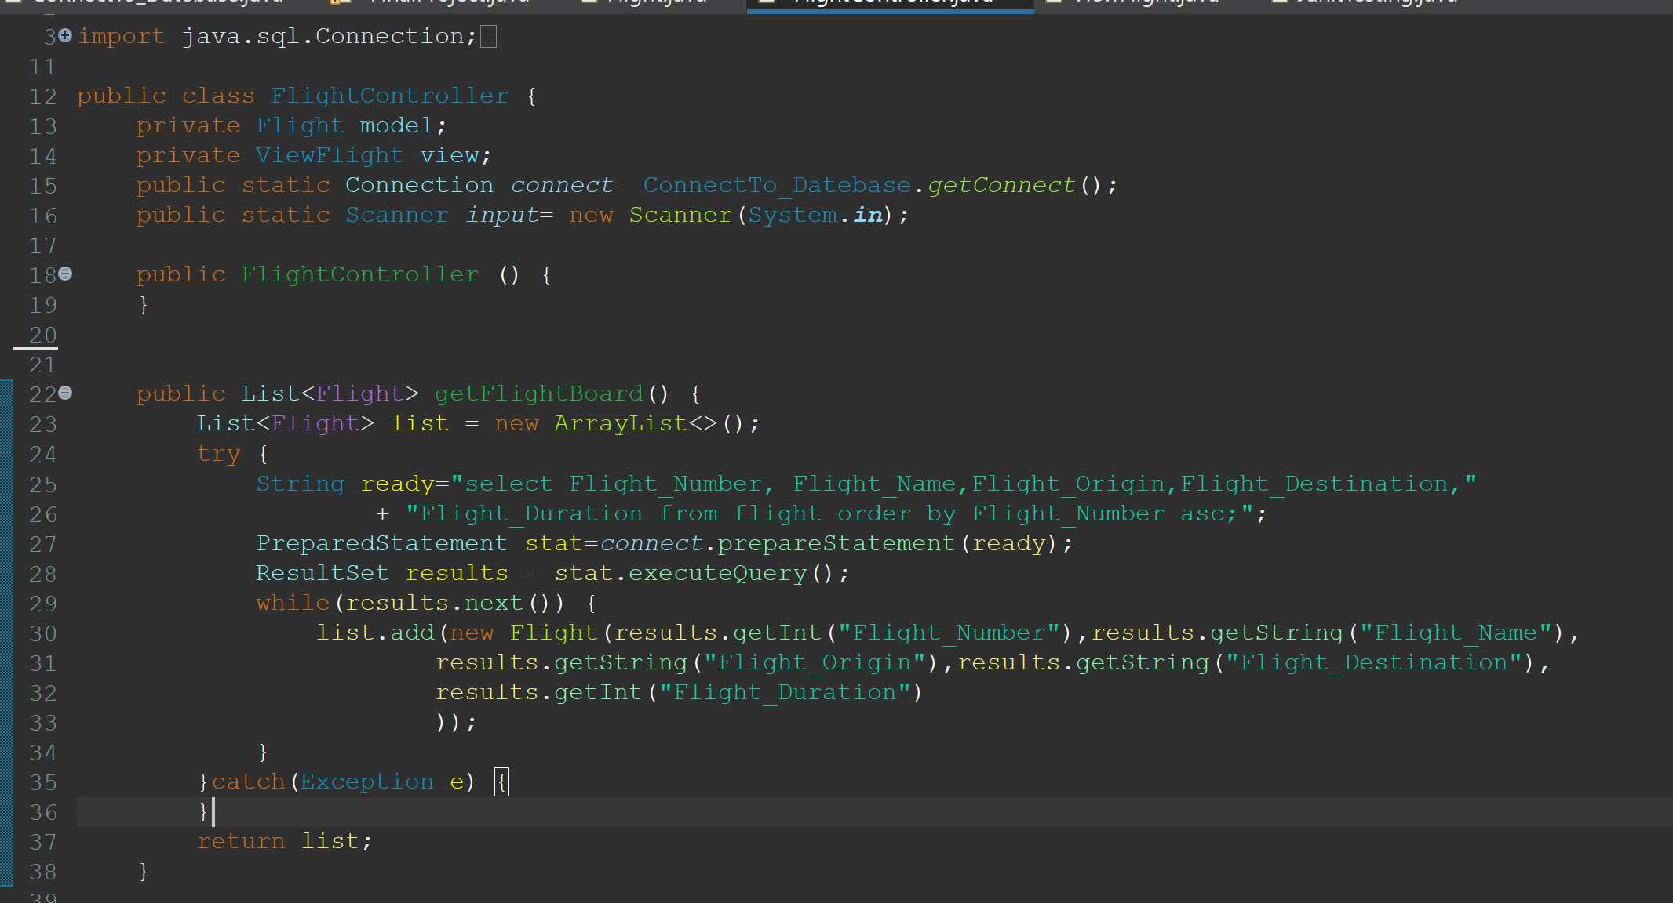

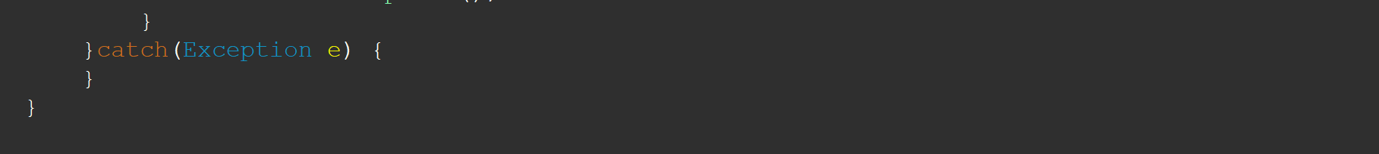

5.FinalProject class to run the code, to show the database result after adding, removing or editing the flight information and show what’s on board.

Use Internalization:

**I use the lambda Expression to print the onboard information:**

**Now I run all my methods at the same time. Below is the output, the data will show in ascending way according to flight number:**

**1. show the flight info and origin database with all the flight information:**

**2.edit the flight and show the database update:**

**3.remove one flight from database and show the change**

**4.add a new flight to the database and show the adding**

**5. I print out the onboard flight information:**

**6. Junit test:**

