**Load testing**

**API URL: https://demoqa.com**

**60 Sec, 166 users:**

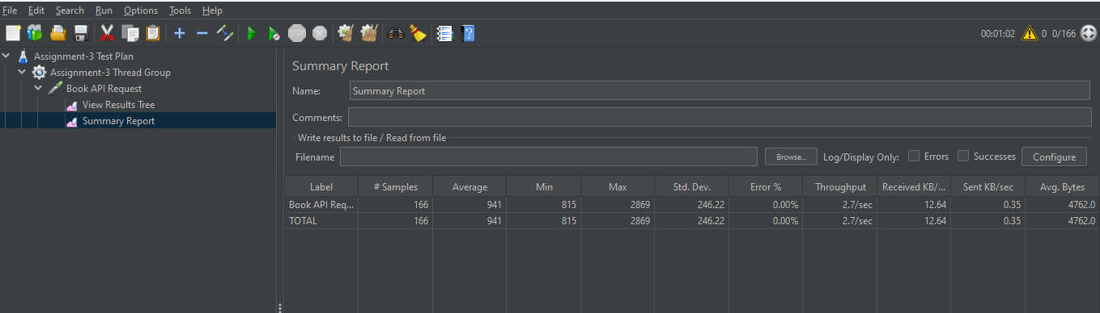

**300 Sec, 833 Users:**

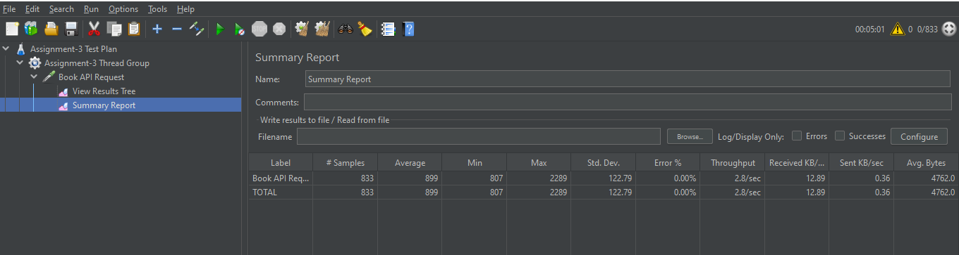

**600 Sec, 1666 Users:**

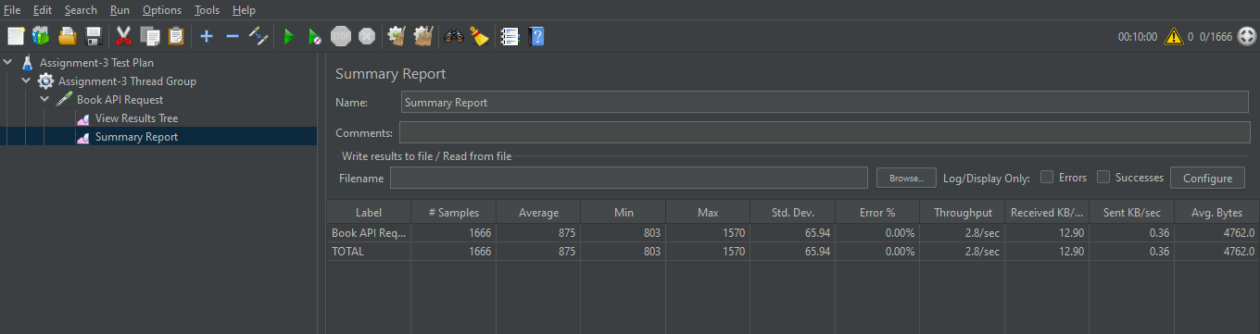

**900 Sec, 2500 Users: This is from CLI (Git bash command line)**

