# bamazon

This app uses Node.js and MySQL to mimic an online storefront.

MySQL is used to create a bamazon database with a table named products that is populated with items.
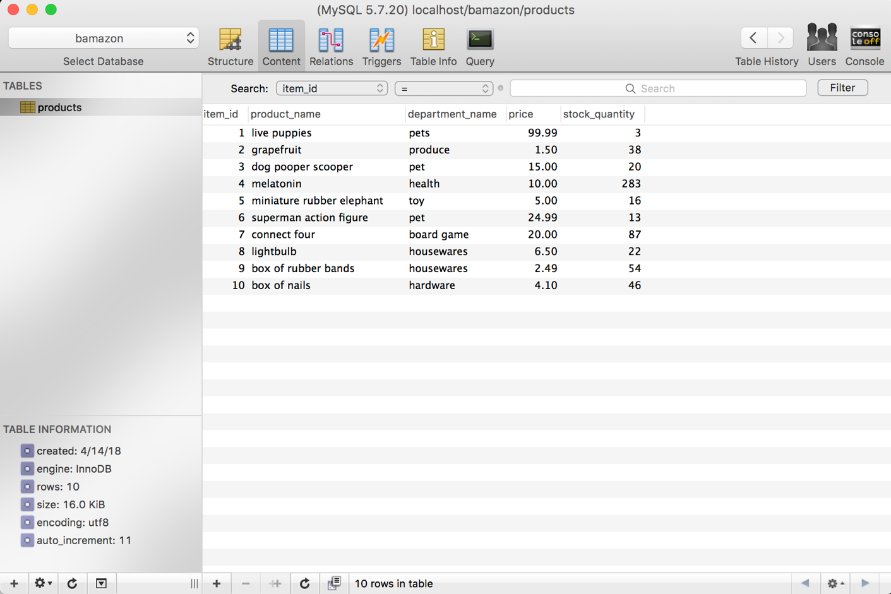

The bamazonCustomer.js application allows the user to select an item and quantity to purchase. The app then checks the item’s stock quantity and if there is enough product, it returns the total product cost.
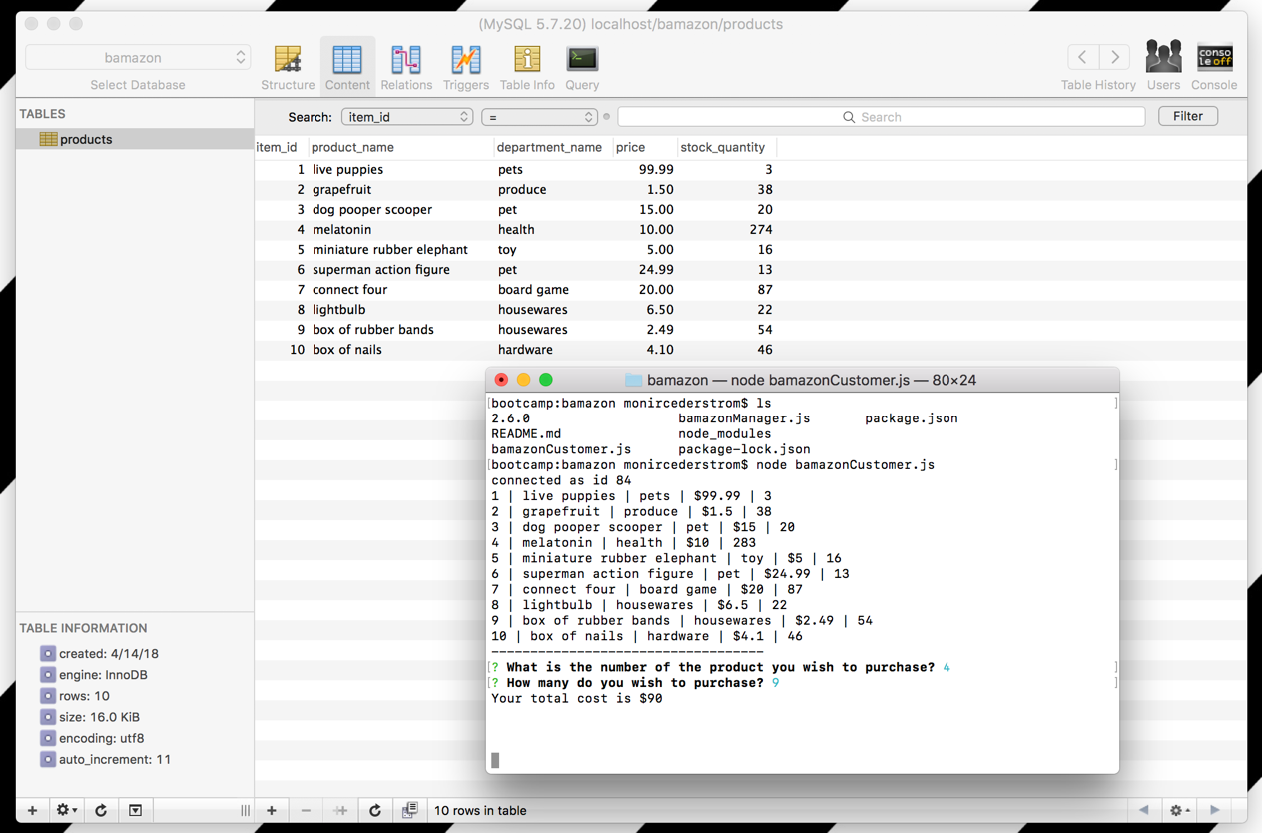

The bamazonManager.js app allows the user to view a menu of options in the terminal.

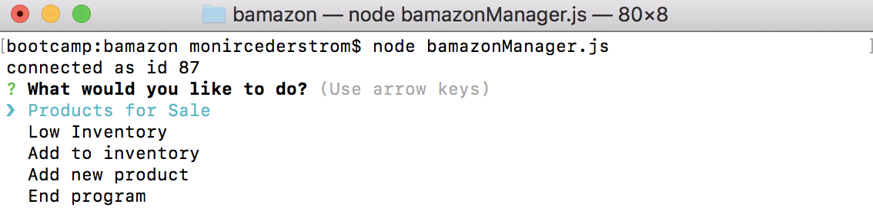

When the user selects “Products for Sale” the list of products from the database is shown.
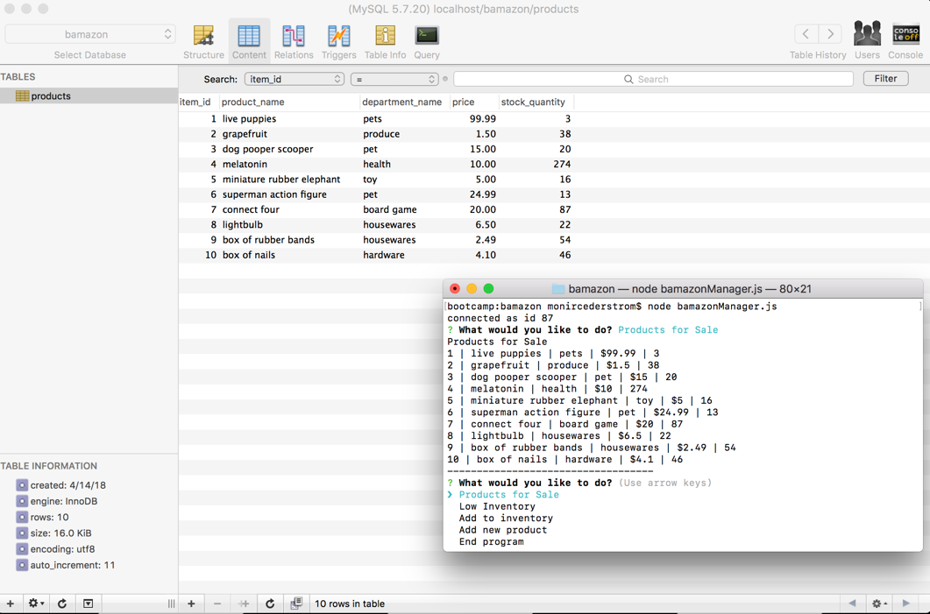

When the user selects “Low Inventory” the inventory with stock quantities 5 or less are displayed.
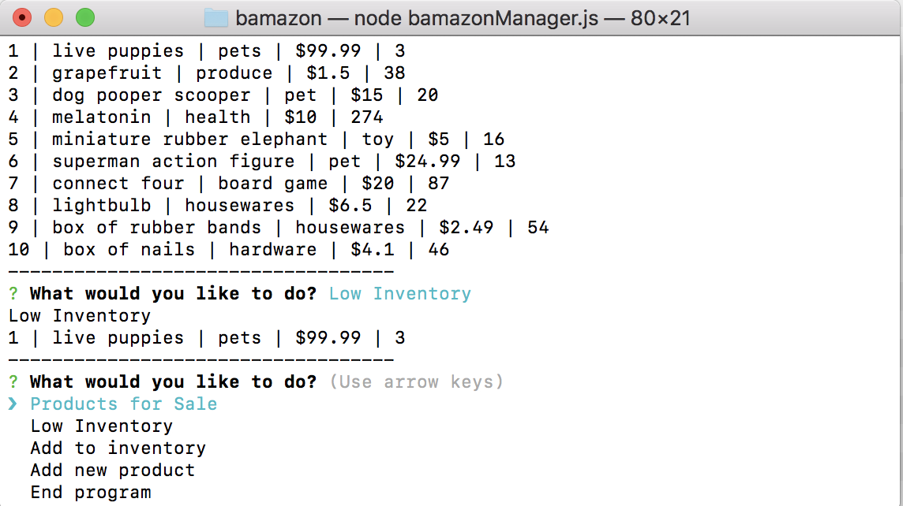

When the user selects “Add to inventory”, the user can choose which products to increase the stock quantity.

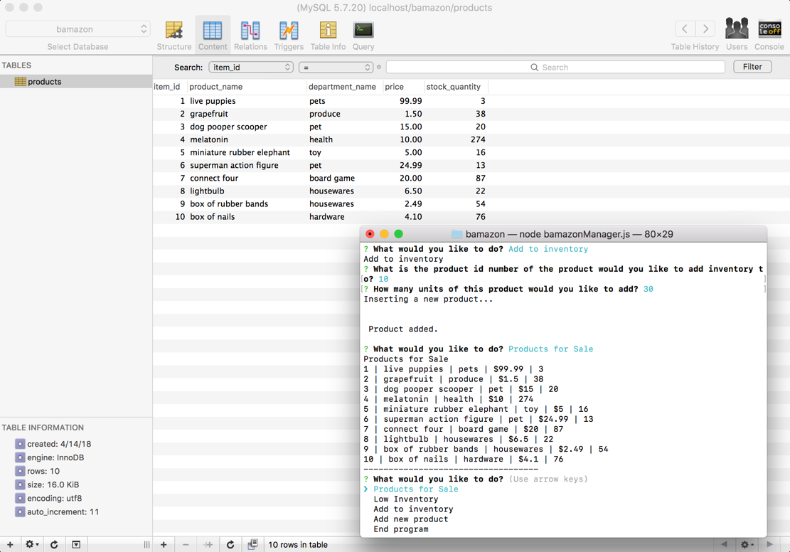

When the user selects “Add new product”, the user can add to the table a new product to sell.
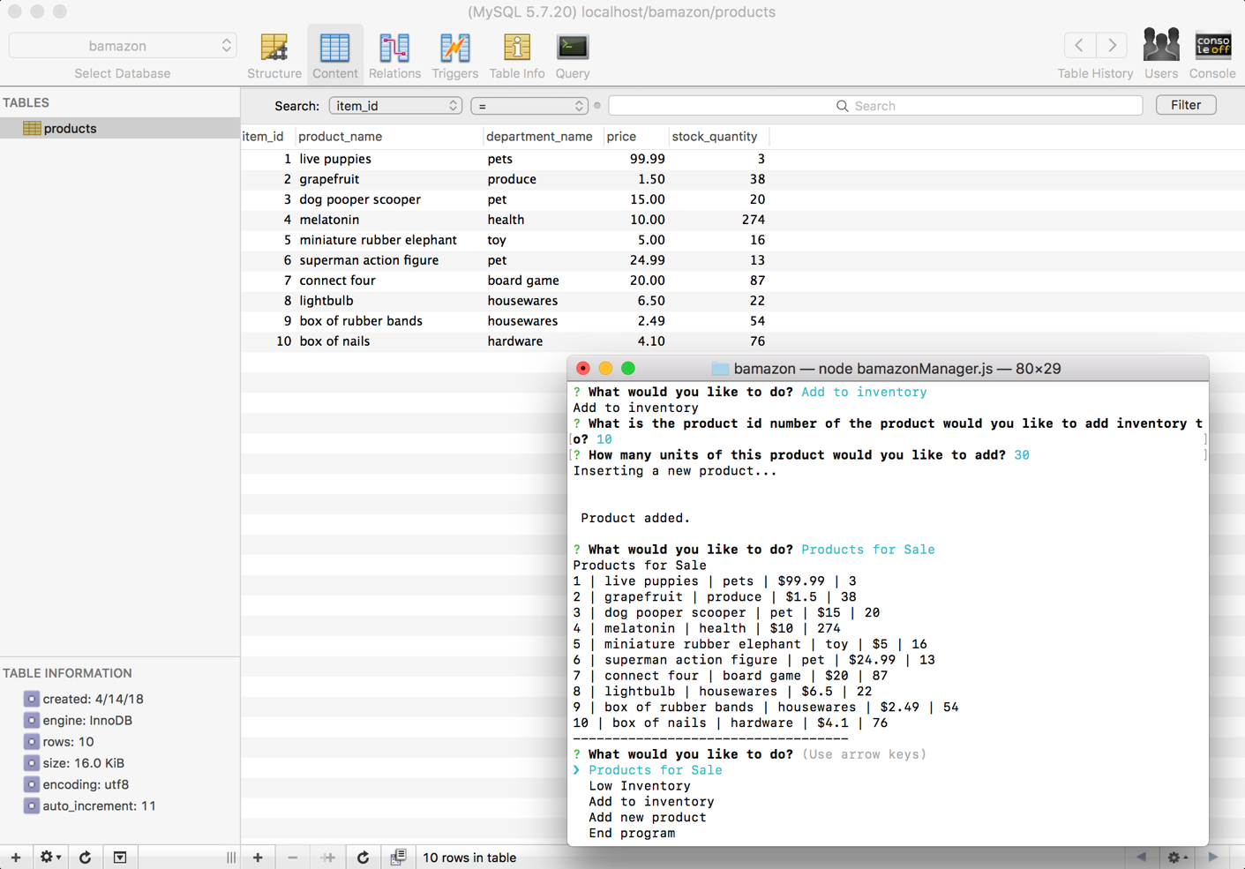

Finally, when the user selects “End program” the connection is closed.
