SmallBasic

precisionWithout 40.798264

precisionTop1 38.524555

precisionMAX 45.733049

precision1(ideal) 49.790018

ideal

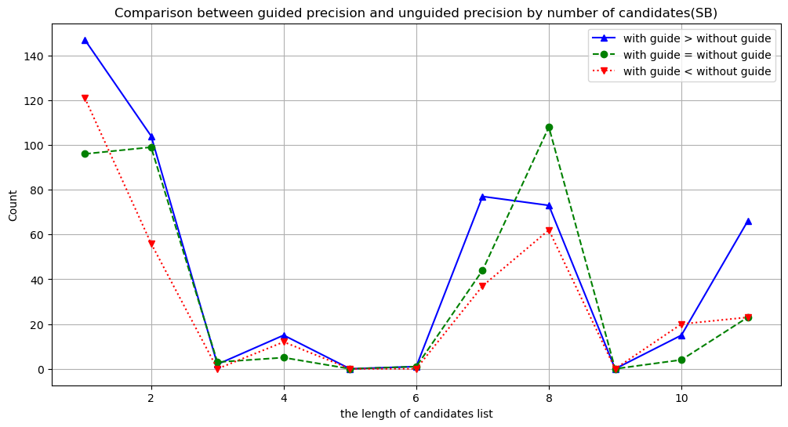

MAX

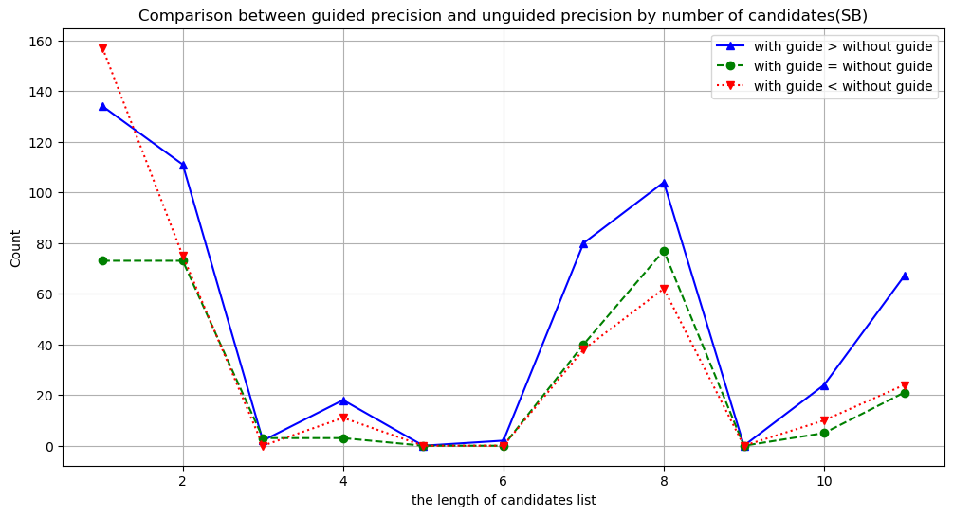

TOP1

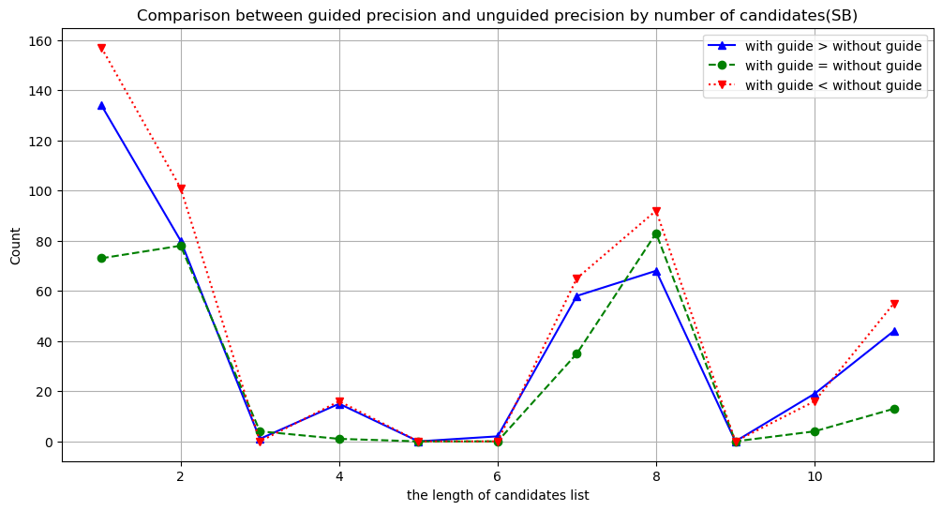

C11

precisionWithout 15.472570

precisionTop1 20.217928

precisionMAX 26.222421

precision1(ideal) 28.368711

ideal

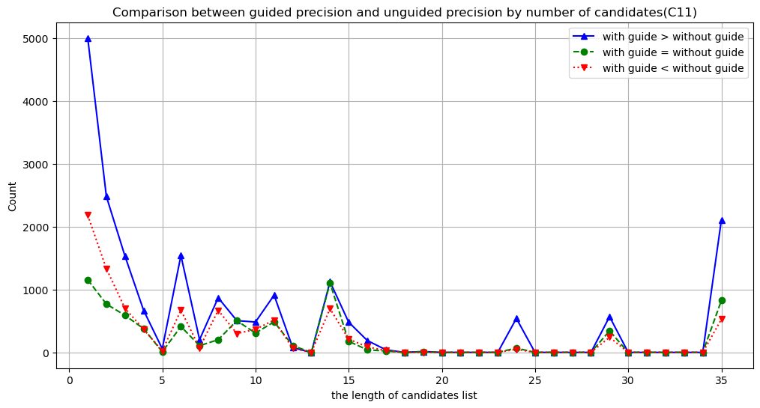

MAX

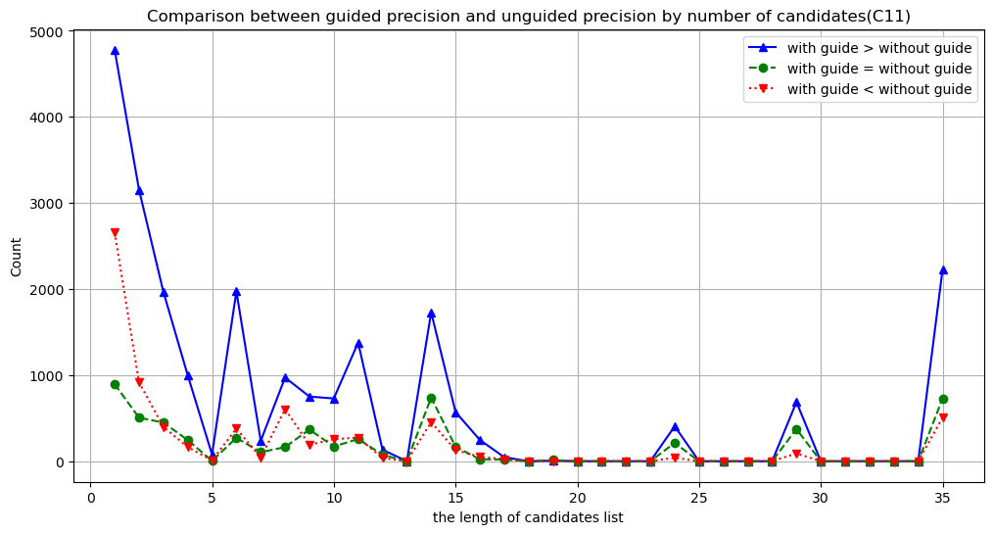

TOP1

