DATA ANALYSIS 1 | FINAL PROJECT REPORT
Gold Price Prediction
What 25 years of daily futures prices can and cannot tell us about tomorrow

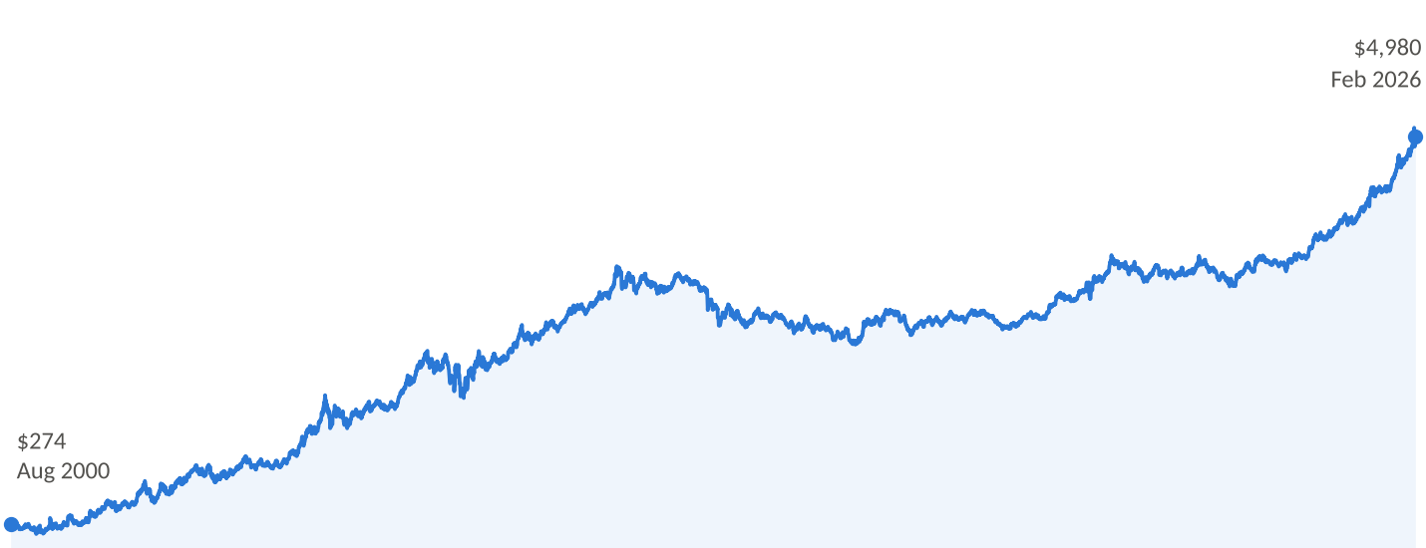
Team members | Len Monireach (2024498)  Dy David (2024583)
Course | Data Analysis 1
Lecturer | Dr. HAS Sothea
Semester | Fall 2026
Date | 12 November 2026

Members and Contributions
Member | Student ID | Sections of the report
Len Monireach | 2024498 | Introduction, Data Preprocessing, Exploratory Data Analysis
Dy David | 2024583 | Model Development, Results and Evaluation, Conclusion

Summary
This report analyses 6,383 daily observations of gold futures, from 30 August 2000 to 6 February 2026, and tests how far tomorrow's price can be predicted from the price history alone.
We began by checking a Kaggle file that describes itself as cleaned. Seven of its 20 columns are redundant. Its "365-day" average covers 1.45 years, because the windows count trading days. On 430 early rows the closing price lies outside the day's own high-low range, and the volume column follows the futures contract calendar. All 520 missing values are warm-up rows of rolling windows, where imputation would have been wrong. The closing price is the reliable column: its daily change matches press reports of three of the largest days to within 10 cents.
Exploration shows an 18-fold rise in price, daily returns with fat tails (84 days beyond three standard deviations where a normal distribution expects 17), volatility that comes in clusters, and no calendar effect on the average return that survives a test.
We then built 37 features that use only information available at the previous close, and compared classical benchmarks with linear models, a random forest and XGBoost on a chronological split that holds out the last 1,029 trading days. Three results follow. First, no model predicts tomorrow's price better than today's price plus the long-run drift. Measured on returns, the seven forecasts we tried all land within 0.6% of the naive forecast's RMSE, and the one that appears to win owes its lead to a single day. Second, no model predicts tomorrow's direction: accuracy runs from 55.0% to 56.1% against a base rate of 55.6%. Third, the size of tomorrow's move is partly predictable. A ridge model explains 11% of its variance on the test set (6% if January 2026 is left out), and a 95% band scaled by that forecast covered 93% to 96% of days in each full test year. A band of constant width covered 97% in 2022 and 91% in 2025.
The practical conclusion is that a next-day gold forecast should be today's price with a band whose width follows recent volatility. An R-squared of 0.998 for the price, which the naive forecast also achieves, says nothing about skill.

Contents
Members and Contributions 1  Summary 1  1. Introduction 3  1.1 Why predict the gold price? 3  1.2 Objectives 3  1.3 The dataset 3  1.4 Method and tools 4  2. Data Preprocessing 4  2.1 First inspection 4  2.2 Redundant columns 5  2.3 Auditing the calculated columns 5  2.4 Price integrity 6  2.5 Is the calendar complete? 7  2.6 Volume 7  2.7 Missing values 8  2.8 Outliers 9  2.9 Feature engineering 11  2.10 Summary of preprocessing decisions 12  3. Exploratory Data Analysis 13  3.1 The price over 25 years 13  3.2 Descriptive statistics 13  3.3 The distribution of daily returns 14  3.4 Volatility comes in clusters 15  3.5 Stationarity: levels against returns 16  3.6 Calendar effects 17  3.7 Drawdowns 18  3.8 Trend and the moving averages 19  3.9 Correlation 20  3.10 Volatility today and the move tomorrow 21  3.11 What the exploration means for the models 22 |  | 4. Model Development 22  4.1 High scores for the wrong reason 22  4.2 Three prediction tasks 24  4.3 Training, validation and test data 24  4.4 Models and why we chose them 25  4.5 Hyperparameter tuning 26  4.6 How the models are judged 27  5. Results and Evaluation 28  5.1 Task A: tomorrow's price 28  5.2 Task B: tomorrow's direction 30  5.3 Task C: the size of tomorrow's move 31  5.4 From a point forecast to a forecast band 33  5.5 Does retraining help? 35  5.6 Answers to the four questions 36  6. Conclusion 36  6.1 Key findings 36  6.2 Implications 37  6.3 Limitations 37  6.4 Future work 37  References 38  Appendix 41  A. Feature dictionary 41  B. Additional figures 42  C. Additional tables 43  D. Code excerpts 44  E. Software and reproducibility 45

1. Introduction

1.1 Why predict the gold price?
Gold is held by central banks as a reserve, traded by funds and bought by households as savings. The years at the end of our dataset were among the most eventful in its recent history. In 2025 the gold price set 53 new record highs, total annual demand passed 5,000 tonnes for the first time, and central banks bought 863 tonnes (World Gold Council, 2026). In our data the futures price closed above $3,000 for the first time in March 2025 and above $5,000 in January 2026. Four days after that it fell 11% in one session.
Anyone who buys, sells or lends against gold would like to know tomorrow's price. Finance theory says not to expect much. In an efficient market today's price already reflects what is publicly known, so the next change should be close to unpredictable from past prices (Fama, 1970). Gold adds a difficulty of its own: it is an asset investors move into when other markets are under stress (Baur & Lucey, 2010), so its largest moves tend to arrive with news that nobody had the day before.
It is easy to build a model of the gold price that reports an R-squared above 0.99, and Section 4.1 does it three times. This project sets out to find what such a number means, and what a careful analysis can offer in its place.

1.2 Objectives
We ask four questions, and the report is organised around them.
- What does 25 years of daily gold data look like once it has been checked and cleaned: its trend, its risk, its seasonal patterns and its anomalies? (Sections 2 and 3)
- Can a model predict tomorrow's closing price better than simply repeating today's price? (Task A)
- Can a model predict whether tomorrow's close will be higher or lower than today's? (Task B)
- If the direction cannot be predicted, can the size of tomorrow's move be predicted, and is that of any use? (Task C)
Questions 2 to 4 are set up in Section 4 and answered in Section 5.

1.3 The dataset
The data are the Kaggle file Gold Price Historical Data (2000-2026) (hamzasamiullah, 2026). It holds daily prices of the gold futures contract traded on COMEX, as published by Yahoo Finance under the ticker GC=F. One contract is for 100 troy ounces and is quoted in US dollars per ounce (CME Group, 2023). Table 1 summarises the file.
Table 1. The dataset at a glance.
Item | Value
Source | Kaggle (hamzasamiullah, 2026); prices from Yahoo Finance, ticker GC=F
Instrument | COMEX gold futures, front-month contract, US dollars per troy ounce
Period | 30 August 2000 to 6 February 2026
Size | 6,383 rows, one per trading day, and 20 columns
Column types | 16 numeric, 4 text
Price columns | Open, High, Low, Close, and Volume
Calculated columns | Price_Change, Price_Change_Percent, MA_7, MA_30, MA_90, MA_365, Volatility_30d
Missing cells | 520 of 127,660 (0.41%), all in the calculated columns
Duplicate rows | None
Targets (built by us) | Tomorrow's log return, tomorrow's direction, size of tomorrow's move

1.4 Method and tools
All work was done in Python in one Jupyter notebook (Kluyver et al., 2016), using pandas (McKinney, 2010), NumPy (Harris et al., 2020), SciPy (Virtanen et al., 2020), statsmodels (Seabold & Perktold, 2010), scikit-learn (Pedregosa et al., 2011), XGBoost (Chen & Guestrin, 2016), Matplotlib (Hunter, 2007) and seaborn (Waskom, 2021). The notebook runs from the raw CSV file to the last figure in a few minutes with a fixed random seed, and every number, table and figure in this report is written by it. Section 2 covers preprocessing, Section 3 the exploratory analysis, Section 4 how the models were built, Section 5 what they achieved and Section 6 what we conclude.

2. Data Preprocessing
The file name ends in cleaned. We treated that as a claim to check. The checks below are reported in the order we ran them, and each ends with the decision we took. Four of them turned up problems that a first look at the table does not show.

2.1 First inspection
The file has 6,383 rows and 20 columns. Each row is a trading day, the rows are in date order, no date appears twice and no row is duplicated. Sixteen columns are numeric and four are text. Table 2 groups the columns by what they hold.
Table 2. The 20 columns, grouped, and what the checks in this section found.
Group | Columns | What the checks found
Date and calendar | DateTime, Date, Year, Month, Day, DayOfWeek, Quarter | Six of the seven repeat information already in Date (2.2)
Prices | Open, High, Low, Close | Close is reliable; Open, High and Low are not in the early years (2.4)
Activity | Volume | Follows the contract calendar, not market activity (2.6)
Calculated from Close | Price_Change, Price_Change_Percent, MA_7, MA_30, MA_90, MA_365, Volatility_30d | Reproduce exactly; windows are in trading days; hold every missing value (2.3, 2.7)
Provenance | Source | A single value, Yahoo Finance (2.2)

Missing values are rare: 520 cells out of 127,660, or 0.41%, spread over the seven calculated columns. We come back to them in Section 2.7, after establishing how those columns were calculated.

2.2 Redundant columns
Seven of the 20 columns carry no information of their own. Year, Month, Day, DayOfWeek and Quarter equal the values we derive from Date on all 6,383 rows. DateTime is Date with a midnight timestamp. The only thing it adds is New York's UTC offset, −04:00 on 4,051 rows and −05:00 on 2,332, which is daylight saving time. Source holds one value.
Decision. We drop DateTime and Source and use Date as the index. The calendar fields stay in the table for grouping in the exploratory analysis, and are rebuilt from the index wherever a model needs them.

2.3 Auditing the calculated columns
We recomputed each of the seven calculated columns from Close and compared the result with the file (Table 3). All seven reproduce to within floating-point rounding, and the missing values fall on the same rows.
Table 3. Recomputing the calculated columns from Close.
Column | Definition that reproduces it | Largest difference | Missing: file / recomputed
Price_Change | Close(t) − Close(t-1) | 2.3 × 10⁻¹³ | 1 / 1
Price_Change_Percent | 100 × (Close(t) / Close(t-1) − 1) | 3.3 × 10⁻¹⁴ | 1 / 1
MA_7 | mean of the last 7 closes | 9.1 × 10⁻¹³ | 6 / 6
MA_30 | mean of the last 30 closes | 9.1 × 10⁻¹³ | 29 / 29
MA_90 | mean of the last 90 closes | 9.1 × 10⁻¹³ | 89 / 89
MA_365 | mean of the last 365 closes | 4.5 × 10⁻¹³ | 364 / 364
Volatility_30d | sample std of the last 30 values of Price_Change_Percent | 1.3 × 10⁻¹⁴ | 30 / 30
Differences are in the units of the column (US dollars or percent). Values of this size are floating-point rounding.
Two details change how the columns should be read. First, the windows count rows, not calendar days. The file has 251 trading days per calendar year, so MA_365 is an average over about 1.45 years and Volatility_30d covers about six weeks. Second, Volatility_30d is the standard deviation of daily percentage changes and is not annualised. A value of 1.0 means that a typical day moves about 1%.
Decision. We keep the seven columns, since they are calculated correctly, and use them under their true definitions: MA_365 is a 1.45-year average and Volatility_30d a six-week daily volatility.

2.4 Price integrity
A daily bar is valid only if its low is the lowest and its high the highest of its four prices. Table 4 counts the rows that break that rule or show no trading, and Figure 1 shows when they occur.
Table 4. Integrity checks on the price and volume columns.
Check | Rows | Share of rows
Close above High | 223 | 3.49%
Close below Low | 207 | 3.24%
Close outside the Low to High range (either) | 430 | 6.74%
Open outside the Low to High range | 56 | 0.88%
Flat bar: Open = High = Low = Close | 812 | 12.72%
Zero volume | 418 | 6.55%
Close unchanged from the previous day | 45 | 0.70%
Zero or negative price | 0 | 0.00%

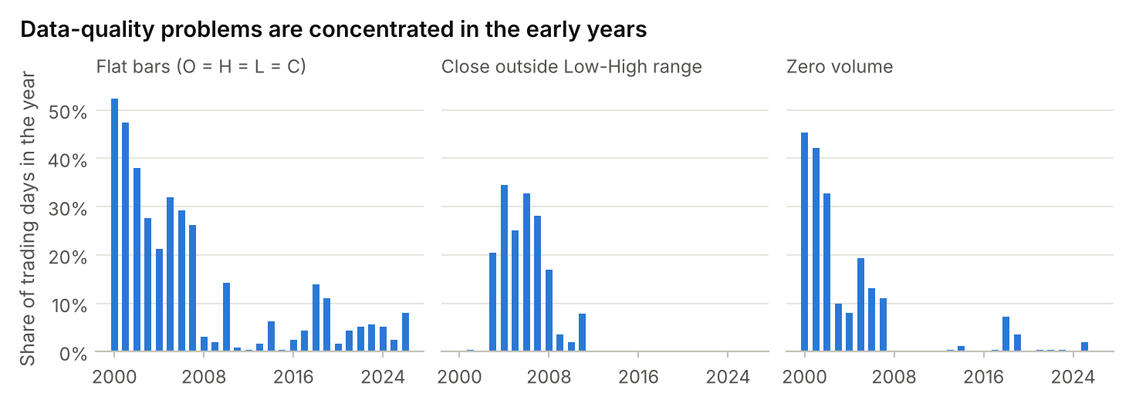
Figure 1. Share of each year's trading days with a flat bar, a close outside the day's range, or zero volume. The problems belong to the first half of the sample.
On 430 days the close lies outside the day's own high-low range, which cannot happen with traded prices. All of these days fall between 2001 and 2011. The likely cause is the way futures are quoted. Close is the exchange's official settlement price, while Open, High and Low record actual trades, and in a contract with very few trades the two can disagree. The same thin trading explains the 812 flat bars and 418 zero-volume days. Before 2008 a third of all bars are flat (33%), against 5% from 2008 onward.
Decision. We trust Close. It is the official price, the calculated columns are built from it, and Section 2.8 confirms it against press reports. We do not trust Open, High and Low before 2012. We repair them in the standard way, by widening the range until it contains Open and Close (441 rows changed), and we build all but two of our model features from Close alone.

2.5 Is the calendar complete?
A table can be complete in every column and still have whole days missing. Between the first and last date there are 6,638 weekdays and 6,383 rows. We tried to explain each of the 255 weekdays without a row (Table 5).
Table 5. Weekdays between the first and last date that have no row.
Explanation | Weekdays
US federal holiday | 207
Good Friday | 25
Day next to a federal holiday | 11
Known market closure: 11 to 13 September 2001, Hurricane Sandy (October 2012), national days of mourning (2004, 2018) | 7
No explanation found | 5
Total | 255

Five single days remain unexplained (30 Mar 2005, 28 Apr 2005, 29 Jun 2005, 27 Nov 2006, 29 Jan 2018), which makes the series 99.9% complete. The longest gap between two consecutive rows is 5 calendar days.
Decision. We do not insert rows or carry prices forward for closed days, because no price existed on them. The file is treated as a sequence of trading days, which is also how its moving averages were built.

2.6 Volume
The median day trades 117 contracts and the busiest 386,334. Investor interest does not explain a spread of that size. Figure 2 shows where the volume sits. Average daily volume in January, March, May, July and November is 9,577 contracts, 16 times the 594 of the other months. The surge is concentrated at the end of the month, with 19,302 contracts a day on days 25 to 31 against 385 on days 1 to 24, and all ten record days fall on or after the 26th.
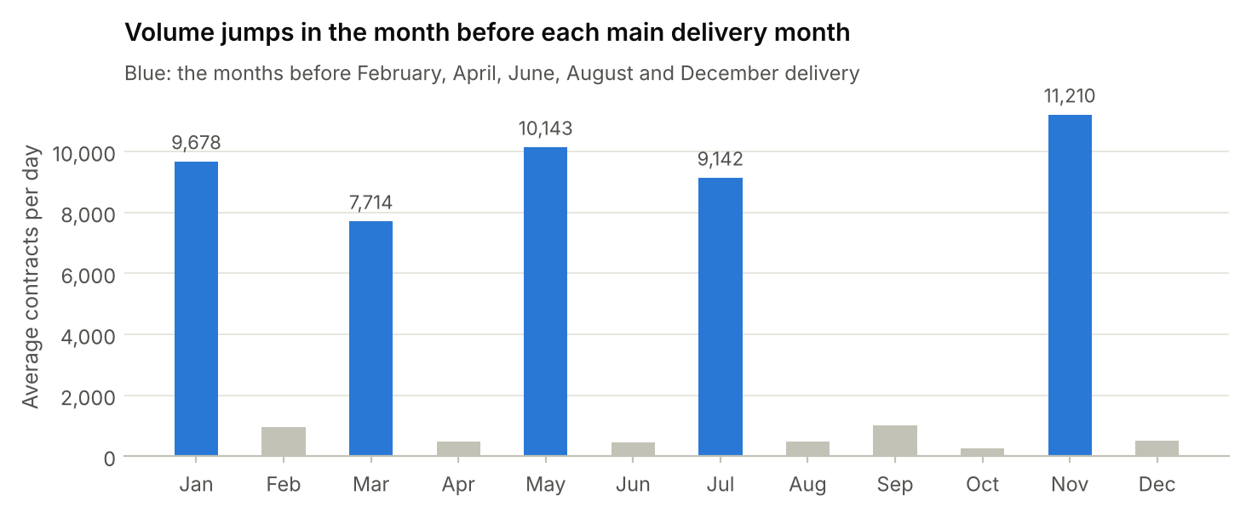
Figure 2. Average daily volume by calendar month. The five months before the main delivery months trade 16 times the volume of the others.
The pattern is what the contract calendar would produce. Gold futures are listed for delivery in particular months, with February, April, June, August, October and December as the regular cycle, and trading in a contract ends on the third-last business day of its delivery month (CME Group, 2023). The ticker GC=F follows the front-month contract, the one closest to delivery. For most of the year that is a thinly traded contract. At the end of January, March, May, July and November the front month becomes one of the main delivery months, and for a few days the series shows the contract that most of the market trades. October is traded far less than the other five, and September shows only a small rise. Consistent with this, the Pearson correlation of Volume with the day of the month is 0.22, and with Close it is 0.04.
Decision. In this file Volume records which contract the ticker is pointing at. It does not measure how active the gold market is, so we leave it out of the models.

2.7 Missing values
With the definitions from Section 2.3 in hand, the 520 missing cells are easy to read (Table 6, Figure 3).
Table 6. Missing values by column.
Column | Window (rows) | Missing rows | Share of rows | First valid date
Price_Change | 1 | 1 | 0.02% | 31 Aug 2000
Price_Change_Percent | 1 | 1 | 0.02% | 31 Aug 2000
MA_7 | 7 | 6 | 0.09% | 8 Sep 2000
MA_30 | 30 | 29 | 0.45% | 11 Oct 2000
MA_90 | 90 | 89 | 1.39% | 9 Jan 2001
MA_365 | 365 | 364 | 5.70% | 20 Feb 2002
Volatility_30d | 30 | 30 | 0.47% | 12 Oct 2000
Rows with at least one missing value: 364 (5.7%), which are rows 1 to 364. Open, High, Low, Close and Volume have no missing values.
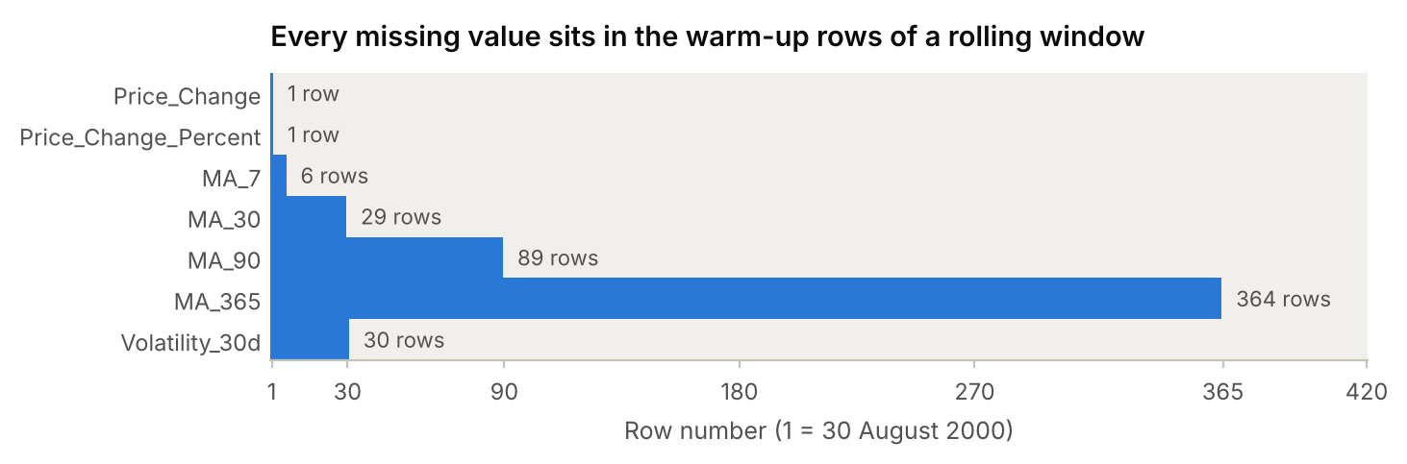
Figure 3. Missing cells (blue) in the first 420 rows of the seven calculated columns. Each column is empty for exactly the length of its window, then complete.
Every missing value sits in the warm-up of a rolling window. A 365-row average cannot exist until 365 rows have passed, so the first 364 values of MA_365 are empty, and the same reasoning gives 89 for MA_90, 29 for MA_30, 6 for MA_7, 30 for Volatility_30d and one for the two change columns. After row 364 (19 February 2002) nothing is missing.
The usual classification asks whether values are missing completely at random, at random or not at random (Rubin, 1976). Formally these cells are missing at random, because whether a cell is missing depends only on something we observe, the row number: the probability is 1 inside the warm-up and 0 after it. The label is not much help, though. The values are not unknown. They are undefined, since an average of 365 rows does not exist on row 200. This is structural missingness, and it rules out the usual remedies. The data show why.
- Mean or median imputation would write about $1,222 (mean) or $1,262 (median) into MA_365 for rows from 2000 to early 2002, when gold averaged $272. The filled value would be 4.5 times the price.
- Back-filling the first valid value puts a number into rows where it could not have been known on that day. In a forecasting project that is look-ahead leakage.
- Recomputing with a shorter window is honest about timing but changes what the column means in those rows.
- Dropping the incomplete rows where a model needs complete ones costs 364 of 6,383 rows (5.7%), all from the oldest part of the sample.
Decision. We leave the gaps as they are for the exploratory analysis, where the price and return columns are complete. For modelling we drop the warm-up rows. Our own features need up to 252 days of history in any case, so the extra cost of keeping MA_365 is 112 rows.

2.8 Outliers
We looked for outliers in two places, the price level and the daily change, and they taught different lessons.
Price level. Tukey's (1977) rule of 1.5 interquartile ranges puts the upper fence for Close at $3,245 and flags 197 rows, all of them since 16 April 2025 (197 of the 205 trading days from that date on). These are not errors. Gold did trade above $3,245. The rule assumes values drawn from one stable distribution, and a price that has risen 18-fold does not qualify. Applied to a trending series, an outlier rule describes the trend.
Daily returns. From here on we measure the daily change as the log return, 100 × ln(Close(t) / Close(t − 1)), which adds up over time and treats rises and falls symmetrically. On returns the rule is meaningful. Its fences are −2.13% and +2.29%, and 317 days (5.0%) fall outside them. Table 7 compares the tails with what a normal distribution would give, and Figure 4 shows when the extreme days happened.
Table 7. Days with a standardised log return (z) beyond each threshold, against the number a normal distribution would produce in 6,382 days.
Threshold | Days observed | Days expected if normal | Observed / expected
|z| > 2 | 304 | 290.4 | 1.0
|z| > 3 | 84 | 17.2 | 4.9
|z| > 4 | 34 | 0.404 | 84
|z| > 5 | 13 | 0.004 | over 3,000

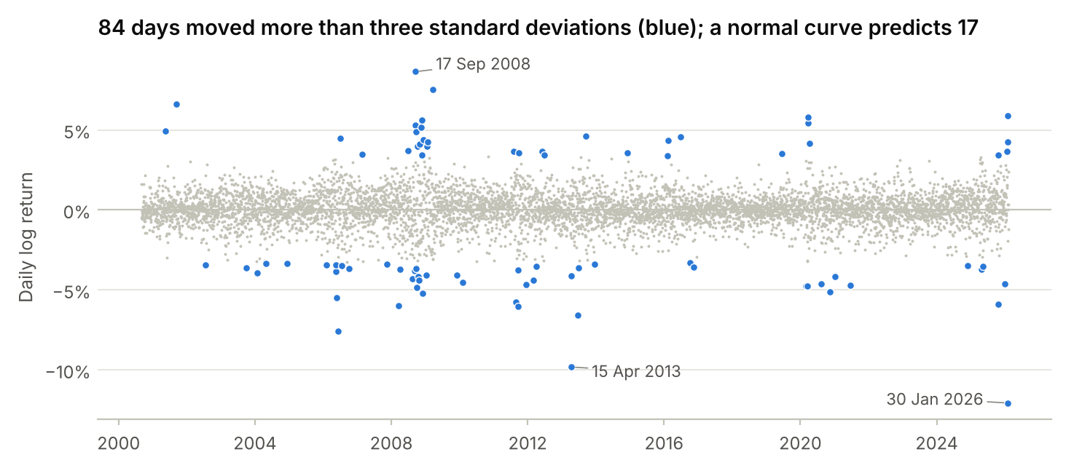
Figure 4. Daily log returns, with the 84 days beyond three standard deviations in blue. The extreme days arrive in clusters.
Days beyond three standard deviations are five times as common as a normal distribution predicts. Days beyond five, which a normal distribution would produce about once in 7,000 years of trading, happened 13 times in 25. The extreme days also cluster in a few periods (2006, 2008, 2011, 2013, 2020, 2025 to 2026), a pattern Section 3.4 returns to.
Checking the extreme days. Before deciding what to do with them we compared the largest ones with press reports of the day (Table 8).
Table 8. The ten largest daily moves by absolute log return, and what was reported at the time.
Date | Close | Change ($) | Change (%) | Reported at the time
30 Jan 2026 | $4,713.90 | −604.50 | −11.4 | Gold fell 9% in a day, the steepest one-day fall since the early 1980s, after a new Federal Reserve chair was named (Morningstar, 2026)
15 Apr 2013 | $1,360.60 | −140.40 | −9.4 | Down $140.30, or 9%, to $1,361; the largest one-day fall in 30 years (Rothwell, 2013)
17 Sep 2008 | $846.60 | +70.10 | +9.0 | Up $70, or 9%, a record one-day dollar gain, after the AIG rescue (CNNMoney, 2008)
13 Jun 2006 | $562.50 | −44.30 | −7.3 | Not checked
19 Mar 2009 | $958.30 | +69.60 | +7.8 | Not checked
14 Sep 2001 | $290.20 | +18.60 | +6.8 | First row in the file after 11 September 2001; the file has no rows for 11 to 13 September
20 Jun 2013 | $1,285.90 | −87.70 | −6.4 | Not checked
23 Sep 2011 | $1,637.50 | −101.70 | −5.8 | Not checked
19 Mar 2008 | $944.70 | −58.50 | −5.8 | Not checked
21 Oct 2025 | $4,087.70 | −248.70 | −5.7 | Front-month futures fell $248.70 to settle at $4,087.70; the largest fall since June 2013 (Almazora, 2025)
Change (%) is the simple percentage change in Close, as in the dataset's Price_Change_Percent column. Not checked: we did not look for a report of that day.
Four of the ten days were checked against a report, and where a report gives the dollar change in the futures price, the file matches it. The change agrees to within 10 cents on all three such days. On 21 October 2025 the close also equals the published front-month settlement. On 17 September 2008 the level differs by $3.90 because the report quotes the December contract and the file tracks the front month. For 30 January 2026 the report we found gives a fall of 9%, from $5,390 to $4,895, without saying which gold price that is, while the front-month close in the file fell 11.4%. That day's event and scale are confirmed. Its exact figure is not.
Decision. We keep every row. The extreme days are real events, they are the days on which a forecast is most needed, and removing or capping them would make gold look safer than it is. We deal with them in how we measure instead. We model log returns. Next to means, Pearson correlations and RMSE we report medians, Spearman correlations and MAE, which one day cannot move much. And in Section 5 we test whether any model's score depends on a single day. One does.

2.9 Feature engineering
The models may use only what was known at the close of day t to predict day t + 1. We built 37 features in six families (Table 9; Appendix A defines every one). Almost all are ratios or changes, not price levels, for two reasons the exploratory analysis makes concrete: price levels are not stationary (Section 3.5), and the eight price-level columns are nearly copies of each other (Section 3.9).
Table 9. The 37 model features by family.
Family | n | Features | What it measures
Recent returns | 6 | Today's log return and the five before it | Short-term reversal or continuation
Momentum | 6 | Cumulative log return over 5, 10, 21, 63, 126 and 252 days | Trend from one week to one year
Trend | 7 | Close relative to MA_7, MA_30, MA_90 and MA_365; MA_7 to MA_30, MA_30 to MA_90, MA_90 to MA_365 | Position against the dataset's own moving averages
Volatility | 8 | Absolute return; standard deviation of returns over 5, 10 and 90 days; Volatility_30d; ratio of 5-day to 30-day volatility; true range and its 14-day average (Wilder, 1978) | Recent size of moves
Oscillators | 3 | 14-day relative strength index (Wilder, 1978); position within 20-day Bollinger bands (Bollinger, 2001); distance below the 252-day high | Overbought and oversold measures used by traders
Calendar | 7 | Four weekday indicators with Monday as reference; month as sine and cosine; first trading day of the month | Seasonal effects

Three targets are defined from the next day's close: its log return (Task A), an indicator for a higher close (Task B) and the absolute log return (Task C). After removing the warm-up rows and the final row, which has no next day, the modelling table has 6,018 rows from 20 February 2002 to 5 February 2026.
Leakage test. Using tomorrow's information by accident is the most common way a forecasting project goes wrong (Kaufman et al., 2012). We tested for it directly. We scrambled every price after 30 June 2015, rebuilt all features and compared the rows up to that date with the originals. They are identical, so no feature looks forward.

2.10 Summary of preprocessing decisions
Table 10. What we found and what we did about it.
Issue | Evidence | Decision
Redundant columns | 7 of 20 columns repeat Date or hold one value | Drop DateTime and Source; index by Date
Misleading names | Windows count trading days: MA_365 spans 1.45 years; volatility is daily, not annualised | Keep the columns; use their true definitions
Invalid bars | 430 closes outside the day's range (2001 to 2011); 812 flat bars | Trust Close; repair High and Low on 441 rows; build features from Close
Calendar gaps | 255 weekdays absent, 5 unexplained | No filling; treat the file as a sequence of trading days
Volume | 16 times higher in the months before main delivery months | Exclude from the models
Missing values | 520 cells, all rolling-window warm-up | Leave for exploration; drop the 364 warm-up rows for modelling
Outliers | 84 days beyond 3 standard deviations (17 expected); largest days confirmed by press reports | Keep all rows; log returns; statistics that resist single days; single-day checks
Leakage | Scrambling the future leaves every feature unchanged | 37 features at day t; targets at day t + 1

3. Exploratory Data Analysis
This section describes the cleaned series: where the price went, how its daily changes are distributed, and which regularities are strong enough to be worth modelling. Statistics are for the full sample unless a subsection says otherwise.

3.1 The price over 25 years
The close rose from $273.90 on 30 August 2000 to $4,979.80 on 6 February 2026, an 18-fold increase, or 12.1% a year compounded (Figure 5). The path has three parts. An eleven-year rise took the price to $1,889 on 22 August 2011. A four-year decline followed, to $1,051 on 17 December 2015. The recovery passed $2,000 on 4 August 2020, and from 2024 the climb became the steepest in the sample: the first close above $3,000 came on 17 March 2025, above $4,000 on 8 October 2025 and above $5,000 on 26 January 2026. The record close is $5,318.40 on 29 January 2026.
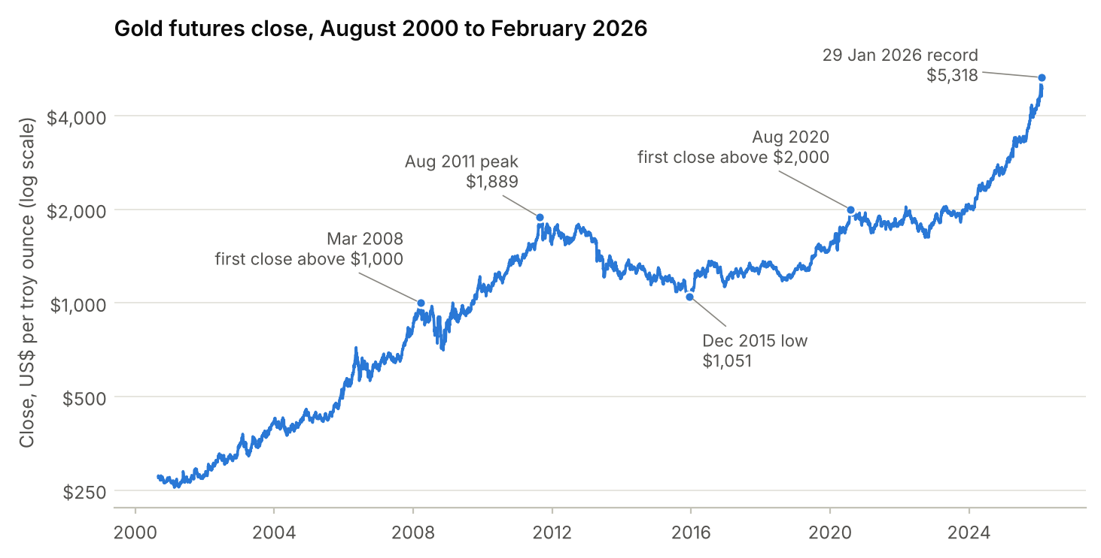
Figure 5. Daily close on a logarithmic scale, so that equal vertical distances are equal percentage changes.
A series like this has no typical level. The mean close of $1,265 describes no period in particular, and every statistic computed on the price level mostly measures the trend. For that reason the rest of this section works with daily returns.

3.2 Descriptive statistics
The average daily log return is 0.045% and its standard deviation is 1.11% (Table 11). The typical swing of one day is therefore about 24 times the average gain. That ratio is the core difficulty of the whole project: the part of tomorrow's move that an upward trend can explain is tiny next to the part it cannot. Gold closed higher on 52.8% of days. The median absolute move is 0.55% and the mean is 0.78%, pulled up by a small number of large days. Annualised, the return is 11.5% and the volatility 17.7%.
Table 11. Descriptive statistics of the main series.
Series | n | Mean | Median | Std. dev. | Min | Max | Skewness | Excess kurtosis
Close (US$) | 6,383 | 1,265.37 | 1,250.20 | 760.27 | 255.10 | 5,318.40 | 1.27 | 3.11
Daily log return (%) | 6,382 | 0.045 | 0.052 | 1.112 | −12.07 | 8.64 | −0.47 | 7.08
Absolute daily return (%) | 6,382 | 0.782 | 0.554 | 0.793 | 0.00 | 12.07 | 2.87 | 17.75
Volatility_30d (%) | 6,353 | 1.027 | 0.932 | 0.402 | 0.43 | 3.21 | 1.84 | 4.46
Volume (contracts) | 6,383 | 4,315 | 117 | 24,171 | 0 | 386,334 | 7.81 | 69.16
Excess kurtosis is zero for a normal distribution. Volatility_30d has 30 missing values (Section 2.7).
Year by year the picture is uneven (Figure 6). Gold rose in 19 of the 25 full years. The best year was 2025 (+64.5%), the worst 2013 (−28.2%), and the median year gained 13.3%. Appendix C lists every year.
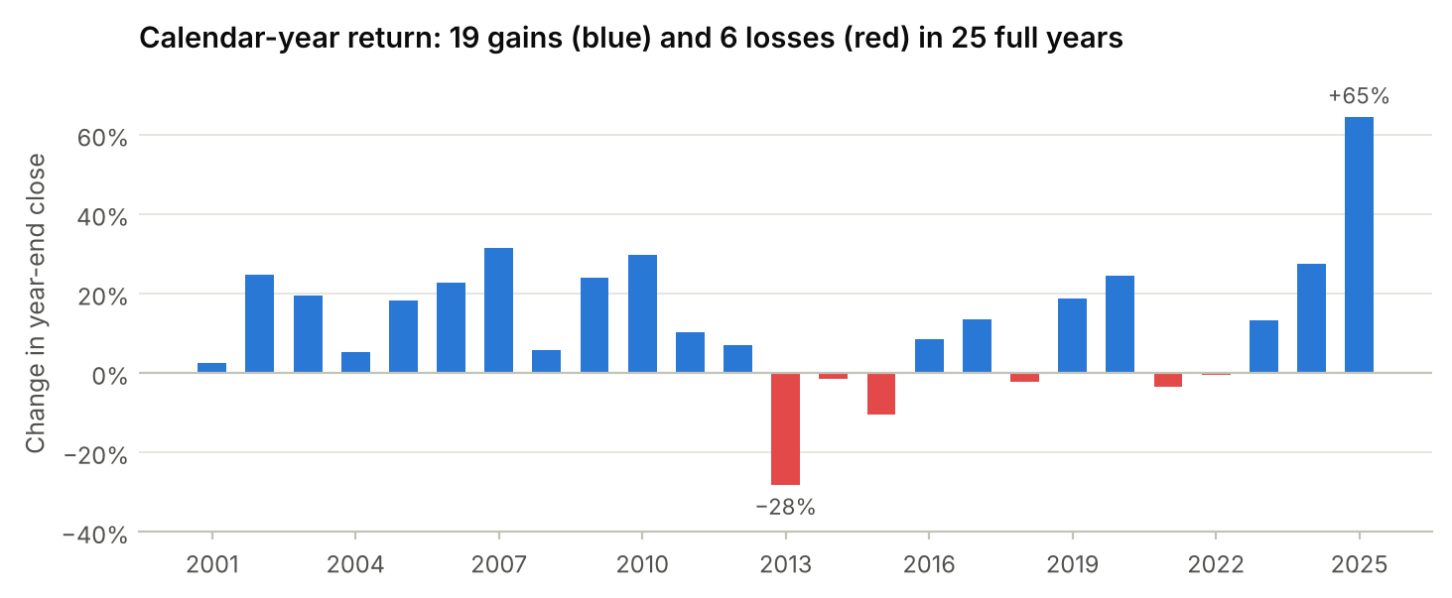
Figure 6. Change in the year-end close for each full calendar year, 2001 to 2025.

3.3 The distribution of daily returns
Daily returns are not normally distributed (Figure 7). The histogram has a taller peak and longer tails than the normal curve, and in the quantile plot both ends bend away from the line. Skewness is −0.47, so the large falls are larger than the large rises, and excess kurtosis is 7.08. The Jarque-Bera test (Jarque & Bera, 1987) gives a statistic of 13,567 and the Kolmogorov-Smirnov test D = 0.074, both with p < 0.001. Heavy tails of this kind are found in the returns of almost every financial asset (Cont, 2001).
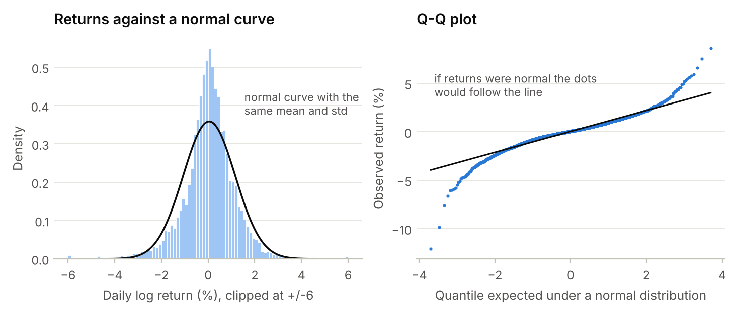
Figure 7. Left: histogram of daily log returns with a normal curve of the same mean and standard deviation. Right: quantile-quantile plot against the normal distribution.
Two consequences follow for the modelling. Squared-error measures such as RMSE can be decided by a handful of days, so every comparison in Section 5 is checked for that. And an interval built from normal theory, such as the mean plus or minus 1.96 standard deviations, will be too narrow in the tails. Section 5.4 sets its interval widths from the data for this reason.

3.4 Volatility comes in clusters
Figure 8 plots Volatility_30d. Its median is 0.93% a day and half of all days lie between 0.76% and 1.16%. It has gone above 2% in only six periods: mid-2006, the financial crisis of 2008 to 2009 (the sample maximum, 3.21% on 23 October 2008), autumn 2011, spring 2013, April 2020 (2.65%) and 2025 to 2026, where the last row of the file stands at 2.99%. Between those episodes the series stays near 1% for years at a time.
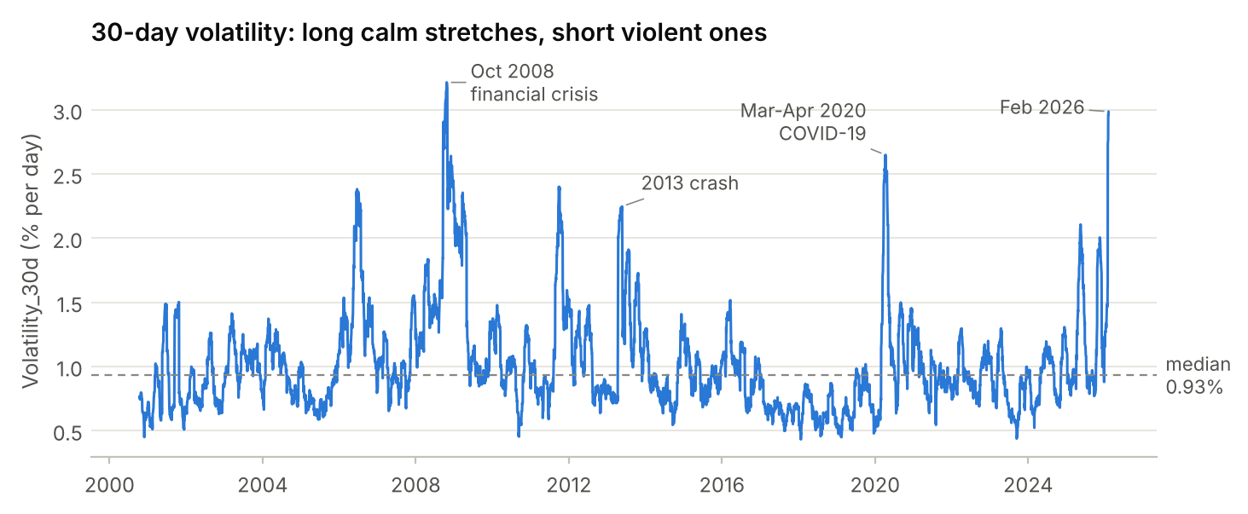
Figure 8. The dataset's Volatility_30d column: standard deviation of the last 30 daily percentage changes.
The autocorrelation plots put a number on this (Figure 9). For the returns themselves, the correlation with the previous day is −0.013 and only 4 of 40 lags fall outside the 95% band of ±0.025, where two would be expected by chance. The largest is 0.035, which corresponds to about a tenth of one percent of the variance. A Ljung-Box test (Ljung & Box, 1978) does detect it (Q(10) = 19.5, p = 0.035), so the returns are not perfectly uncorrelated, but the dependence is too small to forecast with.
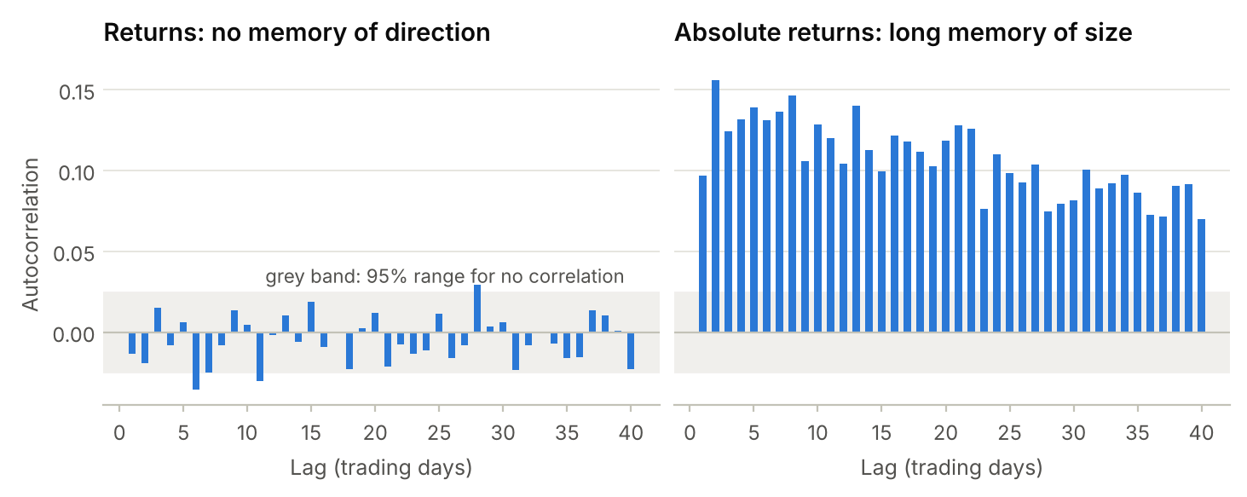
Figure 9. Autocorrelation at lags 1 to 40 of daily returns (left) and of absolute daily returns (right). Bars inside the grey band are within the 95% range expected when there is no correlation.
For absolute returns the result is the opposite. The autocorrelation is 0.097 at lag 1, 0.156 at lag 2 and still 0.070 at lag 40, with every lag outside the band (Ljung-Box Q(10) = 1,092; Engle's ARCH test statistic 329.4; both p < 0.001). A large move tends to be followed by more large moves, of either sign. This is volatility clustering, the property that ARCH and GARCH models were designed for (Engle, 1982; Bollerslev, 1986). Put simply, yesterday tells us almost nothing about which way gold will move today, and a fair amount about how far.

3.5 Stationarity: levels against returns
A stationary series has a constant mean and variance, and most statistical models assume it. We applied two tests with opposite null hypotheses (Dickey & Fuller, 1979; Kwiatkowski et al., 1992), so that a conclusion needs both to agree (Table 12). For the close and for its logarithm, the ADF test cannot reject a unit root and the KPSS test rejects stationarity. For daily returns the ADF test rejects a unit root and the KPSS test does not reject stationarity. Price levels are not stationary. Returns are.
Table 12. Stationarity tests. The ADF test has a unit root (not stationary) as its null hypothesis; the KPSS test has stationarity as its null.
Series | ADF statistic | ADF p-value | KPSS statistic | KPSS p-value | Both tests say
Close | 5.30 | > 0.99 | 9.08 | < 0.01 | Not stationary
log(Close) | 0.03 | 0.96 | 10.27 | < 0.01 | Not stationary
Daily log return | −25.45 | < 0.001 | 0.19 | > 0.10 | Stationary
statsmodels reports KPSS p-values only between 0.01 and 0.10.
Figure 10 shows what that means for prediction. Tomorrow's close plotted against today's is almost a straight line, with a correlation of 0.9997. Tomorrow's return plotted against today's is a round cloud with a correlation of −0.013. Both panels use the same data. The left one explains why any model given today's price will report an R-squared near 1 for tomorrow's price. The right one shows how much of that is forecasting skill.
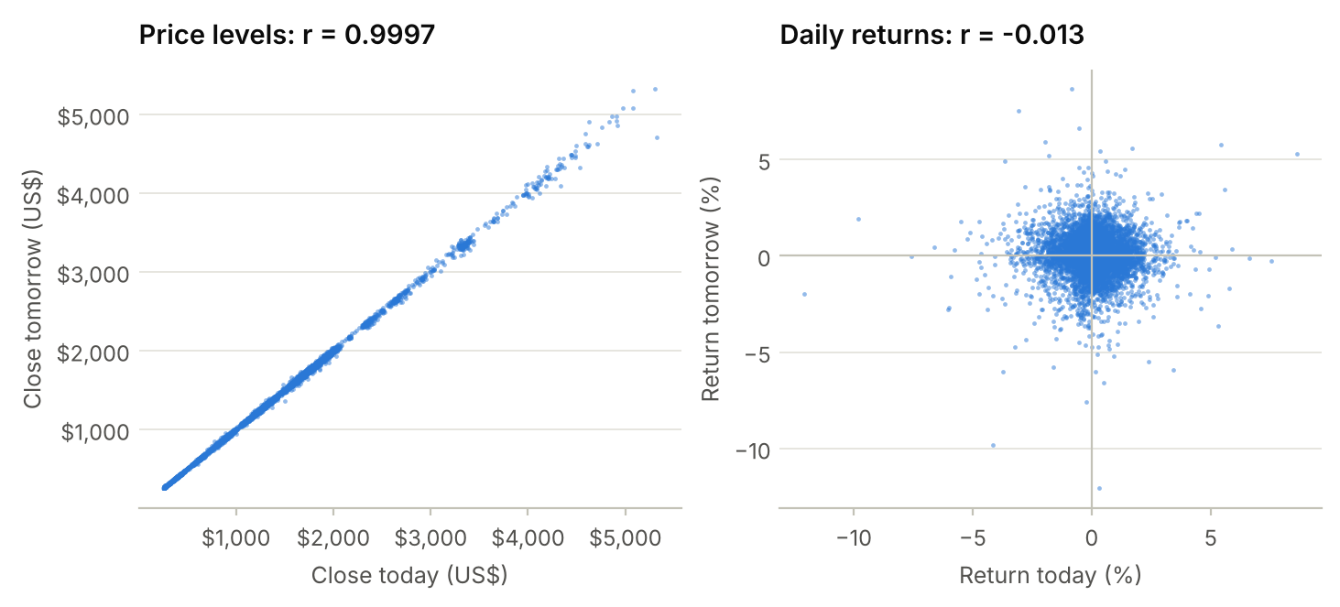
Figure 10. Left: tomorrow's close against today's close. Right: tomorrow's return against today's return.

3.6 Calendar effects
Traders often talk about good and bad months for gold. In our sample Friday has the highest average return (0.083%) and Tuesday the lowest (0.015%). January is the strongest month, with an average gain of 3.0% and a rise in 17 of 26 years, and June is the only month with a negative average (−0.47%). The confidence intervals in Figure 11 overlap heavily, so we tested each pattern (Table 13).
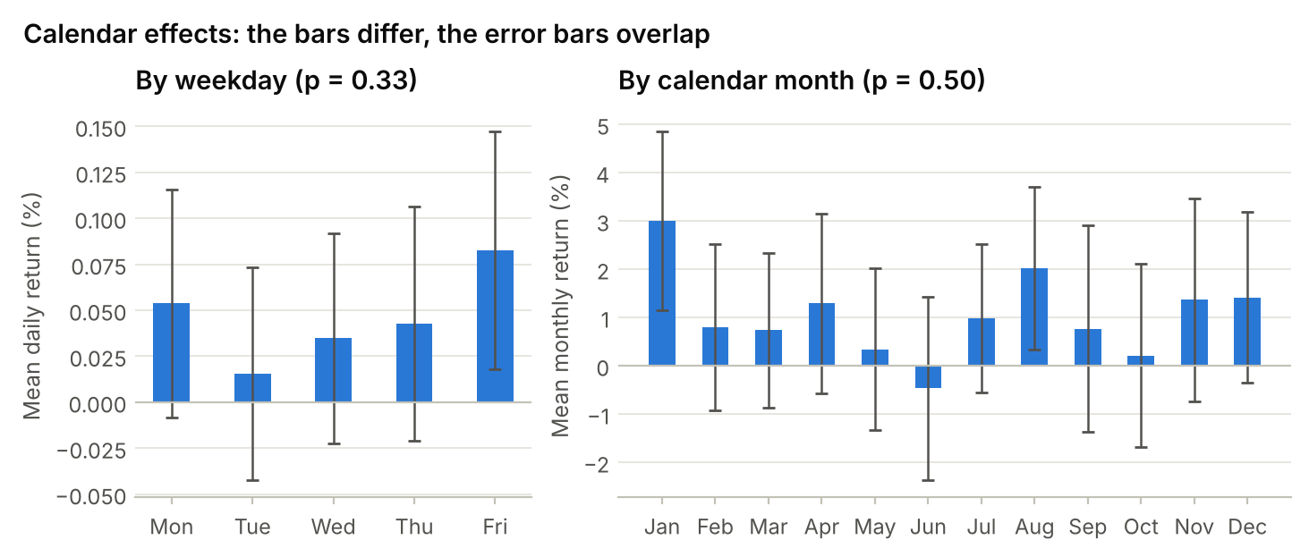
Figure 11. Mean daily return by weekday (left) and mean monthly return by calendar month (right), with 95% confidence intervals. The p-values in the panel titles are from Kruskal-Wallis tests.
Table 13. Eight tests for calendar effects.
Question | Test | Statistic | p-value | At the 5% level
Does the daily return differ by weekday? | Kruskal-Wallis | H = 4.57 | 0.33 | No
Does the mean daily return differ by weekday? | One-way ANOVA | F = 0.65 | 0.63 | No
Does the spread of returns differ by weekday? | Levene | W = 4.53 | 0.001 | Yes
Does the share of up days differ by weekday? | Chi-square | 5.71 (V = 0.030) | 0.22 | No
Does the monthly return differ by calendar month? | Kruskal-Wallis | H = 10.39 | 0.50 | No
Does the daily return differ by calendar month? | Kruskal-Wallis | H = 10.62 | 0.48 | No
Does the share of up days differ by month? | Chi-square | 7.73 (V = 0.035) | 0.74 | No
Is the first trading day of a month different? | Welch t-test | t = 1.84 | 0.066 | No
V is Cramér's V, an effect size between 0 and 1 (Cramér, 1946). Tests: Kruskal & Wallis (1952); Levene (1960).
Seven of the eight tests find nothing. The exception concerns the spread of returns and not their direction: Thursdays and Fridays are more volatile than the first three days of the week (standard deviations of 1.16% and 1.18% against 1.05% to 1.09%). With a p-value of 0.001 it is also the only result that would survive a Bonferroni correction for eight tests. The first trading day of the month has a higher average return than other days (0.166% against 0.039%, n = 306), but with p = 0.066 we cannot rule out chance.
Published findings on gold seasonality have not been stable either. Baur (2013) reported gains concentrated in September and November for 1980 to 2010. A replication with newer data concluded that this autumn pattern has been replaced by a winter one (Potrykus & Augustynowicz, 2024). Our strongest months are January, August, November and December, which sits closer to the later study, but with 25 or 26 observations per month none of the differences is reliable. We keep weekday, month and first-day indicators as model features so that the models can use them if they carry information. Appendix B shows every month of every year.

3.7 Drawdowns
An average return of 11.5% a year hides how long the losing stretches were. Figure 12 plots the drawdown, the distance of each close below the highest close reached so far, and Table 14 lists the largest.
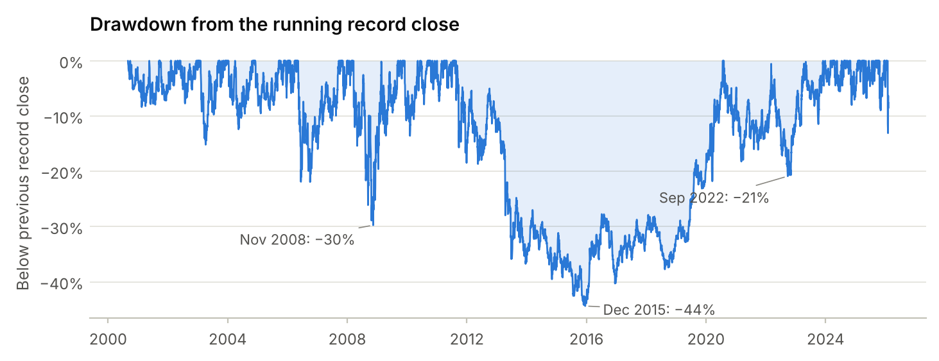
Figure 12. Percentage by which each day's close is below the highest close up to that day.
Table 14. The six largest drawdowns.
Peak | Close at peak | Trough | Close at trough | Depth | Record regained | Days, peak to recovery
22 Aug 2011 | $1,888.70 | 17 Dec 2015 | $1,050.80 | −44.4% | 23 Jul 2020 | 3,258
18 Mar 2008 | $1,003.20 | 13 Nov 2008 | $704.90 | −29.7% | 11 Sep 2009 | 542
11 May 2006 | $719.80 | 4 Oct 2006 | $562.00 | −21.9% | 19 Sep 2007 | 496
6 Aug 2020 | $2,051.50 | 26 Sep 2022 | $1,623.30 | −20.9% | 1 Dec 2023 | 1,212
4 Feb 2003 | $379.00 | 7 Apr 2003 | $321.50 | −15.2% | 9 Sep 2003 | 217
3 Dec 2009 | $1,217.40 | 5 Feb 2010 | $1,052.20 | −13.6% | 11 May 2010 | 159
Days are calendar days.
The deepest fall was −44.4%, from the 2011 peak to December 2015, and the 2011 price was not seen again until 23 July 2020, almost nine years later. The 2008 fall of −29.7% took eight months and was recovered ten months after the trough. Over the whole sample the close was below an earlier record on 93.9% of days and more than 10% below it on 45.2%. On the last day of the file it is 6.4% below the record set eight days earlier.

3.8 Trend and the moving averages
The dataset's four moving averages follow the price with a delay, so in a rising market the price sits above them. The close is above MA_365 on 76.7% of days. At the record close in January 2026 it was 61% above that average, the widest gap in the sample, and on the last day it is still 49% above (Appendix B).
A common trading rule is to expect gains while the price is above a moving average. We compared the next day's return on days above and below each average (Appendix C). For MA_30 and MA_90 the average next-day return is lower above the average than below it (0.031% against 0.066% for MA_30), the opposite of what the rule assumes, and neither difference is significant. For MA_365 the direction agrees with the rule: gold rose on 54.1% of days above it and 50.0% of days below it. A rank test supports that difference (Mann-Whitney p = 0.006) while a test of the means does not (Welch p = 0.39). The long-run trend may tilt the odds slightly. It is the only trend effect with any statistical support, and it is small.

3.9 Correlation
Figure 13 shows the correlation matrix of the original numeric columns. We report Pearson and Spearman coefficients together because several columns have extreme values, and the two can disagree.
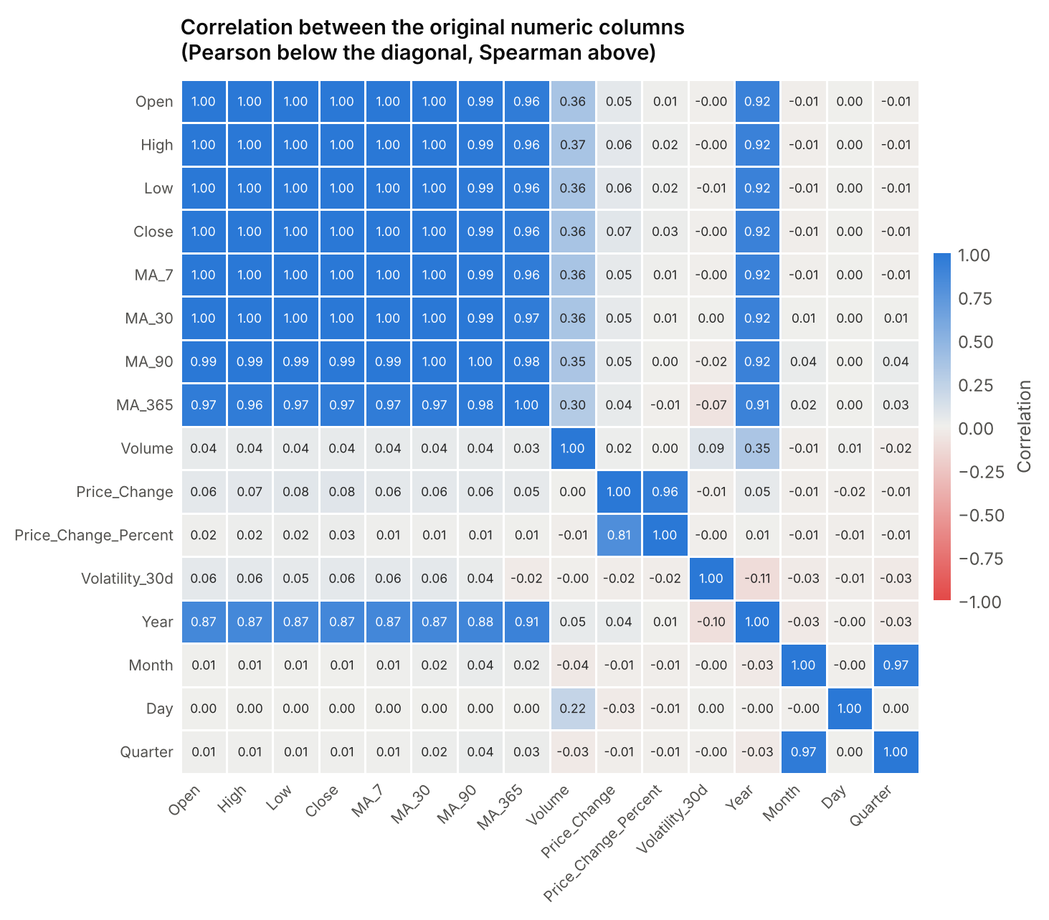
Figure 13. Correlation between the 16 numeric columns of the original file. Pearson coefficients are below the diagonal and Spearman coefficients above it.
- One block of eight. Open, High, Low, Close and the four moving averages are correlated at 0.96 or more with one another, and Open, High, Low, Close and MA_7 at 0.9995 or more. These eight columns are eight measurements of the price level. A regression that used all of them would have unstable coefficients, which is why our features are distances from the averages and not the averages themselves.
- Time. Year correlates 0.87 with Close (Spearman 0.92), which is the trend again. Month and Quarter correlate 0.97 because one is computed from the other.
- Volume. Its Pearson correlation with Close is 0.04 and its Spearman correlation is 0.36. The gap comes from the contract-roll days of Section 2.6, which are extreme enough to swamp a Pearson coefficient. Volume is also the only column correlated with the day of the month (0.22).
- Daily change and volatility. Price_Change_Percent and Volatility_30d are close to uncorrelated with every price-level column (Pearson 0.03 and 0.06 with Close). Knowing the price level says nothing about today's move.
The correlations that matter for modelling are those between today's features and tomorrow's outcome (Figure 14). With 6,018 rows, a Spearman coefficient needs to exceed 0.025 in absolute value to be significant at the 5% level. Against tomorrow's return, only 5 of the 37 features pass that bar, where about two would by chance, and the largest coefficient is 0.051. Against the size of tomorrow's move, 23 features pass it. The five strongest are all measures of recent volatility, led by vol_30 at 0.224.
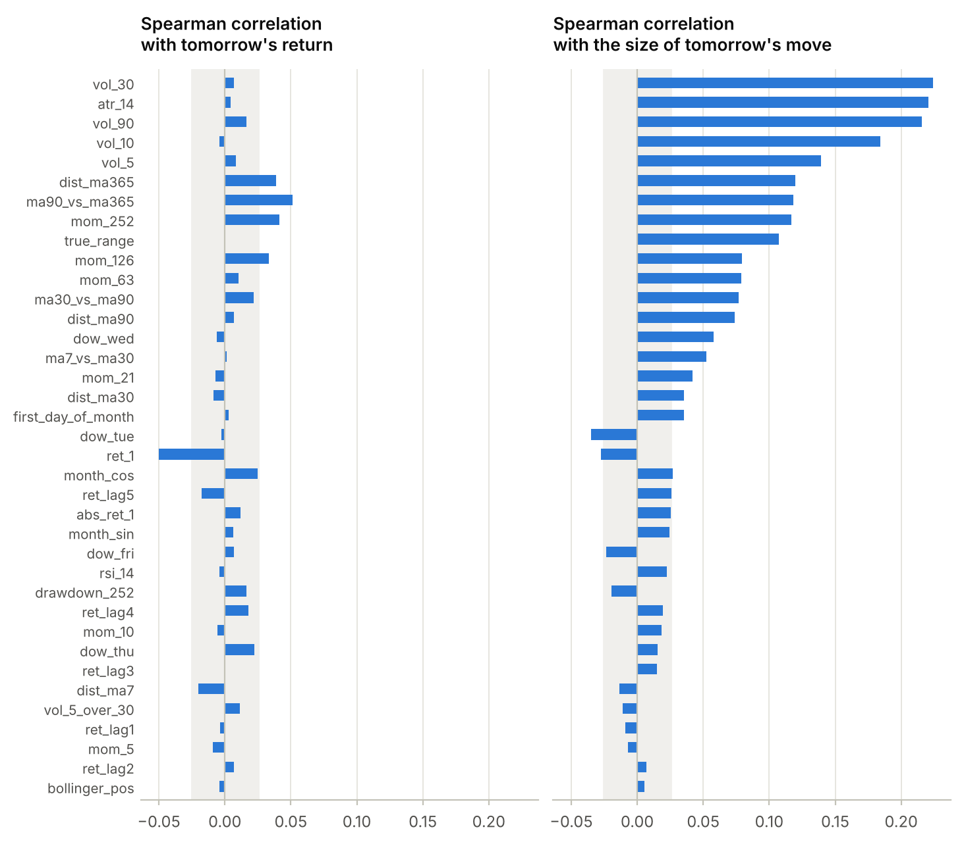
Figure 14. Spearman correlation of each of the 37 model features with tomorrow's return (left) and with the size of tomorrow's move (right). Bars inside the grey band are not significant at the 5% level.

3.10 Volatility today and the move tomorrow
Figure 15 shows the same contrast in a simpler way. We sorted all days into five groups by their Volatility_30d and looked at the following day. The average size of the next move rises from 0.58% in the calmest group to 1.17% in the most volatile, twice as large. The share of next days that close higher stays between 50% and 55% with no pattern.
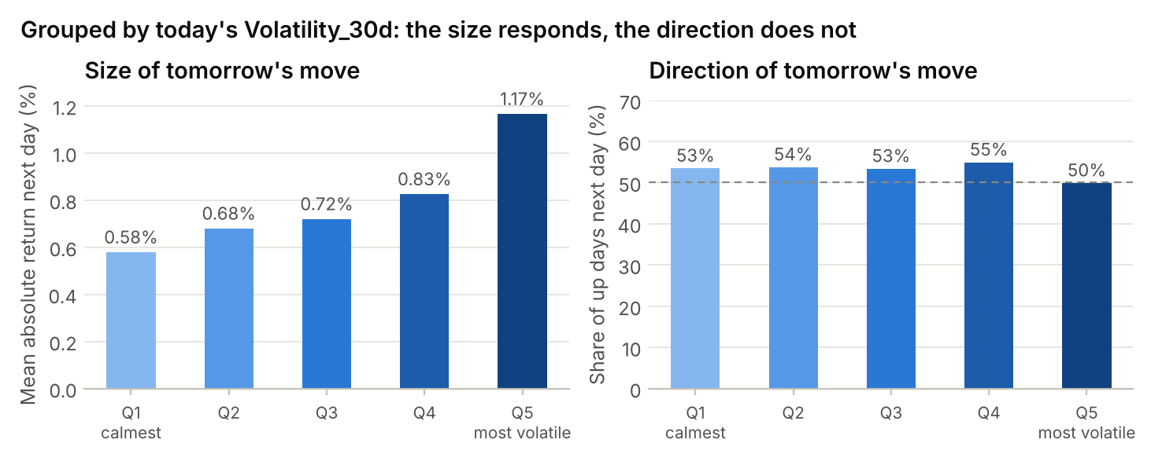
Figure 15. Days sorted into five equal groups by Volatility_30d. Left: mean absolute return on the following day. Right: share of following days with a higher close.

3.11 What the exploration means for the models
- Model returns, not price levels. Levels are not stationary and would give every model an R-squared near 1 for free (Section 3.5).
- Expect little for direction. The average daily return is one 24th of its standard deviation, returns are almost uncorrelated from day to day, and no calendar or trend effect on the mean passes a test (Sections 3.2, 3.4, 3.6 and 3.8).
- Expect something for size. Absolute returns are correlated over at least 40 days and respond to recent volatility (Sections 3.4, 3.9 and 3.10). This is the reason for the third prediction task in Section 4.
- Judge with care. Fat tails mean that one day can decide an RMSE comparison, and that intervals from normal theory are too narrow (Section 3.3).
- Expect the test period to look different. The price keeps reaching levels it has never been at, so any model that depends on the price level will be asked to extrapolate (Section 3.1).

4. Model Development
This section sets up three prediction tasks on the features of Section 2.9 and explains each choice: what is predicted, how the data are split, which models are compared and how they are tuned and judged. We start with three setups we decided against, because the reasons shaped everything that follows.

4.1 High scores for the wrong reason
"Predict the gold price" can be set up so that almost any model scores an R-squared above 0.99. We ran three such setups on purpose (Table 15).
Table 15. Three tempting setups and their test scores. Indented rows are comparisons on the same test rows.
Setup | Split | RMSE | MAPE | R-squared
A. Linear regression of today's close on today's open, high, low and moving averages | Chronological | $11.20 | 0.24% | 0.9998
B. Random forest predicting tomorrow's close from today's price columns | Shuffled 80/20 | $23.28 | 0.90% | 0.9991
Naive forecast (tomorrow = today) | Shuffled 80/20 | $26.72 | 0.83% | 0.9988
C. The same random forest | Chronological | $926.56 | 16.90% | −0.4015
Linear regression on the same price columns | Chronological | $37.94 | 0.80% | 0.9977
Naive forecast (tomorrow = today) | Chronological | $37.60 | 0.79% | 0.9977

A. Features from the same day as the target. Regressing today's close on today's open, high, low and moving averages gives an R-squared of 0.9998. Nothing has been forecast. The high and low bracket the close, and MA_7 contains today's close inside its own average, so the answer is among the inputs.
B. A shuffled split. With an ordinary random 80/20 split, a random forest predicting tomorrow's close has an RMSE of $23.28 and beats the naive forecast on the same rows ($26.72). It looks like skill. But a shuffled split puts the days on both sides of each test day into the training set, so the forest only has to interpolate between neighbours it has already seen.
C. The price level as the target. The same forest on a chronological split has an RMSE of $926.56 and an R-squared of −0.40. A tree predicts by averaging training targets, so it cannot return a value above the highest price it was trained on. That price is $2,051.50, the forest's highest prediction is $1,958, and the test period goes to $5,318 (Figure 16). Linear regression on the same columns avoids this and scores $37.94 with an R-squared of 0.9977, which looks excellent until it is set beside the naive forecast: $37.60 and 0.9977. The regression has learned to repeat today's price.
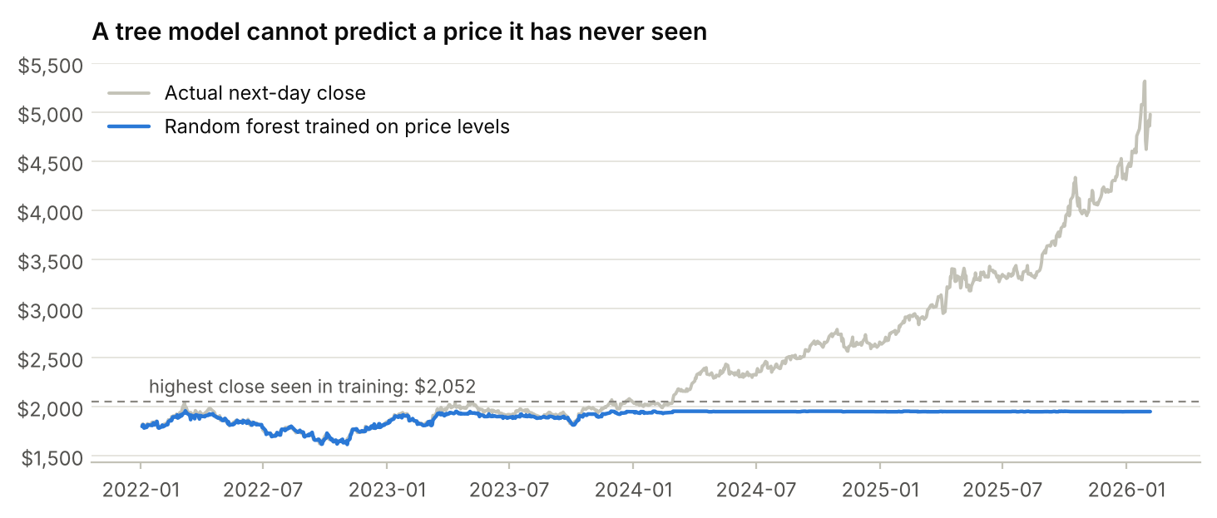
Figure 16. Test period. A random forest trained on price levels (blue) against the actual next-day close (grey). The dashed line is the highest close in the training years.
Three rules follow, and all our models obey them.
- Every feature is measured at or before the close of day t, and every target at day t + 1. Section 2.9 tested this.
- Data are split by date, never at random, both for the final test and inside cross-validation.
- Models predict changes, not levels, and are judged against the naive forecast and not by the R-squared of the price.

4.2 Three prediction tasks
Table 16. The three tasks. All use the same 37 features and the same rows.
Task | Target for day t + 1 | Type | Benchmarks with no fitted model | Main measures
A | Log return, converted to the closing price | Regression | Naive (tomorrow = today); drift (naive plus the average training return) | RMSE, MAE, MAPE, R-squared; RMSE relative to naive and drift; Diebold-Mariano test
B | Whether the close is higher than today's | Classification | Always predict up | Accuracy, precision, recall, F1, ROC-AUC; McNemar test
C | Absolute log return (the size of the move) | Regression | Training mean; Volatility_30d; EWMA volatility | RMSE, MAE, R-squared against the training mean, Spearman correlation; Diebold-Mariano test

Task A is the question in the project title. A predicted return r is turned into a price as Close(t) × exp(r / 100), so errors can be reported in dollars. Task B is the simpler question a trader would ask. Task C came out of the exploratory analysis, which found structure in the size of moves and none in their direction (Table 16).

4.3 Training, validation and test data
The data were split once, by date, and the same split is used for all three tasks (Figure 17).
- Training set: 20 February 2002 to 31 December 2021, 4,989 days (83%).
- Test set: 3 January 2022 to 5 February 2026, 1,029 days (17%). It plays no part in tuning and is used only for the final scores.
- Validation: five expanding-window folds inside the training years (scikit-learn's TimeSeriesSplit). Each fold fits on all days before a date and validates on the next 831 days, from 834 fitting days in the first fold to 4,158 in the last (Figure 17, Appendix C). A model is always validated on days later than those it was fitted on, which is how it will be used (Bergmeir & Benítez, 2012; Hyndman & Athanasopoulos, 2021).
- Scaling: features are standardised inside a scikit-learn Pipeline, so the mean and standard deviation come from the fitting part of each fold only.
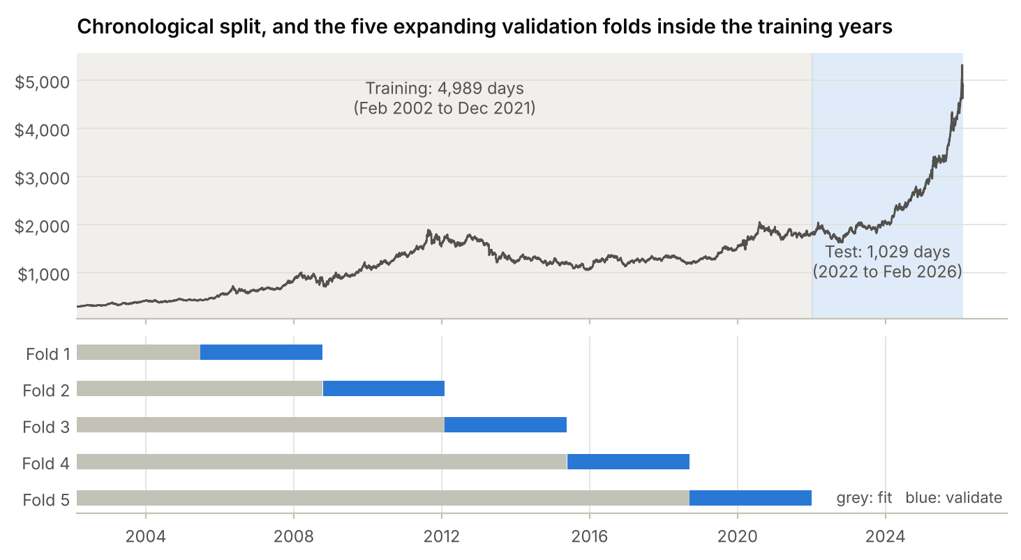
Figure 17. Top: the chronological split. Bottom: the five validation folds inside the training years. Each fold fits on the grey period and validates on the blue one.
The two periods are alike in daily behaviour and very different in level. The standard deviation of daily returns is 1.12% in training and 1.13% in the test period, and gold rose on 52.6% and 55.6% of days. But the highest training close is $2,051.50 and the test period reaches $5,318.40. The test years also contain the largest one-day fall in the file. The split is hard on the models, and we kept it that way: a forecast is only needed for a future that differs from the past.

4.4 Models and why we chose them
Table 17. Benchmarks and models in the comparison.
Model | Tasks | Why it is included | Tuned
Naive | A | Tomorrow's price equals today's. The random-walk forecast that every other model must beat. | Nothing
Drift | A | Naive plus the average daily return of the training years (+0.036%). | Nothing
ARIMA | A | The classical time-series model (Box et al., 2015). It uses only the autocorrelation of returns, so it shows what the past returns alone can do. | Orders p and q from 0 to 2, by AIC
Always up | B | Predicts the majority class of the training years on every day. | Nothing
Training mean, Volatility_30d, EWMA | C | A constant, the dataset's own volatility column, and the exponentially weighted volatility of RiskMetrics with decay 0.94 (J.P. Morgan & Reuters, 1996). | Nothing
Linear regression | A, C | The simplest model that uses all 37 features. With no penalty, it shows what happens without regularisation. | Nothing
Ridge | A, C | Linear with coefficients shrunk toward zero, which suits correlated features (Hoerl & Kennard, 1970). | Penalty alpha
Lasso | A, C | Linear, and able to set coefficients exactly to zero, so it also reports which features it keeps (Tibshirani, 1996). | Penalty alpha
Logistic regression | B | The linear model for a yes/no target, with a ridge penalty. | Inverse penalty C
Random forest | A, B, C | An average of many trees. It can find thresholds and interactions without being told about them (Breiman, 2001). | Tree depth, minimum leaf size
XGBoost | A, B, C | Boosted trees, usually the strongest method on tabular data (Chen & Guestrin, 2016). | Tree depth, learning rate, minimum child weight

The benchmarks carry as much weight as the models (Table 17). They cost nothing to compute, and a model that cannot beat them has learned nothing, whatever its R-squared. The fitted models were chosen to cover two families. If tomorrow's outcome depends on the features in a roughly linear way, ridge and lasso should find it. If it depends on thresholds or combinations, the tree models should. We left out neural networks. With 4,989 training days and a target this noisy there is little for a large model to learn from, and Section 4.5 shows that even very small trees were too flexible for Task A.

4.5 Hyperparameter tuning
Each model was tuned by grid search over the five folds of Section 4.3, with RMSE as the criterion for regression and ROC-AUC for classification. The best setting was then refitted on the whole training set. In total the search covered 119 settings, each fitted five times. Table 18 lists the grids and what was chosen.
Table 18. Hyperparameter grids and the values chosen by cross-validation.
Model | Grid searched | Task A (return) | Task B (direction) | Task C (size)
Ridge | alpha: 1, 10, 100, 1,000, 10,000, 100,000 | alpha 100,000 |  | alpha 1,000
Lasso | alpha: 0.001, 0.003, 0.01, 0.03, 0.1, 0.3 | alpha 0.1 |  | alpha 0.03
Logistic regression | C: 0.0001, 0.001, 0.01, 0.1, 1, 10 |  | C 0.0001
Random forest  (200 trees) | depth: 2, 4, 8  minimum leaf: 20, 50, 100, 200  (50, 100, 200 for Task B) | depth 2  leaf 200 | depth 4  leaf 100 | depth 8  leaf 50
XGBoost  (300 trees) | depth: 1, 2, 3  learning rate: 0.005, 0.01, 0.03  minimum child weight: 20, 100 | depth 1  rate 0.005  weight 100 | depth 2  rate 0.005  weight 100 | depth 3  rate 0.01  weight 100
ARIMA | p and q: 0, 1, 2 (nine models, by AIC) | (1, 0, 1)
The random forest considers a third of the features at each split. XGBoost samples 80% of rows and 80% of columns for each tree. All random seeds are fixed at 42.
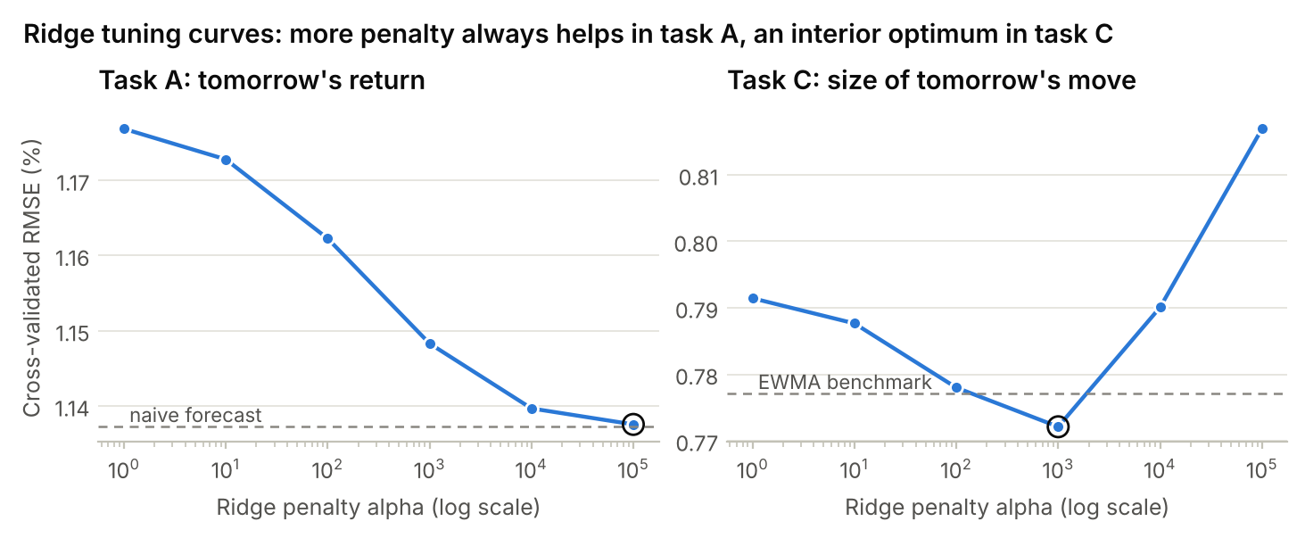
Figure 18. Cross-validated RMSE of ridge regression against its penalty, for Task A (left) and Task C (right). The circled point is the chosen value and the dashed line is the benchmark on the same folds.
What the tuning chose is a result in its own right. For Task A, more penalty always helped (Figure 18, left). The cross-validated RMSE of ridge falls from 1.1769 at alpha = 1 to 1.1376 at alpha = 100,000, the largest value in the grid, where the coefficients are close to zero. Extending the grid would not change this, because the limit of a growing penalty is the drift forecast, which scores 1.1374 on the same folds. Lasso went all the way there: at its chosen penalty it keeps none of the 37 features. The random forest chose the shallowest trees and the largest leaves on offer, and XGBoost chose single-split trees with the slowest learning rate. Four different methods gave the same verdict: the less a model used the features, the better it validated.
For Task C the curve has a minimum inside the grid (Figure 18, right). Ridge does best at alpha = 1,000 with an RMSE of 0.7721, below the EWMA benchmark (0.7771). Too little penalty overfits (0.7914 at alpha = 1) and too much throws the information away (0.8169 at alpha = 100,000). The random forest chose its deepest trees here. In this task there is something for the features to explain.

4.6 How the models are judged
Task A. We report RMSE and MAE in dollars, MAPE, and the R-squared of the predicted price. Since Section 4.1 showed that the R-squared of a price says little, the comparison rests on the RMSE relative to the naive and drift forecasts. Whether a difference is larger than chance is tested with the Diebold-Mariano test on squared errors (Diebold & Mariano, 1995), with the small-sample correction of Harvey et al. (1997).
Task B. We report accuracy, precision, recall and F1 for the "up" class, the macro-averaged F1 and the ROC-AUC. Accuracy is compared with the always-up rule using McNemar's exact test (McNemar, 1947). A model can only differ from that rule on the days it predicts "down", so the test asks whether those calls were right more often than wrong.
Task C. We report RMSE and MAE, the R-squared measured against the training mean, as is usual for out-of-sample forecasts (Welch & Goyal, 2008), and the Spearman correlation between predicted and realised size. The comparison with the EWMA benchmark again uses the Diebold-Mariano test.
Single-day checks. Because of the fat tails found in Section 3.3, every headline comparison is repeated without the forecast for 30 January 2026, the largest move in the file, and the advantage of the best model over its benchmark is plotted day by day.
Feature importance. For the model we end up using, we measure permutation importance by feature family: all features of a family are shuffled together on the test set, 30 times, and we record the rise in RMSE. Shuffling one feature at a time would understate the importance of a family whose members are correlated, since the others would fill in.

5. Results and Evaluation
All scores in this section are for the 1,029 test forecasts. They are for the trading days from 4 January 2022 to 6 February 2026, each made at the previous close, and no model saw these days during fitting or tuning. Cross-validated scores from the training years are shown next to them, because the difference between the two turns out to matter.

5.1 Task A: tomorrow's price
All eight forecasts are nearly the same forecast. Test RMSE lies between $36.93 and $37.60 and the mean absolute error between $20.92 and $21.12. On an average day every forecast misses by about $21, or 0.79% of the price (Table 19). All of them have an R-squared of 0.998, the naive forecast included. In this problem an R-squared of 0.998 is what a forecast with no skill scores.
Table 19. Task A results. RMSE, MAE, MAPE and R-squared are for the predicted closing price.
Model | CV RMSE (%) | Test RMSE ($) | MAE ($) | MAPE (%) | R-squared | Return RMSE / naive | Same, without 30 Jan 2026 | p-value against naive | p-value against drift
Naive (tomorrow = today) | 1.1372 | 37.60 | 21.01 | 0.792 | 0.9977 | 1.0000 | 1.0000
Drift | 1.1374 | 37.52 | 20.92 | 0.789 | 0.9977 | 0.9977 | 0.9970 | 0.022
ARIMA(1, 0, 1) |  | 37.51 | 21.01 | 0.791 | 0.9977 | 0.9980 | 0.9991 | 0.24 | 0.91
Linear regression | 1.1883 | 36.93 | 21.12 | 0.796 | 0.9978 | 0.9946 | 1.0053 | 0.62 | 0.78
Ridge | 1.1376 | 37.51 | 20.93 | 0.789 | 0.9977 | 0.9976 | 0.9974 | 0.003 | 0.89
Lasso | 1.1374 | 37.52 | 20.92 | 0.789 | 0.9977 | 0.9977 | 0.9970 | 0.022
Random forest | 1.1390 | 37.59 | 21.00 | 0.791 | 0.9977 | 0.9990 | 1.0000 | 0.54 | 0.55
XGBoost | 1.1401 | 37.39 | 20.98 | 0.790 | 0.9977 | 0.9960 | 0.9983 | 0.24 | 0.65
CV RMSE is the cross-validated RMSE of the predicted return on the training years. The two ratio columns compare the test RMSE of the predicted return with that of the naive forecast. The p-values are from Diebold-Mariano tests on the return errors; a blank cell means the comparison does not apply. Lasso keeps no features, so its forecast is identical to the drift forecast.
Dollar errors give the most weight to days when the price is high, and by January 2026 the price was more than twice its 2022 level. The fall of 30 January 2026 alone accounts for 25% of the naive forecast's squared error in dollars and 11% in returns. For that reason the two ratio columns of Table 19, and Figure 19, compare the RMSE of the predicted return. On that measure every forecast is within 0.6% of the naive one.
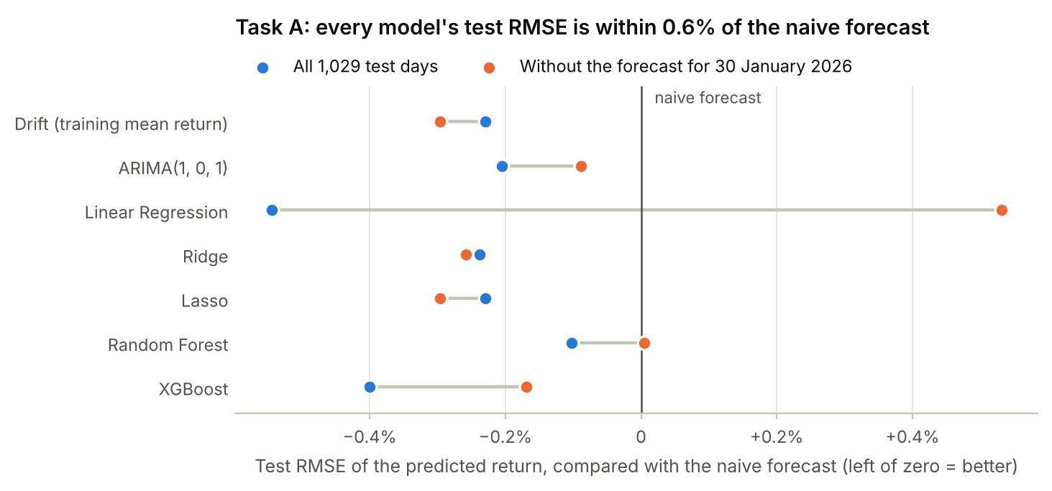
Figure 19. Test RMSE of each forecast as a percentage difference from the naive forecast, for all test days (blue) and without the forecast for 30 January 2026 (orange).
The drift is worth a little. Adding the average training return of 0.036% a day to the naive forecast lowers the RMSE by 0.23%, and the Diebold-Mariano test puts that beyond chance (p = 0.022). The reason is that gold kept rising. It gained 177% over the test years, an average of 0.099% a day (t = 2.81, p = 0.005). Ridge also beats the naive forecast (p = 0.003), but with its heavy penalty it is almost the drift forecast, and against drift its advantage disappears (p = 0.89).
The features add nothing to the drift. Measured against the drift forecast, no model is better by more than chance: the p-values are 0.55 to 0.91. The models have learned to say almost the same thing every day. The standard deviation of ridge's predicted returns is 0.009%, of the random forest's 0.039% and of XGBoost's 0.051%, against 1.13% for the actual returns. Even on the training data, linear regression with all 37 features explains 1.2% of the variance of returns.
The apparent winner wins on one day. Linear regression has the lowest test RMSE, $36.93, which is 0.54% below naive on the return measure. It also had the worst cross-validated RMSE of all (1.1883 against 1.1372 for naive), so validation had already marked it as overfitted. Figure 20 (left) shows where its lead comes from. Through almost the whole test period it runs behind the naive forecast. Then on 30 January 2026 gold fell 11.4% (a log return of −12.07%), the model had predicted −1.17%, and that one forecast outweighs the deficit of the other 1,028 days. Without it the model's RMSE is 0.53% worse than naive, and it beat naive on only 48.1% of days.
That forecast was an extrapolation. On the evening of 29 January the inputs were far outside the training range. The day's true range was 8.3 standard deviations above its training mean, the price was 4.5 to 4.9 standard deviations above its moving averages, and 5 of the 37 features were beyond anything in the training years. A linear model with no penalty applies its coefficients to such values without limit. This time the result pointed the right way. One day cannot show that it would again.
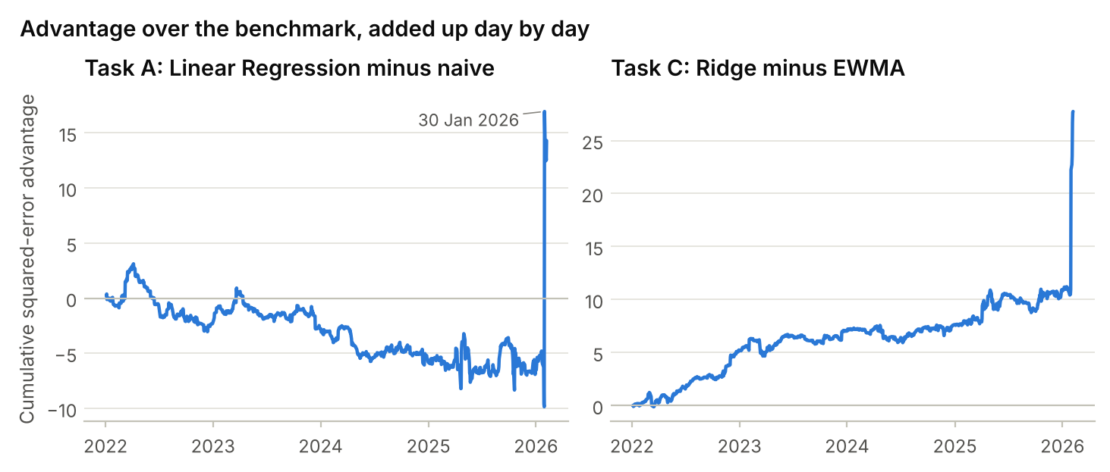
Figure 20. Running total of the benchmark's squared error minus the model's. A rising line means the model is gaining on the benchmark. Left: linear regression against naive, Task A. Right: ridge against EWMA, Task C.
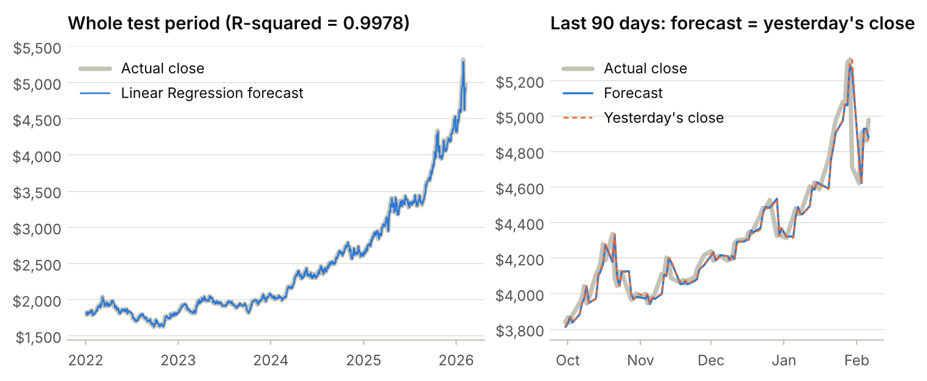
Figure 21. Actual close and the linear regression forecast over the whole test period (left) and over its last 90 days (right), where the forecast can be seen to follow the previous day's close.
Figure 21 shows what these forecasts look like. Over four years the predicted line cannot be told apart from the actual one. Over the last 90 days it can: the forecast is the previous day's close, one day late. A chart like the left panel, with an R-squared near 1 printed above it, looks like a successful forecast. The right panel shows that it is the naive forecast again.

5.2 Task B: tomorrow's direction
Gold closed higher on 55.6% of test days, so the rule "always predict up" is right 55.6% of the time. The three fitted models score between 55.0% and 56.1% (Table 20).
Table 20. Task B results. Precision, recall and F1 are for the "up" class.
Model | CV AUC | Accuracy (%) | Precision | Recall | F1 | Macro F1 | Test AUC | "Down" calls right / made | McNemar p-value
Always up |  | 55.59 | 0.556 | 1.000 | 0.715 | 0.357 | 0.500 | 0 / 0
Logistic regression | 0.519 | 55.49 | 0.555 | 0.998 | 0.714 | 0.357 | 0.545 | 0 / 1 | 1.00
Random forest | 0.524 | 55.00 | 0.562 | 0.860 | 0.680 | 0.461 | 0.541 | 74 / 154 | 0.69
XGBoost | 0.525 | 56.07 | 0.564 | 0.920 | 0.699 | 0.442 | 0.528 | 51 / 97 | 0.68
AUC is the area under the ROC curve; 0.5 means no ability to rank days. McNemar's exact test compares each model with the always-up rule.
Each model deals with the lack of information in its own way. Logistic regression chose the strongest penalty in its grid and predicts "up" on 99.9% of days. It made one "down" call in four years, and that call was wrong. The random forest made 154 "down" calls and was right on 74 of them. XGBoost, which had the best cross-validated AUC, made 97 and was right on 51. That is 51 correct against 46 incorrect, and McNemar's test gives p = 0.68. A coin would do as well. The predicted probabilities tell the same story: XGBoost's never leave the range 0.46 to 0.58.
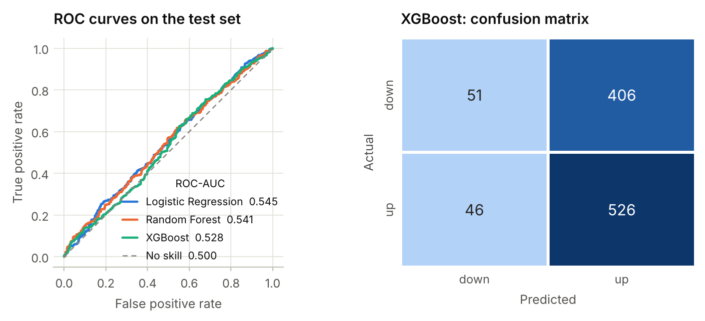
Figure 22. Left: ROC curves of the three classifiers on the test set. Right: confusion matrix of XGBoost, the model with the best cross-validated AUC.
The ROC curves stay close to the diagonal (Figure 22), with a test AUC of 0.528 to 0.545 and a cross-validated AUC of 0.519 to 0.525. The confusion matrix shows why the usual classification measures mislead here. XGBoost's recall for "up" days is 0.92 and its F1 is 0.70, which sound respectable. They are high because the model says "up" on 91% of days. It identifies 51 of the 457 down days, a recall of 11%. The always-up rule has an F1 of 0.715 with no model at all, and the macro-averaged F1, which weights both classes equally, is below 0.5 for every model.

5.3 Task C: the size of tomorrow's move
Here the benchmarks are beaten. Unlike Tasks A and B, there is a clear ordering, and it is the same in cross-validation and on the test set (Table 21). The dataset's own Volatility_30d explains 4.5% of the variance in the size of the next move, the EWMA 7.2% and ridge regression 11.3%.
Table 21. Task C results. Errors are in percentage points of absolute return.
Model | CV RMSE | Test RMSE | Test MAE | R-squared (%) | R-squared through 2025 (%) | Spearman | p-value against EWMA
Training mean | 0.8256 | 0.8082 | 0.5485 | 0.0 | 0.0 |  | 0.060
Volatility_30d | 0.7831 | 0.7897 | 0.5407 | 4.5 | 0.8 | 0.157 | 0.010
EWMA, decay 0.94 | 0.7771 | 0.7787 | 0.5401 | 7.2 | 4.1 | 0.158
Linear regression | 0.8109 | 0.7423 | 0.5267 | 15.6 | 7.3 | 0.225 | 0.095
Ridge (chosen by CV) | 0.7721 | 0.7612 | 0.5272 | 11.3 | 6.4 | 0.212 | 0.031
Lasso | 0.7734 | 0.7765 | 0.5299 | 7.7 | 5.8 | 0.178 | 0.72
Random forest | 0.7815 | 0.7797 | 0.5443 | 6.9 | 3.8 | 0.172 | 0.89
XGBoost | 0.7820 | 0.7765 | 0.5433 | 7.7 | 3.7 | 0.166 | 0.75
R-squared is measured against the training mean. Volatility_30d and EWMA estimate a standard deviation and are multiplied by 0.80, the ratio of mean absolute value to standard deviation for a normal variable. The p-values are from Diebold-Mariano tests.
We use the model that validation chose. Ridge with alpha = 1,000 had the lowest cross-validated RMSE, so it is our model for this task. Plain linear regression scores better on the test set (0.7423), but it had the worst cross-validated RMSE of the fitted models, the same pattern as in Task A, and we do not rely on it.
The gain over EWMA is real but modest. Ridge has a 2.2% lower RMSE than the EWMA and a 2.4% lower MAE, and the difference is significant (p = 0.031). We ran the same single-day check as before. The forecast for 30 January 2026 accounts for 41% of ridge's total lead. This time the lead survives without it: through the end of 2025 ridge still explains 6.4% against 4.1% for the EWMA, the test remains significant (p = 0.028), and the lead in Figure 20 (right) builds from the first year. The tree models and lasso are no better than the EWMA (p = 0.72 to 0.89). The relation between recent volatility and the next move is close to linear, which leaves the trees nothing extra to find.
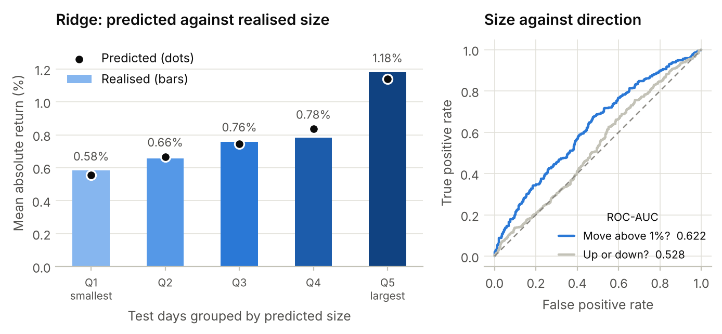
Figure 23. Left: test days sorted into five equal groups by ridge's predicted size, with the predicted (dots) and realised (bars) mean absolute return of each group. Right: ROC curves for two yes/no questions asked of the same days.
What 11% is worth. Most of the day-to-day variation in the size of moves stays unexplained. What the model does well is rank days. When test days are sorted into five groups by predicted size, the realised average move rises from 0.58% in the lowest group to 1.18% in the highest, and the predicted values track it (Figure 23, left). A move of more than 1% happened on 17% of days in the lowest group and 43% in the highest. As a detector of such days the model has an AUC of 0.622, against 0.591 for the EWMA and 0.528 for the direction model of Task B (Figure 23, right).
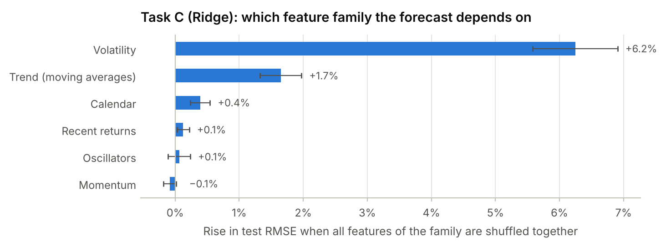
Figure 24. Rise in ridge's test RMSE when all features of one family are shuffled together (mean of 30 repeats, with the standard deviation).
What the model uses. Shuffling the eight volatility features raises the test RMSE by 6.2%. Shuffling the trend features raises it by 1.7% and the calendar features by 0.4%. Recent returns, momentum and the oscillators contribute nothing measurable (Figure 24). The four largest standardised coefficients are all on volatility features: atr_14 (0.091), true_range (0.060), abs_ret_1 (−0.058) and vol_90 (0.050). The forecast is mostly a weighted average of volatility over several horizons. The smaller terms say that moves are larger when the price is far above its long-run average or far below its one-year high, and on Thursdays (the Wednesday indicator has a positive coefficient and the target is the following day), which agrees with the weekday result of Section 3.6.
Individual coefficients should not be read closely. The negative sign on abs_ret_1 does not mean that a big move today predicts a quiet tomorrow. It offsets true_range, which measures much the same thing (their correlation is 0.83). This is the reason we measured importance by family.

5.4 From a point forecast to a forecast band
Tasks A and C can be combined into one forecast that is honest about what is and is not known. Task A says the best estimate of tomorrow's close is today's close. Task C says how wide the uncertainty around it is. We build a 95% band for tomorrow's close as
Close(t) × exp(−k × s / 100) to Close(t) × exp(+k × s / 100),
where s is the predicted size of the move in percent and k is a multiplier. We set k so that 95% of training days fall inside the band, using only predictions for days the model had not been fitted on (the validation parts of the five folds, 4,155 days). This follows the idea of split conformal prediction with a locally scaled width (Lei et al., 2018). For ridge, k is 2.68. If returns were normal it would be 2.46, so the fat tails of Section 3.3 show up again here.
We compare three bands: a constant half-width of 2.29%, a width scaled by the EWMA, and a width scaled by the ridge forecast (Table 22).
Table 22. Three 95% bands for tomorrow's close, scored on the test set.
Band | Coverage (%) | Mean half-width (%) | Interval score | 2022 | 2023 | 2024 | 2025 | 2026 (25 days)
Constant width | 94.8 | 2.29 | 6.26 | 97.2 | 97.2 | 96.4 | 90.9 | 72.0
EWMA-scaled | 94.8 | 2.15 | 5.76 | 94.8 | 94.8 | 95.6 | 94.4 | 88.0
Ridge-scaled | 94.7 | 2.12 | 5.57 | 93.2 | 94.0 | 96.0 | 96.0 | 88.0
The year columns give coverage in percent. The interval score rewards narrow bands and penalises misses; lower is better (Gneiting & Raftery, 2007).
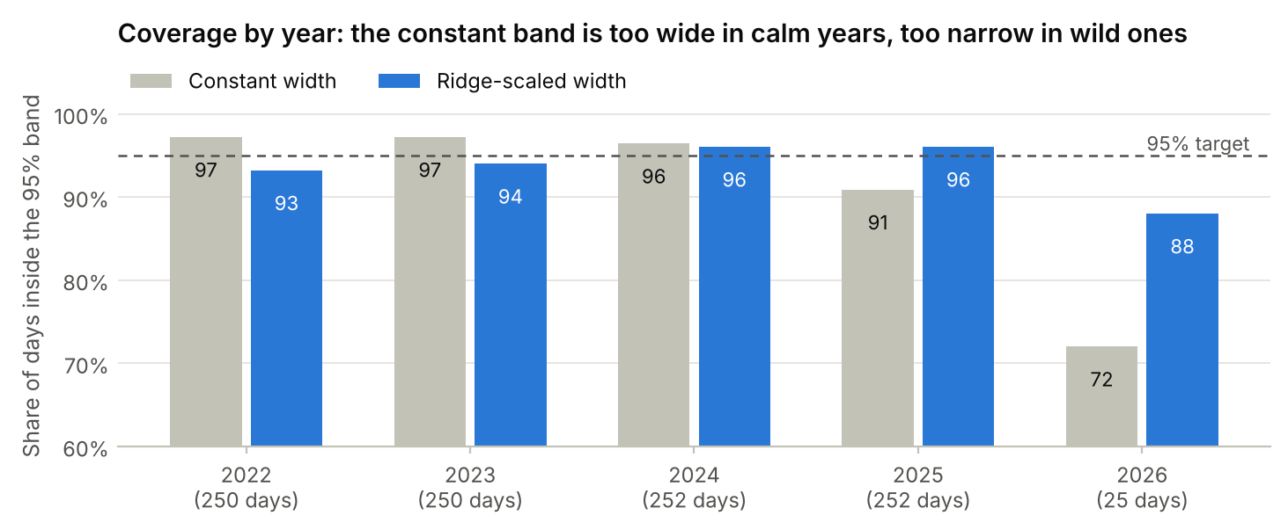
Figure 25. Share of days on which the actual close fell inside the 95% band, by year, for the constant-width and ridge-scaled bands.
Over the whole test set all three bands cover close to 95% of days. The difference is in when they miss (Figure 25). The constant band covered 97% of days in the calm years 2022 and 2023, 91% in 2025 and 72% in the first 25 trading days of 2026. It is too wide when nothing is happening and too narrow when it matters. The ridge-scaled band stayed between 93% and 96% in every full year. It is also narrower on average (2.12% against 2.29%) and has the best interval score.
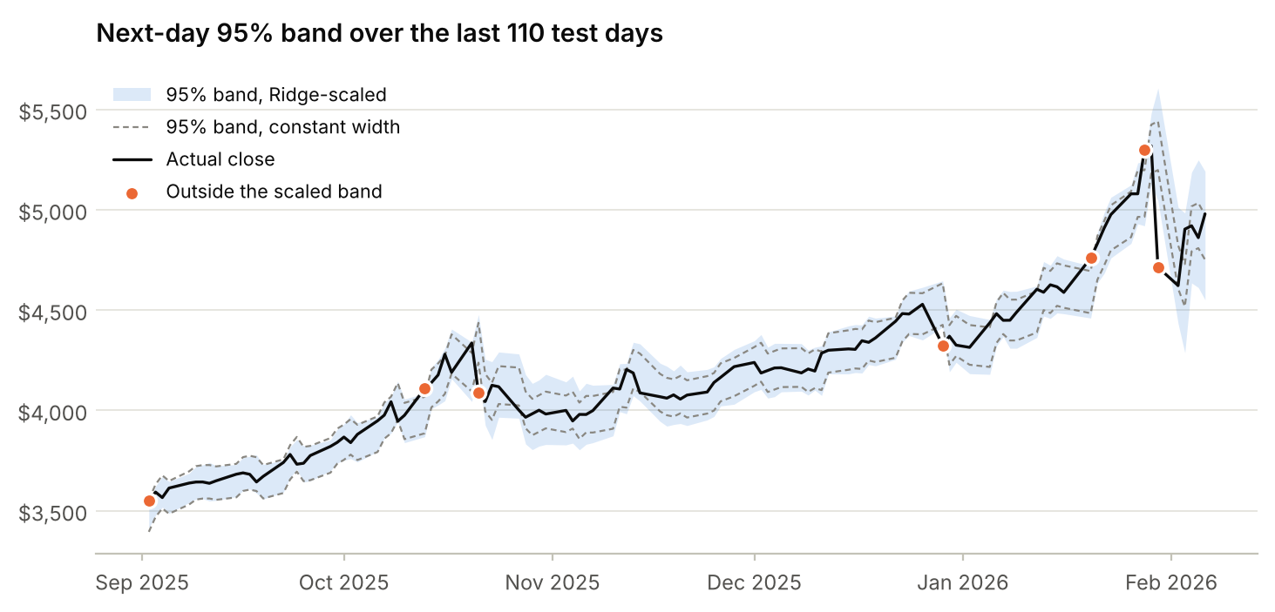
Figure 26. The last 110 test days: actual close, the ridge-scaled 95% band (shaded) and the constant-width band (dashed). Orange dots are days outside the scaled band.
Figure 26 shows the band at work. Its half-width ranges from 1.0% in the quietest stretch of the test period (August 2023) to 7.5% for 3 February 2026. In the last 110 days the close fell outside the scaled band 7 times and outside the constant band 17 times. The band does not foresee shocks. The record close of 29 January 2026 and the fall of 30 January both landed outside it, and with 3 misses in the 25 test days of 2026 its coverage there is 88%, below the target. What it does is widen within a day once volatility has risen, so the days after a shock are covered.

5.5 Does retraining help?
The models above were fitted once, on data to the end of 2021, and then used for four years. Someone using them in practice would retrain as new data arrive. We refitted ridge and XGBoost every 63 trading days, about once a quarter, on all data available at that point (Table 23).
Table 23. Test RMSE with a single fit and with refitting every 63 trading days.
Task and model | Fitted once | Refitted every quarter | Change (%)
Task A (return), Ridge | 1.1289 | 1.1286 | −0.03
Task A (return), XGBoost | 1.1271 | 1.1266 | −0.04
Task C (size), Ridge | 0.7612 | 0.7587 | −0.33
Task C (size), XGBoost | 0.7765 | 0.7711 | −0.69
RMSE of the predicted return (Task A) or absolute return (Task C), in percentage points. The naive forecast scores 1.1316 on Task A.
Retraining changes every score by less than 1%. The Task A models stay level with the naive forecast, and the Task C models improve slightly. None of the conclusions depends on the models having been fitted only once.

5.6 Answers to the four questions
Table 24. The four questions of Section 1.2 and what the evidence says.
Question | Answer | Main evidence
1. What does the data look like once it is checked? | An 18-fold rise with long drawdowns, fat-tailed returns and clustered volatility | 84 days beyond three standard deviations (17 expected); deepest drawdown −44%; seven of eight calendar tests find nothing
2. Can tomorrow's price be predicted better than by repeating today's? | Only by adding the long-run drift. The 37 features add nothing to it | All forecasts within 0.6% of naive (RMSE of returns); no model better than drift (p from 0.55 to 0.91); the one apparent winner depends on a single day
3. Can tomorrow's direction be predicted? | No | Accuracy 55.0% to 56.1% against 55.6% for always-up; McNemar p of 0.68 or more
4. Can the size of tomorrow's move be predicted, and is that useful? | Partly, and yes | Ridge explains 11% of the variance (6% through 2025) and beats the EWMA (p = 0.031); a band scaled by it covers 93% to 96% of days in each full year

6. Conclusion

6.1 Key findings
- A file labelled "cleaned" still had to be checked. Seven of its 20 columns are redundant. Its windows count trading days, so MA_365 covers 1.45 years. On 430 early rows the close lies outside the day's own range, and the volume column tracks the contract calendar. All 520 missing values are warm-up rows that should not be imputed. The close itself is sound, and the rest of the project is built on it.
- Gold rose 18-fold in 25 years, unevenly. The average gain of 11.5% a year came with a drawdown of 44% that took almost nine years to recover. Daily returns have fat tails, with extreme days about five times as common as a normal distribution predicts, and volatility arrives in clusters.
- Tomorrow's price cannot be predicted better than "today's price plus the drift". Four kinds of model, tuned by time-ordered cross-validation, all shrank toward that forecast on their own, and none beat it on four years of unseen data. In practical terms the best forecast we found for tomorrow's close is today's close plus about 0.04%.
- Tomorrow's direction cannot be predicted either. Three classifiers scored 55.0% to 56.1% where always saying "up" scores 55.6%.
- The size of tomorrow's move can be predicted in part. A ridge model explains 11% of its variance (6% without January 2026) and beats a standard volatility benchmark. That is enough to give the naive price forecast a 95% band that held between 93% and 96% coverage in every full test year.
- A high score proved nothing. The naive forecast has an R-squared of 0.998. A model with same-day features reached 0.9998 without forecasting anything. The one model that seemed to beat the benchmark in Task A owed its lead to a single day. Each of these would have passed for a good result without a benchmark beside it.

6.2 Implications
For someone who needs a number for tomorrow. Use today's close, and quote a range with it. From this data the range is about ±2.1% on average, close to ±1% when the market has been quiet and several times wider after a turbulent week. A forecast that gives one price and no range claims more than the data can support.
For someone reading a gold-price model's results. Three questions settle most cases. What does the naive forecast score on the same test days? Was the data split by date? Does the result survive when the most extreme day is left out? In this project each of the three changed a conclusion.
For risk. The useful information in the price history is about volatility. It supports decisions that depend on how far the price may move, such as how large a position to hold or how much margin to keep, and it does not support decisions that depend on which way.

6.3 Limitations
- Price history only. The file holds one futures series. Interest rates, the dollar, inflation, fund flows and central-bank buying are not in it. Our finding is that the price history does not predict the next day's return. It says nothing about what those other variables could do.
- The series itself. GC=F follows the front-month contract, so it switches contracts over time and can jump slightly when it does. Its Open, High and Low are unreliable before 2012, which affects the two features built from them.
- One test period. The years 2022 to early 2026 contain the strongest rally and the largest one-day fall in the file. The Task C result leans on that last month: 41% of ridge's lead over the benchmark comes from one day, although the lead remains significant without it.
- One horizon. Everything here is about the next trading day. Weekly or monthly returns may behave differently.
- Many tests. We ran dozens of significance tests at the 5% level and did not correct for that across the report. A few results near the threshold, such as the trend effect in Section 3.8, should be read as suggestions.
- The band. It was calibrated for 95% only, its coverage in early 2026 was 88%, and the method carries no guarantee for time series, where tomorrow's errors are not independent of today's.
- No trading test. We did not simulate a strategy or include costs, and we make no claim about profit.

6.4 Future work
- Add macroeconomic and market variables (real interest rates, a dollar index, inflation expectations, fund holdings) and test them against the drift forecast with the same procedure.
- Compare the ridge volatility forecast with GARCH-type models (Bollerslev, 1986) and with models that use intraday data to measure each day's volatility.
- Repeat the three tasks at weekly and monthly horizons, where the long-run trend effect of Section 3.8 would have more room to show.
- Replace the single 95% band with quantile forecasts at several levels, and use a conformal method designed for time series.
- Rebuild the series from a back-adjusted continuous contract or from the London spot price, which would give reliable daily highs and lows for the early years.
- Keep the fitted models as they are and score them on data published after 6 February 2026. That would be a test that no choice in this report could have influenced.

References
References are in APA style, in three groups: the data and the market reports used to check it, the software, and the methods and background literature.

Data and market sources
Almazora, L. (2025, October 21). Gold, silver post steepest declines in over 13 years as rally stalls. InvestmentNews. https://www.investmentnews.com/alternatives/gold-silver-post-steepest-declines-in-years-as-rally-stalls/262658
CME Group. (2023). Gold futures and options [Fact card]. https://www.cmegroup.com/content/dam/cmegroup/market-regulation/files/gold-futures-and-options-fact-card.pdf
CNNMoney. (2008, September 17). Gold posts record gain. https://money.cnn.com/2008/09/17/markets/gold/index.htm
hamzasamiullah. (2026). Gold price historical data (2000-2026) [Data set]. Kaggle. https://www.kaggle.com/datasets/hamzasamiullah/gold-price-historical-data-2000-2026
Morningstar. (2026). Why did gold and silver prices plunge? https://global.morningstar.com/en-nd/markets/why-are-gold-silver-plunging
Rothwell, S. (2013, April 15). Gold price: Biggest tumble in 30 years. The Christian Science Monitor. https://csmonitor.com/Business/Latest-News-Wires/2013/0415/Gold-price-biggest-tumble-in-30-years
World Gold Council. (2026, January 29). Gold demand trends: Q4 and full year 2025. https://www.gold.org/goldhub/research/gold-demand-trends/gold-demand-trends-full-year-2025

Software and libraries
Chen, T., & Guestrin, C. (2016). XGBoost: A scalable tree boosting system. In Proceedings of the 22nd ACM SIGKDD International Conference on Knowledge Discovery and Data Mining (pp. 785–794). Association for Computing Machinery. https://doi.org/10.1145/2939672.2939785
Harris, C. R., Millman, K. J., van der Walt, S. J., Gommers, R., Virtanen, P., Cournapeau, D., Wieser, E., Taylor, J., Berg, S., Smith, N. J., Kern, R., Picus, M., Hoyer, S., van Kerkwijk, M. H., Brett, M., Haldane, A., del Río, J. F., Wiebe, M., Peterson, P., … Oliphant, T. E. (2020). Array programming with NumPy. Nature, 585(7825), 357–362. https://doi.org/10.1038/s41586-020-2649-2
Hunter, J. D. (2007). Matplotlib: A 2D graphics environment. Computing in Science & Engineering, 9(3), 90–95. https://doi.org/10.1109/MCSE.2007.55
Kluyver, T., Ragan-Kelley, B., Pérez, F., Granger, B., Bussonnier, M., Frederic, J., Kelley, K., Hamrick, J., Grout, J., Corlay, S., Ivanov, P., Avila, D., Abdalla, S., Willing, C., & Jupyter Development Team. (2016). Jupyter Notebooks: A publishing format for reproducible computational workflows. In F. Loizides & B. Schmidt (Eds.), Positioning and power in academic publishing: Players, agents and agendas (pp. 87–90). IOS Press. https://doi.org/10.3233/978-1-61499-649-1-87
McKinney, W. (2010). Data structures for statistical computing in Python. In Proceedings of the 9th Python in Science Conference (pp. 56–61). https://doi.org/10.25080/Majora-92bf1922-00a
Pedregosa, F., Varoquaux, G., Gramfort, A., Michel, V., Thirion, B., Grisel, O., Blondel, M., Prettenhofer, P., Weiss, R., Dubourg, V., Vanderplas, J., Passos, A., Cournapeau, D., Brucher, M., Perrot, M., & Duchesnay, É. (2011). Scikit-learn: Machine learning in Python. Journal of Machine Learning Research, 12, 2825–2830.
Seabold, S., & Perktold, J. (2010). Statsmodels: Econometric and statistical modeling with Python. In Proceedings of the 9th Python in Science Conference (pp. 92–96). https://doi.org/10.25080/Majora-92bf1922-011
Virtanen, P., Gommers, R., Oliphant, T. E., Haberland, M., Reddy, T., Cournapeau, D., Burovski, E., Peterson, P., Weckesser, W., Bright, J., van der Walt, S. J., Brett, M., Wilson, J., Millman, K. J., Mayorov, N., Nelson, A. R. J., Jones, E., Kern, R., Larson, E., … SciPy 1.0 Contributors. (2020). SciPy 1.0: Fundamental algorithms for scientific computing in Python. Nature Methods, 17(3), 261–272. https://doi.org/10.1038/s41592-019-0686-2
Waskom, M. L. (2021). seaborn: Statistical data visualization. Journal of Open Source Software, 6(60), Article 3021. https://doi.org/10.21105/joss.03021

Methods and background
Baur, D. G. (2013). The autumn effect of gold. Research in International Business and Finance, 27(1), 1–11. https://doi.org/10.1016/j.ribaf.2012.05.001
Baur, D. G., & Lucey, B. M. (2010). Is gold a hedge or a safe haven? An analysis of stocks, bonds and gold. The Financial Review, 45(2), 217–229. https://doi.org/10.1111/j.1540-6288.2010.00244.x
Bergmeir, C., & Benítez, J. M. (2012). On the use of cross-validation for time series predictor evaluation. Information Sciences, 191, 192–213. https://doi.org/10.1016/j.ins.2011.12.028
Bollerslev, T. (1986). Generalized autoregressive conditional heteroskedasticity. Journal of Econometrics, 31(3), 307–327. https://doi.org/10.1016/0304-4076(86)90063-1
Bollinger, J. (2001). Bollinger on Bollinger bands. McGraw-Hill.
Box, G. E. P., Jenkins, G. M., Reinsel, G. C., & Ljung, G. M. (2015). Time series analysis: Forecasting and control (5th ed.). Wiley.
Breiman, L. (2001). Random forests. Machine Learning, 45(1), 5–32. https://doi.org/10.1023/A:1010933404324
Cont, R. (2001). Empirical properties of asset returns: Stylized facts and statistical issues. Quantitative Finance, 1(2), 223–236. https://doi.org/10.1080/713665670
Cramér, H. (1946). Mathematical methods of statistics. Princeton University Press.
Dickey, D. A., & Fuller, W. A. (1979). Distribution of the estimators for autoregressive time series with a unit root. Journal of the American Statistical Association, 74(366a), 427–431. https://doi.org/10.1080/01621459.1979.10482531
Diebold, F. X., & Mariano, R. S. (1995). Comparing predictive accuracy. Journal of Business & Economic Statistics, 13(3), 253–263. https://doi.org/10.1080/07350015.1995.10524599
Engle, R. F. (1982). Autoregressive conditional heteroscedasticity with estimates of the variance of United Kingdom inflation. Econometrica, 50(4), 987–1007. https://doi.org/10.2307/1912773
Fama, E. F. (1970). Efficient capital markets: A review of theory and empirical work. The Journal of Finance, 25(2), 383–417. https://doi.org/10.2307/2325486
Gneiting, T., & Raftery, A. E. (2007). Strictly proper scoring rules, prediction, and estimation. Journal of the American Statistical Association, 102(477), 359–378. https://doi.org/10.1198/016214506000001437
Harvey, D., Leybourne, S., & Newbold, P. (1997). Testing the equality of prediction mean squared errors. International Journal of Forecasting, 13(2), 281–291. https://doi.org/10.1016/S0169-2070(96)00719-4
Hoerl, A. E., & Kennard, R. W. (1970). Ridge regression: Biased estimation for nonorthogonal problems. Technometrics, 12(1), 55–67. https://doi.org/10.1080/00401706.1970.10488634
Hyndman, R. J., & Athanasopoulos, G. (2021). Forecasting: Principles and practice (3rd ed.). OTexts. https://otexts.com/fpp3/
Jarque, C. M., & Bera, A. K. (1987). A test for normality of observations and regression residuals. International Statistical Review, 55(2), 163–172. https://doi.org/10.2307/1403192
J.P. Morgan & Reuters. (1996). RiskMetrics: Technical document (4th ed.). J.P. Morgan.
Kaufman, S., Rosset, S., Perlich, C., & Stitelman, O. (2012). Leakage in data mining: Formulation, detection, and avoidance. ACM Transactions on Knowledge Discovery from Data, 6(4), Article 15. https://doi.org/10.1145/2382577.2382579
Kruskal, W. H., & Wallis, W. A. (1952). Use of ranks in one-criterion variance analysis. Journal of the American Statistical Association, 47(260), 583–621. https://doi.org/10.1080/01621459.1952.10483441
Kwiatkowski, D., Phillips, P. C. B., Schmidt, P., & Shin, Y. (1992). Testing the null hypothesis of stationarity against the alternative of a unit root. Journal of Econometrics, 54(1–3), 159–178. https://doi.org/10.1016/0304-4076(92)90104-Y
Lei, J., G'Sell, M., Rinaldo, A., Tibshirani, R. J., & Wasserman, L. (2018). Distribution-free predictive inference for regression. Journal of the American Statistical Association, 113(523), 1094–1111. https://doi.org/10.1080/01621459.2017.1307116
Levene, H. (1960). Robust tests for equality of variances. In I. Olkin (Ed.), Contributions to probability and statistics: Essays in honor of Harold Hotelling (pp. 278–292). Stanford University Press.
Ljung, G. M., & Box, G. E. P. (1978). On a measure of lack of fit in time series models. Biometrika, 65(2), 297–303. https://doi.org/10.1093/biomet/65.2.297
McNemar, Q. (1947). Note on the sampling error of the difference between correlated proportions or percentages. Psychometrika, 12(2), 153–157. https://doi.org/10.1007/BF02295996
Potrykus, M., & Augustynowicz, U. (2024). The "autumn effect" in the gold market—does it contradict the Adaptive Market Hypothesis? International Journal of Management and Economics, 60(3), 157–172. https://doi.org/10.2478/ijme-2024-0011
Rubin, D. B. (1976). Inference and missing data. Biometrika, 63(3), 581–592. https://doi.org/10.1093/biomet/63.3.581
Tibshirani, R. (1996). Regression shrinkage and selection via the lasso. Journal of the Royal Statistical Society: Series B (Methodological), 58(1), 267–288. https://doi.org/10.1111/j.2517-6161.1996.tb02080.x
Tukey, J. W. (1977). Exploratory data analysis. Addison-Wesley.
Welch, I., & Goyal, A. (2008). A comprehensive look at the empirical performance of equity premium prediction. The Review of Financial Studies, 21(4), 1455–1508. https://doi.org/10.1093/rfs/hhm014
Wilder, J. W. (1978). New concepts in technical trading systems. Trend Research.

Appendix
The source code of the project is the Jupyter notebook gold_price_analysis.ipynb, submitted with this report. It contains every step from the raw CSV file to the figures and tables shown here, with the outputs of a complete run.

A. Feature dictionary
Table 25. The 37 model features. All are computed from data up to the close of day t.
Feature | Family | Definition
ret_1 | Recent returns | Log return of day t, in percent: 100 × ln(Close(t) / Close(t − 1))
ret_lag1 to ret_lag5 | Recent returns | Log returns of days t − 1 to t − 5
mom_5, mom_10, mom_21, mom_63, mom_126, mom_252 | Momentum | 100 × ln(Close(t) / Close(t − n)) for n = 5, 10, 21, 63, 126 and 252 trading days
dist_ma7, dist_ma30, dist_ma90, dist_ma365 | Trend | Distance of the close from the dataset's moving average, in percent: 100 × (Close / MA_n − 1)
ma7_vs_ma30, ma30_vs_ma90, ma90_vs_ma365 | Trend | Shorter average relative to the longer one, in percent
abs_ret_1 | Volatility | Absolute value of ret_1
vol_5, vol_10, vol_90 | Volatility | Standard deviation of the last 5, 10 and 90 log returns
vol_30 | Volatility | The dataset's Volatility_30d column
vol_5_over_30 | Volatility | vol_5 divided by vol_30: whether volatility is rising or falling
true_range | Volatility | 100 × (max(High, previous Close) − min(Low, previous Close)) / previous Close, using the repaired High and Low
atr_14 | Volatility | Mean of true_range over the last 14 days (Wilder, 1978)
rsi_14 | Oscillators | Relative strength index over 14 days: 100 − 100 / (1 + average gain / average loss), with Wilder's smoothing
bollinger_pos | Oscillators | Position of the close between the Bollinger bands (20-day mean ± 2 standard deviations): 0 at the lower band, 1 at the upper
drawdown_252 | Oscillators | Close relative to the highest close of the last 252 days, in percent
dow_tue, dow_wed, dow_thu, dow_fri | Calendar | 1 if day t is that weekday, otherwise 0. Monday is the reference day
month_sin, month_cos | Calendar | sin and cos of 2π × month / 12, so that December and January are neighbours
first_day_of_month | Calendar | 1 if day t is the first trading day of its month

B. Additional figures
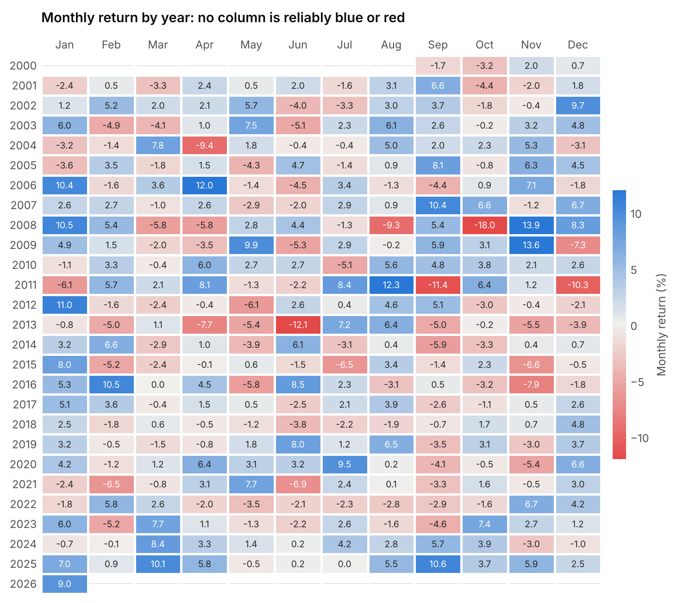
Figure 27. Return of every calendar month, in percent. Blue is a gain and red a loss. No column is consistently one colour, which is the visual form of the test results in Section 3.6.
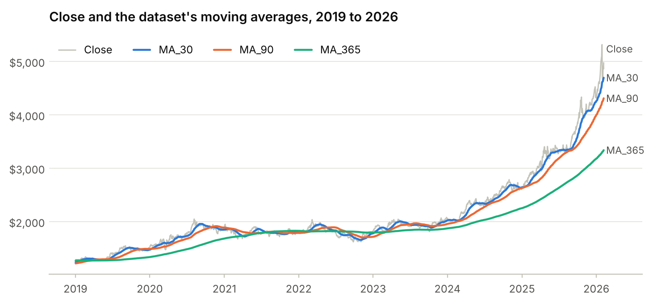
Figure 28. Close and three of the dataset's moving averages from 2019. The gap between the close and MA_365 in January 2026 is the widest in the sample.

C. Additional tables
Table 26. Year-by-year summary. 2000 and 2026 are part years.
Year | Year-end close | Return (%) | Annualised volatility (%) | Up days (%) | Trading days
2000 | $272.00 |  | 10.5 | 39.8 | 84
2001 | $278.70 | 2.5 | 14.8 | 49.0 | 247
2002 | $347.60 | 24.7 | 13.6 | 54.4 | 250
2003 | $415.70 | 19.6 | 16.8 | 55.2 | 250
2004 | $437.50 | 5.2 | 16.4 | 52.2 | 249
2005 | $517.10 | 18.2 | 12.6 | 54.0 | 248
2006 | $635.20 | 22.8 | 24.0 | 51.6 | 250
2007 | $834.90 | 31.4 | 16.6 | 54.0 | 252
2008 | $883.60 | 5.8 | 30.5 | 50.6 | 253
2009 | $1,095.20 | 23.9 | 22.1 | 56.0 | 252
2010 | $1,421.10 | 29.8 | 16.0 | 59.9 | 252
2011 | $1,565.80 | 10.2 | 21.2 | 56.7 | 252
2012 | $1,674.80 | 7.0 | 16.3 | 52.0 | 250
2013 | $1,201.90 | −28.2 | 22.5 | 45.6 | 252
2014 | $1,183.90 | −1.5 | 14.2 | 47.2 | 252
2015 | $1,060.30 | −10.4 | 14.7 | 44.4 | 252
2016 | $1,150.00 | 8.5 | 16.2 | 48.8 | 250
2017 | $1,306.30 | 13.6 | 10.4 | 55.0 | 251
2018 | $1,278.30 | −2.1 | 10.5 | 48.0 | 250
2019 | $1,519.50 | 18.9 | 11.5 | 54.4 | 252
2020 | $1,893.10 | 24.6 | 21.4 | 58.5 | 253
2021 | $1,827.50 | −3.5 | 15.0 | 53.6 | 252
2022 | $1,819.70 | −0.4 | 15.5 | 52.6 | 251
2023 | $2,062.40 | 13.3 | 13.2 | 50.8 | 250
2024 | $2,629.20 | 27.5 | 15.0 | 57.5 | 252
2025 | $4,325.60 | 64.5 | 20.5 | 59.9 | 252
2026 | $4,979.80 | 15.1 | 50.6 | 68.0 | 25
Return is the change in the year-end close. For 2026 it is the change from the end of 2025 to 6 February 2026.
Table 27. Next-day return on days when the close is above or below a moving average (Section 3.8).
Average | Days above (%) | Mean next-day return above (%) | Mean next-day return below (%) | Up days above (%) | Up days below (%) | Welch p-value | Mann-Whitney p-value
MA_30 | 56.6 | 0.031 | 0.066 | 52.7 | 53.1 | 0.21 | 0.43
MA_90 | 64.3 | 0.036 | 0.065 | 53.4 | 52.2 | 0.32 | 0.75
MA_365 | 76.7 | 0.054 | 0.025 | 54.1 | 50.0 | 0.39 | 0.006

Table 28. The five cross-validation folds (Section 4.3).
Fold | Fit from | Fit to | Validate from | Validate to | Fit days | Validation days
1 | 20 Feb 2002 | 23 Jun 2005 | 24 Jun 2005 | 14 Oct 2008 | 834 | 831
2 | 20 Feb 2002 | 14 Oct 2008 | 15 Oct 2008 | 1 Feb 2012 | 1,665 | 831
3 | 20 Feb 2002 | 1 Feb 2012 | 2 Feb 2012 | 22 May 2015 | 2,496 | 831
4 | 20 Feb 2002 | 22 May 2015 | 26 May 2015 | 13 Sep 2018 | 3,327 | 831
5 | 20 Feb 2002 | 13 Sep 2018 | 14 Sep 2018 | 31 Dec 2021 | 4,158 | 831

D. Code excerpts
Three short pieces of the notebook that the report relies on, lightly condensed. The first is the leakage test of Section 2.9.
cut = pd.Timestamp("2015-06-30")
tampered = df.copy()
after = tampered.index > cut
for col in ["Open", "High", "Low", "Close", "MA_7", "MA_30", "MA_90", "MA_365",
"Volatility_30d", "log_return"]:
tampered.loc[after, col] = rng.permutation(tampered.loc[after, col].to_numpy())
same = np.allclose(build_features(tampered).loc[:cut].to_numpy(),
features.loc[:cut].to_numpy(), equal_nan=True)
print("Features up to the cut-off are unchanged when the future is scrambled:", same)
The Diebold-Mariano test used in Sections 5.1 and 5.3.
def dm_test(err_reference, err_model):
"""Diebold-Mariano test on squared errors (one-step forecasts, with the
Harvey-Leybourne-Newbold correction). A positive statistic means the model's
errors are smaller than the reference's."""
d = np.asarray(err_reference) ** 2 - np.asarray(err_model) ** 2
n = len(d)
statistic = d.mean() / np.sqrt(d.var(ddof=0) / n) * np.sqrt((n - 1) / n)
return statistic, 2 * stats.t.sf(abs(statistic), df=n - 1)
The calibration of the band multipliers in Section 5.4, from out-of-fold predictions.
oof = pd.Series(np.nan, index=train.index)
for tr, va in tscv.split(X_train):
fitted = clone(model_C).fit(X_train.iloc[tr], y_train_abs.iloc[tr])
oof.iloc[va] = fitted.predict(X_train.iloc[va])
has_oof = oof.notna()

k_constant = y_train_abs[has_oof].quantile(0.95)
k_ewma = (y_train_abs[has_oof] / ewma_train[has_oof]).quantile(0.95)
k_model = (y_train_abs[has_oof] / oof[has_oof].clip(lower=FLOOR)).quantile(0.95)

half_width = k_model * np.clip(predicted_size, FLOOR, None) # in percent
lower = close_today * np.exp(-half_width / 100)
upper = close_today * np.exp(+half_width / 100)

E. Software and reproducibility
Table 29. Software used for the run reported here.
Package | Version | Used for
Python | 3.13.18 | Language
pandas | 3.0.5 | Data handling
NumPy | 2.5.3 | Numerical arrays
SciPy | 1.18.1 | Statistical tests
statsmodels | 0.15.0 | ADF, KPSS, Ljung-Box and ARCH tests; ARIMA
scikit-learn | 1.9.1 | Pipelines, linear models, random forest, cross-validation, metrics
XGBoost | 3.4.1 | Gradient-boosted trees
Matplotlib | 3.11.2 | Figures
seaborn | 0.13.2 | Heatmaps

To reproduce the results, place the CSV file in a folder named data next to the notebook and run all cells. A full run takes a few minutes. The random seed is fixed at 42, so the numbers in this report should be reproduced exactly with the versions above and closely with others.

