P T A C R E G U L A T O R Y S U B M I S S I O N
Pesticide Regulation
in Bangladesh
A Mode-of-Action-Based Review of the National Pesticide Register and Regulatory Readiness
Prepared for: Pesticide Technical Advisory Committee (PTAC)
Plant Protection Wing, Ministry of Agriculture, Bangladesh
Prepared by: Abu Md Moniruzjaman, Additional Deputy Director
Source: Pesticide MoA Master Database, Rev 4.0 (5,452 products)
Issue date: 8 October 2026

Pesticide Technical Advisory Committee October 2026

Table of Contents

1. Executive Summary 1
2. Background and Objectives 2
2.1 Context: Pesticide Dependence and Emerging Resistance 2
2.2 Purpose and Objectives of This Report 2
2.3 Scope and Limitations 3
3. Regulatory and Institutional Framework 3
3.1 Legal Instruments Governing Pesticides 4
3.2 Institutional Architecture 4
3.3 International Classification Alignment and Comparative Labelling Mandates 4
4. Data Sources, Database Architecture and Methodology 5
4.1 Source Database 5
4.2 Classification Standards and the Unified Notation 5
4.3 Analytical Method 6
5. Composition of the National Register: Core Findings 6
5.1 Register Profile at a Glance 6
5.2 Distribution by Pesticide Type 7
5.3 Mode-of-Action Landscape and Concentration 7
5.4 Combination Products 8
6. Hazard, Policy and Resistance Risk Profile 9
6.1 Bangladesh Policy Risk Tiers 9
6.2 HHP Screening Against WHO/FAO Criteria and Reference Regulators 9
6.3 Resistance Risk Structure 10
6.4 Registration Holder Concentration 11
7. Problem Diagnosis: Regulatory Gaps and Systemic Risks 11
7.1 Structural Over-Concentration in High-Risk Chemistry 11
7.2 Classification Deficit and the Unmapped Quarter 12
7.3 Data Quality and Label Deficiencies 12
7.4 Resistance-Management Deficit at Field Level 12
8. Conclusions and Recommendations 13
8.1 Conclusions 13
8.2 Recommendations 14
9. References 14
Appendix A: Major Mode-of-Action Groups in the Register 17
Appendix B: Leading Registration Holders by Portfolio 17

Note: This Table of Contents is generated via field codes. To ensure page number accuracy after editing, please right-click the TOC and select "Update Field."

1. Executive Summary
This report presents a comprehensive regulatory review of pesticide management in Bangladesh, prepared for submission to the Pesticide Technical Advisory Committee (PTAC) of the Plant Protection Wing, Ministry of Agriculture. The review is built upon the PTAC Pesticide Mode-of-Action (MoA) Master Database, Revision 4.0, which consolidates the national register of 5,452 approved pesticide products with internationally harmonised resistance-management classifications issued by the Insecticide Resistance Action Committee (IRAC, v11.3), the Fungicide Resistance Action Committee (FRAC, Code List 2024) and the Herbicide Resistance Action Committee (HRAC, 2020 numeric system). The analysis maps every classified product to its biochemical mode of action, screens the register against World Health Organization and Food and Agriculture Organization criteria for highly hazardous pesticides (HHPs), and assigns each product to a Bangladesh-specific policy risk tier.
Three findings define the current state of the register. First, the register is heavily concentrated in older, resistance-prone chemistry: the four largest insecticide groups alone — organophosphates (IRAC 1B, 545 products), neonicotinoids (IRAC 4A, 489), pyrethroids (IRAC 3A, 447) and avermectins (IRAC 6, 394) — account for 34.4 percent of all registered products. Second, hazard screening flagged 1,294 products (23.7 percent) as HHP-positive, of which 608 products (11.2 percent) fall in the RED tier warranting immediate or pre-emptive ban and 686 products (12.6 percent) fall in the AMBER tier for phase-out or strict control; only 23 products currently qualify as whitelisted safer alternatives. Third, structural data gaps persist: 1,312 products (24.1 percent) carry no committee-level MoA classification, the WHO toxicity class field is unpopulated for the entire register, and pre-harvest interval (PHI) and re-entry interval (REI) data are available for only 21.4 percent of products.
The report concludes that Bangladesh's regulatory framework — anchored in the Pesticides Ordinance, 1971 and the Pesticides Rules, 1985 — provides adequate legal authority but lacks three operational instruments that international peers now treat as standard: a mandatory mode-of-action labelling requirement, a resistance-management plan tied to registration renewal, and a phase-out roadmap for RED-tier active ingredients. Eight prioritised recommendations are presented in Chapter 8, covering MoA labelling, tiered ban and phase-out implementation, biopesticide substitution incentives, digitisation of the register, and inspectorate capacity building. Implementation of the short-term measures would bring the national register into measurable alignment with the labelling and stewardship practices already mandated by Health Canada, the United States Environmental Protection Agency and the Australian Pesticides and Veterinary Medicines Authority.

2. Background and Objectives

2.1 Context: Pesticide Dependence and Emerging Resistance
Agriculture remains the backbone of Bangladesh's economy, and intensive rice-based cropping systems supported by recurrent pest pressure have made crop protection products an indispensable input for national food security. The national register analysed in this report contains 2,500 insecticide products (45.9 percent of the register), 1,052 fungicides (19.3 percent), 892 herbicides (16.4 percent) and 665 public-health pesticide products (12.2 percent), together with smaller miticide, stored-grain, biopesticide and rodenticide segments. This product mix reflects both the diversity of the country's agro-ecological challenges and the commercial reality of a registration system dominated by reformulated combinations of a comparatively small set of active ingredients.
Dependence on a narrow chemical base carries a well-documented consequence: resistance. Products built on acetylcholinesterase-inhibiting organophosphates and carbamates (IRAC groups 1B and 1A), sodium-channel-modulating pyrethroids (IRAC 3A) and β-tubulin-binding benzimidazoles (FRAC 1) are classified by their respective international action committees as high resistance-risk tools that require strict rotation strategies. At the product level, 3,319 products (60.9 percent of the register) carry a High resistance-risk rating in the source database, while a further 840 products (15.4 percent) cannot be rated at all because their mode of action is unmapped. In the absence of enforceable rotation rules, the practical effect is that farmers can and do apply the same biochemical target site repeatedly within a season, which is precisely the exposure pattern that selects for resistant pest populations.
International context reinforces the urgency of the review. Reference regulators in the European Union, the United States, Canada, Australia and elsewhere have progressively withdrawn or restricted many of the actives still circulating in South Asian markets, and global instruments such as the Stockholm Convention on persistent organic pollutants now list several of them for global elimination. The source database records that 296 registered products contain active ingredients banned in the European Union and listed in Annex A of the Stockholm Convention, and a further 268 products are built on actives that are EU-restricted with high residue concerns. Understanding how many such products remain on the national register — and which policy tier each belongs to — is the empirical foundation on which this report builds its recommendations.

2.2 Purpose and Objectives of This Report
The purpose of this report is to provide PTAC and the Plant Protection Wing with a submission-ready, evidence-based assessment of the national pesticide register and the regulatory posture it implies. The report pursues four objectives. Each objective corresponds to a chapter of the analysis and to identifiable policy instruments, so that the Committee can act on individual findings without waiting for the whole programme to complete.
- Characterise the composition of the national register by product type, mode-of-action group, combination status and registration holder, using a single consistent aggregation of the 5,452-product master register (Chapter 5).
- Quantify hazard and policy exposure by screening the register against WHO/FAO HHP criteria, EU and other reference-regulator status flags, and the Bangladesh policy risk tiers defined in the database (Chapter 6).
- Diagnose structural regulatory gaps — classification deficits, data-quality shortfalls and resistance-management weaknesses — that constrain effective control under the current legal framework (Chapter 7).
- Recommend prioritised, executable measures with responsible bodies and implementation horizons, aligned with international resistance-management practice (Chapter 8).

2.3 Scope and Limitations
The scope of this report is the registered product universe captured in Revision 4.0 of the PTAC master database, comprising 5,452 product records, 260 normalised active-ingredient dictionary entries, 1,399 combination-product mappings and 880 registration-holder profiles. The report addresses regulatory composition, hazard screening and resistance-management posture; it does not evaluate field efficacy, residue levels in food commodities, environmental fate, or the economic cost of any proposed restriction, all of which require separate technical studies. Findings are therefore framed as regulatory-risk indicators rather than as definitive risk assessments for individual products.
Three limitations should be noted when interpreting the figures. First, product counts attributed to individual mode-of-action groups exceed the number of physical products whenever a combination product contributes to more than one group, so group-level shares are reported against the full register and are explicitly labelled as such. Second, the register inherits the classification confidence of the source mapping: products matched through the active-ingredient dictionary (86.4 percent) are more reliably classified than products whose MoA string derives from the legacy register code (13.6 percent). Third, the WHO toxicity classification column exists in the database schema but is not populated for any product, so acute-toxicity conclusions in this report rest on the HHP screening layer rather than on a complete WHO class distribution.

3. Regulatory and Institutional Framework

3.1 Legal Instruments Governing Pesticides
The legal foundation of pesticide control in Bangladesh is the Pesticides Ordinance, 1971 (Ordinance No. II of 1971), which regulates the import, manufacture, formulation, sale, distribution and use of agricultural pesticides and empowers the government to prohibit unregistered products, to prescribe registration procedures and to constitute a technical advisory committee. The Ordinance is operationalised through the Pesticides Rules, 1985, framed under the Ordinance and subsequently amended, which detail the registration procedure, data requirements, dealer licensing, packaging and labelling obligations, record-keeping duties and offence provisions. Together these instruments establish the core permit architecture: no pesticide may be marketed in Bangladesh without registration, and no dealer may sell pesticides without a licence issued through the Department of Agricultural Extension field administration.
This statutory framework has proven durable, but it predates the modern resistance-management paradigm. The Ordinance and Rules regulate products as discrete chemical entities; they contain no obligation to declare a product's mode-of-action group on the label, no quantitative limits on how often a single mode of action may be applied within a season, and no mechanism that ties registration renewal to a documented resistance-management plan. The practical consequence, visible throughout the register analysis in Chapters 5 and 6, is that functionally identical chemistries enter the market under dozens of brand names without any signal to the user that they rotate the same target site. Modernising this architecture does not require a new statute: the existing rule-making powers are sufficient to introduce MoA labelling and rotation conditions through amended rules and registration conditions.

3.2 Institutional Architecture
Four institutional actors carry the pesticide regulatory mandate. The Ministry of Agriculture (MoA) holds overall policy authority and issues statutory rules and registration decisions. The Plant Protection Wing (PPW) of the Ministry serves as the administrative nucleus for pesticide regulation, including the maintenance of the register and the technical secretariat function for advisory processes. The Department of Agricultural Extension (DAE) enforces controls in the field through its national, district and upazila networks: dealer licensing, inspection of sales points, monitoring of use practices and delivery of integrated pest management training. Finally, the Pesticide Technical Advisory Committee (PTAC) — the recipient body of this report — provides the scientific evaluation layer, assessing registration applications, efficacy and toxicity evidence, and technical questions referred by the Ministry.
The institutional design concentrates analytical capacity in PTAC and enforcement capacity in DAE, which is efficient in principle but creates a structural dependency: the quality of national decisions is bounded by the quality of the technical evidence base that PTAC receives. The master database that underpins this report is a direct response to that dependency. By normalising 5,452 product records against 260 active-ingredient dictionary entries and three international classification schemes, and by logging 189 mapping corrections in its Rev 4 update trail, the database converts a fragmented product list into an auditable regulatory instrument. Sustaining that asset — through the annual re-mapping cycle recommended in Chapter 8 — is as much an institutional task as a technical one.

3.3 International Classification Alignment and Comparative Labelling Mandates
Bangladesh's classification framework in this submission rests on three international schemes. The IRAC Mode of Action Classification (v11.3) organises insecticides into numbered groups and subgroups by target site, with the subgroup letters (1A versus 1B, 3A versus 3B) treated as strategically decisive for rotation. The FRAC Code List (2024) performs the same function for fungicides, distinguishing single-site high-risk groups such as 1, 4, 7 and 11 from multi-site protectants in the M series. The HRAC classification migrated from legacy letters to numeric codes in 2020, and the database carries both forms for crosswalk purposes. Hazard screening applies the WHO/FAO criteria for highly hazardous pesticides together with reference-regulator status flags drawn from EU Regulation 1107/2008 outcomes, United States registration status and other national ban lists.
Comparative practice shows that mode-of-action transparency is now a regulatory norm rather than a voluntary stewardship measure. Health Canada (PMRA Regulatory Directive DIR2013-04) requires multi-group labelling — for example, "GROUP 1 2 3 HERBICIDES" — on all products containing multiple sites of action. The United States EPA (PR Notices 2016-X and 2017-1) directs registrants to include IRAC/FRAC/HRAC group identifiers on labels to support resistance management. The Australian APVMA makes MoA codes mandatory on labels and requires alignment with published resistance-management strategies. Bangladesh has no equivalent mandate; its registration certificates do not require MoA group declarations, and its labels therefore cannot communicate rotation guidance. Closing this gap requires only a labelling condition within existing rule-making authority, and Chapter 8 proposes exactly that as the first short-term recommendation.

4. Data Sources, Database Architecture and Methodology

4.1 Source Database
The evidentiary base of this report is the Pesticide Mode-of-Action Master Database, Revision 4.0, prepared for official PTAC submission and issued on 8 October 2026. The workbook merges four predecessor data assets — the MoA dictionary, the 72-group rotation quick reference, the 5,452-product register export and the PTAC field guide — into a single normalised structure with a documented data dictionary. Revision 4 applies eleven canonical active-ingredient corrections, migrates all herbicide codes to the HRAC 2020 numeric system, and integrates the Bangladesh policy layer that assigns every product to a risk tier. Table 1 summarises the components used in this analysis.
Table 1: Components of the PTAC Pesticide MoA Master Database (Rev 4.0) used in this report
Component (sheet) | Records | Role in the regulatory evidence base
Product_Register | 5,452 | Master list of registered products with MoA mapping, HHP status, policy tier, formulation, crops and pests
AI_Dictionary | 260 | Normalised active-ingredient entries mapped to IRAC/FRAC/HRAC codes, mechanism, risk and rotation partners
Combination_Register | 1,399 | Multi-MoA combination products with full per-component MoA strings
MoA_Groups | 72 | Rotation quick reference across IRAC, FRAC, HRAC, biological and auxiliary groups
IRAC / FRAC / HRAC_Groups | 31 / 18 / 10 | Committee-level group metadata: mechanism, resistance risk, rotation partners, live product counts
Registration_Holder_Summary | 880 | Holder-level portfolio analysis: product counts, MoA diversity, HHP share
Common_Name_Index | 464 | Active-ingredient cross-reference with products, brands, holders and crops covered
MoA_Update_Log | 189 | Audit trail of Rev 4 re-mapping decisions (old and new MoA codes per record)
Policy_Dashboard / Risk_Framework / Notation_Standards | 4 + 4 + 8 | Policy tier definitions, resistance risk framework, unified multi-MoA notation rules
Two properties of the database deserve emphasis. First, every product carries a mapping-basis flag that records whether its mode of action was established through the active-ingredient dictionary, through a register-level MoA code, or through the Rev 4 AgriChem correction batch — this flag allows every statistic in this report to be traced to its evidentiary source. Second, combination products are mapped per component rather than per product, which means a premix of two active ingredients contributes one product record to each of its two mode-of-action groups; this convention follows FRAC and IRAC guidance for mixtures and is applied consistently throughout Chapters 5 and 6.

4.2 Classification Standards and the Unified Notation
The database certifies its classification basis against IRAC MoA Classification v11.3 (insecticides), the FRAC Code List 2024 (fungicides) and the HRAC global classification in its 2020 numeric form (herbicides). Because modern products frequently combine several active ingredients, a unified notation standard is required to express multi-MoA products unambiguously. The standard distinguishes premixes (two or more active ingredients formulated in one product, denoted by a forward slash in the FRAC and HRAC systems) from tank mixes (separate products combined in the spray tank, denoted by a plus sign), preserves IRAC subgroup letters, and reserves the codes FRAC U, IRAC UN and HRAC Z/0 for products pending classification. Table 2 reproduces the operative rules.
Table 2: Unified multi-MoA notation standard applied in the database
Committee | Case | Notation rule | Example
IRAC | Combination product with two or more distinct modes of action | Group numbers joined by +, subgroups retained | IRAC 4+28 (thiamethoxam + chlorantraniliprole)
IRAC | Three or more modes of action | Extended + chain | IRAC 3A+4A+28
FRAC | Premix (single formulated product) | Codes joined by / | FRAC 3/11 (DMI + QoI premix)
FRAC | Tank mix (separate products) | Codes joined by + | FRAC 3+11
HRAC | Premix or multi-target single active | Numeric codes joined by / | HRAC 9/4 (glyphosate + 2,4-D)
HRAC | Legacy labels (pre-2020) | Letter codes with numeric crosswalk | G/O [9/4]
The notation is more than a documentation convention: it is the hook on which quantitative application limits hang. The database binds IRAC's rule of no more than two applications of the same MoA group within an application window, FRAC's limit of one-third of total fungicide applications for high-risk groups used solo (one-half when the high-risk group is a premix partner), and HRAC's programme-risk ladder, in which a one-MoA programme rates High risk and diversified mixtures rate Moderate or Low. These limits are the quantitative core of the resistance-management recommendations in Chapter 8.

4.3 Analytical Method
All statistics in this report were computed by aggregating the Product_Register sheet directly, so that every figure traces to one consistent source. The aggregation treats each of the 5,452 rows as one registered product; counts by pesticide type, committee, policy tier, HHP status and mapping basis are simple tallies of the respective columns; and the top-mode-of-action ranking counts each product once under each normalised MoA code it contains, which is why combination-heavy groups appear in multiple rows. Percentage shares of MoA groups are therefore expressed against the full register of 5,452 products and are additive beyond 100 percent when summed across groups.
Policy-tier totals follow the Policy_Dashboard definitions: products containing one or more blacklist HHP actives are RED (immediate or pre-emptive ban); products containing actives under phase-out, substitution or strict-control decisions are AMBER; EU- or US-approved biopesticides and botanicals flagged as safer alternatives are GREEN; and all remaining products are STANDARD. The HHP-positive flag is a binary screen against WHO/FAO HHP criteria using the EU and global regulatory status column. Where this report cites group metadata — mechanism, resistance risk, rotation partners — it quotes the MoA_Groups and committee sheets of the database verbatim. Minor differences between counts published in the database dashboard and counts computed here (for example, 607 RED products in the register column plus one product explicitly flagged for multiple HHPs, against the dashboard total of 608) are noted in the text and do not alter any conclusion.

5. Composition of the National Register: Core Findings

5.1 Register Profile at a Glance
The national register contains 5,452 approved products across eight pesticide categories, supplied by 880 registration holders and built on 464 indexed active-ingredient common names. Classification coverage is strong but incomplete: 4,140 products (76.0 percent) are assigned to one of the three resistance committees — 2,396 to IRAC, 979 to FRAC and 765 to HRAC — while 1,312 products (24.1 percent) remain committee-unclassified. Mapping against the 260-entry active-ingredient dictionary resolves 4,711 products (86.4 percent, including the 189 records corrected in the Rev 4 AgriChem batch), 740 products are classified only through legacy register codes, and one product is unmapped. Table 3 consolidates these headline metrics.
Table 3: Headline profile of the national pesticide register (register-level aggregation)
Indicator | Value | Share of register
Total registered products | 5,452 | 100%
Insecticide products (incl. stored-grain) | 2,588 | 47.5%
Committee-classified products (IRAC/FRAC/HRAC) | 4,140 | 76.0%
Products mapped via AI dictionary (incl. Rev 4 corrections) | 4,711 | 86.4%
Combination products (multi-MoA) | 1,398 | 25.6%
Products carrying a foreign regulatory status flag | 1,317 | 24.2%
HHP-positive products (WHO/FAO criteria) | 1,294 | 23.7%
RED-tier products (ban) | 608 | 11.2%
Products with PHI/REI data recorded | 1,165 | 21.4%
Registration holders | 880 | —
Three figures in this table frame the entire report. The 76.0 percent classification coverage defines how much of the register can presently be managed through resistance policy; the 25.6 percent combination share shows how much of the market is already multi-MoA and therefore depends on the premix notation and per-component mapping described in Chapter 4; and the 21.4 percent PHI/REI completeness rate quantifies the labelling data gap that Chapter 7 addresses. Each is actionable with existing rule-making authority.

5.2 Distribution by Pesticide Type
Figure 1 shows the register's composition by product type. Insecticides dominate with 2,500 products — 45.9 percent of the register — and the share rises to 46.9 percent when the 88 stored-grain insecticides are included. Fungicides (1,052 products) and herbicides (892) form the second and third blocks, reflecting rice, vegetable and wheat protection needs respectively. The public-health segment is substantial at 665 products (12.2 percent), driven largely by household insecticide formulations, while miticides account for 205 products.
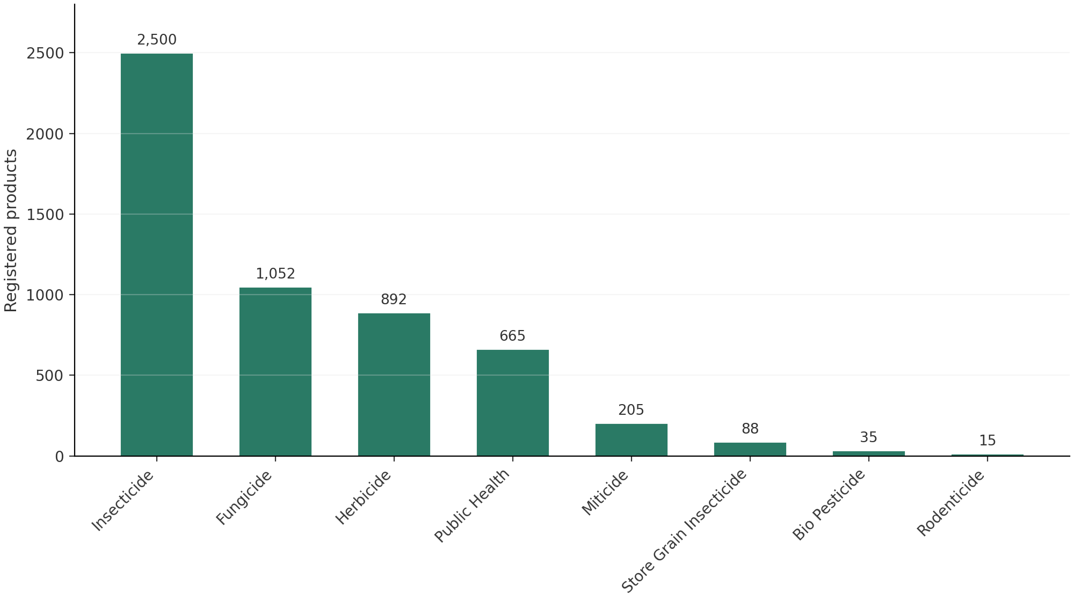
Figure 1: Registered products by pesticide type (n = 5,452)
Two segments warrant policy attention despite their small size. The biopesticide category holds only 35 products (0.6 percent), which is strikingly low against the 23-product GREEN whitelist of internationally approved safer alternatives and against the biopesticide growth observed in reference markets; the segment is too thin to absorb substitution demand if RED-tier products are withdrawn without transition planning. The rodenticide segment (15 products) is small but concentrates second-generation anticoagulants (bromadiolone, flocoumafen, brodifacoum per the MoA group reference), a chemistry class with significant secondary-poisoning concerns that the HHP screening layer already flags.

5.3 Mode-of-Action Landscape and Concentration
Figure 2 ranks the twelve largest mode-of-action groups by registered products, colour-coded by committee. The pattern is unambiguous: insecticide chemistry dominates the top of the ranking, and the four leading IRAC groups — organophosphates (IRAC 1B, 545 products), neonicotinoids (IRAC 4A, 489), pyrethroids (IRAC 3A, 447) and avermectins (IRAC 6, 394) — together account for 1,875 products, or 34.4 percent of the entire register. All four are high resistance-risk groups. In the fungicide domain, triazoles (FRAC 3, 274), multi-site dithiocarbamates (FRAC M3, 267) and benzimidazoles (FRAC 1, 172) lead, with the high-risk MBC and DMI groups relying on multi-site partners for dilution. In herbicides, the ALS-inhibitor group (HRAC 2, 255) is the single largest, followed by VLCFA inhibitors (HRAC 15, 107) and bipyridyliums (HRAC 22, 98).
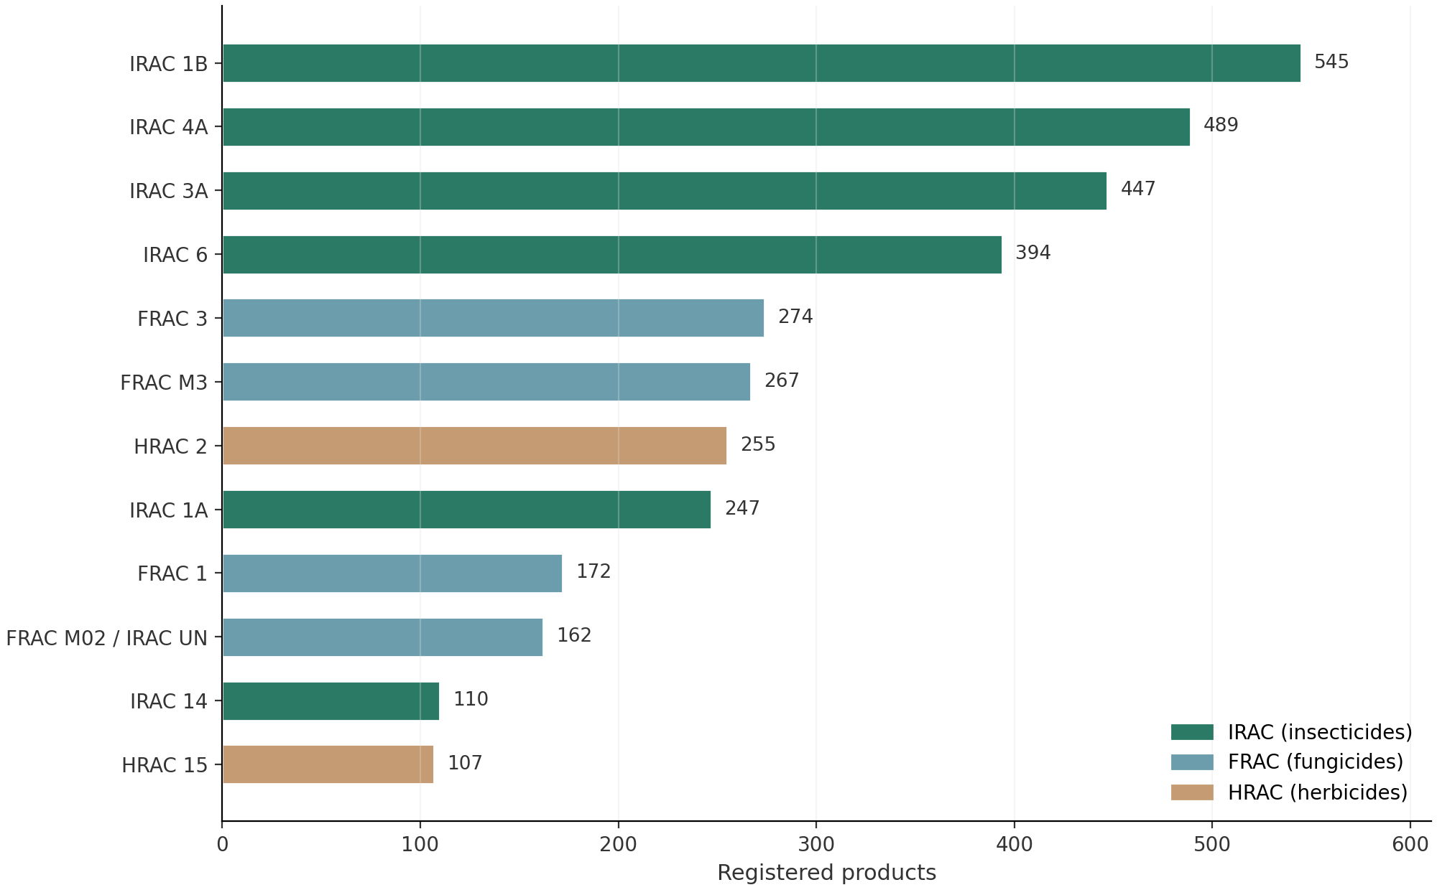
Figure 2: Twelve largest mode-of-action groups by registered products (committee-coded)
Table 4: Ten largest mode-of-action groups — product counts, mechanism and resistance risk
No. | MoA code | Products | Share | Mechanism / chemical family | Resistance risk
1 | IRAC 1B | 545 | 10.0% | Organophosphates — Acetylcholinesterase inhibitors | High
2 | IRAC 4A | 489 | 9.0% | Neonicotinoids — nAChR competitive modulators | High
3 | IRAC 3A | 447 | 8.2% | Pyrethroids & Pyrethrins — Sodium channel modulators | High
4 | IRAC 6 | 394 | 7.2% | Avermectins & Milbemycins — GluCl allosteric modulators | High
5 | FRAC 3 | 274 | 5.0% | DMI (Azoles) — Sterol C14-demethylase inhibitors (Propiconaz | Medium
6 | FRAC M3 | 267 | 4.9% | M3 — Multi-site contact (Dithiocarbamates: Mancozeb, Propine | Low (multi-site)
7 | HRAC 2 | 255 | 4.7% | ALS inhibitor (pyrimidinyl-oxybenzoate) | High
8 | IRAC 1A | 247 | 4.5% | Carbamates — Acetylcholinesterase inhibitors | High
9 | FRAC 1 | 172 | 3.2% | MBC — β-tubulin synthesis inhibitors (Carbendazim, Thiophana | High
10 | FRAC M02 / IRAC UN | 162 | 3.0% | Multi-site — sulphur (fungicide/acaricide) | Low (multi-site)
The concentration pattern has a direct operational meaning under the quantitative application limits introduced in Chapter 4. If the register's largest groups are also its highest-risk groups, then the register's default usage pattern — whichever brand the farmer picks — is likely to violate IRAC's two-application rule or FRAC's one-third rule within a single season unless the user actively selects across groups. Because 24.1 percent of products carry no group designation at all, the register cannot currently signal that choice through labelling. The concentration statistics therefore translate directly into the labelling mandate proposed in Chapter 8.

5.4 Combination Products
Combination products — formulations containing two or more active ingredients with distinct modes of action — number 1,398 in the register (25.6 percent) and are mapped per component in the 1,399-entry Combination Register. The combination segment is dominated by insecticide premixes: the single most repeated pattern in the register pairs the juvenile-hormone mimetic pyriproxyfen (IRAC 7C) with the pyrethroid fenpropathrin (IRAC 3A), a combination registered under at least a dozen separate brand names for crops as varied as tea, mango, brinjal, jute and cotton. Other recurring families pair organophosphates with pyrethroids (IRAC 1B + 3A) and neonicotinoids with emamectin benzoate (IRAC 4A + 6).
Combinations are double-edged from a resistance-management standpoint. Used correctly, a premix delivers two target sites simultaneously and can dilute selection pressure on each partner — the basis for FRAC's more lenient one-half application limit for high-risk premix components. Used incorrectly, they multiply exposure: when ten brands of the same 7C + 3A premix circulate, a farmer rotating brands is not rotating modes of action at all. The register-level view provided by the Combination Register — which assigns each premix a full MoA string such as IRAC 7C + 3A — is precisely the instrument needed to police this distinction, provided group codes appear on labels as recommended in Chapter 8.

6. Hazard, Policy and Resistance Risk Profile

6.1 Bangladesh Policy Risk Tiers
Every product in the register is assigned to one of four policy risk tiers based on its active-ingredient content. The RED tier captures products containing blacklist HHP actives that warrant immediate or pre-emptive ban; the AMBER tier captures actives under phase-out, substitution or strict-control decisions; the GREEN tier marks internationally approved biopesticides and botanicals serving as safer alternatives; and the STANDARD tier covers products with no HHP flag, to which ordinary registration controls apply. Figure 3 and Table 5 present the tier distribution.
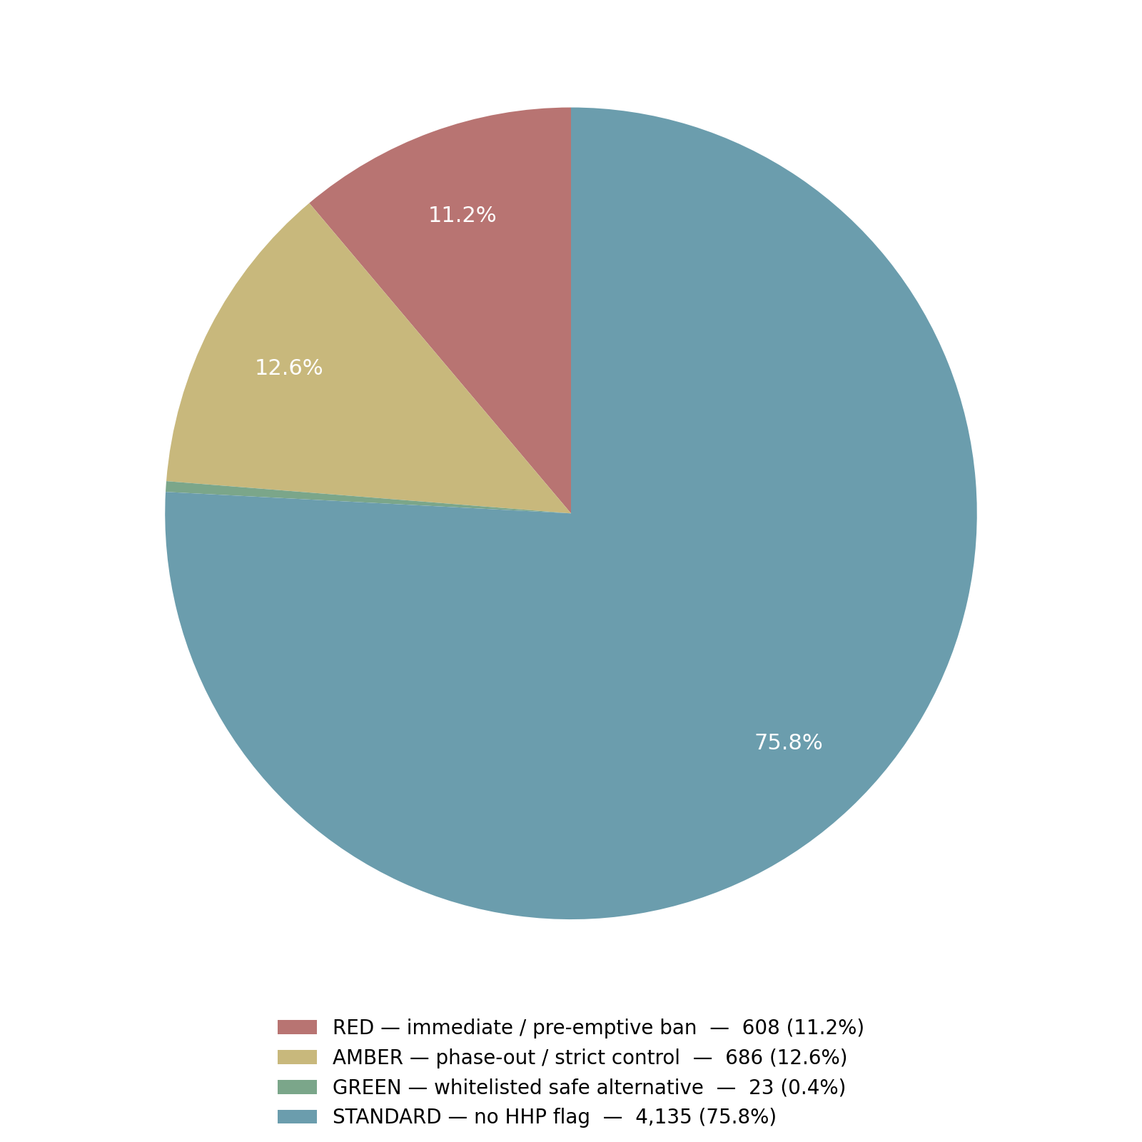
Figure 3: Products by Bangladesh policy risk tier (n = 5,452)
Table 5: Policy risk tier definitions and product counts
Tier | Products | Share | Definition
RED | 608 | 11.2% | Contains one or more blacklist HHP actives; immediate or pre-emptive ban indicated
AMBER | 686 | 12.6% | Contains HHP actives under phase-out, substitution or strict-control decisions
GREEN | 23 | 0.4% | EU/US-approved biopesticides and botanicals whitelisted as safer alternatives
STANDARD | 4,135 | 75.8% | No HHP flag; standard registration controls apply
The combined RED and AMBER exposure — 1,294 products, 23.7 percent of the register — represents the enforceable core of a national HHP risk-reduction programme. The RED tier's 608 products include the 296 products built on actives banned in the EU and listed in Annex A of the Stockholm Convention, where international obligations already point toward prohibition. The GREEN tier's 23 products are the current ceiling of whitelisted alternatives, which quantifies the substitution gap: for every whitelisted safer product there are 26 RED-tier products awaiting replacement. This asymmetry is the central logistical argument for pairing any ban schedule with the biopesticide fast-track recommended in Chapter 8.

6.2 HHP Screening Against WHO/FAO Criteria and Reference Regulators
The database screens the full register against WHO/FAO highly hazardous pesticide criteria using reference-regulator status flags from the EU (Regulation 1107/2008 outcomes), the United States and other national ban lists. The screen classifies 1,294 products as HHP-positive (23.7 percent), 4,135 products as carrying no flag, and 23 products as whitelisted safer alternatives. Figure 4 breaks down the 1,317 products that carry any foreign regulatory status flag by the nature of that flag. The largest single block — 296 products — involves actives banned in the EU and listed in Annex A of the Stockholm Convention, followed by 268 products on EU-restricted, not-approved actives with high residue concern, 262 products whose EU renewal was denied, and 178 products banned in both the EU and the United States. A further 112 products rely on actives banned in at least 72 countries including Brazil and China.
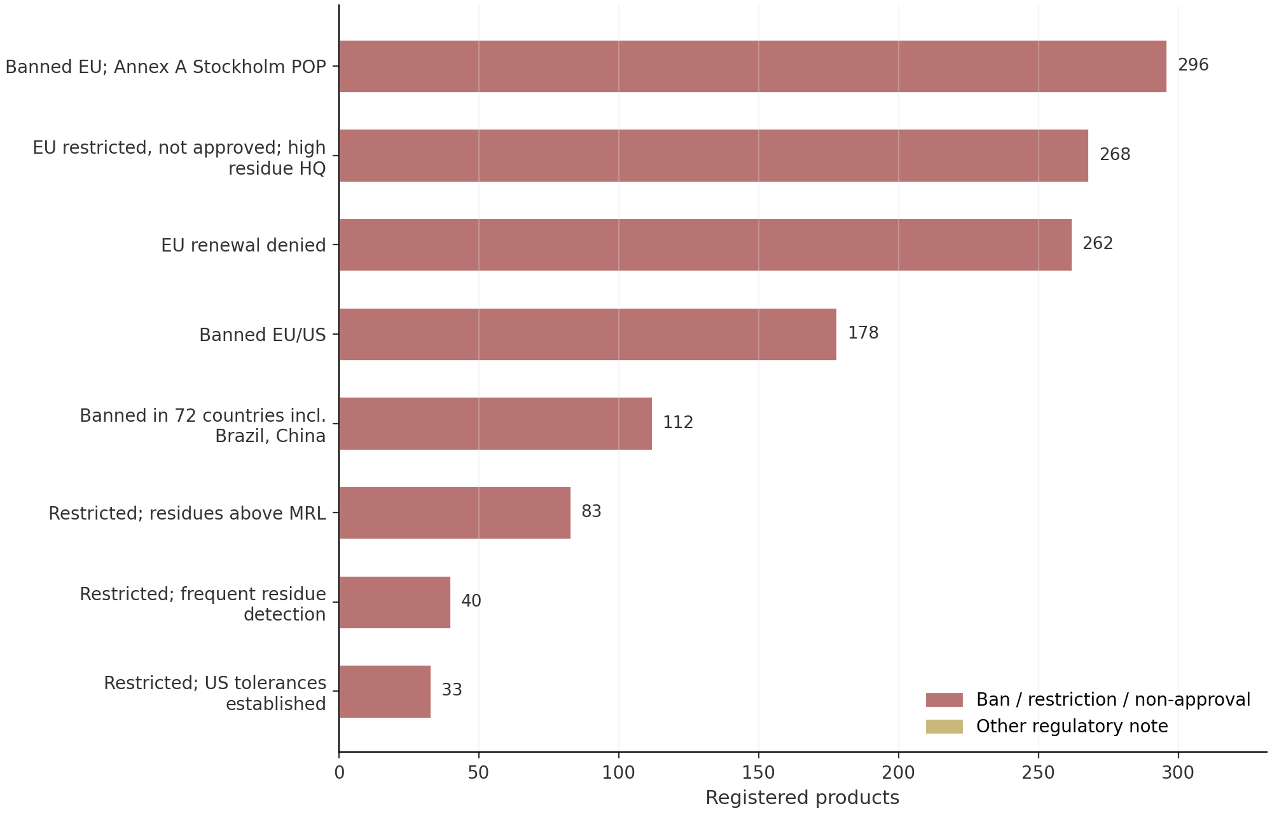
Figure 4: Registered products by reference-regulator regulatory status (top statuses; n = 1,317 flagged)
The screening arithmetic is internally consistent and therefore auditable: 4,135 unflagged products plus 23 approved alternatives plus 1,294 HHP-positive products reconstructs the 5,452-product register exactly. It follows that every flagged status except explicit EU/US approval maps into the HHP-positive class. This one-to-one traceability matters procedurally: when PTAC acts on individual registrations, the tier and the foreign-status evidence for each decision are already attached to the product record, so the Committee's task is prioritisation rather than reconstruction.

6.3 Resistance Risk Structure
Figure 5 profiles the resistance-risk ratings of the mode-of-action groups present in the register, by committee. Of the 31 IRAC groups, 7 are rated High risk, 15 Medium and 7 Low, with 2 groups unclassified; of the 18 FRAC groups, 3 are High, 8 Medium and 7 Low; and of the 10 HRAC groups, 2 are High, 2 Medium and 6 Low. High-risk groups are a minority of the classification space but command the majority of the market: product-level risk ratings show 3,319 products (60.9 percent) rated High, 594 (10.9 percent) Medium, 699 (12.8 percent) Low and 840 (15.4 percent) Unknown.
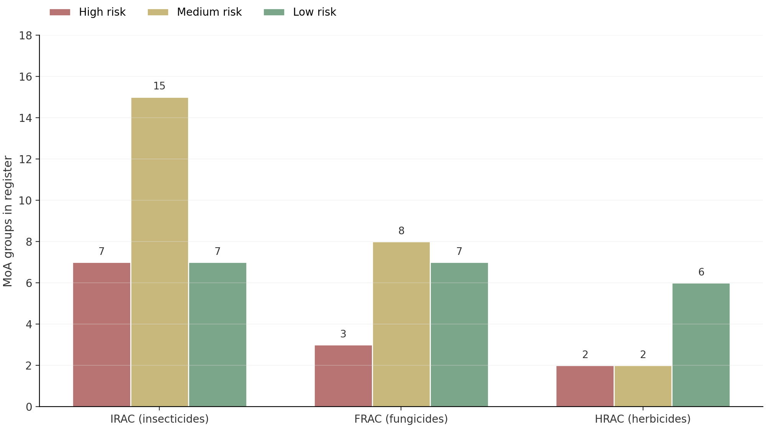
Figure 5: Resistance-risk ratings of mode-of-action groups by committee (group counts)
The asymmetry between group counts and product counts is the quantified core of the resistance problem: high-risk groups hold 30 percent of classified group slots but 60.9 percent of products. The Risk Framework sheet prescribes the corresponding controls — high-risk groups limited to one-third of seasonal applications, medium-risk groups rotated without back-to-back use, low-risk multi-site and biological groups used as rotation anchors, and unknown-risk products treated as Medium until field data exist. The framework exists in the database; what is missing is its translation into label conditions and dealer-level enforcement, which Chapter 7 takes up as a diagnosis and Chapter 8 converts into recommendations.

6.4 Registration Holder Concentration
The register's 5,452 products are distributed across 880 registration holders, but the distribution is top-heavy: the ten largest holders alone control 699 products (12.8 percent), and the fifteen largest control 942 (17.3 percent). Table 6 profiles the leading holders with their mode-of-action diversity and HHP exposure. HHP shares within the leading portfolios range from roughly 17 to 37 percent, and several holders with mid-sized portfolios carry proportionally higher HHP loads than the register average of 23.7 percent.
Table 6: Ten largest registration holders — portfolio size, MoA diversity and HHP exposure
Registration holder | Products | Distinct MoA codes | HHP-flagged products | HHP share of portfolio
ACI Formulations Limited | 115 | 23 | 26 | 22.6%
Haychem (Bangladesh) Limited | 101 | 25 | 18 | 17.8%
Sun Seed Pesticides | 76 | 24 | 16 | 21.1%
Intefa | 62 | 26 | 12 | 19.4%
Mimpex Agrochemicals Limited | 61 | 24 | 15 | 24.6%
Auto Crop Care Limited | 59 | 26 | 17 | 28.8%
Mamun Agro Products Ltd. | 58 | 21 | 16 | 27.6%
McDonald Bangladesh (Pvt) Limited | 58 | 25 | 10 | 17.2%
Valent Tech Limited | 56 | 23 | 10 | 17.9%
Bangladesh Agricultural Industries | 53 | 20 | 12 | 22.6%
Holder-level analysis matters for sequencing reform. Because a limited number of companies concentrate both volume and HHP exposure, consultations on ban schedules and substitution plans can reach a disproportionate share of the market through a manageable number of counterparts. Mode-of-action diversity within portfolios (19 to 27 distinct codes among the top holders) also indicates that most large companies already have rotation-friendly product ranges and could comply with labelling and rotation conditions without portfolio restructuring; the marginal cost of compliance is concentrated in label reprinting and training rather than in product withdrawal.

7. Problem Diagnosis: Regulatory Gaps and Systemic Risks

7.1 Structural Over-Concentration in High-Risk Chemistry
The register's demand pattern is anchored to chemistry classes that international practice has moved away from. The four leading insecticide groups (IRAC 1B, 4A, 3A, 6) hold 34.4 percent of the register; adding carbamates (IRAC 1A, 247 products) lifts the AChE-plus-neonicotinoid-plus-pyrethroid-plus-avermectin complex to nearly 39 percent. In fungicides, the three highest-risk groups — MBCs (FRAC 1, 172 products), DMIs (FRAC 3, 274) and QoIs (FRAC 11, 95) — jointly hold 541 products, meaning that roughly half of the fungicide market (1,052 products) depends on groups for which FRAC prescribes strict seasonal proportion limits. In herbicides, the ALS-inhibitor block (HRAC 2, 255 products) is the largest single group, and the HRAC crosswalk rates legacy Group B as Very High risk.
This concentration creates three interacting exposures. Agronomically, repeated use of the same target site accelerates resistance fixation, and field failures in organophosphate and benzimidazole chemistry are among the most widely documented resistance cases globally. Commercially, dozens of brands compete inside each group — 545 organophosphate products is not 545 distinct tools — so market competition drives price down without adding rotation value. Operationally, concentration in high-risk groups makes the register fragile to external shocks: a single international reclassification or import-supply disruption would simultaneously affect hundreds of registrations, as the paraquat and carbendazim episodes in other jurisdictions illustrate.

7.2 Classification Deficit and the Unmapped Quarter
A regulatory system cannot rotate what it cannot see. In the current register, 1,312 products (24.1 percent) have no committee classification, 740 products rely on legacy register codes rather than dictionary-normalised mapping, one product is entirely unmapped, and 840 products (15.4 percent) consequently carry an Unknown resistance-risk rating. The compound code FRAC M02 / IRAC UN — sulphur-based multi-site fungicide paired with an unclassified insecticide — appears in 162 products, illustrating how pending classifications propagate through combination formulations. The database's own update log demonstrates the fix is tractable: the Rev 4 AgriChem batch resolved 189 previously unmapped records through systematic re-mapping, and the PTAC conformance checklist confirms every mapped product now carries at least one committee code.
The unmapped quarter is not randomly distributed. It clusters in public-health products (household aerosols and coils built on allethrin-class actives), older combination products whose declared composition uses percentages instead of active-ingredient names, and store-grain treatments. These are segments where user safety and residue control depend heavily on label clarity, so the classification deficit compounds rather than merely accompanies the hazard profile. Because the AI dictionary already contains 260 normalised entries with synonyms, completing the remaining 740 records is a bounded data-engineering task — the kind of exercise Rev 4 performed 189 times — rather than an open-ended research problem.

7.3 Data Quality and Label Deficiencies
Three schema-level gaps limit what the register can tell users. First, the WHO_Toxicity_Class column is present in the data model but populated for zero of the 5,452 products, so the register cannot support acute-toxicity-based handling classes at the point of sale, even though the PTAC conformance checklist lists WHO class assignment as a design requirement. Second, pre-harvest interval (PHI) and re-entry interval (REI) values exist for only 1,165 products (21.4 percent), leaving nearly four-fifths of the register without the two numeric fields that most directly drive safe-use compliance by farmers. Third, common-name normalisation is incomplete: the index contains near-duplicate entries such as d-trans allethrin and d-allethrin, aluminium and aluminum phosphide, which fragment product counts and complicate holder-level compliance analysis.
These gaps interact with the absence of a national MoA labelling mandate. A label that omits the mode-of-action group also typically omits structured rotation guidance, quantitative application windows and, in the unmapped cases, any reliable basis for resistance advice. International comparison in Chapter 3 shows the fix is administrative, not scientific: PMRA, US EPA and APVMA all publish group codes on labels under existing regulatory authority. Bangladesh's register already contains every datum needed to print those codes tomorrow — the gap is a labelling condition, not a data problem.

7.4 Resistance-Management Deficit at Field Level
Finally, the register's quantitative limits — IRAC's two-application rule per mode of action, FRAC's one-third and one-half seasonal proportion rules, HRAC's programme-risk ladder — exist in the database and in PTAC's field guide but have no enforcement vehicle. Nothing in the current registration certificate conditions a product's use on rotation; nothing on the label communicates the group; nothing in dealer licensing tests the concept. The combination market illustrates the resulting distortion: at least twelve separately registered brands of the identical pyriproxyfen + fenpropathrin premix (IRAC 7C + 3A) compete across tea, mango, brinjal, jute and cotton, so a farmer who switches brands for price is re-applying the same two target sites season after season. That pattern — brand rotation without mode-of-action rotation — is the single most consequential behaviour the current framework fails to interrupt, and it is the behaviour the recommendations in Chapter 8 are designed to change.

8. Conclusions and Recommendations

8.1 Conclusions
The analysis supports six conclusions, each traceable to the register evidence in Chapters 5 through 7 and each actionable within the existing legal framework of the Pesticides Ordinance, 1971 and the Pesticides Rules, 1985.
- The register is large but chemically narrow. Five thousand four hundred fifty-two products rest on 464 common names and concentrate 34.4 percent of all registrations in four high-risk insecticide groups, so brand-level competition overstates the true diversity of available modes of action.
- Hazard exposure is material and precisely quantified. The WHO/FAO-aligned screen flags 1,294 products (23.7 percent) as HHP-positive, with 608 products in the RED ban tier and 686 in the AMBER phase-out tier; only 23 whitelisted safer alternatives exist to absorb substitution.
- Classification coverage is incomplete in ways that block policy. 24.1 percent of products lack a committee MoA classification, 15.4 percent carry an Unknown resistance rating, and the FRAC M02 / IRAC UN compound code alone covers 162 products.
- The labelling regime predates resistance management. No MoA group code, rotation window or seasonal proportion limit appears on Bangladeshi labels, in contrast with the mandatory group labelling of Canada, the United States and Australia.
- Safety data fields are structurally incomplete. WHO toxicity class is unpopulated register-wide and PHI/REI coverage stands at 21.4 percent, so point-of-sale safe-use guidance cannot be systematically delivered.
- Reform capacity is concentrated and therefore reachable. The fifteen largest holders control 17.3 percent of products with 17 to 37 percent HHP shares and 19 to 27 MoA codes per portfolio, so consultations and label mandates reach the market efficiently through a limited number of counterparts.

8.2 Recommendations
Eight recommendations follow, sequenced by implementation horizon. The first four are short-term administrative measures executable under existing rule-making powers; the remainder build the substitution, data and institutional base for durable reform. Table 7 assigns each measure a lead body and horizon; the paragraphs that follow state the expected outcome and the evidence base.
Table 7: Prioritised recommendations with lead responsibility and implementation horizon
No. | Recommendation | Lead responsibility | Horizon
R1 | Mandate IRAC/FRAC/HRAC mode-of-action group codes on all pesticide labels, including multi-group strings for combination products | PPW with PTAC technical standard | Short (0–12 months)
R2 | Publish and execute a RED-tier cancellation schedule for 608 products, prioritising Stockholm Convention POP actives (296 products) | MoA, enforced by DAE | Short (start 0–12 months; complete 24 months)
R3 | Adopt an AMBER phase-out roadmap with product-by-product substitution plans for 686 products | PTAC with MoA | Medium (1–3 years)
R4 | Fast-track biopesticide and botanical registration to expand the 23-product GREEN whitelist | PTAC | Medium (1–2 years)
R5 | Condition registration and renewal on a resistance-management plan applying the database's quantitative limits (IRAC ≤2 applications per window; FRAC ≤1/3 solo, ≤1/2 premix) | PTAC | Short–Medium (12–24 months)
R6 | Complete MoA mapping for the 740 legacy-code products and the single unmapped record via the next AgriChem update cycle | PPW data cell with PTAC reviewers | Short (6–12 months)
R7 | Populate WHO toxicity class, PHI and REI fields for all products in a digital register with public search | PPW with DAE | Medium (1–2 years)
R8 | Institute an annual register re-mapping and publication cycle, with MoA-based compliance modules in inspector and dealer training | PPW | Ongoing (annual; training from year 1)
Recommendation R1 is the keystone. Group-code labelling converts the register's classification layer into field-level information at near-zero marginal cost, aligns Bangladesh with PMRA DIR2013-04, US EPA PRN 2017-1 and APVMA practice, and is a precondition for the combination-market discipline described in Section 5.4. R2 and R3 act on the quantified hazard core: the RED schedule should begin with the Stockholm POP block, where international obligations are explicit, and the AMBER roadmap should pair each phase-out with a named substitute drawn from the same committee's lower-risk groups. R4 corrects the substitution asymmetry — 23 whitelisted products against 1,294 flagged ones — by reducing data requirements for internationally approved biopesticides and botanicals.
R5 through R8 build the standing machinery. Embedding resistance-management plans in registration renewal (R5) makes the database's quantitative limits enforceable conditions rather than guidance; completing the mapping backlog (R6) shrinks the unmapped quarter below five percent within one AgriChem cycle; a fully populated toxicity and PHI/REI layer in a public digital register (R7) closes the data gaps that currently prevent point-of-sale safe-use guidance; and the annual re-mapping cycle with inspector training (R8) converts the Rev 4 exercise from a one-off submission into a permanent regulatory asset. Taken together, the eight measures would bring the national register into measurable alignment with reference-regulator practice within three years, using legal authority that already exists.

9. References
Regulatory instruments, classification standards and data assets cited in this report are listed below. Classification codes, mechanism descriptions, resistance-risk ratings, policy tiers and all product counts originate from the Rev 4.0 master database (item 3) and the source assets merged within it (item 15).
- Government of the People's Republic of Bangladesh. The Pesticides Ordinance, 1971 (Ordinance No. II of 1971). Dhaka.
- Government of the People's Republic of Bangladesh. The Pesticides Rules, 1985 (as amended). Dhaka.
- Pesticide Technical Advisory Committee. Pesticide Mode-of-Action Master Database, Rev 4.0 — Official Regulatory Submission, 8 October 2026 (source file: PTAC_Pesticide_MoA_Master_Database_2026_Rev4.xlsx).
- Pesticide Technical Advisory Committee. Pesticide Field Guide, PTAC Edition 2026.
- Insecticide Resistance Action Committee (IRAC). Mode of Action Classification, Version 11.3. Available at: irac-online.org.
- Fungicide Resistance Action Committee (FRAC). FRAC Code List 2024: Fungicides grouped by mode of action. Available at: frac.info.
- Herbicide Resistance Action Committee (HRAC). Global Herbicide MoA Classification — 2020 numeric system and 2026 update. Available at: hracglobal.com.
- World Health Organization / Food and Agriculture Organization. WHO Recommended Classification of Pesticides by Hazard, and Guidelines on Highly Hazardous Pesticides (HHP criteria).
- European Union. Regulation (EC) No 1107/2008 concerning the placing of plant protection products on the market (basis of EU approval-status flags).
- Health Canada, Pest Management Regulatory Agency. Regulatory Directive DIR2013-04: Mode of Action Labelling for Multiple Sites of Action.
- United States Environmental Protection Agency. Pesticide Registration Notice 2017-1: Pesticide Resistance Management Labeling (with PR Notice 2016-X).
- Australian Pesticides and Veterinary Medicines Authority (APVMA). Data Guidelines Part 8: Efficacy and Crop Safety — resistance management alignment.
- CropLife International. Mode of Action Labelling Guidance (revised 2020).
- IRAC. Statement on Insecticide Mixtures and Resistance Management. Available at: irac-online.org.
- Source data assets merged in Rev 4.0: MoA_Dictionary_IRAC_FRAC_HRAC.csv; MoA_Rotation_QuickReference.xlsx; all_pesticides.csv (5,452-product register export); Pesticide_Field_Guide_PTAC_Edition_2026.pdf.

Appendix A: Major Mode-of-Action Groups in the Register
Table A1 profiles the twenty largest mode-of-action groups at register level, using the same aggregation rule as Chapters 5 and 6: each product contributes once to every normalised group code it contains, so combination products appear under multiple groups and group counts are not intended to sum to the register total. Mechanism descriptions and resistance-risk ratings are quoted from the database's MoA summary and group reference sheets; multi-site (M-series) fungicide groups carry the framework's Low rating by construction, and codes shown with a dash are pending committee classification.
Table A1: Twenty largest mode-of-action groups — mechanism, resistance risk and register counts
MoA group | Mechanism / chemical family | Resistance risk | Products | Share of register
IRAC 1B | Organophosphates — Acetylcholinesterase inhibitors | High | 545 | 10.0%
IRAC 4A | Neonicotinoids — nAChR competitive modulators | High | 489 | 9.0%
IRAC 3A | Pyrethroids & Pyrethrins — Sodium channel modulators | High | 447 | 8.2%
IRAC 6 | Avermectins & Milbemycins — GluCl allosteric modulators | High | 394 | 7.2%
FRAC 3 | DMI (Azoles) — Sterol C14-demethylase inhibitors (Propiconaz | Medium | 274 | 5.0%
FRAC M3 | M3 — Multi-site contact (Dithiocarbamates: Mancozeb, Propine | Low (multi-site) | 267 | 4.9%
HRAC 2 | ALS inhibitor (pyrimidinyl-oxybenzoate) | High | 255 | 4.7%
IRAC 1A | Carbamates — Acetylcholinesterase inhibitors | High | 247 | 4.5%
FRAC 1 | MBC — β-tubulin synthesis inhibitors (Carbendazim, Thiophana | High | 172 | 3.2%
FRAC M02 / IRAC UN | Multi-site — sulphur (fungicide/acaricide) | Low (multi-site) | 162 | 3.0%
IRAC 14 | Cartap, Nereistoxins — nAChR channel blockers | Medium | 110 | 2.0%
HRAC 15 | VLCFA elongase inhibitor (chloroacetamide) | Low | 107 | 2.0%
HRAC 22 | PSI electron divertor (bipyridylium) | Low | 98 | 1.8%
HRAC 1 | ACCase inhibitor (aryloxyphenoxypropionate) | High | 96 | 1.8%
FRAC 11 | QoI — Complex III (cyt bc1) inhibitors (Azoxystrobin, Pyracl | High | 95 | 1.7%
HRAC 9 | EPSPS inhibitor (glycine) | Medium | 89 | 1.6%
IRAC 24A | Acequinocyl, Fluacrypyrim — Complex III inhibitors | — | 87 | 1.6%
HRAC 4 | Synthetic auxin (phenoxy-carboxylate) | Low | 45 | 0.8%
FRAC M1 | M1 — Multi-site contact (Inorganic copper) | Low (multi-site) | 40 | 0.7%
FRAC 2 | Dicarboximides (Iprodione, Procymidone) | Medium | 38 | 0.7%
Read together, the twenty groups cover 4,062 product assignments — roughly three-quarters of all group assignments in the register — and fifteen of the twenty carry Medium or High resistance ratings. The table also illustrates the classification deficit described in Chapter 7: the compound code FRAC M02 / IRAC UN and the unclassified IRAC 24A fumigant-class entries sit inside the top twenty, so completing pending classifications would materially improve even this most-mapped portion of the register.

Appendix B: Leading Registration Holders by Portfolio
Table B1 extends the holder analysis of Section 6.4 to the fifteen largest portfolios. The distinct-MoA-code column counts the normalised group codes appearing in each holder's products and indicates portfolio breadth rather than resistance safety; the HHP columns use the register's RED-plus-AMBER definition so that the shares are directly comparable with the 23.7 percent register-wide HHP rate. Holder names are reproduced as recorded in the database's registration holder summary sheet.
Table B1: Fifteen largest registration holders — portfolio size, MoA diversity and HHP exposure
Registration holder | Products | Distinct MoA codes | HHP-flagged products | HHP share of portfolio
ACI Formulations Limited | 115 | 23 | 26 | 22.6%
Haychem (Bangladesh) Limited | 101 | 25 | 18 | 17.8%
Sun Seed Pesticides | 76 | 24 | 16 | 21.1%
Intefa | 62 | 26 | 12 | 19.4%
Mimpex Agrochemicals Limited | 61 | 24 | 15 | 24.6%
Auto Crop Care Limited | 59 | 26 | 17 | 28.8%
Mamun Agro Products Ltd. | 58 | 21 | 16 | 27.6%
McDonald Bangladesh (Pvt) Limited | 58 | 25 | 10 | 17.2%
Valent Tech Limited | 56 | 23 | 10 | 17.9%
Bangladesh Agricultural Industries | 53 | 20 | 12 | 22.6%
Shetu Pesticides Limited | 51 | 22 | 17 | 33.3%
Sweet Agrovet Limited | 50 | 21 | 11 | 22.0%
Amco Agricultural Industries | 48 | 19 | 10 | 20.8%
Corbel International Limited | 48 | 20 | 10 | 20.8%
Eon Agro Industries Limited | 46 | 20 | 6 | 13.0%
The concentration picture is consistent across both tables: no single holder exceeds a 2.1 percent register share, so the market is not oligopolistic in product count, yet the top fifteen holders jointly account for 942 products and a disproportionate share of the HHP-flagged volume. This makes holder-level engagement — label reprinting under R1, cancellation consultations under R2, substitution planning under R3 — an efficient administrative route for the Ministry, since each engagement propagates across twenty to sixty products on average.

