**Vehicle Management System (VMS)**

1. **Project Overview:** This is a Vehicle Management System that efficiently manages all the aspects of vehicle-related operations, including vehicle tracking, driver management, bookings, geofencing, maintenance and expense tracking.
2. **Possible Entities:**
3. Users
4. Permissions
5. Vehicle Groups
6. Vehicles
7. Customers
8. Drivers
9. Bookings
10. Geofence Events
11. Income/Expense
12. Maintenance
13. Maintenance Parts
14. Parts Inventory
15. Fuel
16. Reminders
17. Tracking
18. Email Templates
19. Settings
20. SMTP Configuration
21. **Schemas:***Note: The attributes are just imagination based on the figma design*.

| **1. Users** | | | | |
| --- | --- | --- | --- | --- |
| **Attributes** | **Data Types** | **Indexed?** | **PK** | **FK** |
| user_id | INT | Yes | Yes | - |
| name | VARCHAR(255) | - | - | - |
| email | VARCHAR(255) | - | - | - |
| username | VARCHAR(255) | - | - | - |
| password | VARCHAR(255) | - | - | - |

| **2. Permissions** | | | | |
| --- | --- | --- | --- | --- |
| **Attributes** | **Data Types** | **Indexed?** | **PK** | **FK** |
| permission_id | INT | Yes | Yes | - |
| user_id | INT | Yes | - | Yes (users) |
| entity_name | VARCHAR(255) | - | - | - |
| can_view | BOOLEAN | - | - | - |
| can_edit | BOOLEAN | - | - | - |
| can_add | BOOLEAN | - | - | - |
| can_delete | BOOLEAN | - | - | - |

| **3. VehicleGroups** | | | | |
| --- | --- | --- | --- | --- |
| **Attributes** | **Data Types** | **Indexed?** | **PK** | **FK** |
| group_id | INT | Yes | Yes | - |
| group_name | VARCHAR(255) | Yes | - | - |

| **4. Vehicles** | | | | |
| --- | --- | --- | --- | --- |
| **Attributes** | **Data Types** | **Indexed?** | **PK** | **FK** |
| vehicle_id | INT | Yes | Yes | - |
| registration_number | VARCHAR(255) | Yes | - | - |
| name | VARCHAR(255) | - | - | - |
| model | VARCHAR(255) | - | - | - |
| chassis_no | VARCHAR(255) | - | - | - |
| engine_no | VARCHAR(255) | - | - | - |
| manufacturer | VARCHAR(255) | - | - | - |
| vehicle_type | VARCHAR(100) | - | - | - |
| status | ENUM | - | - | - |
| registration_expiry_date | DATE | - | - | - |
| vehicle_group_id | INT | Yes | - | Yes (vehicle_groups) |
| vehicle_image | VARCHAR(255) | - | - | - |
| mileage_per_litre | DECIMAL(5,2) | - | - | - |
| gps_api_username | VARCHAR(255) | - | - | - |
| gps_api_password | VARCHAR(255) | - | - | - |
| api_url | VARCHAR(255) | - | - | - |

| **5. Customers** | | | | |
| --- | --- | --- | --- | --- |
| **Attributes** | **Data Types** | **Indexed?** | **PK** | **FK** |
| customer_id | INT | Yes | Yes | - |
| name | VARCHAR(255) | - | - | - |
| mobile | VARCHAR(20) | - | - | - |
| email | VARCHAR(255) | - | - | - |
| address | TEXT | - | - | - |

| **6. Drivers** | | | | |
| --- | --- | --- | --- | --- |
| **Attributes** | **Data Types** | **Indexed?** | **PK** | **FK** |
| driver_id | INT | Yes | Yes | - |
| name | VARCHAR(255) | - | - | - |
| mobile | VARCHAR(20) | - | - | - |
| age | INT | - | - | - |
| license_no | VARCHAR(255) | Yes | - | - |
| license_expiry_date | DATE | - | - | - |
| experience_years | INT | - | - | - |
| joining_date | DATE | - | - | - |
| address | TEXT | - | - | - |
| status | ENUM | - | - | - |
| driver_photo | VARCHAR(255) | - | - | - |
| driver_document | VARCHAR(255) | - | - | - |

| **7. Bookings** | | | | |
| --- | --- | --- | --- | --- |
| **Attributes** | **Data Types** | **Indexed?** | **PK** | **FK** |
| booking_id | INT | Yes | Yes | - |
| customer_id | INT | Yes | - | Yes (customers) |
| vehicle_id | INT | Yes | - | Yes (vehicles) |
| driver_id | INT | Yes | - | Yes (drivers) |
| trip_type | VARCHAR(100) | - | - | - |
| trip_start_location | VARCHAR(255) | - | - | - |
| trip_end_location | VARCHAR(255) | - | - | - |
| trip_start_date | DATE | - | - | - |
| trip_end_date | DATE | - | - | - |
| approx_total_km | DECIMAL(10,2) | - | - | - |
| total_amount | DECIMAL(10,2) | - | - | - |
| trip_status | ENUM | - | - | - |

| **8. GeofenceEvents** | | | | |
| --- | --- | --- | --- | --- |
| **Attributes** | **Data Types** | **Indexed?** | **PK** | **FK** |
| geofence_event_id | INT | Yes | Yes | - |
| vehicle_id | INT | Yes | - | Yes (vehicles) |
| geo_name | VARCHAR(255) | - | - | - |
| geo_event | ENUM | - | - | - |
| event_time | TIMESTAMP | - | - | - |

| **9. IncomeExpenses** | | | | |
| --- | --- | --- | --- | --- |
| **Attributes** | **Data Types** | **Indexed?** | **PK** | **FK** |
| transaction_id | INT | Yes | Yes | - |
| vehicle_id | INT | Yes | - | Yes (vehicles) |
| type | ENUM | - | - | - |
| date | DATE | - | - | - |
| description | TEXT | - | - | - |
| amount | DECIMAL(10,2) | - | - | - |

| **10. PartsInventrory** | | | | |
| --- | --- | --- | --- | --- |
| **Attributes** | **Data Types** | **Indexed?** | **PK** | **FK** |
| part_id | INT | Yes | Yes | - |
| part_name | VARCHAR(255) | - | - | - |
| description | TEXT | - | - | - |
| stock | INT | - | - | - |
| status | ENUM | - | - | - |

| **11. Maintenance** | | | | |
| --- | --- | --- | --- | --- |
| **Attributes** | **Data Types** | **Indexed?** | **PK** | **FK** |
| maintenance_id | INT | Yes | Yes | - |
| vehicle_id | INT | Yes | - | Yes (vehicles) |
| start_date | DATE | - | - | - |
| end_date | DATE | - | - | - |
| service_details | TEXT | - | - | - |
| vendor_name | VARCHAR(255) | - | - | - |
| total_cost | DECIMAL(10,2) | - | - | - |
| maintenance_status | ENUM | - | - | - |

| **12. MaintenanceParts** | | | | |
| --- | --- | --- | --- | --- |
| **Attributes** | **Data Types** | **Indexed?** | **PK** | **FK** |
| maintenance_part_id | INT | Yes | Yes | - |
| maintenance_id | INT | Yes | - | Yes (vehicles) |
| part_id | INT | Yes | - | Yes (parts_inventories) |
| quantity | INT | - | - | - |

| **13. Fuel** | | | | |
| --- | --- | --- | --- | --- |
| **Attributes** | **Data Types** | **Indexed?** | **PK** | **FK** |
| fuel_id | INT | Yes | Yes | - |
| vehicle_id | INT | Yes | - | Yes (vehicles) |
| driver_id | INT | Yes | - | Yes (drivers) |
| fill_date | DATE | - | - | - |
| quantity | DECIMAL(10,2) | - | - | - |
| odometer_reading | DECIMAL(10,2) | - | - | - |
| amount | DECIMAL(10,2) | - | - | - |
| comments | TEXT | - | - | - |

| **14. Reminders** | | | | |
| --- | --- | --- | --- | --- |
| **Attributes** | **Data Types** | **Indexed?** | **PK** | **FK** |
| reminder_id | INT | Yes | Yes | - |
| vehicle_id | INT | Yes | - | Yes (vehicles) |
| reminder_date | DATE | - | - | - |
| message | TEXT | - | - | - |

| **15. Tracking** | | | | |
| --- | --- | --- | --- | --- |
| **Attributes** | **Data Types** | **Indexed?** | **PK** | **FK** |
| tracking_id | INT | Yes | Yes | - |
| vehicle_id | INT | Yes | - | Yes (vehicles) |
| history_tracking | JSON | - | - | - |
| live_location | TEXT | - | - | - |

| **16. EamilTemplate** | | | | |
| --- | --- | --- | --- | --- |
| **Attributes** | **Data Types** | **Indexed?** | **PK** | **FK** |
| template_id | INT | Yes | Yes | - |
| template_name | VARCHAR(255) | Yes | - | - |
| template_content | TEXT | - | - | - |

| **17. Settings** | | | | |
| --- | --- | --- | --- | --- |
| **Attributes** | **Data Types** | **Indexed?** | **PK** | **FK** |
| setting_id | INT | Yes | Yes | - |
| company_name | VARCHAR(255) | - | - | - |
| address | TEXT | - | - | - |
| invoice_prefix | VARCHAR(50) | - | - | - |
| currency_prefix | VARCHAR(10) | - | - | - |
| api_key | VARCHAR(255) | - | - | - |
| service_name | VARCHAR(255) | - | - | - |
| date_format | VARCHAR(50) | - | - | - |
| logo | VARCHAR(255) | - | - | - |
| invoice_terms | TEXT | - | - | - |

| **18. SMTPConfiguration** | | | | |
| --- | --- | --- | --- | --- |
| **Attributes** | **Data Types** | **Indexed?** | **PK** | **FK** |
| smtp_id | INT | Yes | Yes | - |
| host | VARCHAR(255) | - | - | - |
| auth | BOOLEAN | - | - | - |
| username | VARCHAR(255) | - | - | - |
| password | VARCHAR(255) | - | - | - |
| secure_type | ENUM | - | - | - |
| port | INT | - | - | - |
| email_from | VARCHAR(255) | - | - | - |
| reply_to | VARCHAR(255) | - | - | - |

1. **Entity Relationship Diagram (ERD)**

* **Directory:** *root/diagrams/ERD/VMS_ERD.pdf*
* **Google Draw Link:** [*https://docs.google.com/drawings/d/1-MjBpQfqXzzkcGdPOpZ_xrsNHFQG24lkjvLfdtqshy0/edit?usp=sharing*](https://docs.google.com/drawings/d/1-MjBpQfqXzzkcGdPOpZ_xrsNHFQG24lkjvLfdtqshy0/edit?usp=sharing)

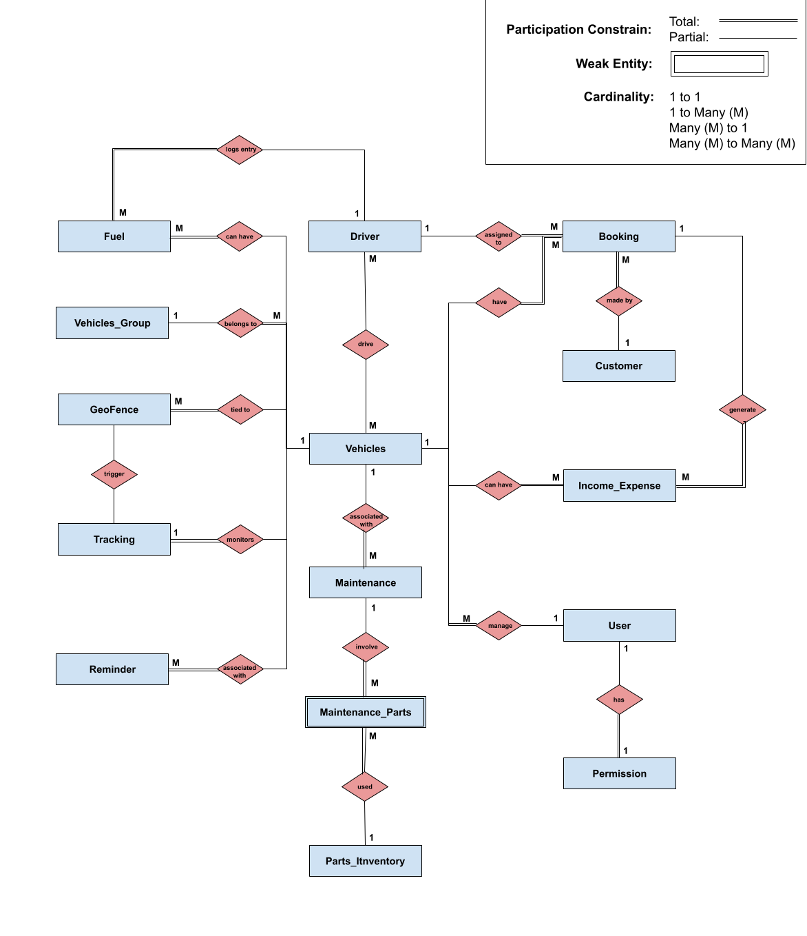

Figure: ERD of VMS

1. **Data Flow Diagram**

* **Directory:** *root/diagrams/DFD/VMS_Context_Level_Diagram.pdf*
* **Google Draw Link:** [*https://docs.google.com/drawings/d/1ojXcYALvts0DZ9lvhOrlGbAS-dnsKIV58rZUGNod-70/edit?usp=sharing*](https://docs.google.com/drawings/d/1ojXcYALvts0DZ9lvhOrlGbAS-dnsKIV58rZUGNod-70/edit?usp=sharing)

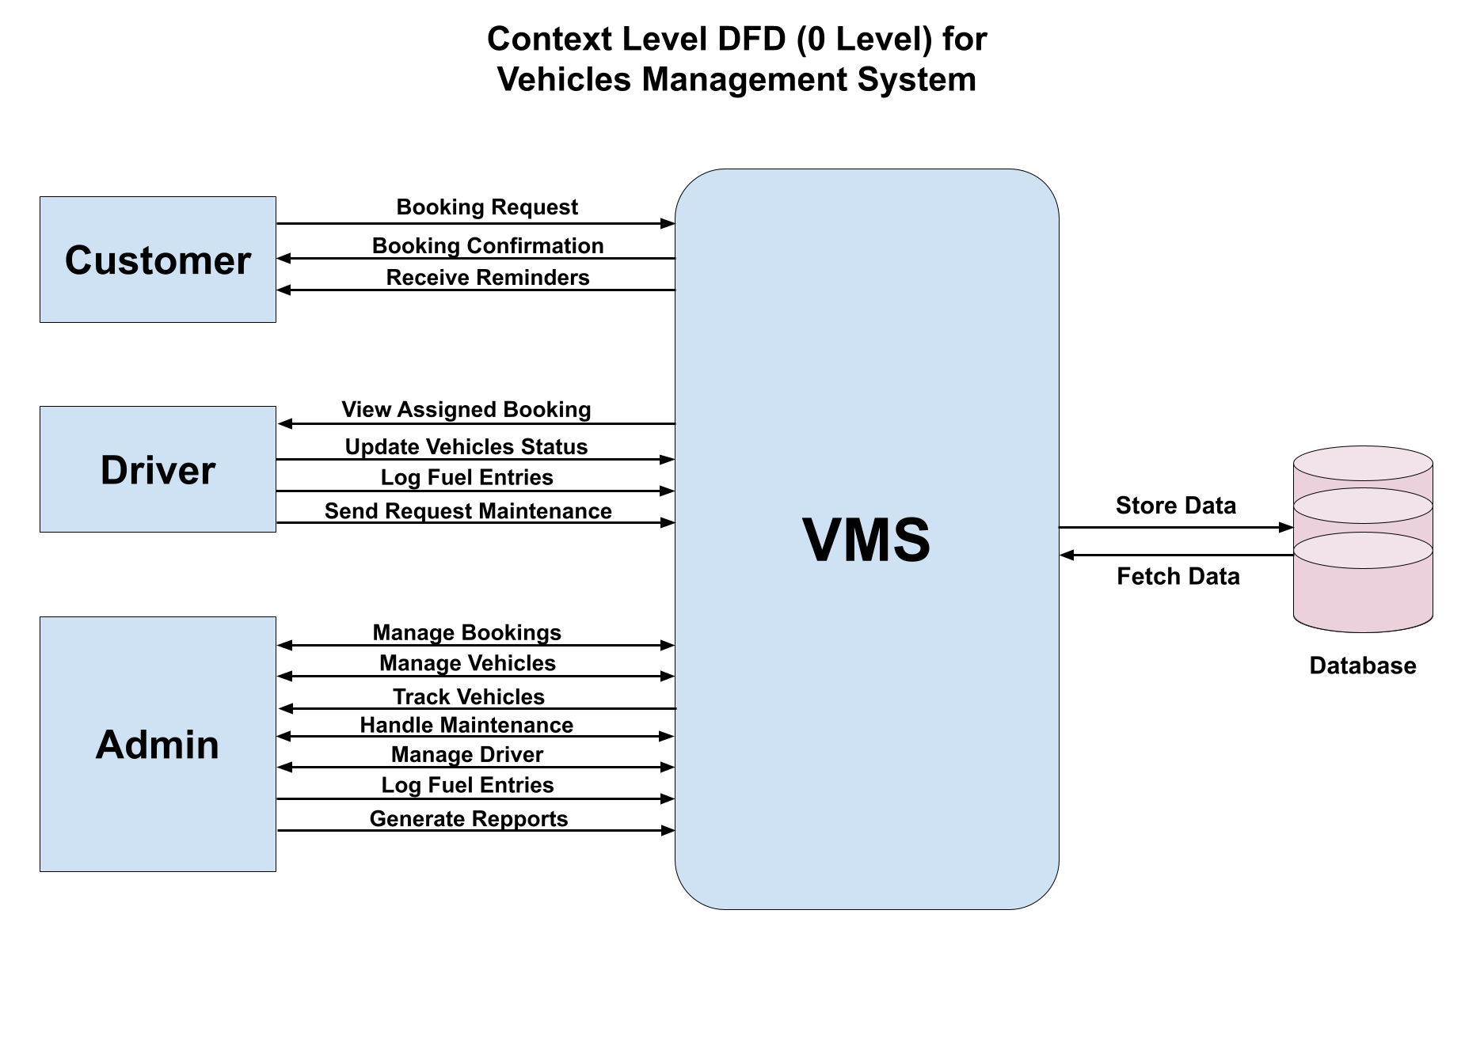

Figure: 0 Level Diagram for VMS

1. **SQL Script:**

* **Directory:** *root/sql/vms_db_schema.sql*

In conclusion, the **Vehicle Management System (VMS)** database model organizes vehicles, bookings, maintenance, and fuel records efficiently. It ensures clear relationships between entities, supporting scalability and data integrity. This model provides a solid structure for smooth and effective Vehicle Management.