**RESUME PARSER**

**MANUAL /INSTRUCTIONS**

* **Introduction**

The overwhelming amount of unstructured text data available today provides a rich source of information if the data can be structured. [Named-entity Recognition (NER](https://en.wikipedia.org/wiki/Named-entity_recognition))(also known as Named-entity Extraction) is one of the first steps to build knowledge from semi-structured and unstructured text sources.

To take steps further, create something useful, this project will cover how to develop and deploy a simple named entities extractor using spaCy and serve it with a Flask API in python.

* We have build an API that we provide text, for example, a resume .pdf (or any article) as input, our named entity extractor will then identify and extract entities. The basic architecture looks like this:

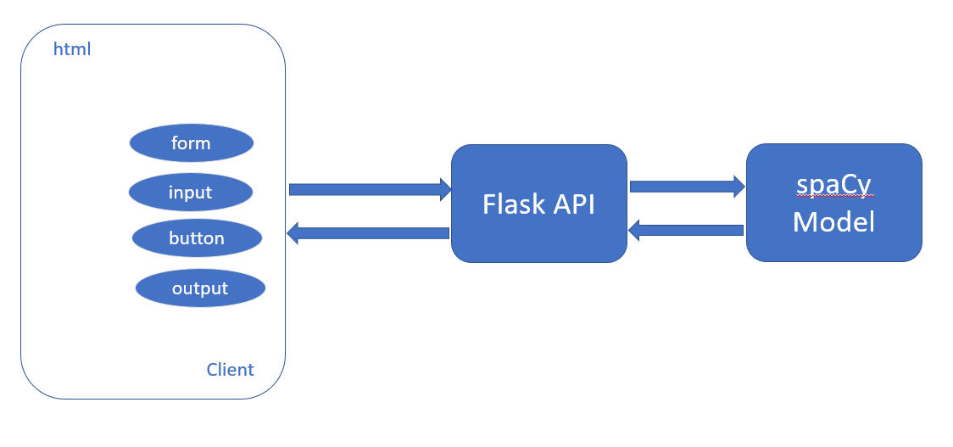

* To build the API, we will need to create two files:

1. **index.html** to handle the template of the API.

2.**app.py to** handle the requests and return the output file.

And the final product will look like this:

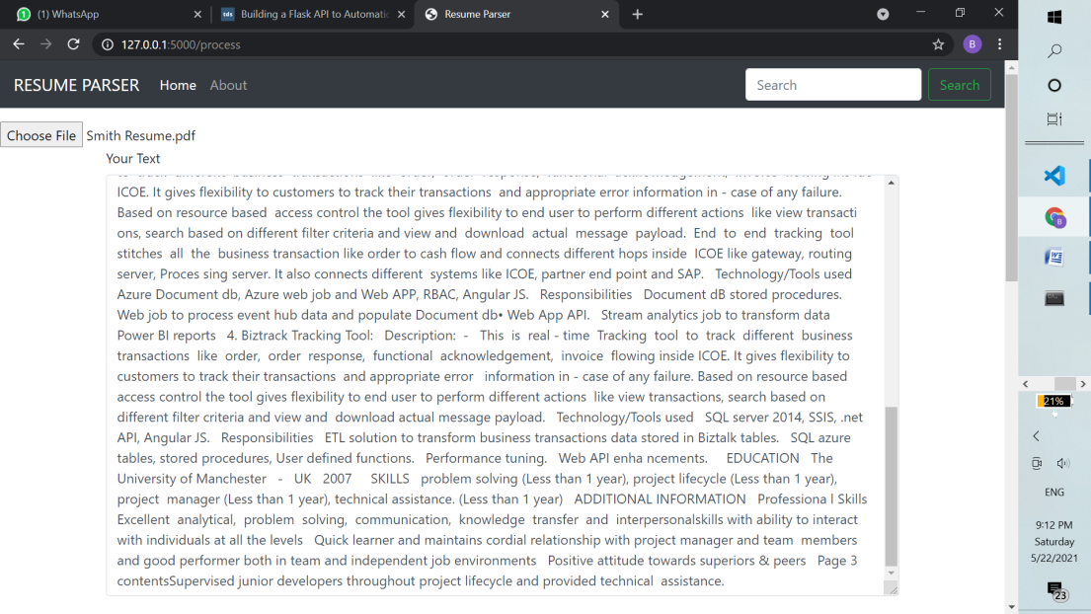

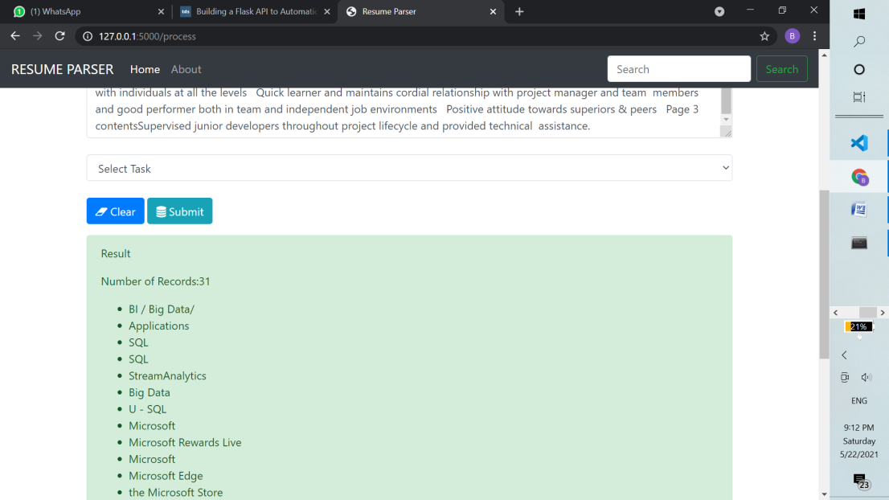

Let’s start building the API and create two files step-by-step. Our project folder structure is like below:

* Our project is located in ***ner_extractor***folder.

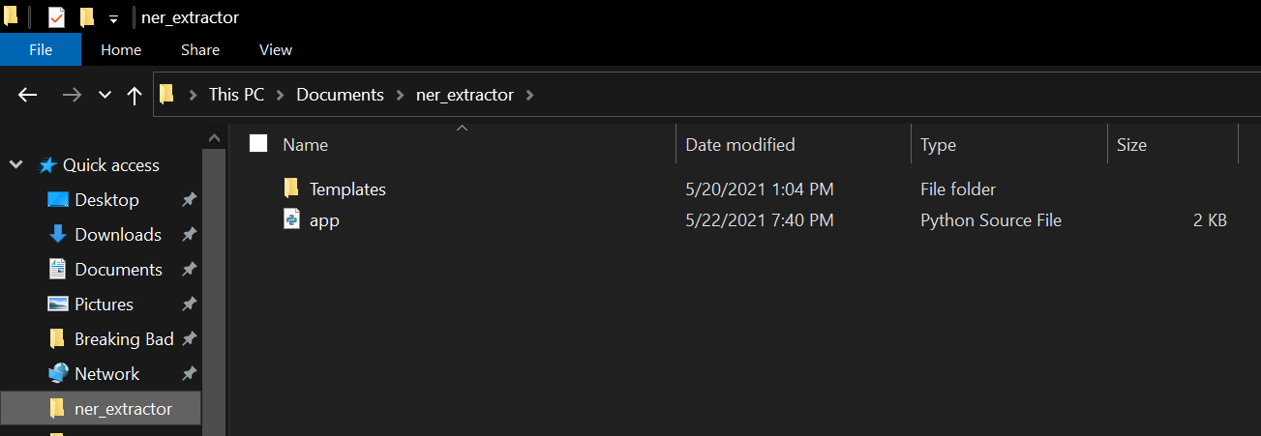

* The templates directory is in the same folder as the app.py in which it is created it is included in zip folder.
* The index.html is located in the templates folder it is also included in zip folder.

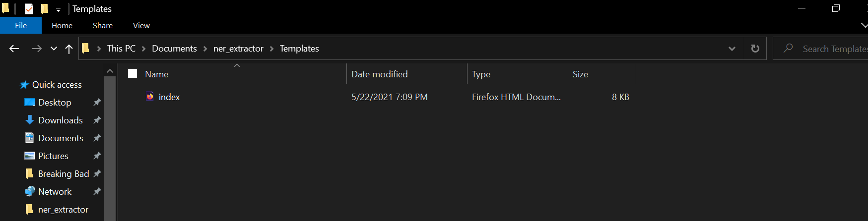

* Following need to be imported in app.py

from flask import Flask,render_template,url_for,request

import pandas as pd

import spacy

from spacy import displacy

import en_core_web_sm

from flask import Flask, send_from_directory

* **Try our API**

1.Start the ***Command Prompt*.**

2.Navigate to our ***ner_extractor*** folder.

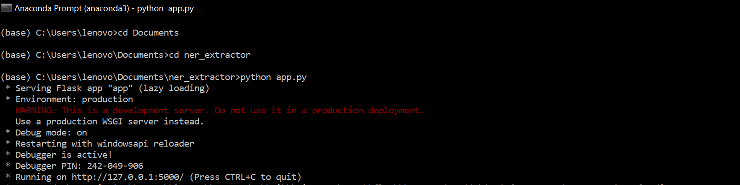

* Open your Web browser, copy-paste “<http://127.0.0.1:5000/>” into the address bar, and we will see this form:

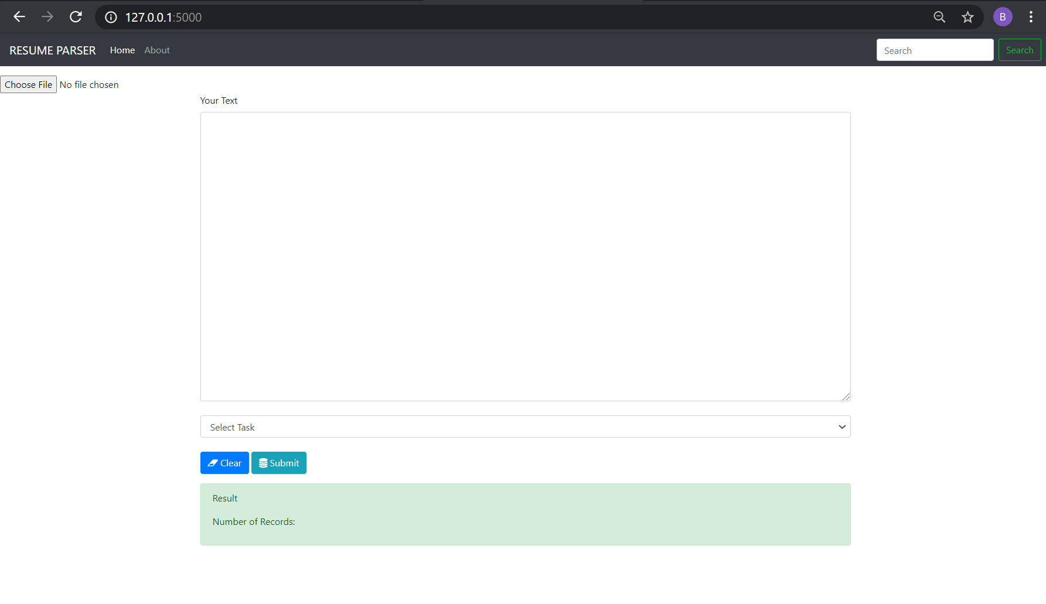

* TESTING :

1.Choosing a resume pdf file from system (eg: smith_resume.pdf)and checking whether it contents are displaying.

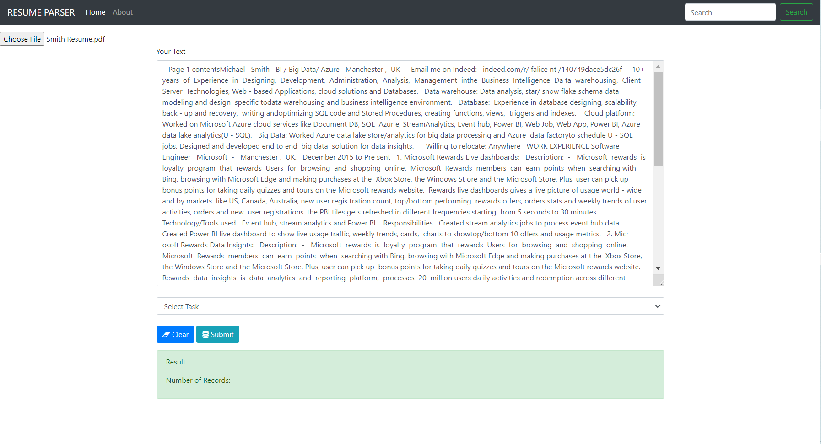

* 2. Select “***skills***” under “Select task”, then click “Submit”, this is what we get:



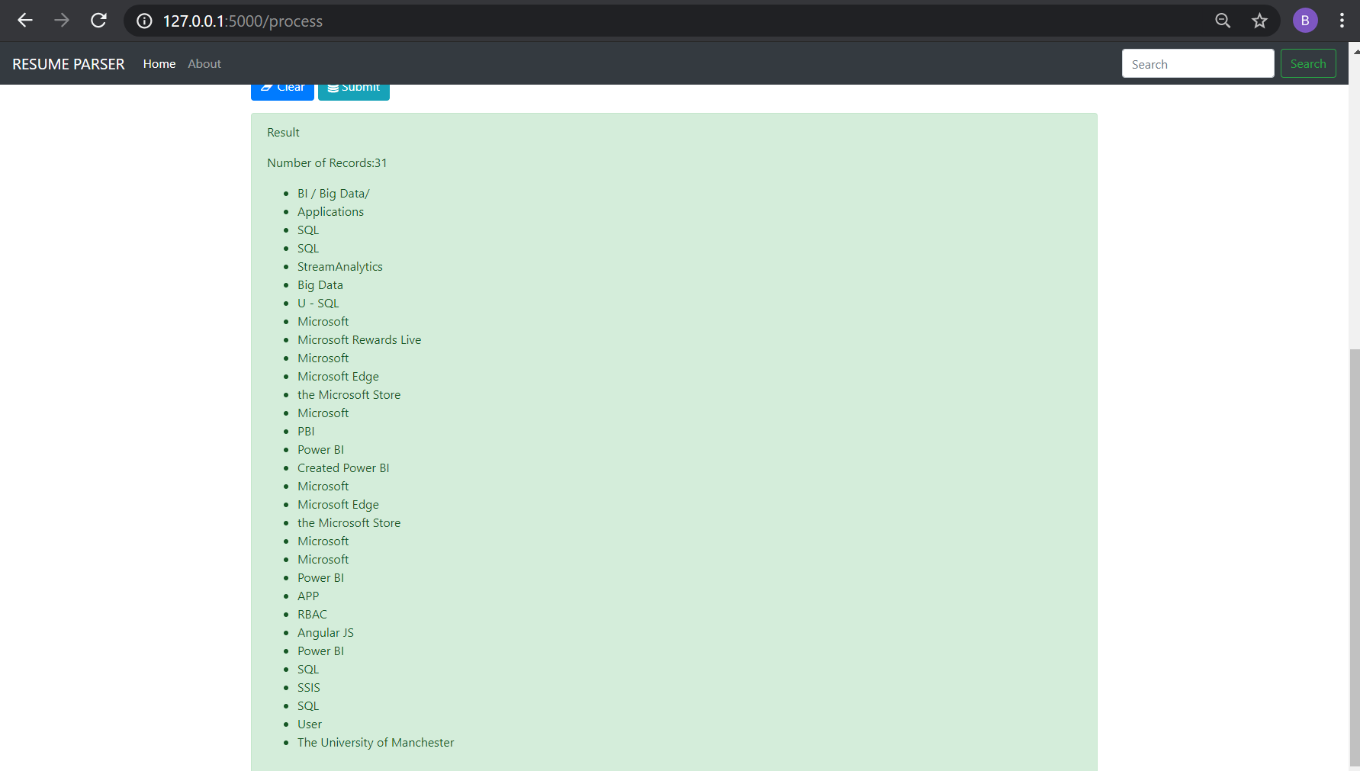

We are done!