**Part A: Accessing your Virtual Machines**

VM login

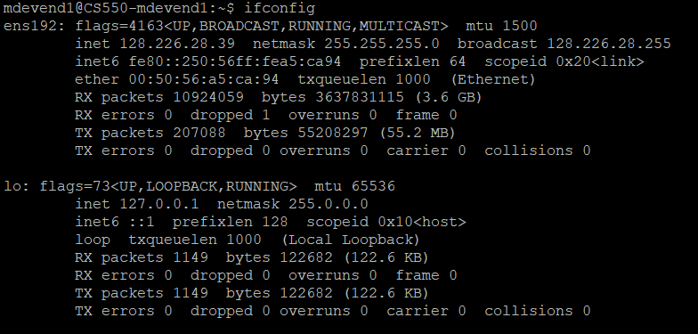

Vsphere setup

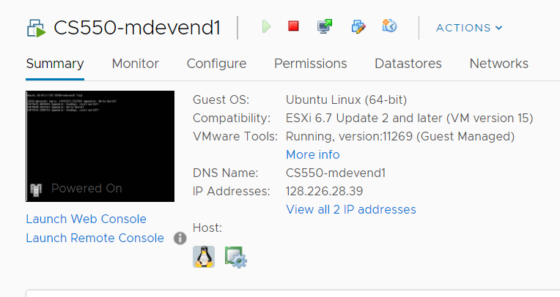

Teamviewer setup

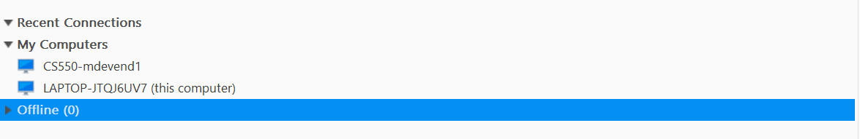

## Part B: Learn how to write and execute a Linux kernel module.

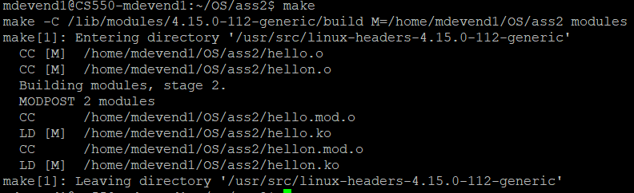

Inserting module



Removing module

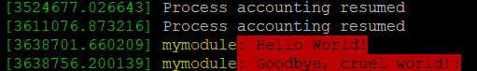

## Part C: Learn how to write a miscellaneous character device driver: </code attached>



## Part D: How to browse Linux source code

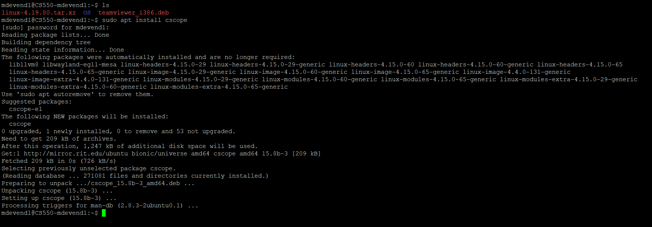

## Part E & F:

A basic and very simple implementation will be followed. Step1 to identify the necessary kernel library to be included. Step2 Create a character devices struct with name and followed by inbuilt operations required for processes. The operations will be open_p to create a process based on buffer number provided to create the process in a seamless manner and to perform a read_p to list all the process created and a flag to list its parent process its state and its id . The read_p will return the process and its corressponfing. and perform a close_p to close or terminate all the process created. Generate a make file to load it inside a kernel space.

Then to execute the loaded kernel module create a user space program and call each loaded module by /dev/<character_device_name>. Then execute each and every methods under the character_Device : open_p , read_p and close_p. use a struct to store the process read from the character device.