**WIPRO**

MAINFRAME INTERNSHIP BATCH 1

CAPSTONE PROJECT

**BANKING MANAGEMENT SYSTEM**

**DONE BY:**

GROUP-6

|  |  |  |
| --- | --- | --- |
|  | **NAME** | **SUPERSET-ID** |
| 1. | Monish P | 1746727 |
| 2. | Tushar Kaundal | 1731950 |
| 3. | Vibhu Kalash Jain | 1693774 |
| 4. | Sushree Rinsipriya Swain | 1703967 |
| 5. | Sandeep Kumar Yedla | 1791124 |
| 6. | Naveen Kumar Rai | 1178402 |
| 7. | VEGI RAVI | 1730392 |

**BANKING MANAGEMENT SYSTEM**

**REPORT**

**ABSTRACT**

This project is about banking system administration, in which the administrator can add and delete both retail and corporate clients, while the user can access and update their information if necessary.

**TECHSTACK**

* **CICS (Customer Information Control System):**

a general-purpose transaction processing subsystem for the z/OS® operating system and screen design.

* **COBOL (Common Business Oriented Language):**

COBOL is primarily used in business, finance, and administrative systems for companies and governments. COBOL is still widely used in applications deployed on mainframe computers, such as large-scale batch and transaction processing jobs.

* **DB2 (RDBMS):**

DB2 is designed to store, analyze and retrieve the data efficiently.

* **DCLGEN (Declaration Generator):**

a structure‑generating utility that maps the columns of a database table into a structure (a COBOL record) that can be included in an embedded SQL declaration section.

* **JCL (Job Control Language):**

Job control language (JCL) is a set of statements that you code to tell the z/OS® operating system about the work you want it to perform.

**OUTPUT**

**HOME SCREEN:**

Here user type should be selected by inputting 1 or 2 and then pressing enter key.  
KEY FUNCTION:

* F3 -Exit
* Enter -Go to Employee Login Screen
* F5 -Clear the input field

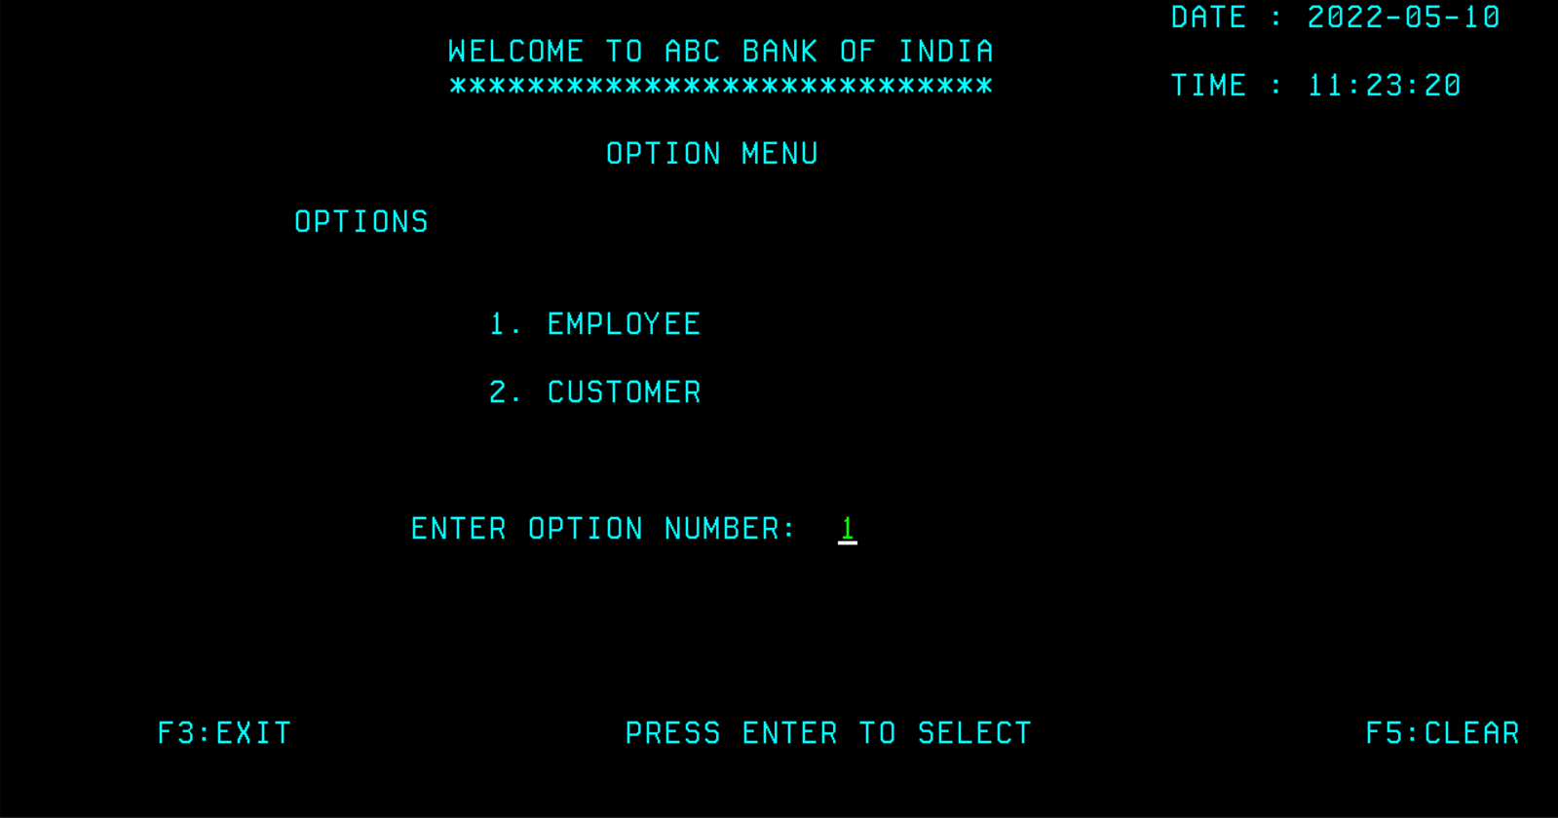

**EMPLOYEE LOGIN SCREEN:**

Here employee can enter the user ID and password to log in.

KEY FUNCTION:

* F4 -Go Back
* Enter -Login
* F5 -Clear the input field

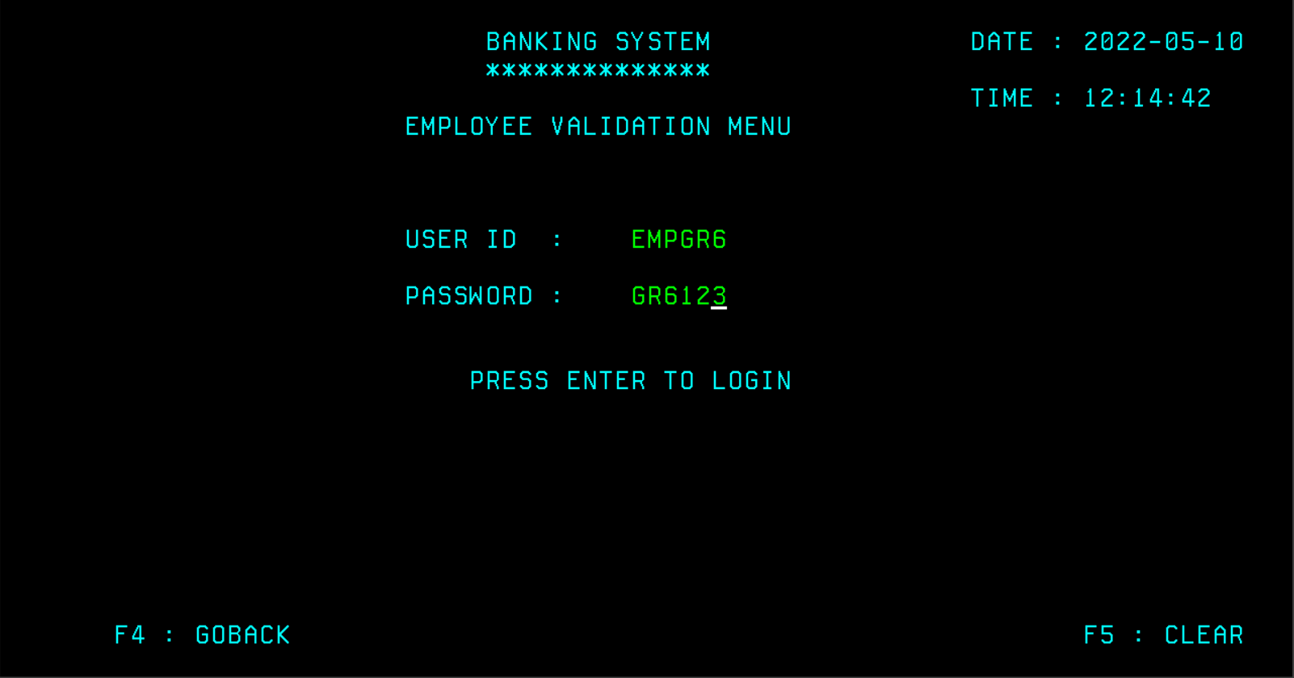

**ADMIN HOMESCREEN:**

Here admin can add or delete customer by inputting 1 or 2 and then pressing enter key.

KEY FUNCTION:

* F6 -Logout
* Enter -Enter to Add customer screen
* F5 -Clear the input field

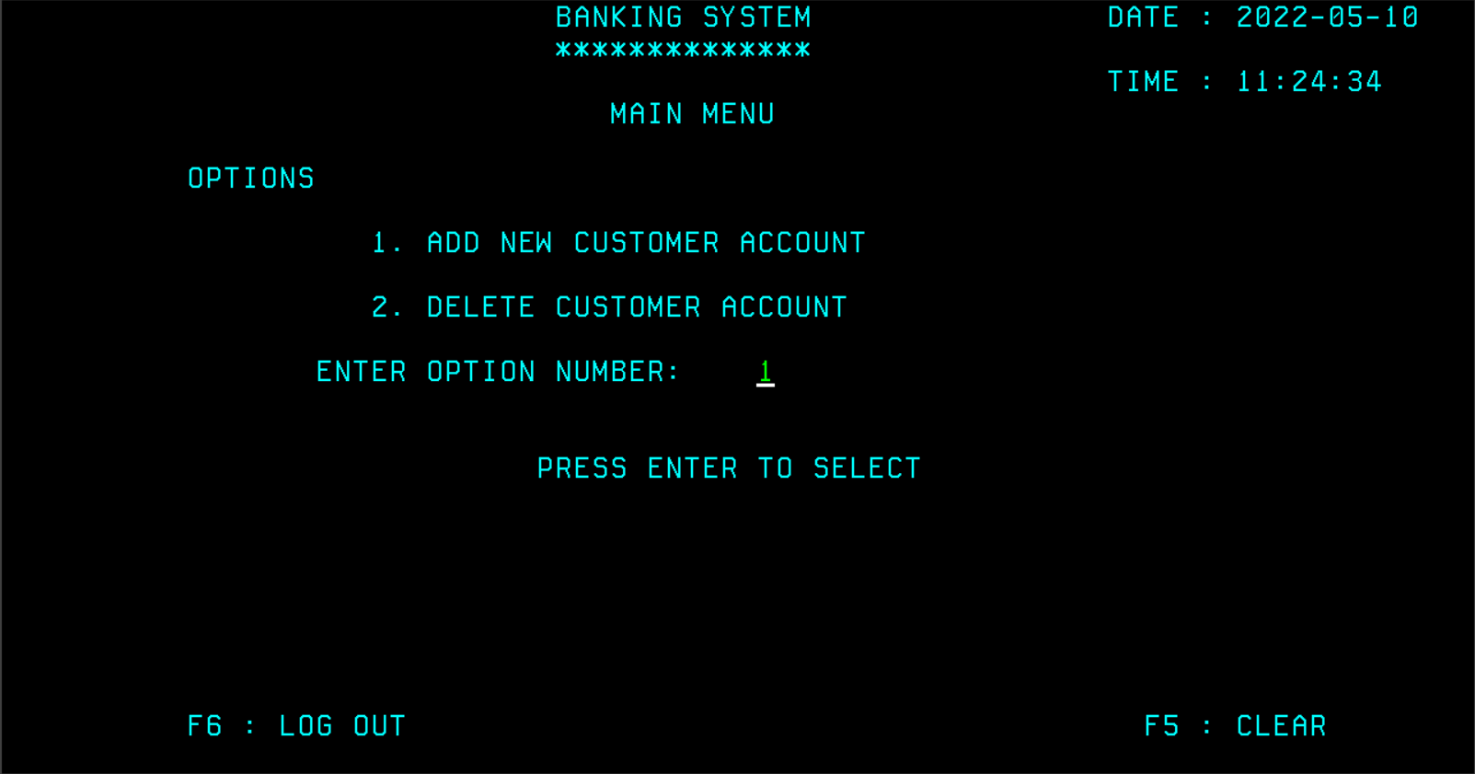

**ADD CUSTOMER SCREEN:**

Here employee can enter the customer details and can create a new customer account by pressing F9.

KEY FUNCTION:

* F4 -Go Back
* F9 -To create a new customer with the inputted details
* F5 -Clear the input field

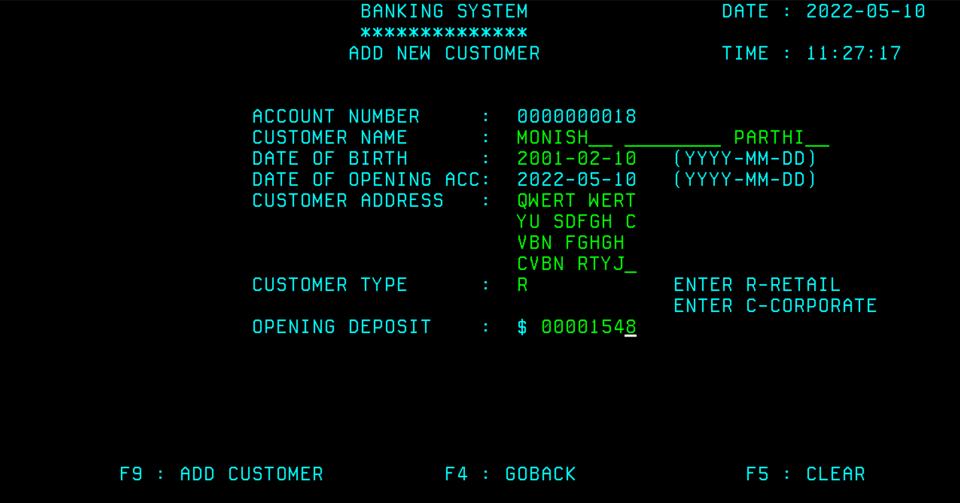

After clicking F9 new customer account will be created and success message will be displayed along with the user ID and Password.

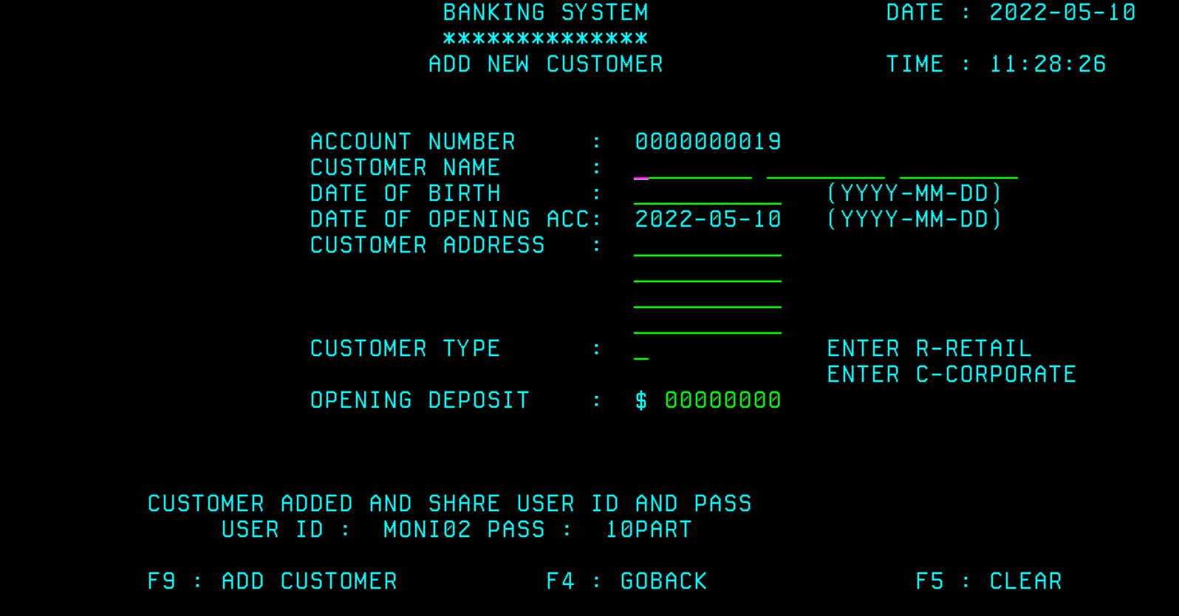

The customer details can be viewed in SPUFI

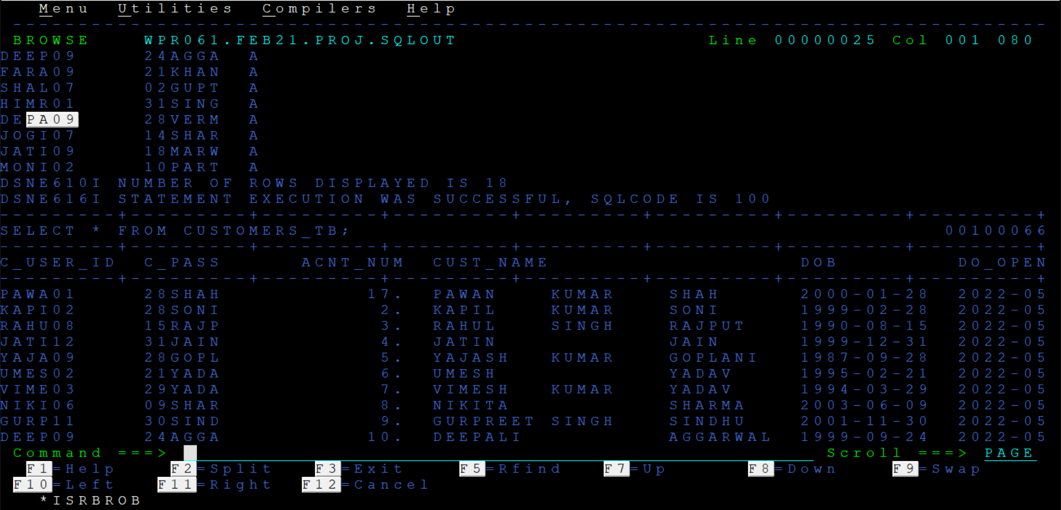

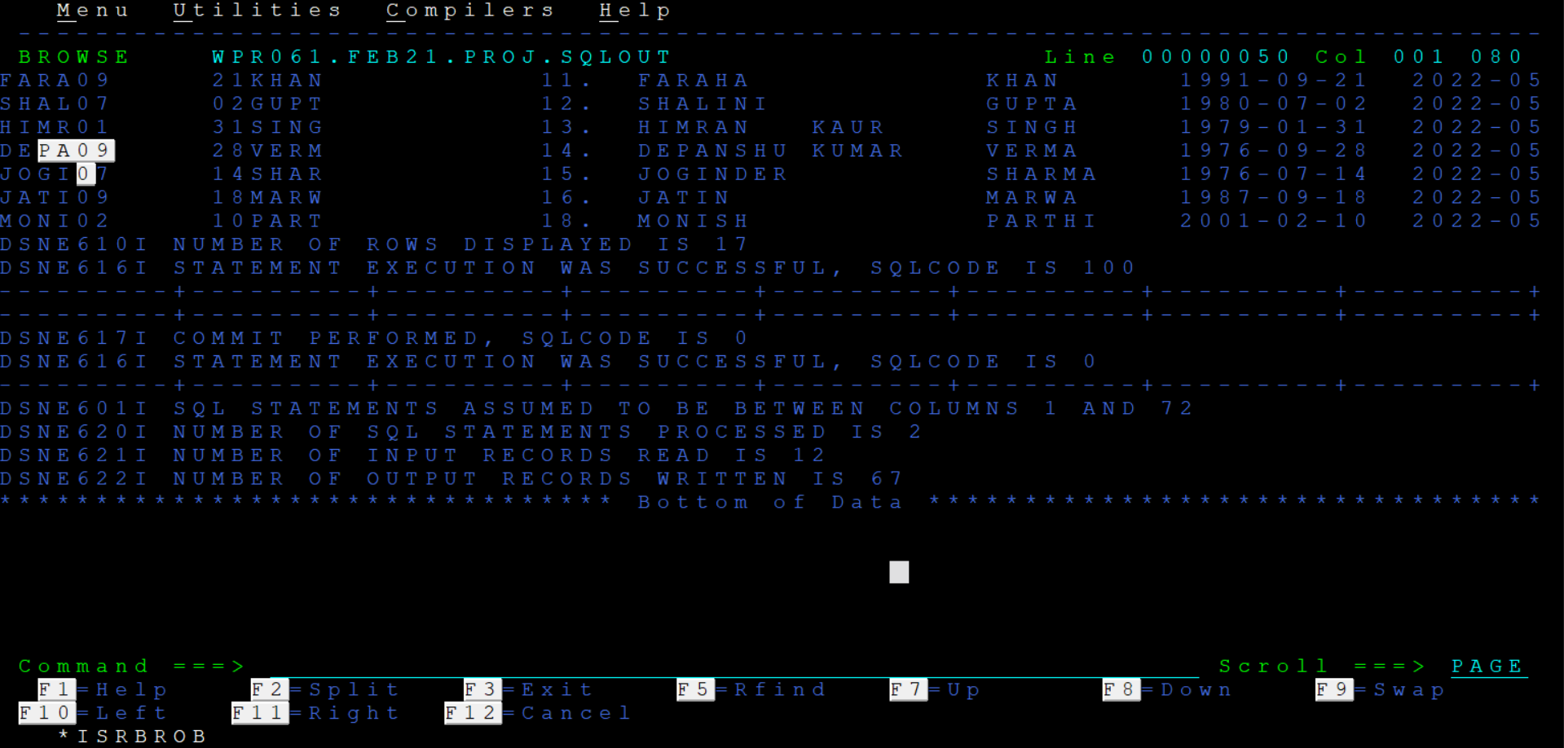

**HOME SCREEN:**

Now, entering to the Customer login page using the input 2 and then clicking enter.

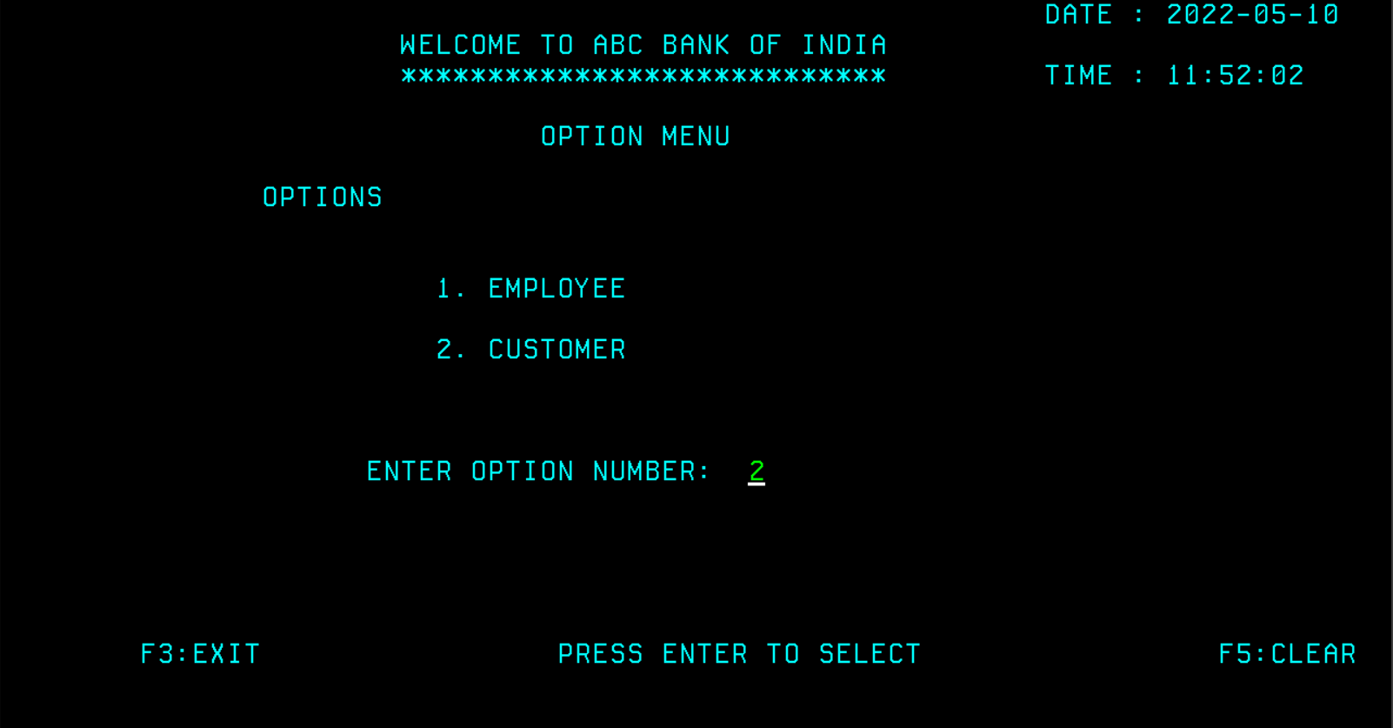

**CUSTOMER LOGIN SCREEN:**

Here customer can enter the login details and login by pressing Enter key

KEY FUNCTION:

* F4 -Go Back
* Enter -Login
* F5 -Clear the input field

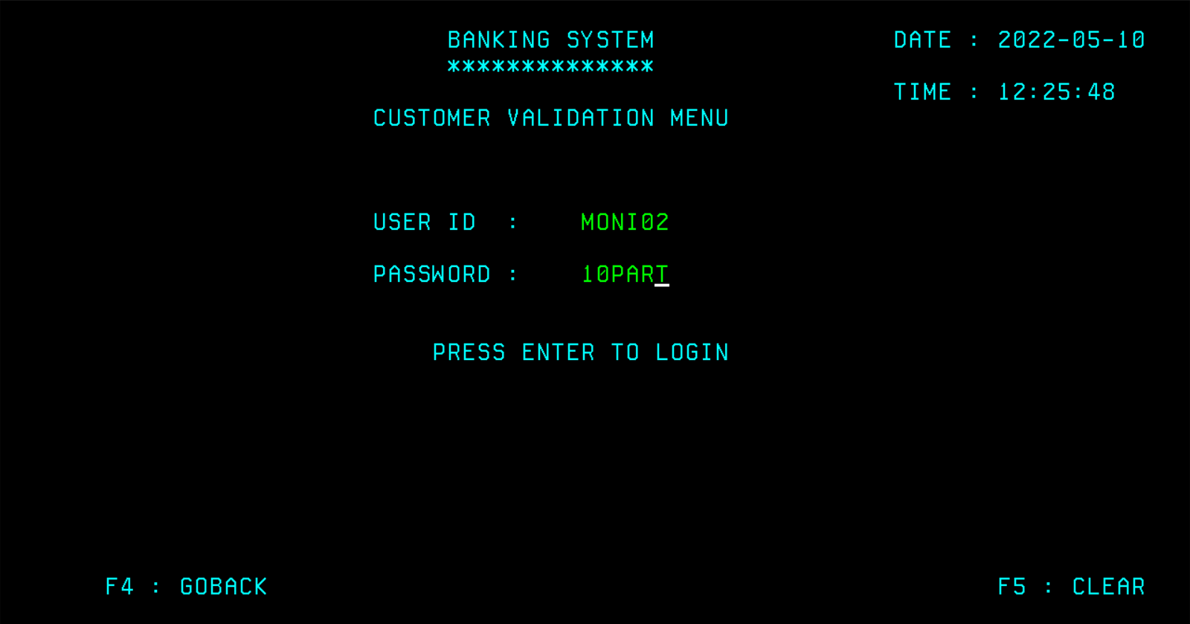

After logging in UPDATE CUSTOMER SCREEN will appear.

**UPDATE CUSTOMER SCREEN:**

Here account number should be entered and F6 key should be pressed to fetch customer details.

KEY FUNCTION:

* F4 -Logout
* F6 -To fetch details
* F1 -To update customer address
* F9 -To deposit or withdraw money
* F5 -Clear the input field

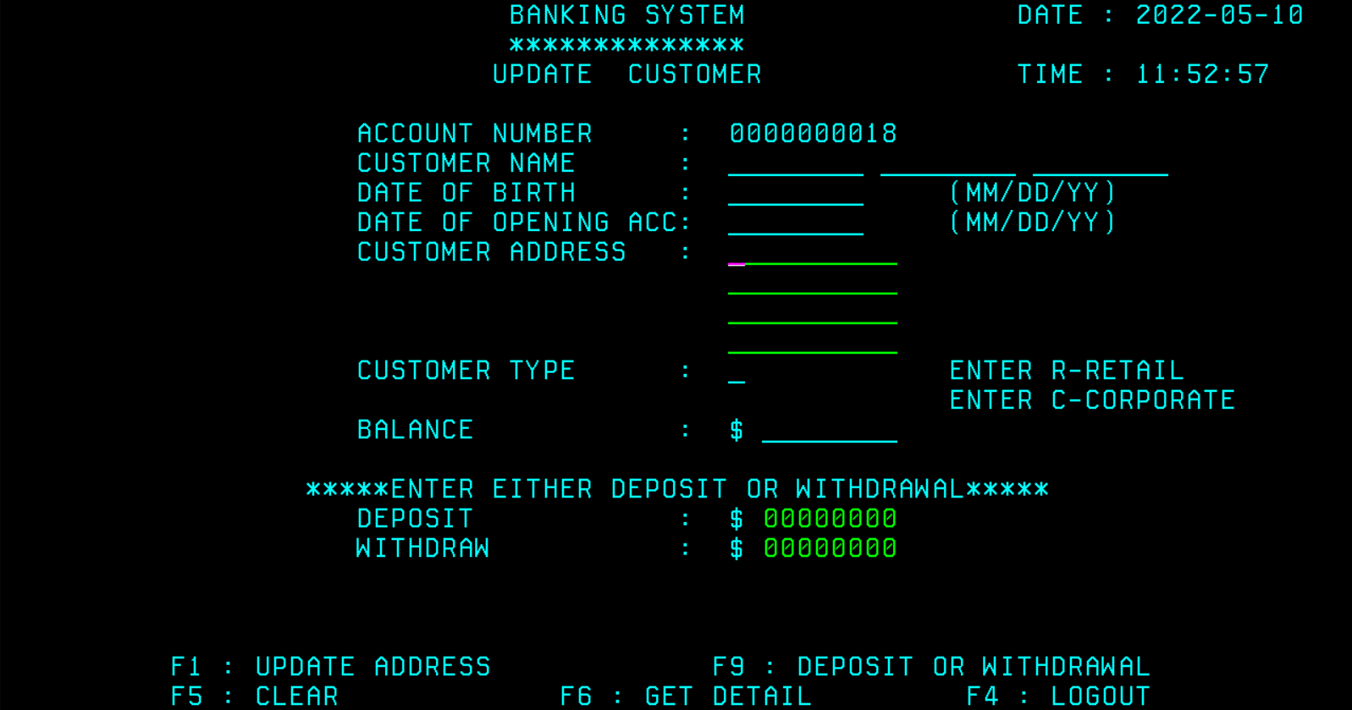

Updating address (Press F1 key)

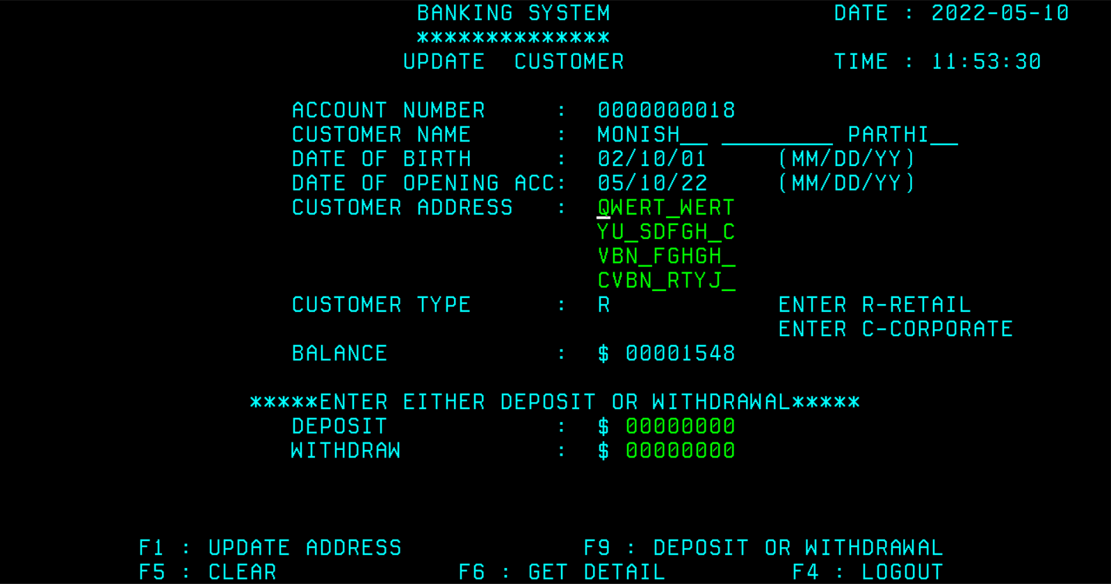

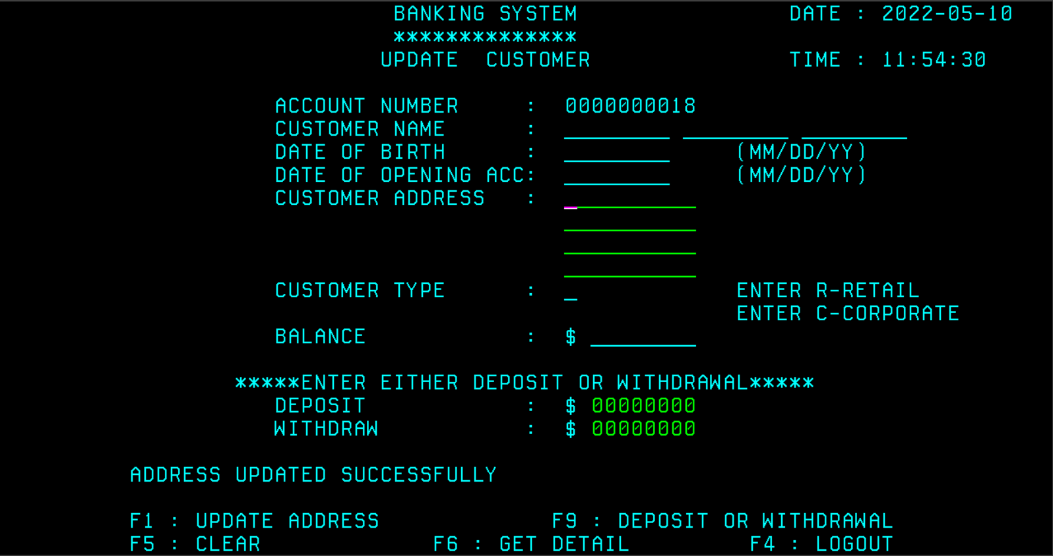

Deposit/Withdrawal (F9 key)

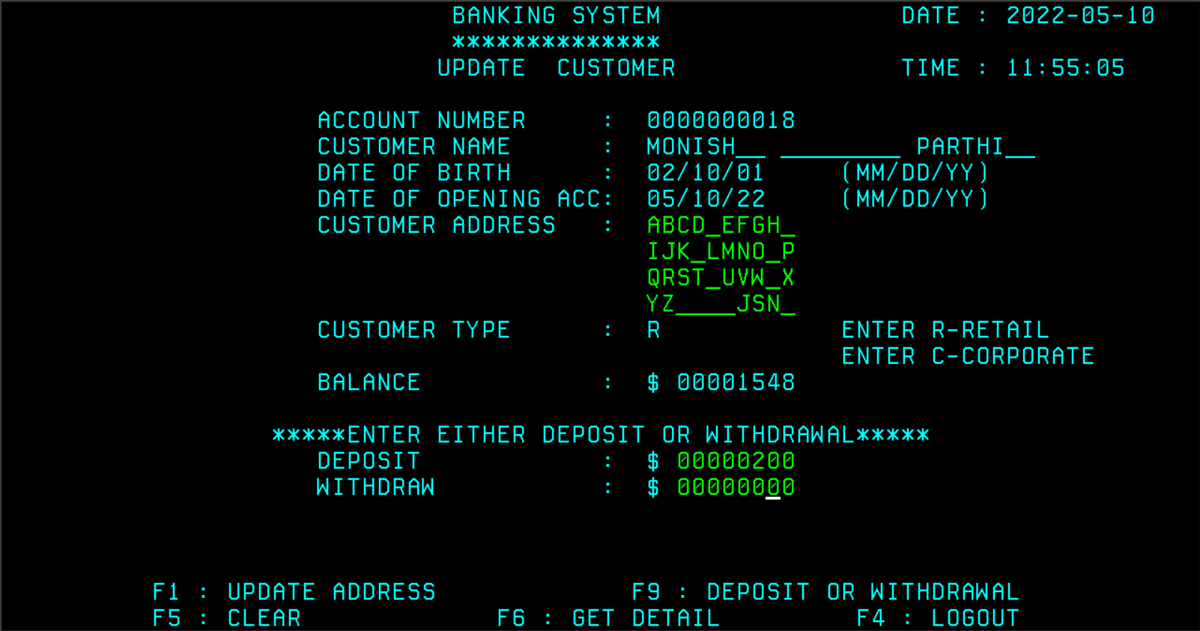

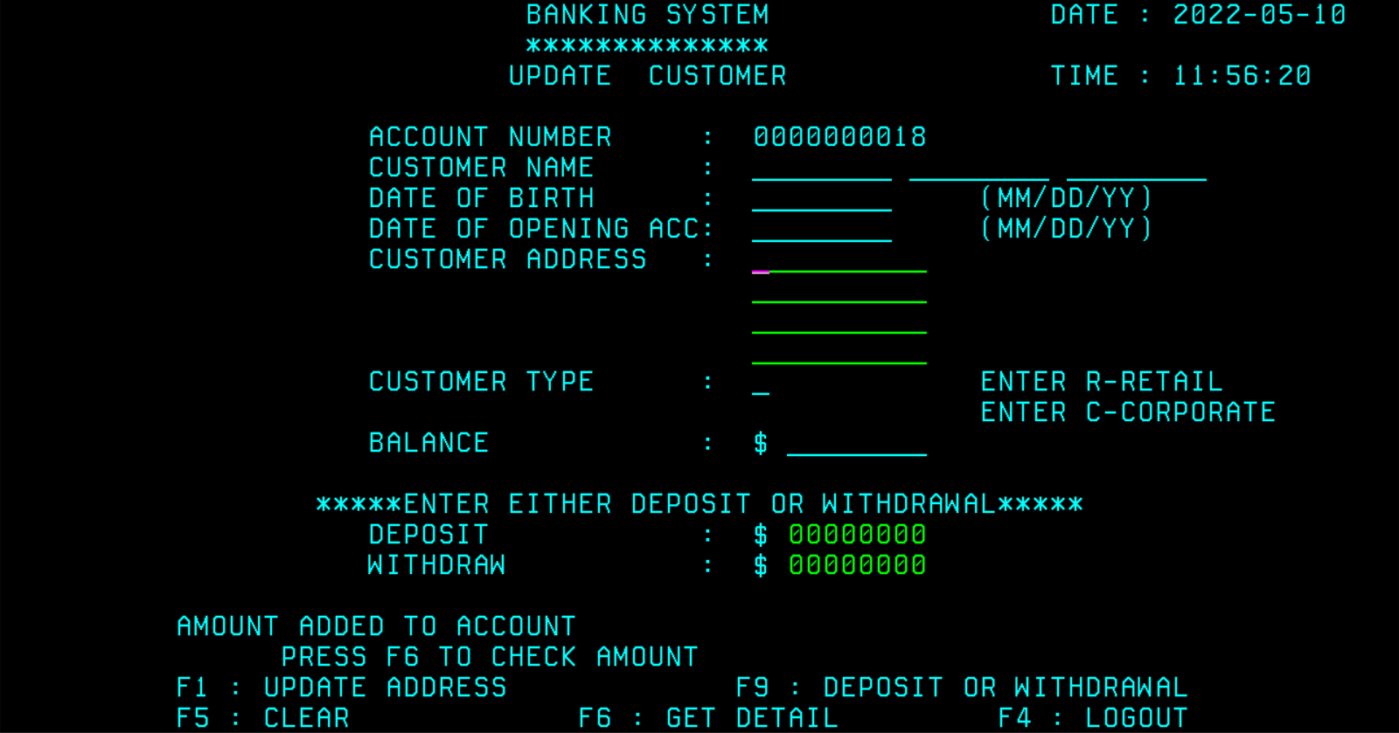

Details getting updated in SPUFI.

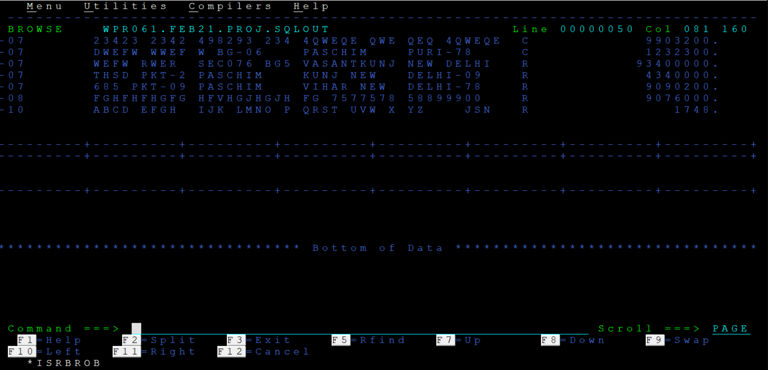

**EMPLOYEE MAIN MENU SCREEN**

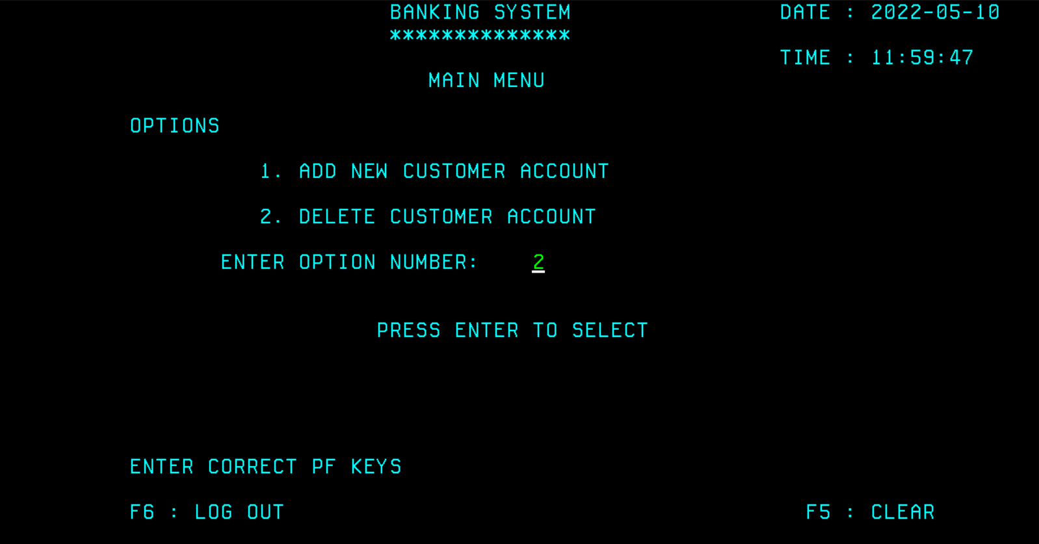

**DELETE CUSTOMER SCREEN:**

Here employee can enter customer account number then press enter to fetch their details.

KEY FUNCTION:

* F4 -Go Back
* Enter -Get details
* F5 -Clear the input field
* F6 -Delete customer account and its details

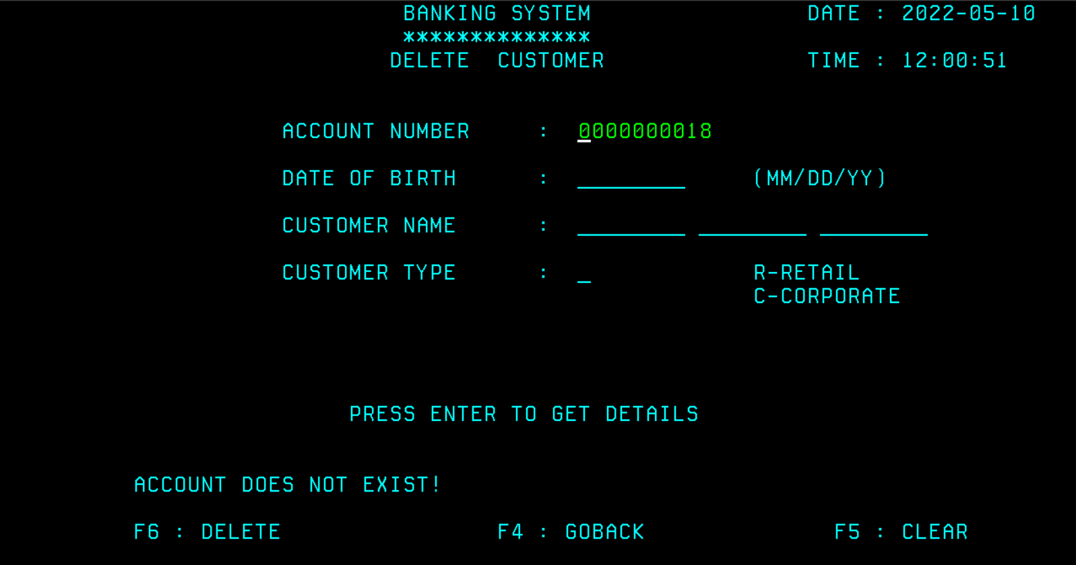

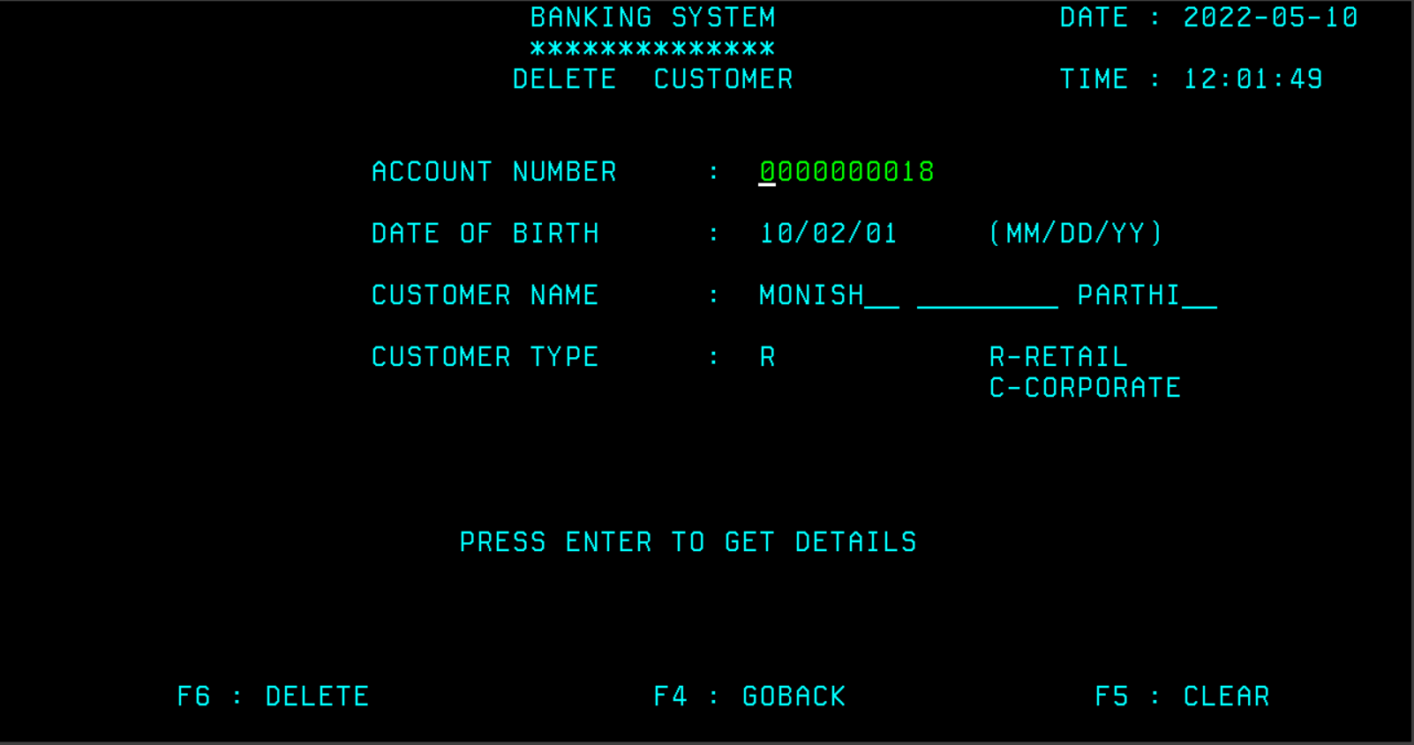

To delete account (F6 key)

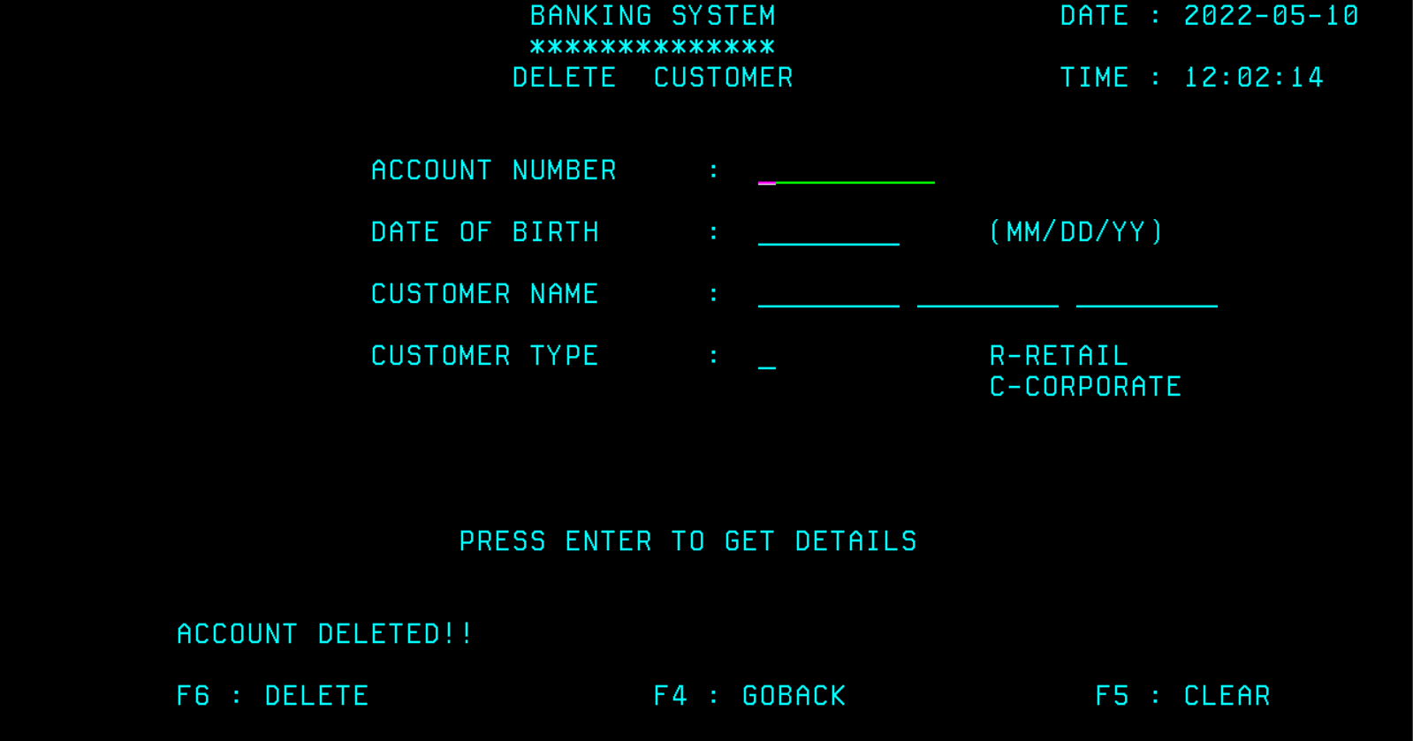

After Deleting, the data get removed from SPUFI

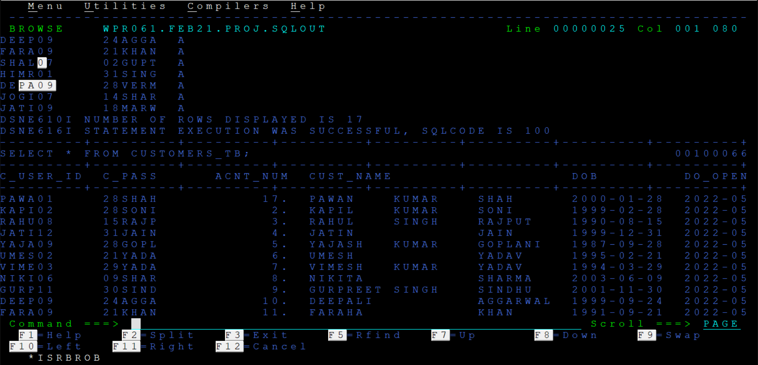

**REPORT GENERATION**

**CORPORATE CUSTOMERS:**

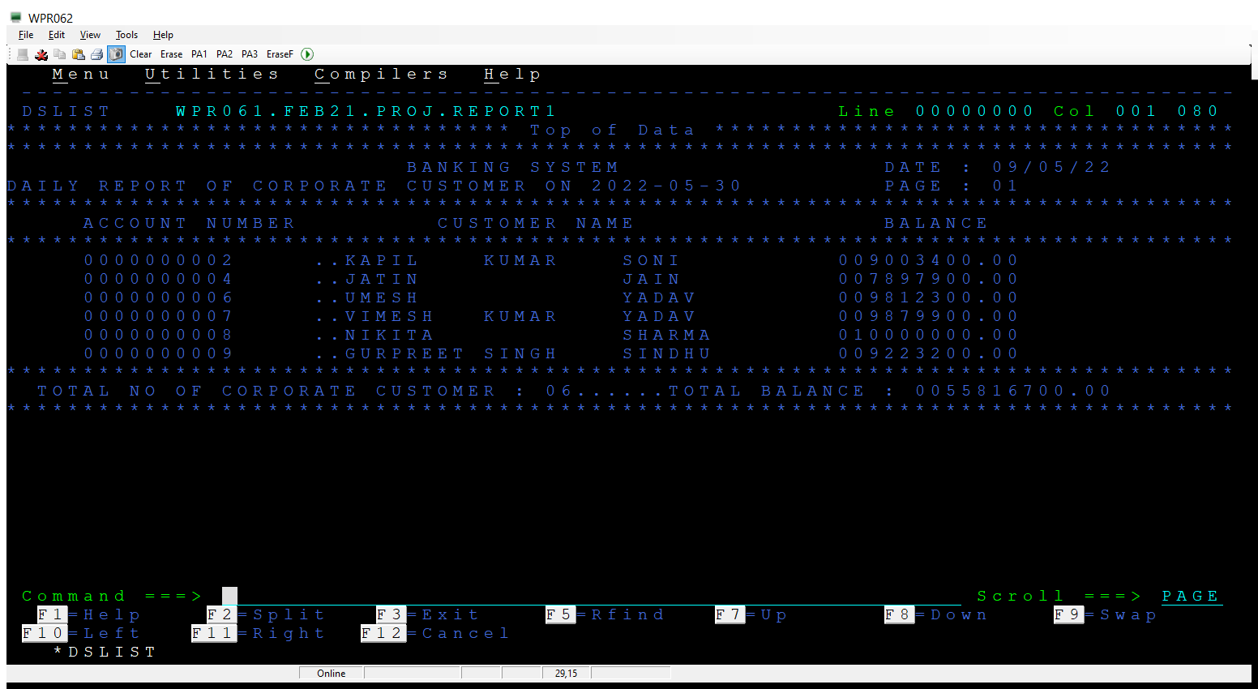

**RETAIL CUSTOMERS:**

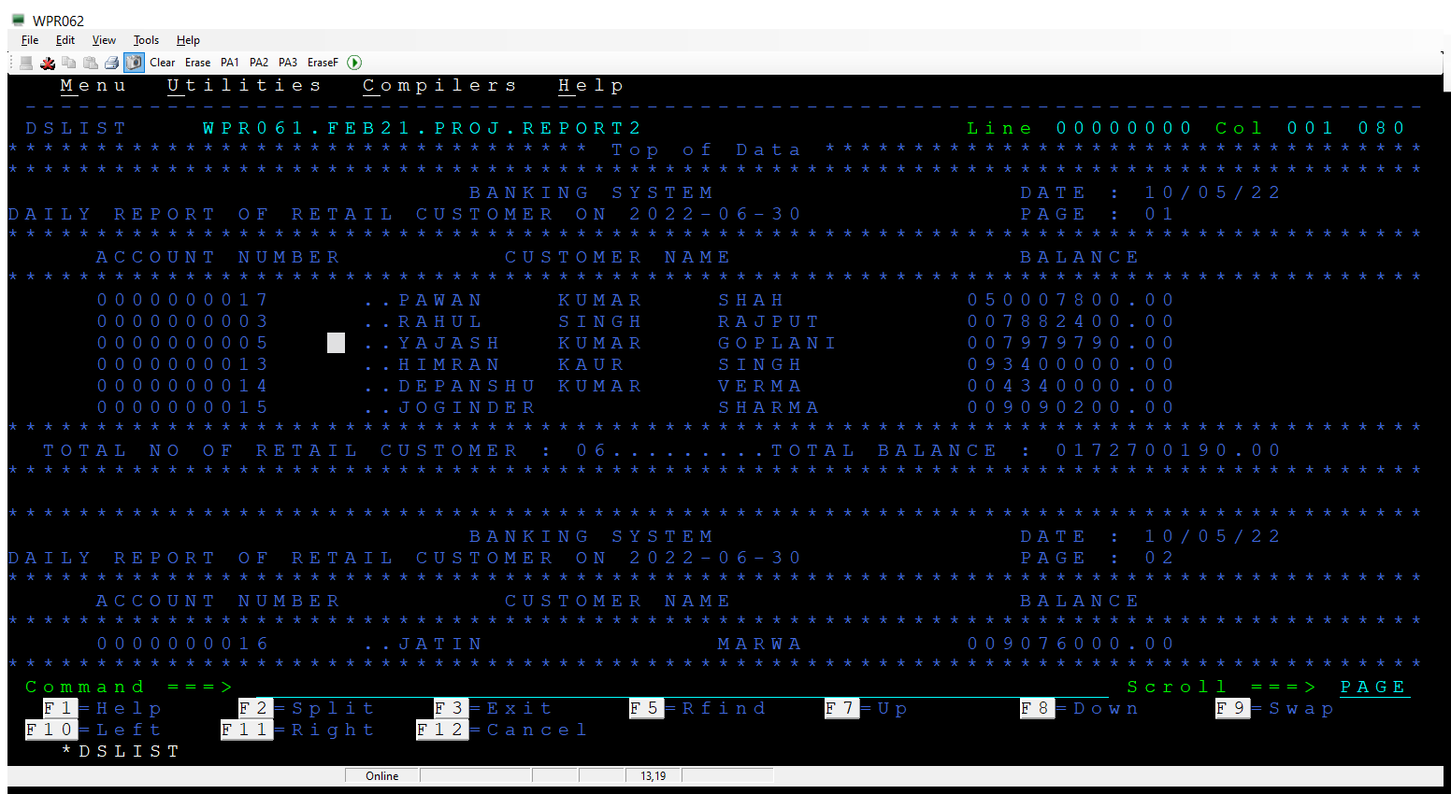

**CONCLUSION**

In this world of modernization digital technology is getting more & more adaptable than the paperwork’s. So, this online Banking System is a step addition to the process to make things easier.

.

Click [here](https://github.com/monish-it/Wipro_Capstone_Project_Banking_System_Management.git) to view the code

**END**