AIM
To write a C program to input marks of five subjects, calculate the total and percentage, and determine the grade based on the given percentage criteria.

PROCEDURE
- Start the program.
- Declare integer variables to store marks of five subjects and total marks.
- Declare a float variable to store the percentage.
- Read marks of five subjects from the user using scanf().
- Calculate the total marks by adding all five subject marks.
- Calculate the percentage.
- Use an if–else if ladder to compare the percentage and assign the grade.
- Display the total marks, percentage, and grade.
- End the program.
CODE
/*
File Name : grade.c
Author : Monish Kanna
Date : 12-01-2026
Purpose : Program to input marks of five subjects,
calculate percentage and display grade
*/
#include <stdio.h>
int main()
{
int m1, m2, m3, m4, m5;
int total;
float percentage;
printf("Enter marks of five subjects:\n");
scanf("%d %d %d %d %d", &m1, &m2, &m3, &m4, &m5);
total = m1 + m2 + m3 + m4 + m5;
percentage = (total / 500.0) * 100;
printf("Total Marks = %d\n", total);
printf("Percentage = %.2f%%\n", percentage);
if (percentage >= 90)
printf("Grade: A");
else if (percentage >= 80)
printf("Grade: B");
else if (percentage >= 70)
printf("Grade: C");
else if (percentage >= 60)
printf("Grade: D");
else if (percentage >= 40)
printf("Grade: E");
else
printf("Grade: F");
return 0;
}
OUTPUT
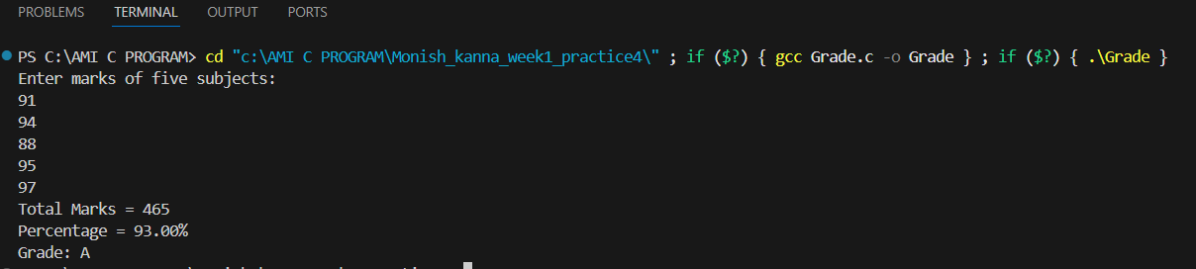
RESULT
The program correctly calculated the total marks and percentage of five subjects and displayed the appropriate grade according to the given percentage criteria.

