PROGRAM 1

#include <stdio.h>
int main()
{
printf("\n\n This is simple program to the size of integer float double character \n\n");
printf("Size of int: %lu bytes\n", sizeof(int));
//sizeof() function return long unsigned int that's why Format Specifiers is lu
printf("Size of float: %lu bytes\n", sizeof(float));
printf("Size of double: %lu bytes\n", sizeof(double));
printf("Size of char: %lu byte\n", sizeof(float));
return 0;
}

OUTPUT

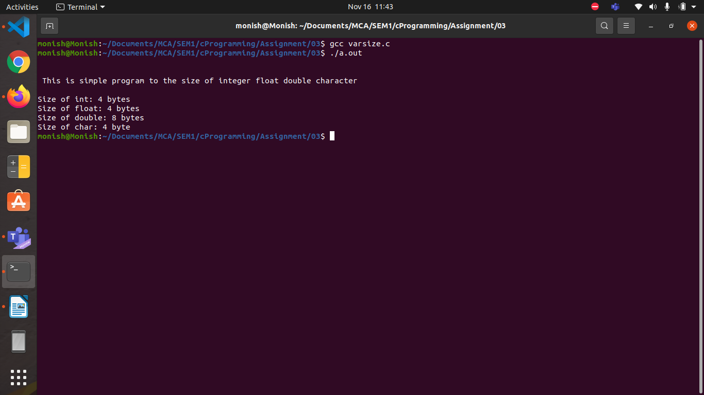
PROGRAM 2
#include <stdio.h>
int main()
{
int num1, num2, num3;

printf("Enter the numbers Number 1, Number 2 and Number 3: ");
scanf("%d %d %d", &num1, &num2, &num3);

if (num1 >= num2 && num1 >= num3)
printf("%d is the largest number.", num1);
else if (num2 >= num1 && num2 >= num3)
printf("%d is the largest number.", num2);
else if (num3 >= num1 && num2>= num2)
printf("%d is the largest number.\n\n", num3);
return 0;
}

OUTPUT 1
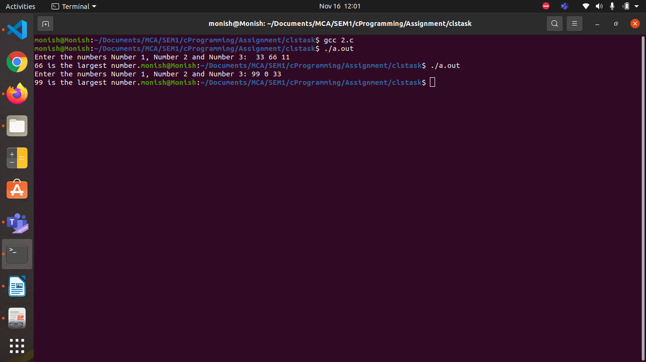

OUTPUT 2

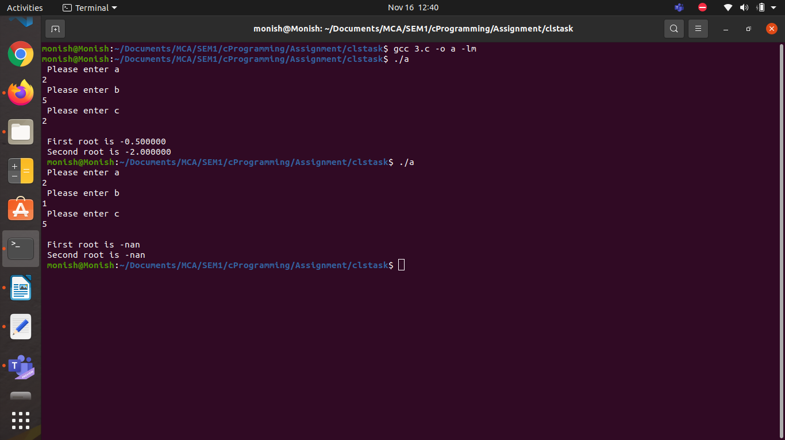

PROGRAM 3

#include <stdio.h>
#include <math.h>
int main()
{
double a,b,c,root1,root2;
printf(" Please enter a \n");
scanf("%lf",&a);
printf(" Please enter b \n");
scanf("%lf",&b);
printf(" Please enter c \n");
scanf("%lf",&c);
root1 = (-b + sqrt(b*b-4.*a*c) ) / (2.*a);
root2 = (-b - sqrt(b*b-4.*a*c) ) / (2.*a);
printf("\n First root is %lf ",root1);
printf("\n Second root is %lf ",root2);
printf("\n ");
return 0;
}

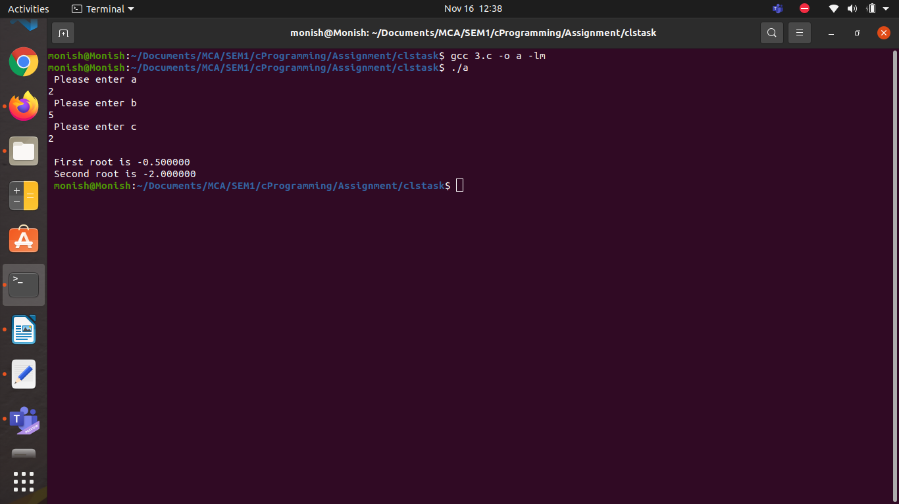

PROGRAM 4

Pr#include<stdio.h>
int main()
{
int i;
float mark, sum=0, avg;
for(i=0; i<6; i++)
{
printf("\nPlease inter the subject marks of %d : ",i+1);
scanf("%f", &mark);
sum = sum+mark;
}
avg = sum/6;
printf("\nAverage Mark = %0.2f", avg);
return 0;
}

OUTPUT
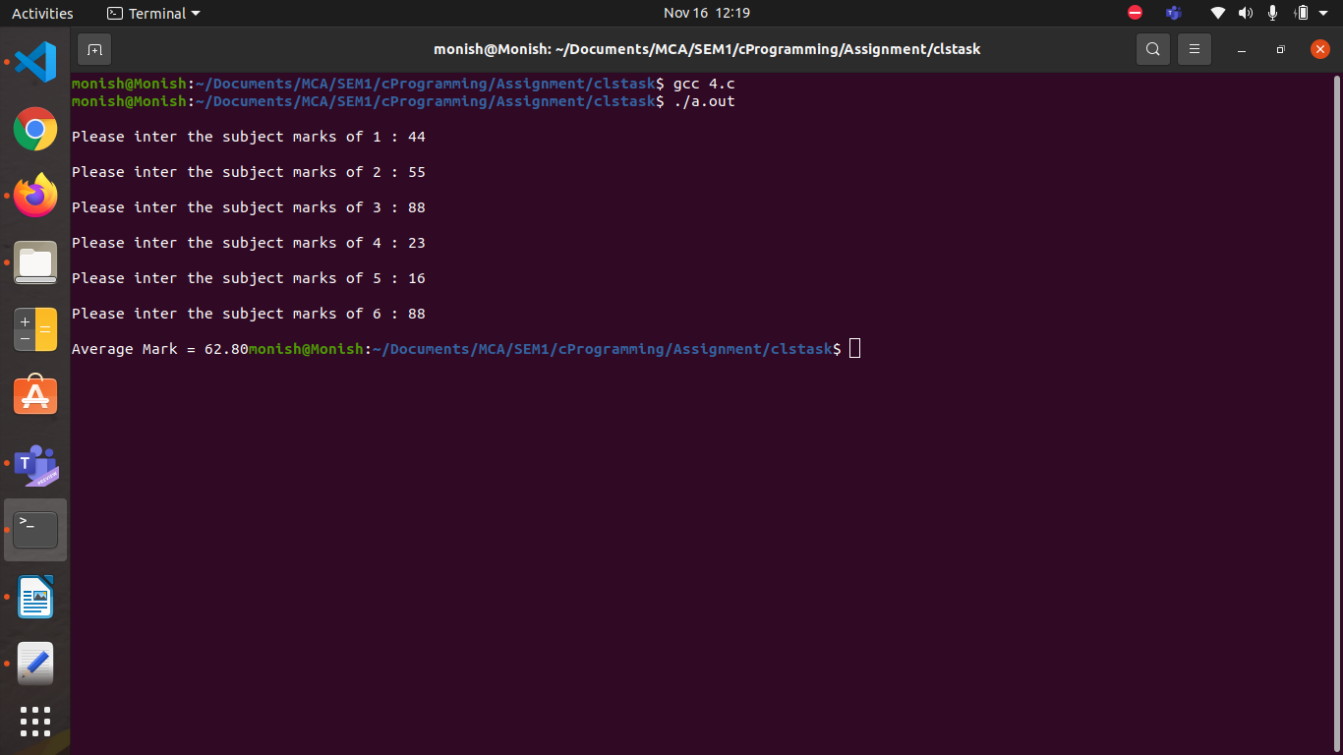

PROGRAM 5

#include<stdio.h>
int main()
{
int num;
printf("Please Enter a number: ");
scanf("%d", &num);
if(num%2 == 0)
printf("\nIt's an even number\n\n");
else
printf("\nIt's an odd number\n\n");
return 0;
}

OUTPUT

