Game Design Document

Fill up the following document

1. Write the title of your project.

Roll no 21

1. What is the goal of the game?

To excape from villan

1. Write a brief story of your game.

Ajay is playing a game known as ROLL NO:21. The villan is planning to defeat krish,do plese help krish to excape from his plan.

1. Which are the playing characters of this game?

* Playing characters are the ones who respond to the user based on the input from the user.
* Cars, monkeys, dinos, wizards, etc., are the playing characters in the game.

|  |  |  |
| --- | --- | --- |
| Number | Character Name | What can this character do? |
| 1 | krish | Move to right and left |
| 2 | kanish | Can attack krish |
| 3 |  |  |
| 4 |  |  |
| 5 |  |  |
| 6 |  |  |
| 7 |  |  |
| 8 |  |  |

1. Which are the Non-Playing Characters of this game?

* Non-Playing characters are the ones that don't have an action or behavior when the user interacts with the game.
* Hurdles, stones, bananas, coins, etc., are non-playing characters in the game.

|  |  |  |
| --- | --- | --- |
| Number | Character Name | What can this character do? |
| 1 | background |  |
| 2 |  |  |
| 3 |  |  |
| 4 |  |  |
| 5 |  |  |
| 6 |  |  |
| 7 |  |  |
| 8 |  |  |

Draw your imagination of this game. What does this game look like?

* Draw the game either on your computer or on paper.
* Add images of the game scenes to show each of the playing and non-playing characters at least once.

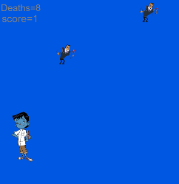

How do you plan to make your game engaging?

BY ADDING THE SPEED OF VILLAN WHEN KRISH SCORES 1 POINTAND IT WILL REPEAT.