GIT and Visual Studio Code
Git is software for tracking changes in any set of files, usually used for coordinating work among programmers collaboratively developing source code during software development. Its goals include speed, data integrity, and support for distributed, non-linear workflows.
Documentation of visual studio and git repository creation: -https://code.visualstudio.com.mcas.ms/docs/editor/github
Step 1:-First download the git in system
Install Git on your Download
https://git-scm.com/download/win
Step 2:- Create account on github
https://github.com/
step 3:- create a repository on github manually and copy url
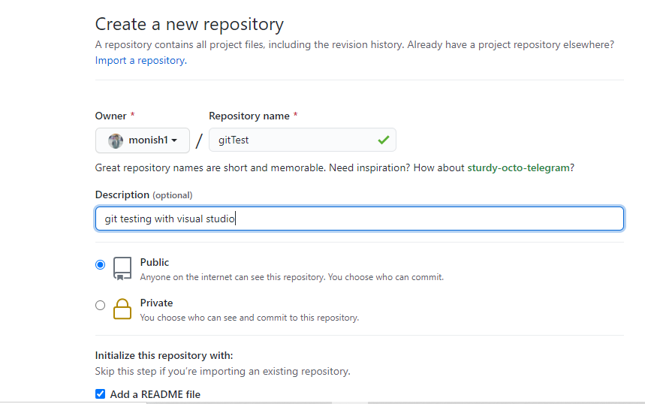
Note :- In visual studio link git to github using enabled the git

step 4:- Goto vs code and open project/folder
Note:- Check git is enabled from settings

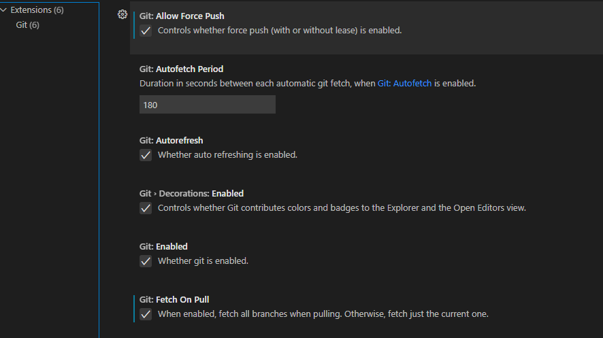
Note:- Give the Authorization to access the visual studio to GitHub.
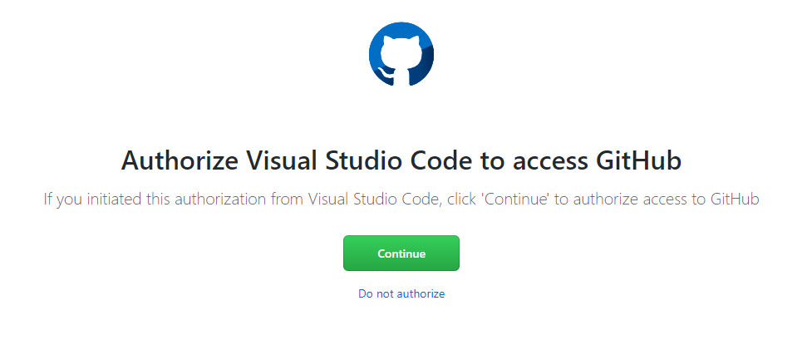
Step 5: Git source control Section and click on git icon
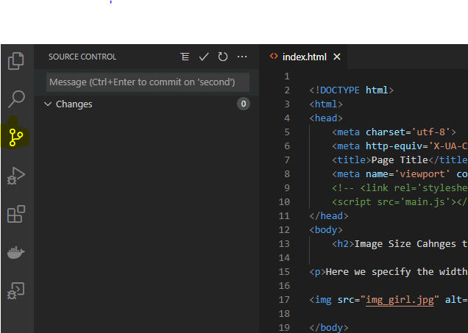

Step 6: Give commit message & commit the changes
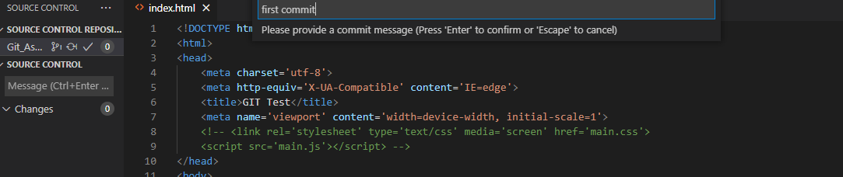
Step 7: Add remote repository(github repository)
Shortcut key: - Ctrl+shift +p is keyword to open the add remote repository to gitub
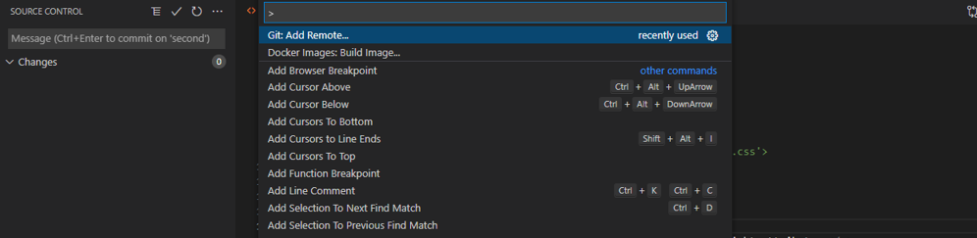
Step 8: push committed changes to github repository

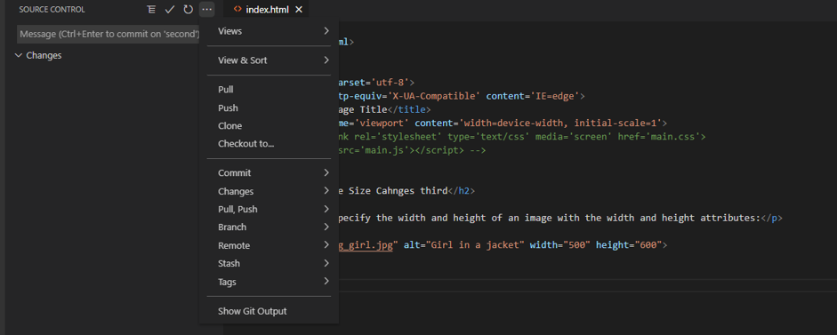
- We can push the changes of code to github or pull from github
Push - pushing sends the recent commit history from your local repository up to GitHub.
Pull – A pull grabs any changes from the GitHub repository and merges them into your local repository.
Clone:-
Step 9: Final URL of my github repository
url:- https://github.com/monish1/gitAssignment.git

